Appendix

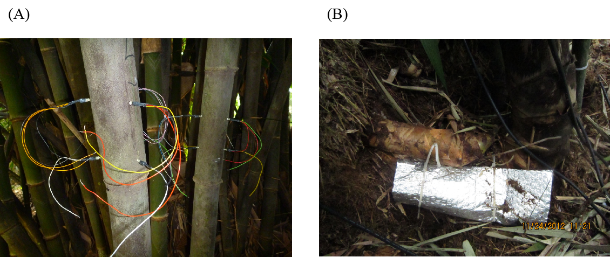

Appendix Figure 1. Field installation of TDP and the modified TDP for measuring sap flow of bamboo culms (A) and rhizomes (B), respectively.

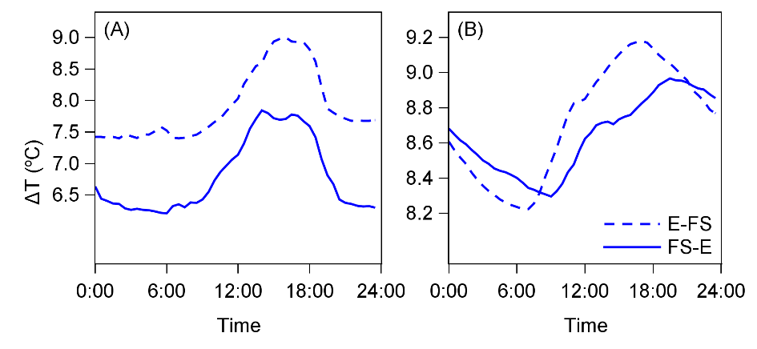
Appendix Figure 2. Typical diurnal patterns of temperature differences of upstream probes (ΔT_{E-FS}) and downstream probes (ΔT_{FS-E}) from rhizome: (A), temperature difference of downstream probes were lower than that of upstream probes (ΔT_{E-FS}>ΔT_{FS-E}); (B), temperature difference of downstream probes lagged behind that of upstream probes (ΔT_{E-FS} earlier than ΔT_{FS-E}). Both scenarios implied flowing from established culm to freshly sprouted culm.

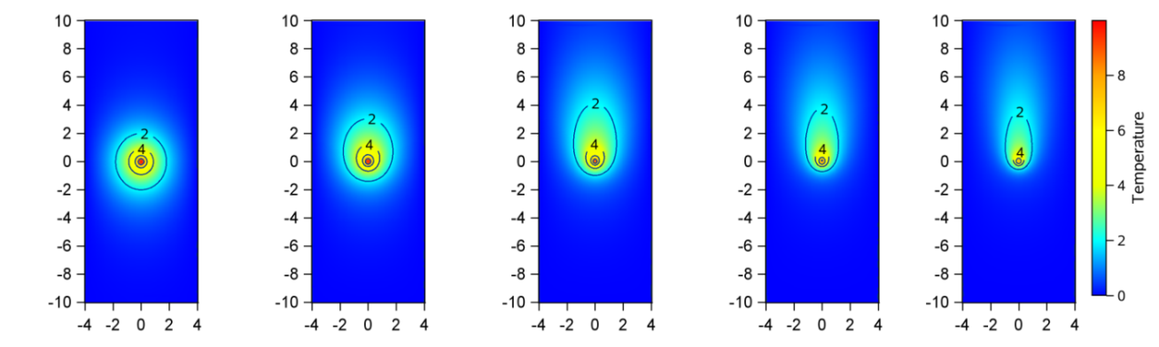
Appendix Figure 3. The simulated increased temperature fields (K) with different sap flux densities (from left to right: 0, 5, 10, 15, 20 g m⁻² s⁻¹). The values on x and y axis stand for the distances from the heating probe in tangential and axial directions, respectively.

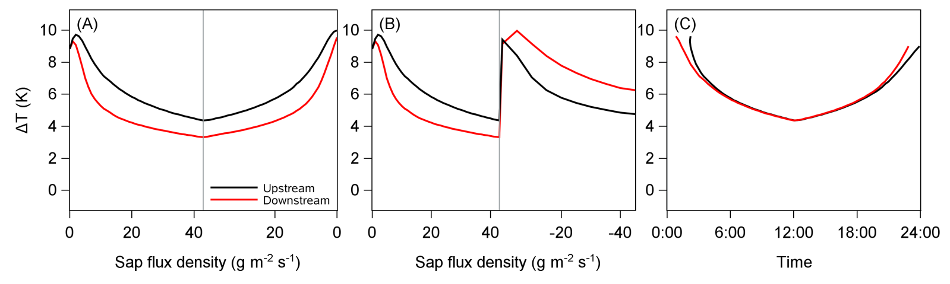
Appendix Figure 4. temperature difference (ΔT_{up} and ΔT_{down}) with different sap flux densities (A) increasing from 0 to 43 g m⁻² s⁻¹ and then dropping down to 0 g m⁻² s⁻¹, (B) increasing from 0 to 43 g m⁻² s⁻¹ and then dropping suddenly down to 0 and increasing from 0 to 43 g m⁻² s⁻¹ in reverse direction, and (C) the proposed lagging patterns of temperature difference (ΔT_{up} andΔT_{down}) in scenarios (3).

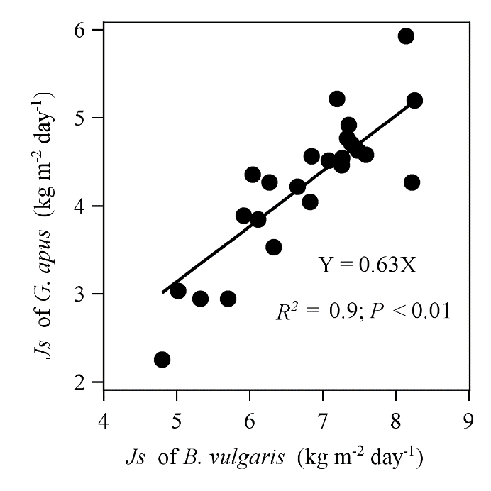
Appendix Figure 5. The linear relationship between J_{s} (kg m⁻² day⁻¹) of established culms of G. apus and B. vulgaris. Data averaged from 5 culms of each species in 24 days ranging from Dec 29, 2012 to Feb 7, 2013.

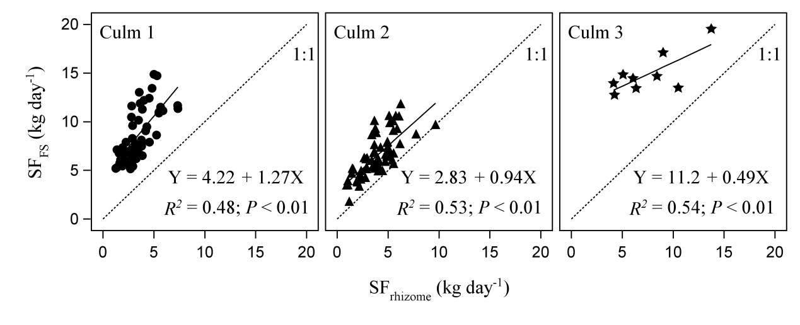
Appendix Figure 6. Estimated daily water use (kg day⁻¹) of three freshly sprouted culms (SF_{FS}) of Bambusa vulgaris in relation to water use of the corresponding rhizomes (SF_{rhizome}). The water use of both freshly sprouted culms and rhizomes is based on the estimated sap flux density calculated with the adjusted formula for established culms, multiplied by the cross-sectional water conductive area at the location of the sensors.

