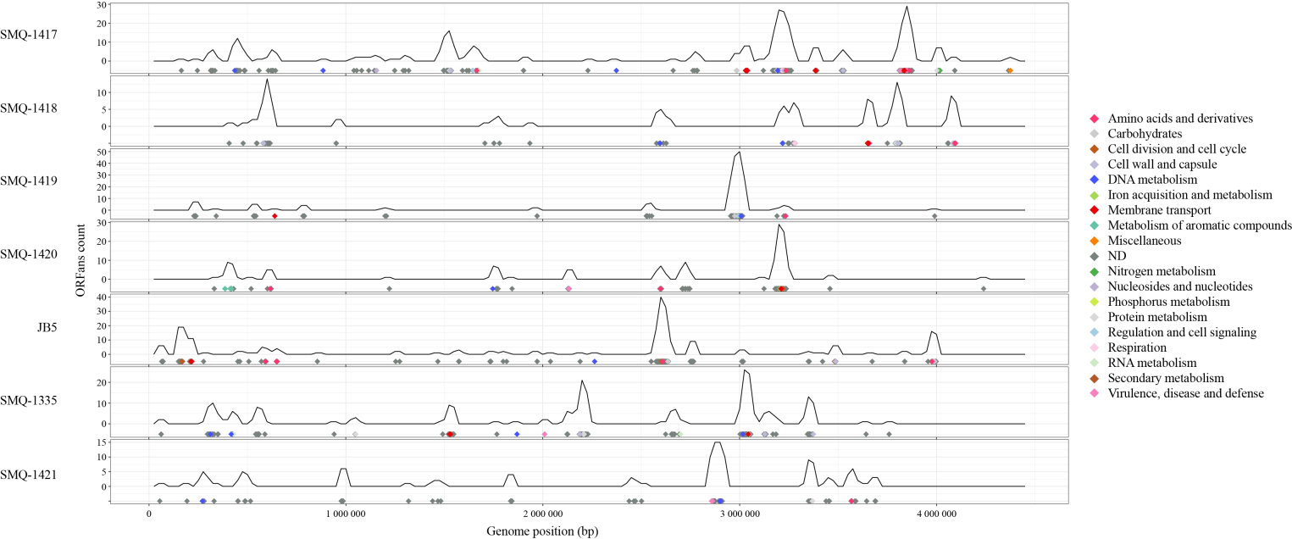

Supplementary Figure S1 ORFans distribution in B. aurantiacum genomes. ORFans genomic positions and abundance are presented. Diamond colors correspond to RAST subsystem categories.

