Supplementary Figure 1. Receiver operator characteristics (ROC) curves of serum IL-10 levels and cerebrospinal fluid (CSF) white blood cells (WBC) count.
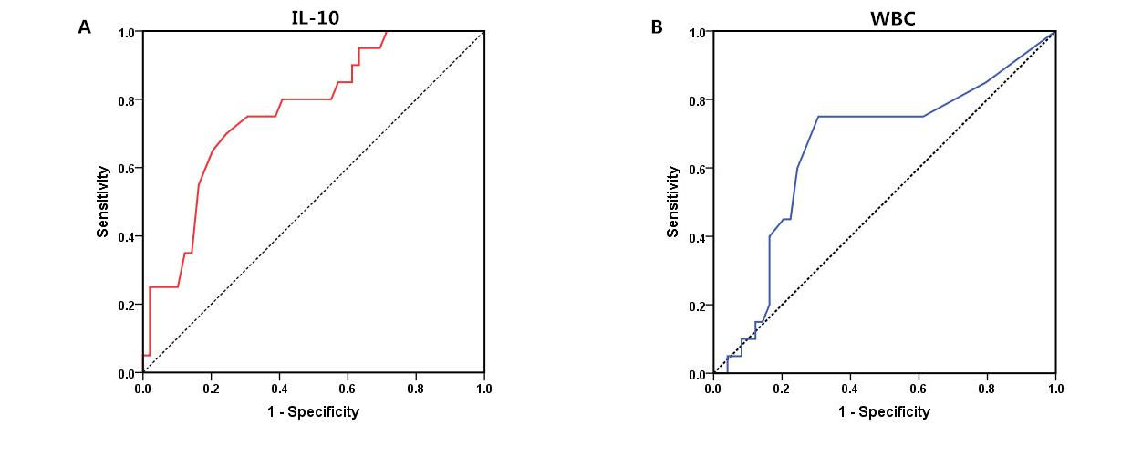
A. The areas under the ROC curve (AUC) of serum IL-10 were significant with respect to relapse (AUC = 0.77; 95% confidence interval [CI] 0.65–0.89; p = 0.001).
B. The AUC of the CSF WBC count were significant with respect to relapse (AUC = 0.66; 95% CI 0.51–0.81; p =0.042).

