SUPPLEMENTARY MATERIAL
The Supplementary Material for the article titled: “Nitrogen and phosphorus retranslocation of leaves and stemwood in a mature Eucalyptus forest exposed to five years of elevated CO₂” by Kristine Y. Crous, Agnieszka Wujeska-Klause, Mingkai Jiang, Belinda E. Medlyn and David S. Ellsworth can be found online at: https://www.frontiersin.org/articles/10.3389/fpls.2019.00664/full#supplementary-material

Figure S1| Annual variation in means and standard error plots of leaf chemistry for mature green leaves collected in February (the austral summer) of each year for (A) mass-based phosphorus in mg g⁻¹, (B) mass-based nitrogen in mg g⁻¹, (C) N:P ratio and (D) C:P ratio (dimensionless).

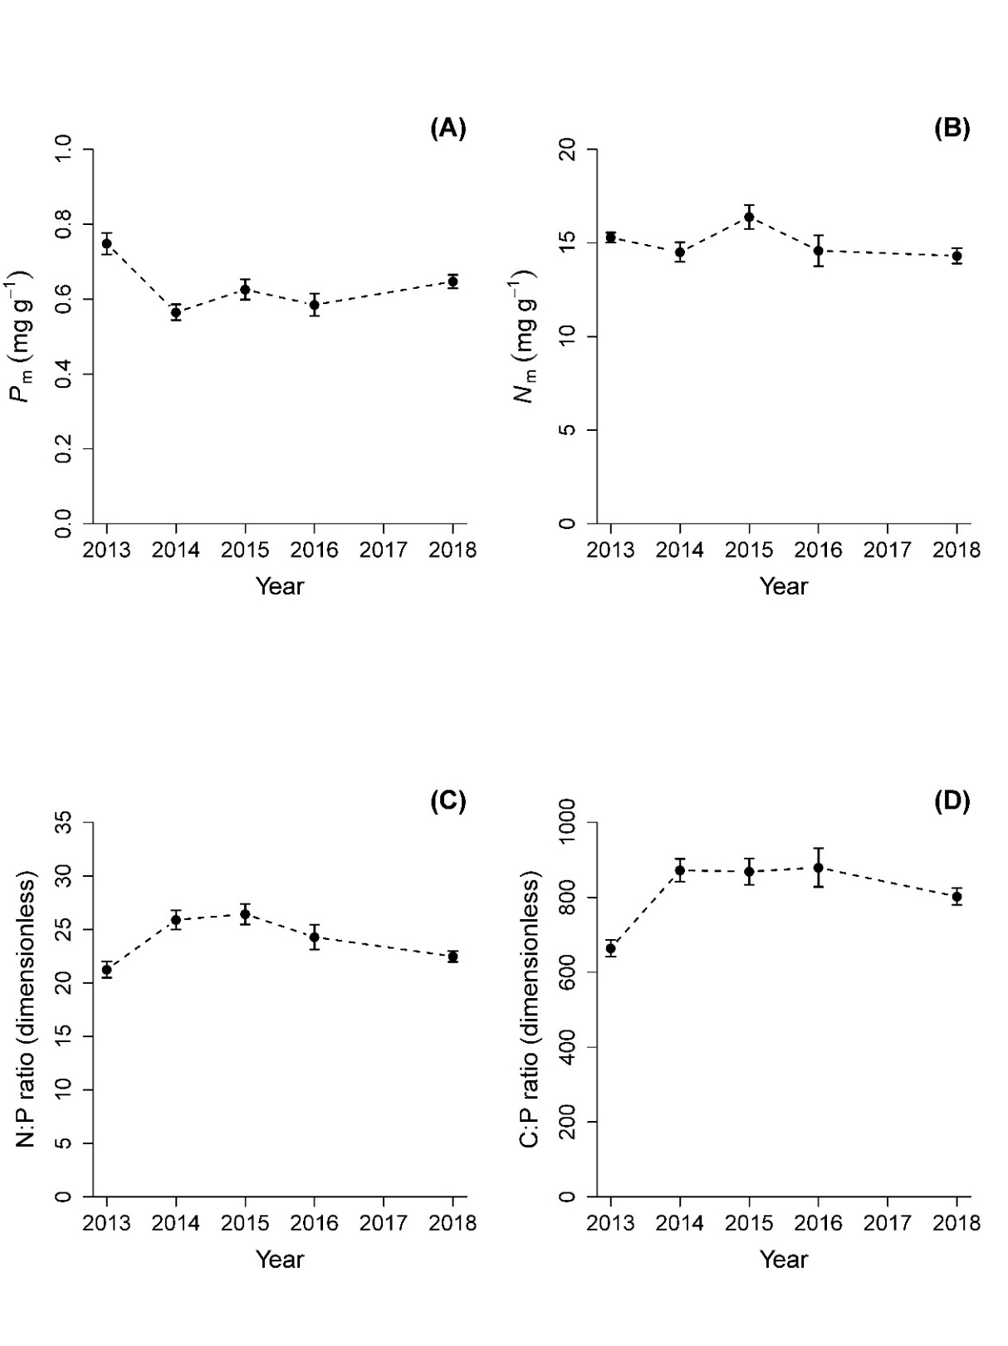
Figure S2: Correlations between mass-based leaf P and N concentration (mg g⁻¹) of mature green leaves and the amount of rainfall of the preceding one month (left panels, A and C) and six months (right panels, B and D). Pearson correlation coefficients for each panel respectively were: A) 0.82, B) 0.59, C) 0.56 and D) 0.45. All correlations were significant (P < 0.008). Elevated CO₂ treatment is not indicated as it was not significant (P > 0.10).

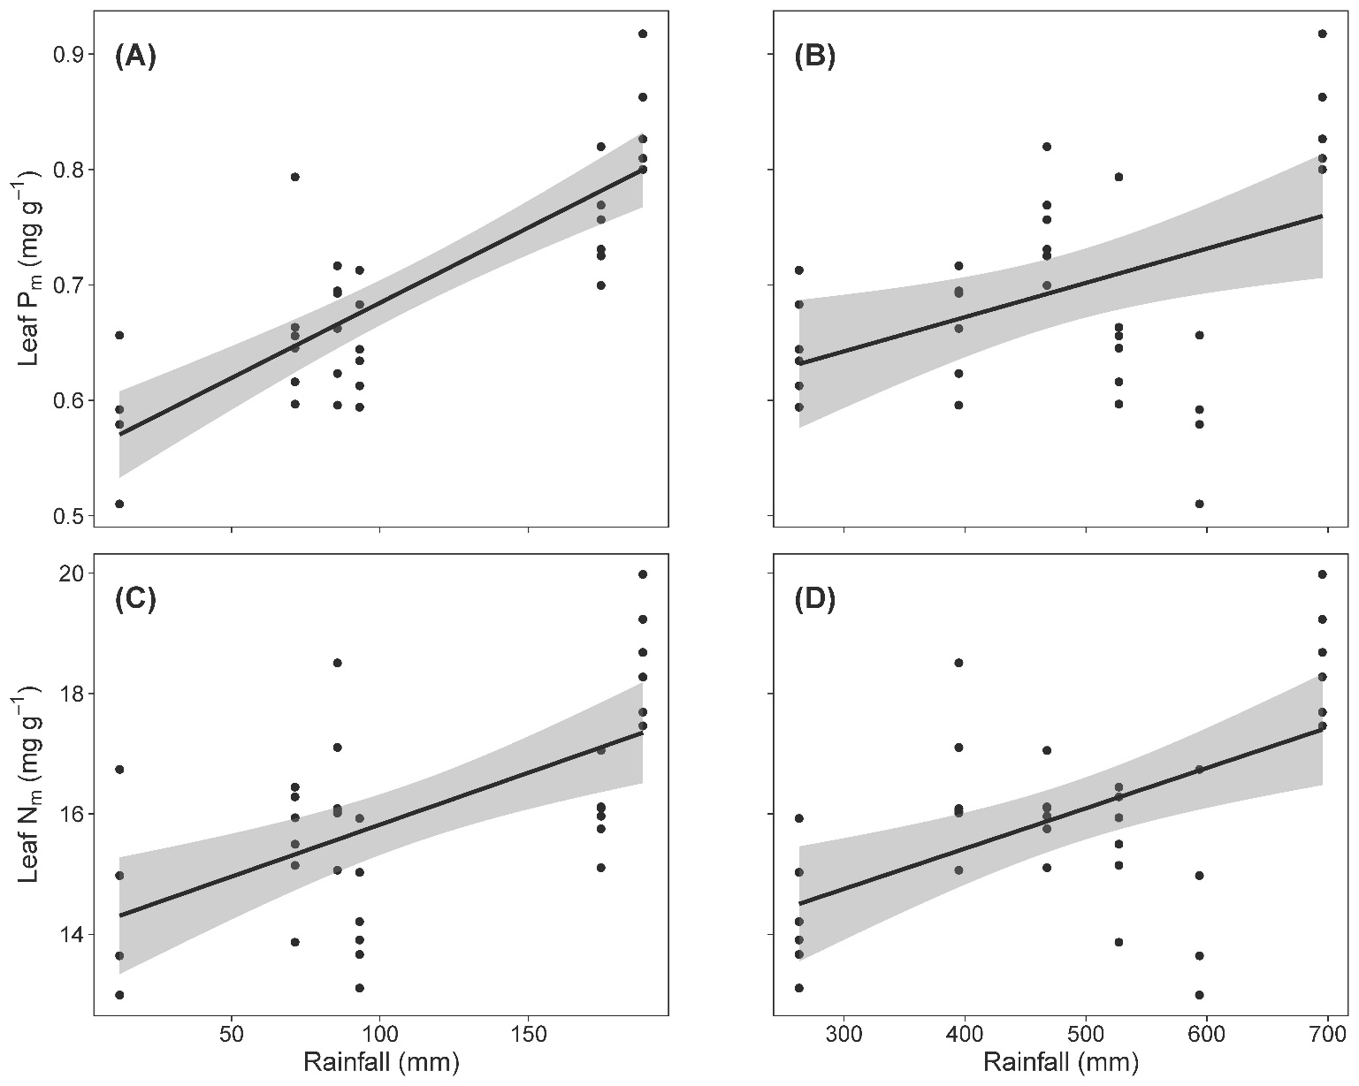
TABLE S1: Mixed model ANOVA table with F-statistic of green upper canopy leaves over five years with CO₂, Age and Year as fixed factors and tree nested within ring as random factors. df represents the degrees of freedom, where two years did not have the newly-flushed age class resulting in a reduction of df from 5 to 3 for the interactions. The variables are as follows: area-based phosphorus in g m⁻² (P_{a}), area-based nitrogen in g m⁻² (N_{a}) and leaf mass per area ratio in g m⁻² (LMA). P_{a} was log-transformed for this analysis to conform with normality assumptions. Significant F-statistics are highlighted in bold with significance level indicated as *** for P < 0.0001, ** for P < 0.01, * for P < 0.05 and ⁺ for P > 0.05 and P < 0.1.

GREEN upper canopy leaves F-statistic and significance
Source | df | P_{a} | N_{a} | LMA
CO₂ | 1 | 1.56 | 0.48 | 5.30⁺
Age | 1 | 20.24*** | 174.2*** | 288.7***
Year | 5 | 20.43*** | 24.24*** | 19.72***
CO₂ x Age | 1 | 0.07 | 3.35⁺ | 1.41
CO₂ x Year | 5 | 2.09⁺ | 1.19 | 1.78
Age x Year | 3 | 11.88*** | 6.12*** | 0.80
CO₂ x Age x Year | 3 | 0.81 | 0.19 | 1.20

