1. Cervical spine

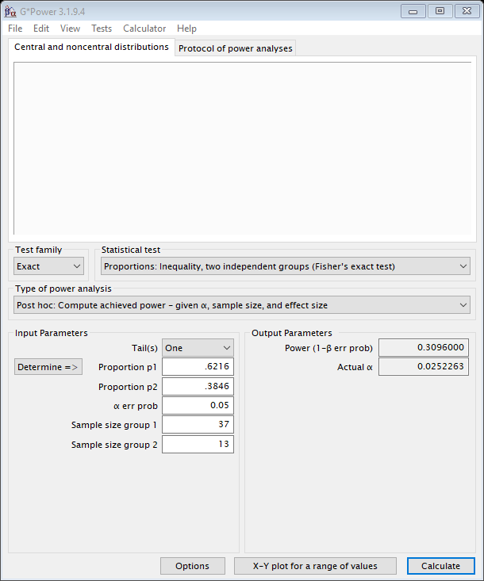

2. Thoracic spine Tx

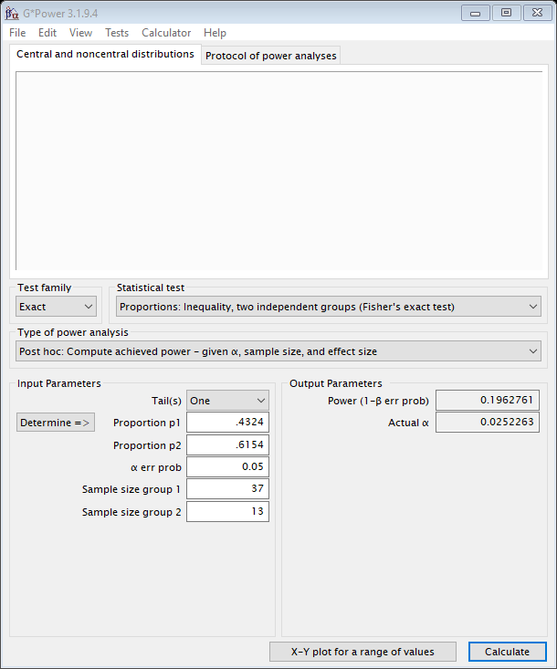

3. Lumbar spine Lx

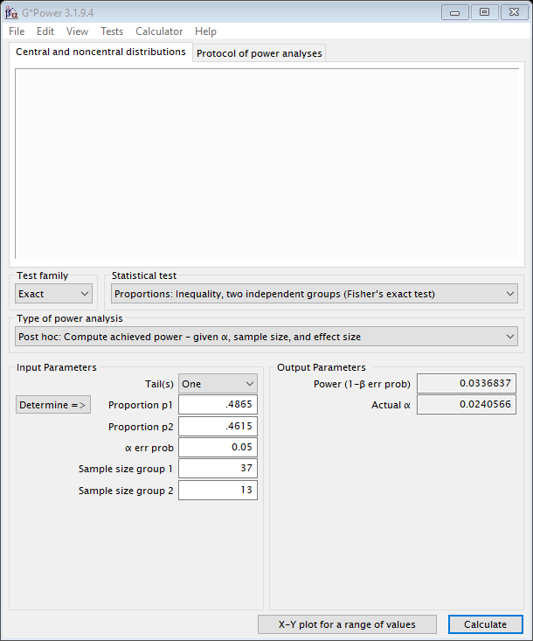

4. Sacrum Sc

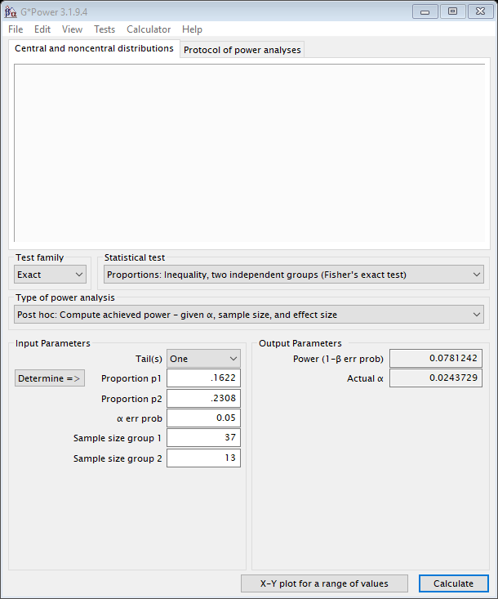

5. Pelvis

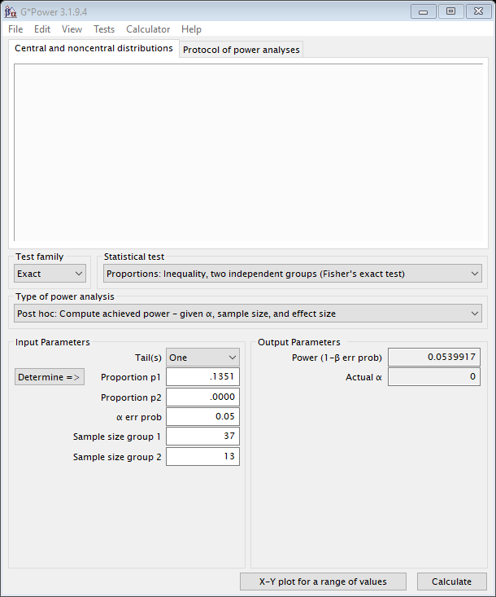

6. Temporal muscle on the right side

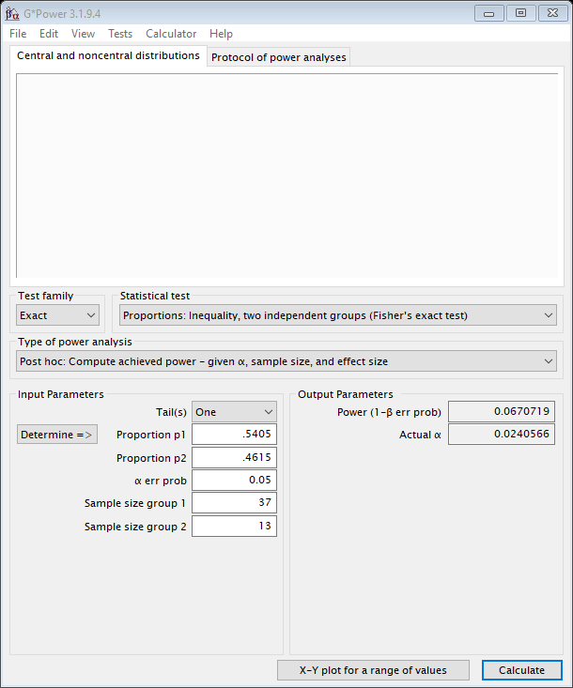

7. Temporal muscle on the left side

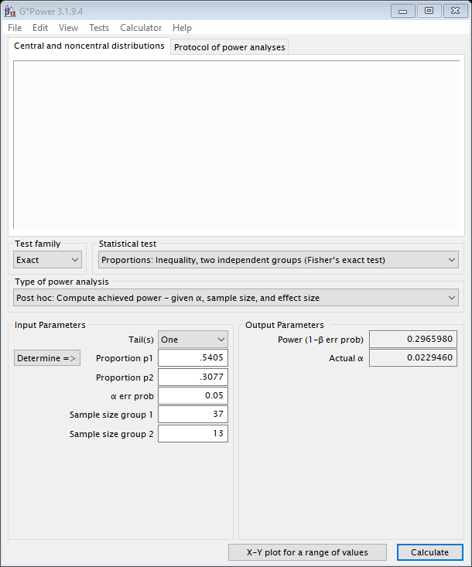

8.Masseter muscle on the right side

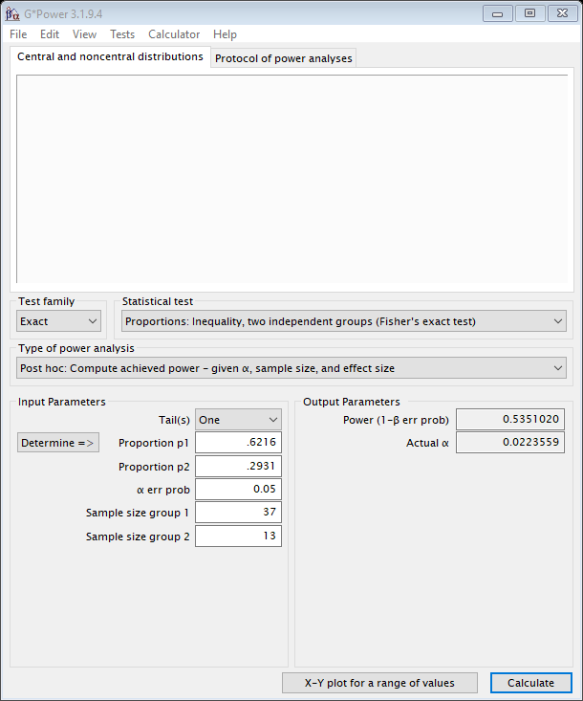

9. Masseter muscle on the left side

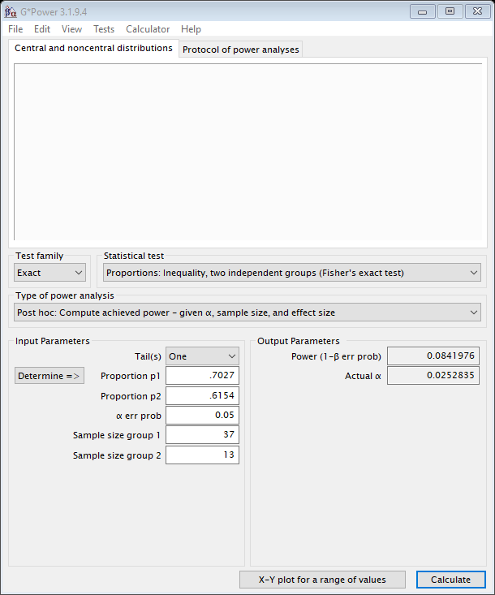

10. Musculus sternocleidomastoideus on the right side

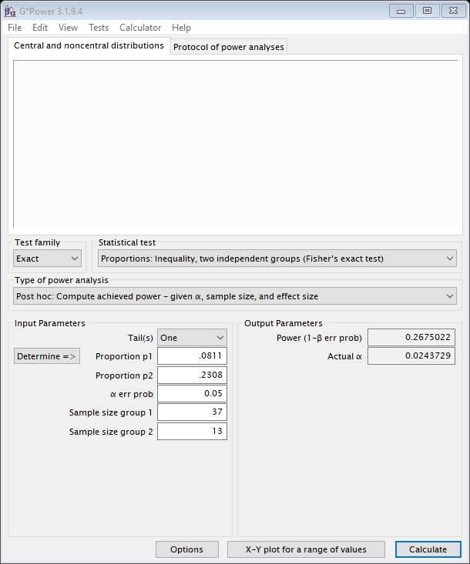

11. Musculus sternocleidomastoideus on the left side

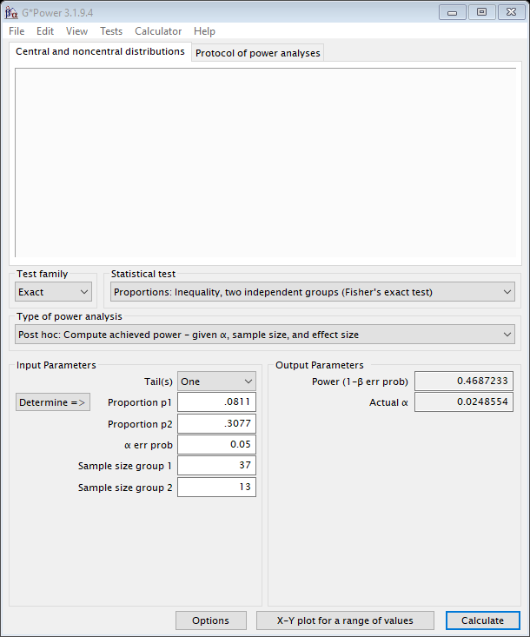

12. TMJ on the left side

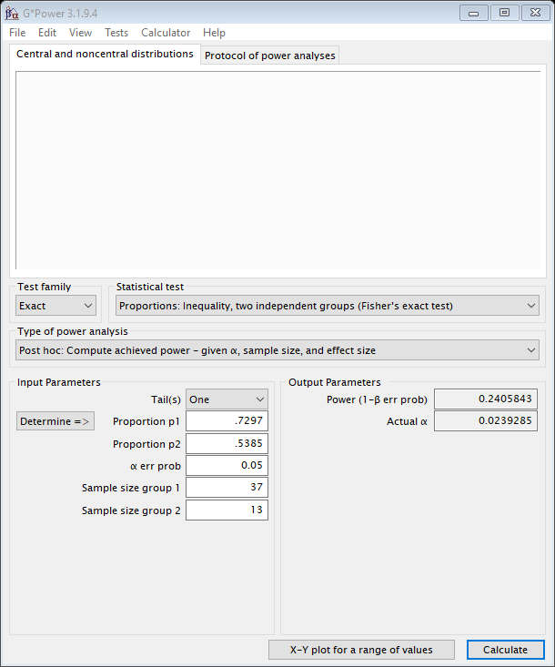

13. TMJ on the right side

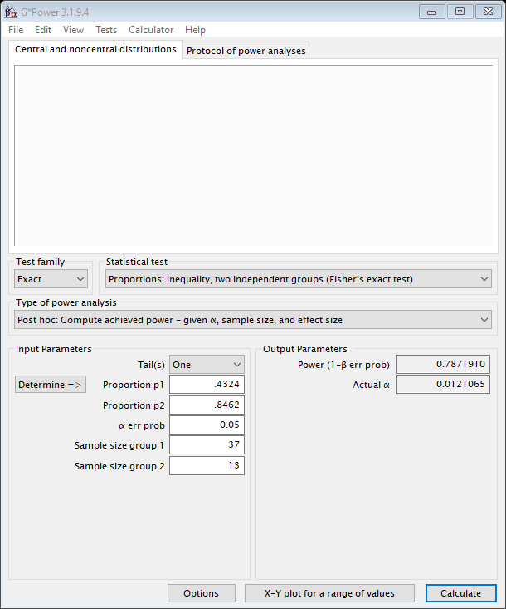

14. Area of the lower angle of the left scapula

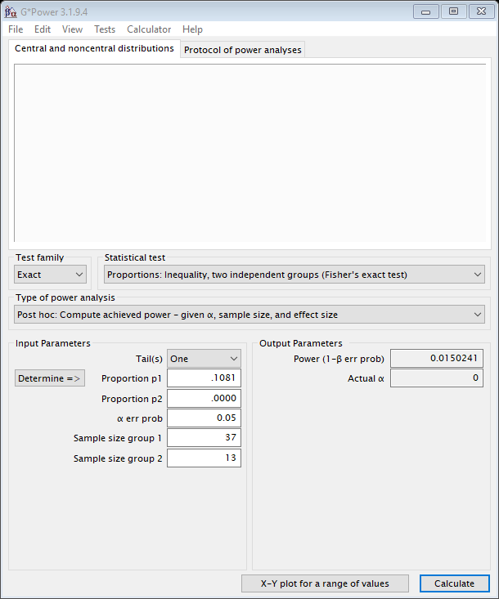

15. Area of the lower angle of the right scapula



16. Right shoulder

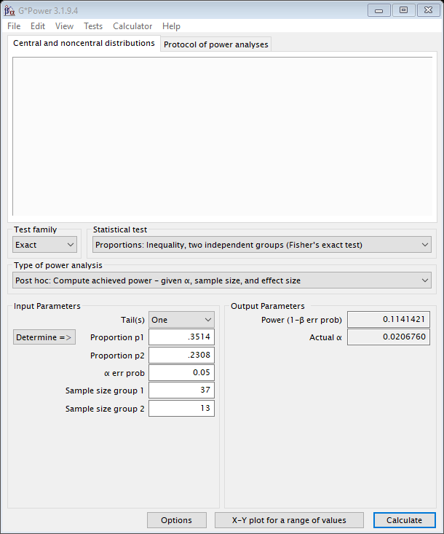

17. Left shoulder

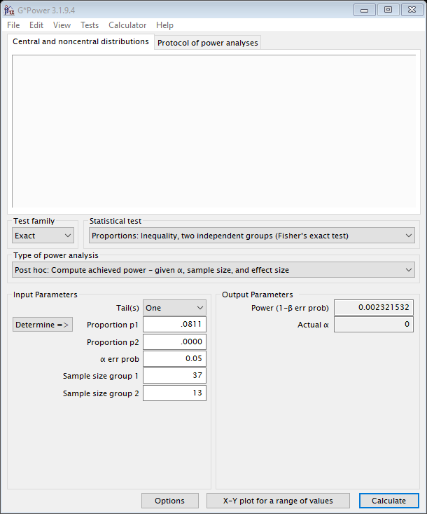

18. Thoracic outlet



19. Right hip band

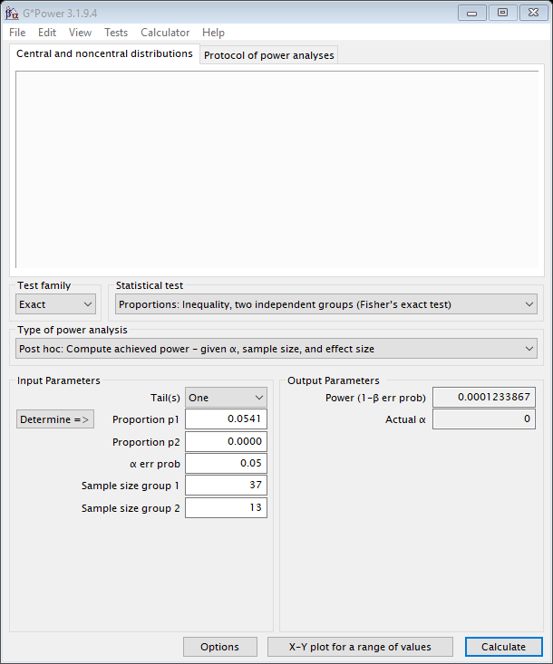

20. Left hip band

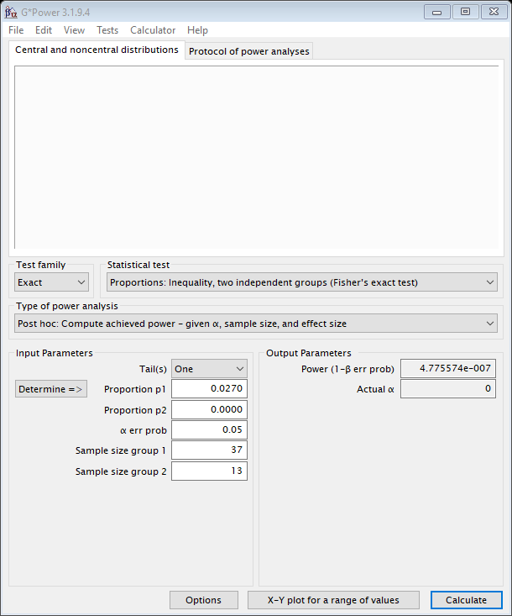

21. Sternum

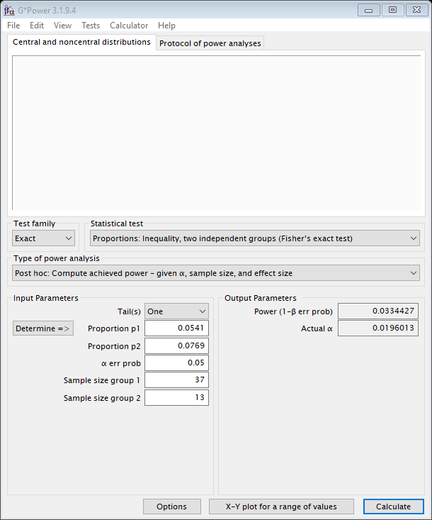

22. Right knee

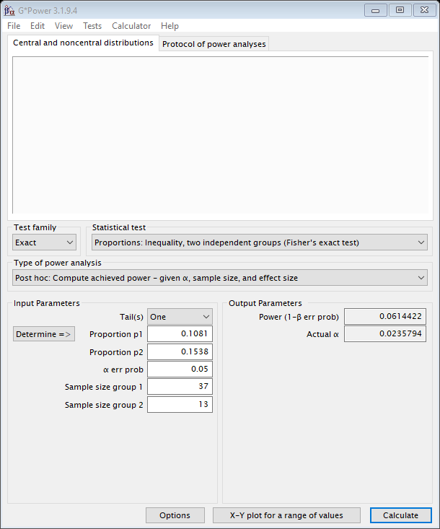

23. Left knee



24. Right shinbone

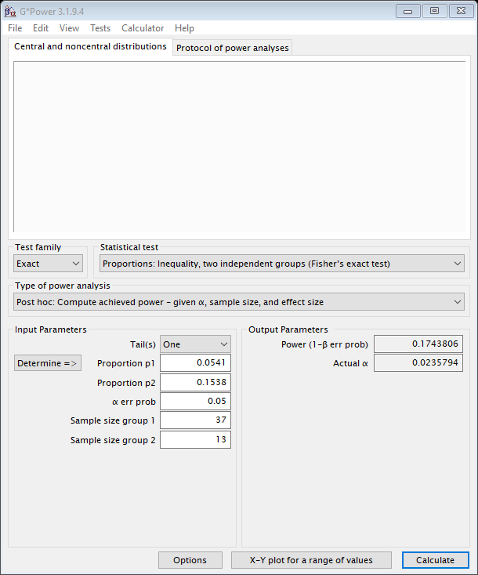

25. Left shinbone

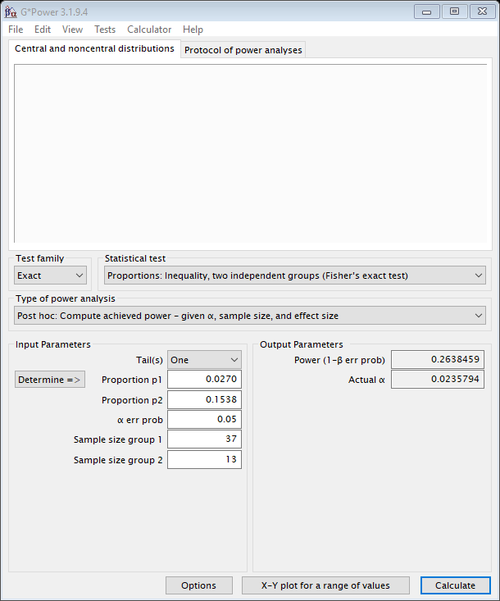

26. Teeth 18-14

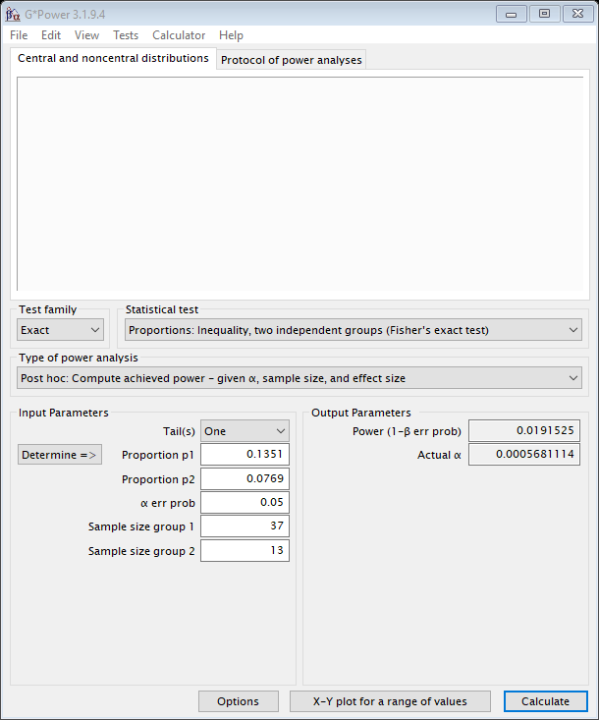

27. Teeth 13-11

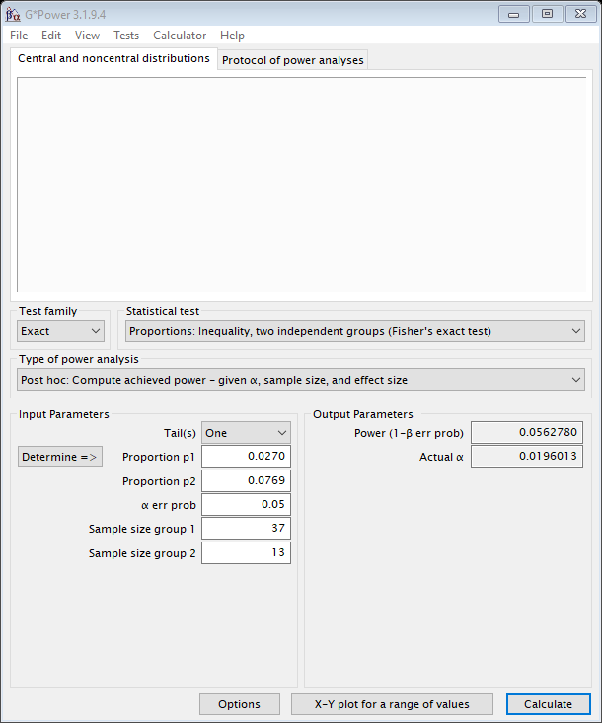

28. Teeth 21-23



29. Teeth 24-28



30. Teeth 34-38



31. Teeth 31-33



32. Teeth 41-43

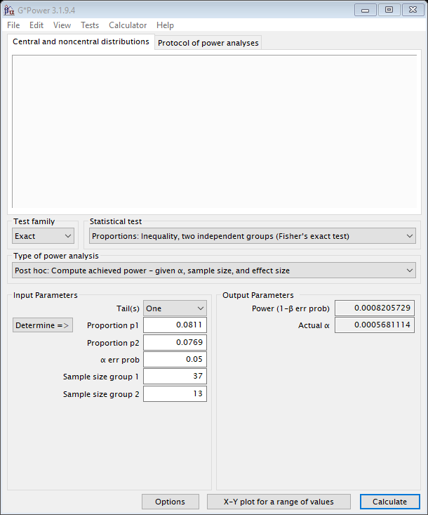

33. Teeth 44-48

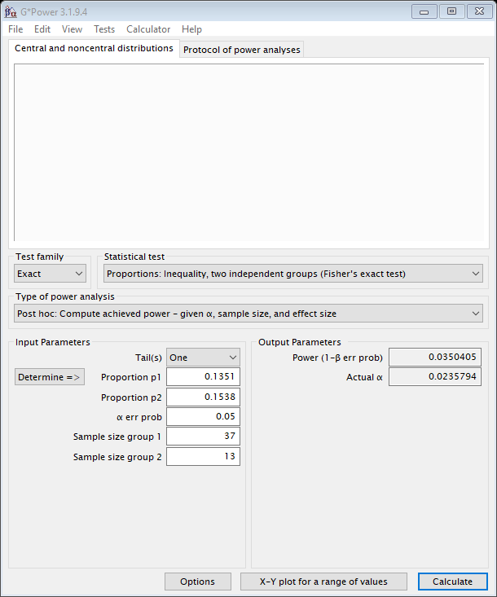

34. Palate



35. Right hand



36. Left hand



37. Right pterygomandibular ligament

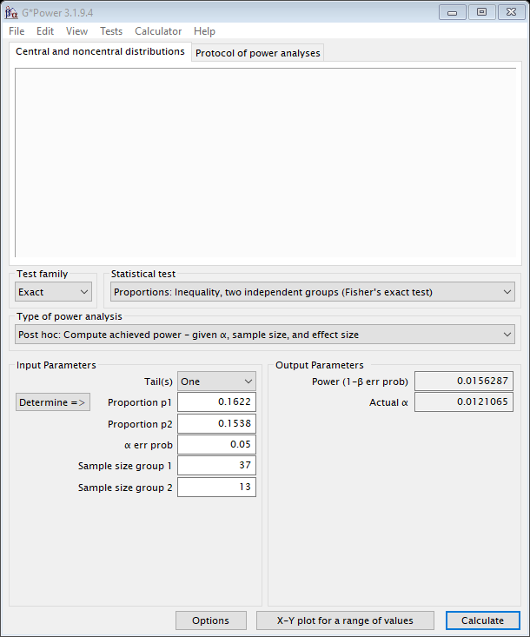

38. Left pterygomandibular ligament

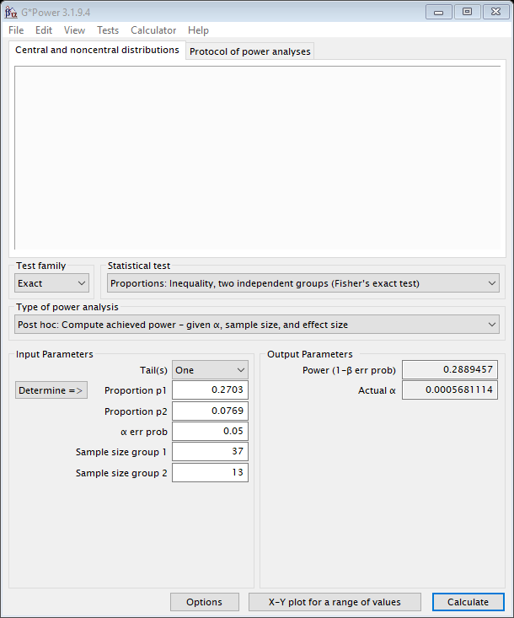

39. Right eye

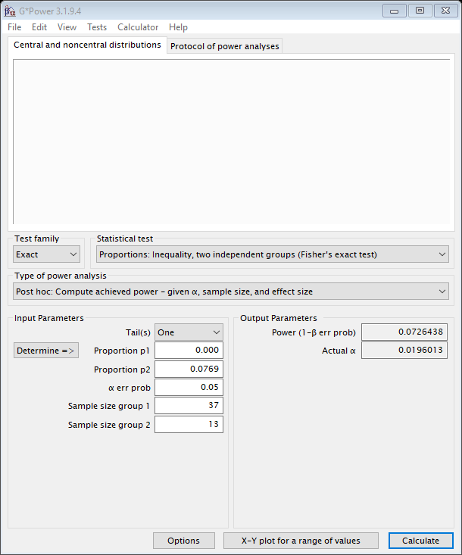

40. Left eye

