Supplementary Figure S1 Western blot identification of β-catenin and LEF1 expression vectors in ICP2 cells. Cells were transfected with pCMV-HA-β-catenin, pEASY-Blunt-M2-LEF1, pCMV-HA, and pEASY-Blunt-M2, respectively. Cells were harvested, and β-catenin and LEF1 expression were verified by western blotting using anti-HA (A), anti-Myc (A), anti-LEF1 (B) and anti-β-catenin antibodies (B), respectively. β-actin was used as a loading control.

Supplementary Figure S2 Quantitative RT-PCR (A) and Western blot analysis (B) showing the knockdown efficiency of LEF1 and β-catenin by small interfering RNA in DF1 and ICP2 cells. Cells were transfected with either si-β-catenin, si-LEF1 or si-NC by Lipofectamine 2000. The knockdown efficiency of β-catenin and LEF1 at the mRNA level was verified by real-time RT-PCR. The relative gene expression was normalized to TBP. (A). The knockdown efficiency of β-catenin and LEF1 at the protein level was verified by western blotting using antibodies against LEF1 and β-catenin. β-actin served as the loading control. All data are representative of three independent experiments and shown as the mean ± SD. *P < 0.05; **P < 0.01; determined by two-tailed Student’s t-test.

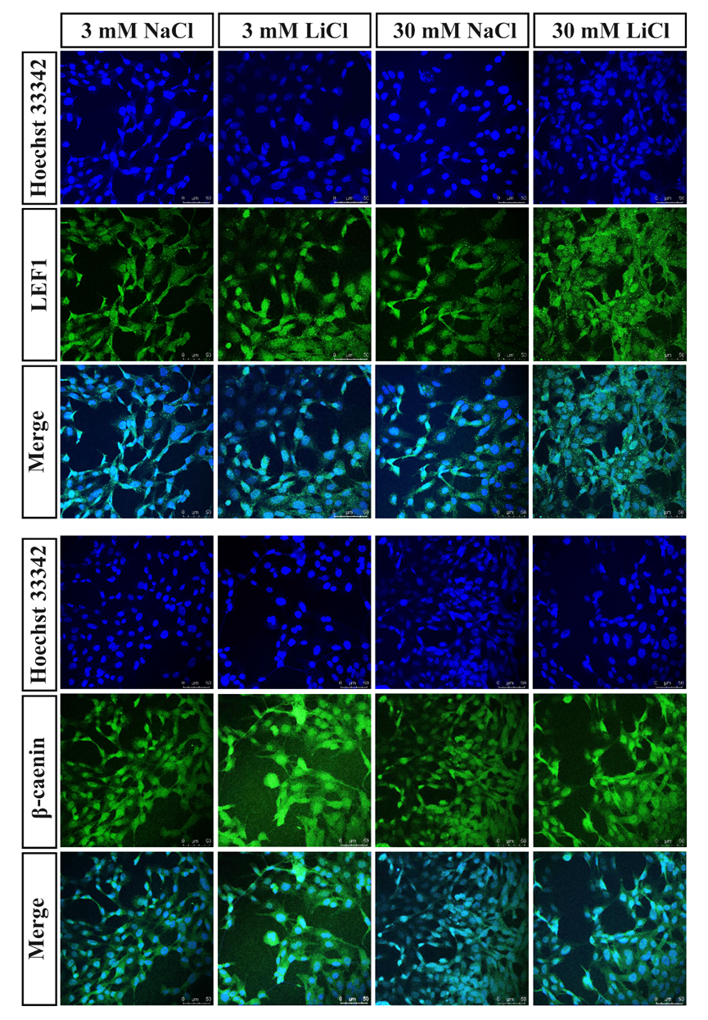
Supplementary Figure S3 Immunofluorescence showing nuclear levels of β-catenin and LEF1 in DF1 cells treated at indicated concentrations of LiCl.

