Supplementary Figure 1. WT p53 harboring HCT116 cells remain the most sensitive CRC cells after long-term exposure to MC3. The three CRC cells were treated with increasing concentrations of MC3 as indicated for 96 h, after which MTT assay was performed. %cell viability was calculated by normalizing to mock treatment (0.1% DMF). Multiple comparisons were employed using two-way ANOVA test and a post-hoc Tukey test. *, **, ***, and **** represent p-values less than or equal to 0.05, 0.01, 0.001, and 0.001, respectively.
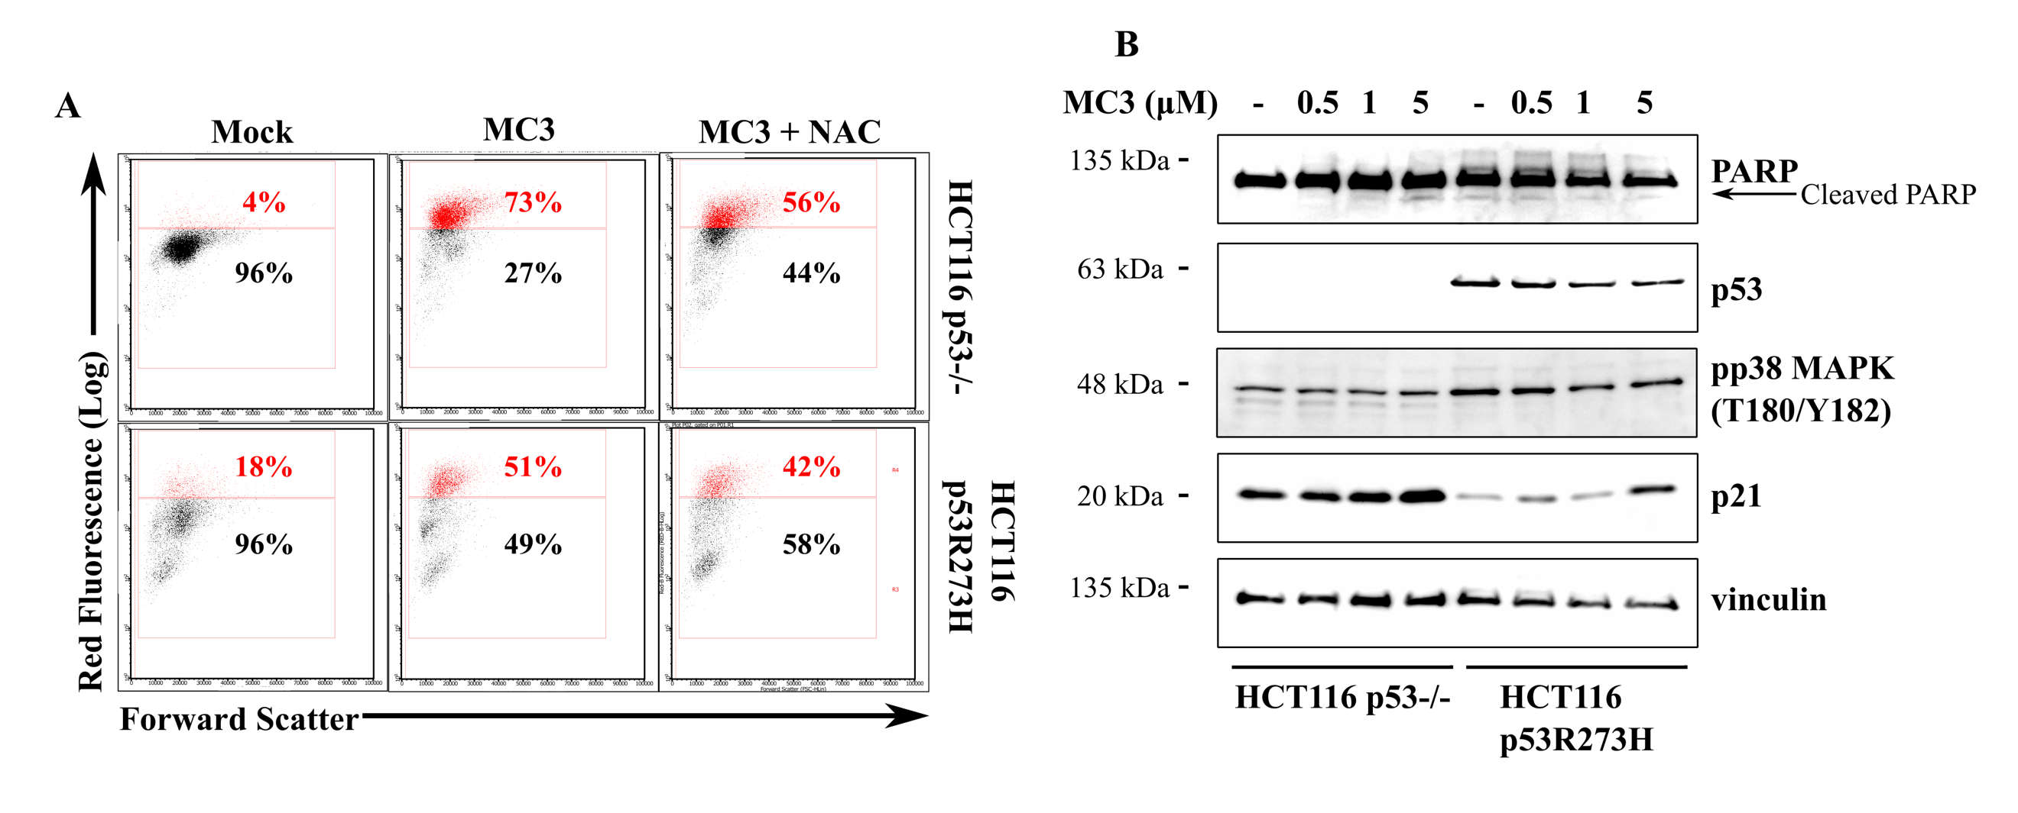
Supplementary Figure 2. MC3's cellular mechanisms in mutant p53 harboring HCT116 cells. (A) MC3 (5 µM, 24 h) enhances the generation of ROS in p53 R273H over-producing HCT116 cells, an effect which is compromised when cells are pre-treated with NAC (10 mM, 30 min). (B) HCT116 p53-/- cells over-expressing mutant p53 (R273H) demonstrate increased p21 expression, whereas they fail to induce pp38 (T180/Y182) levels and cleavage of PARP upon 24 h treatment with MC3 at the indicated concentrations, as determined by immunoblotting. 0.1% DMF served as mock treatment.
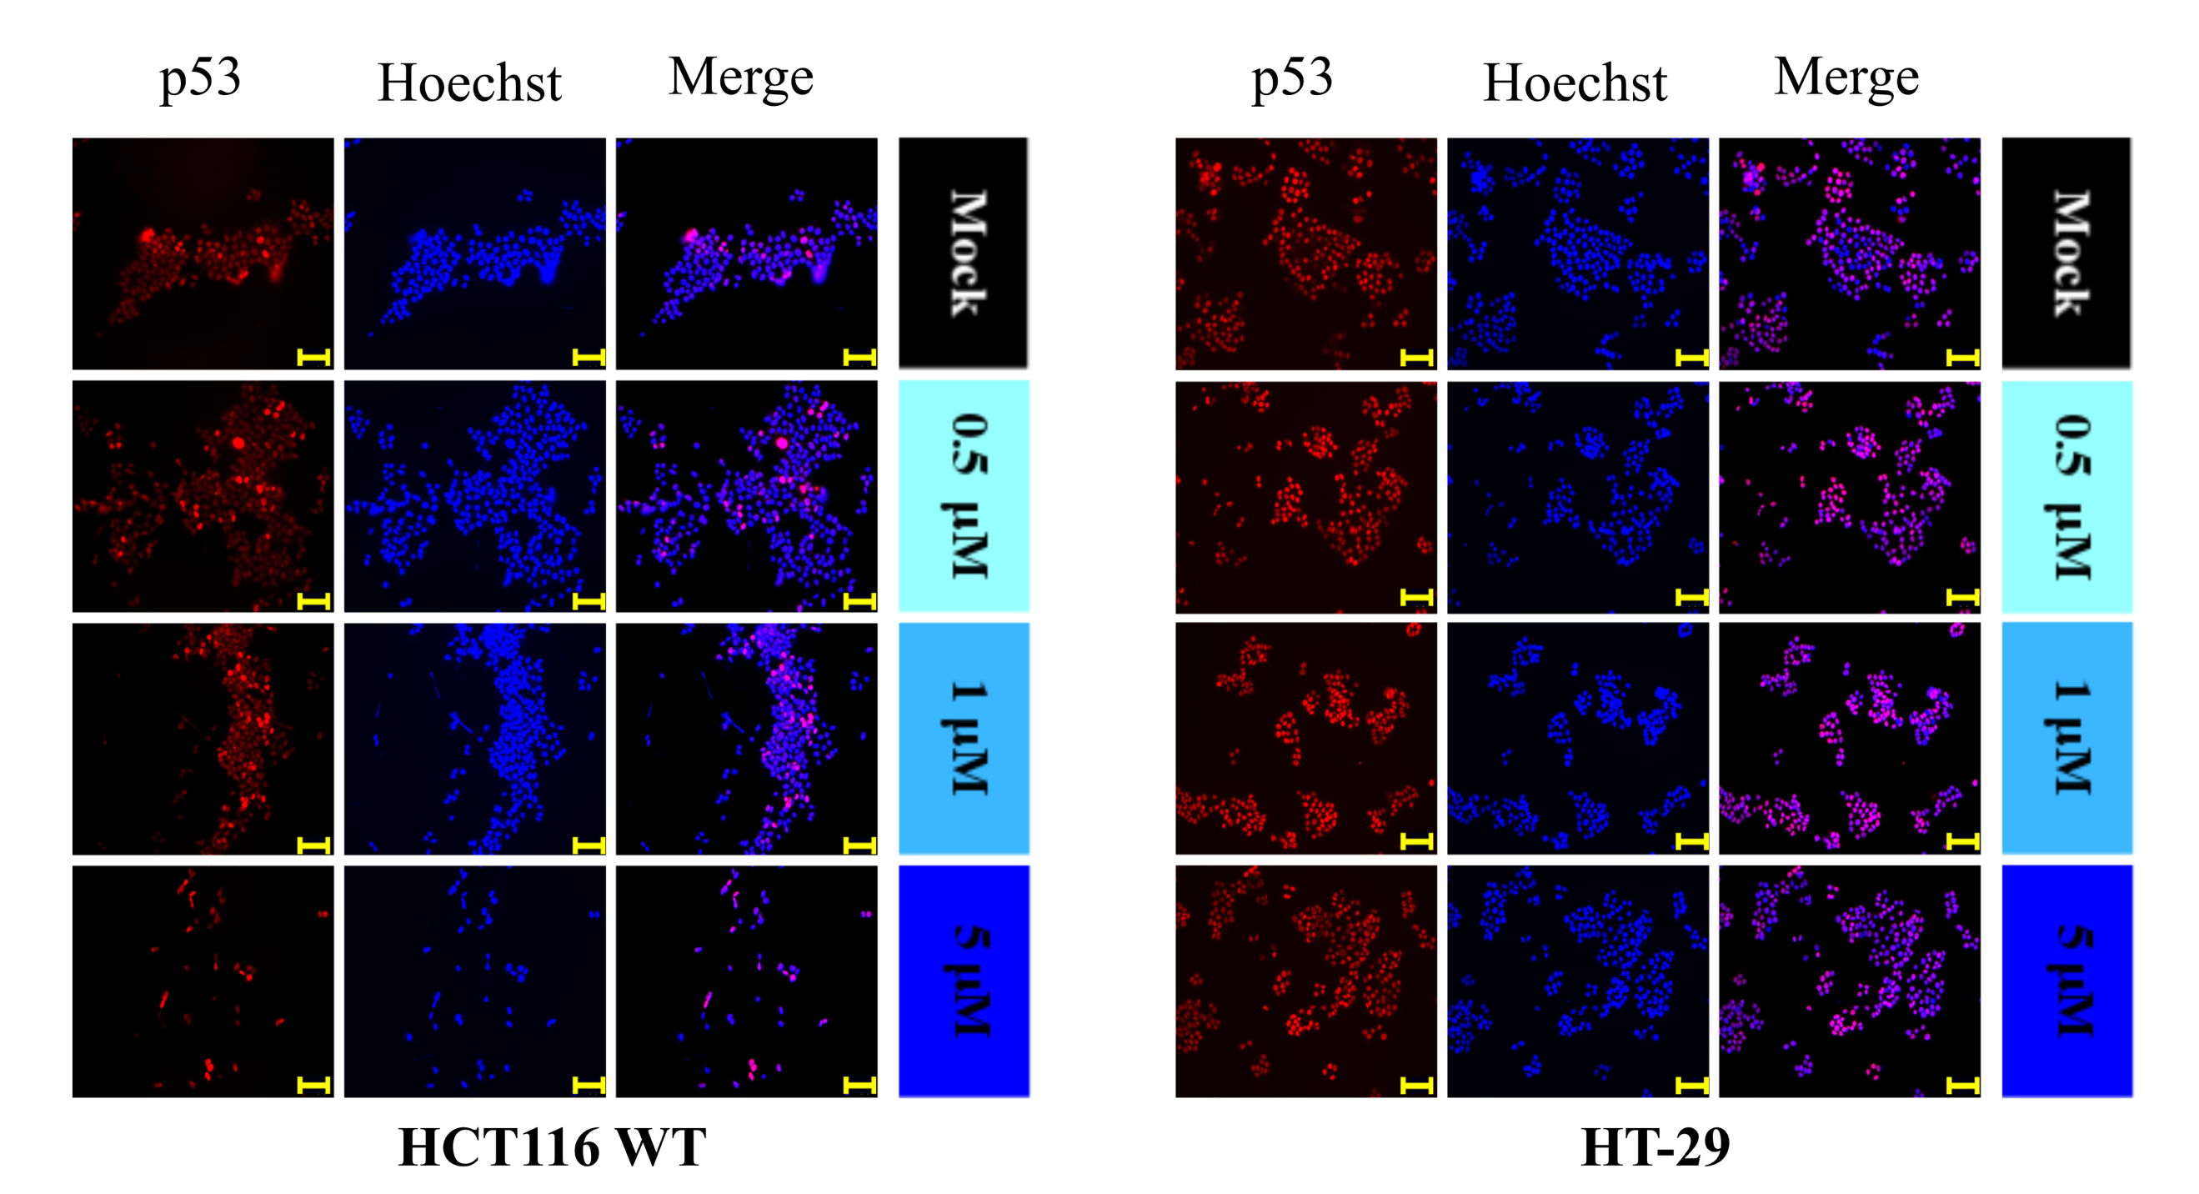

Supplementary Figure 3. Fluorescence micrographs of HCT116 WT and HT-29 treated with MC3 for 24 h illustrate no major change in p53 nuclear accumulation in both cell lines as compared to the respective mock (0.1% DMF) treatments. Hoechst dye was used to indicate nuclei. Scale bar: 100 µm.

