Supplementary Material

Phenothiazinen-Dimesitylarylborane based Thermally Activated Delayed Fluorescence: High Performance Nondoped OLEDs with Reduced Efficiency Roll-Off at High Luminescence
Xiangyang Tang^{1#}, Yanchun Tao^{1#}, Hui Liu¹, Futong Liu¹, Xin He¹, Qiming Peng², Jinyu Li¹, Ping Lu^{1*}
* Correspondence: Ping Lu: lup@jlu.edu.cn
Figure S1 (a) TGA and (b) DSC of PTZMes₂B.

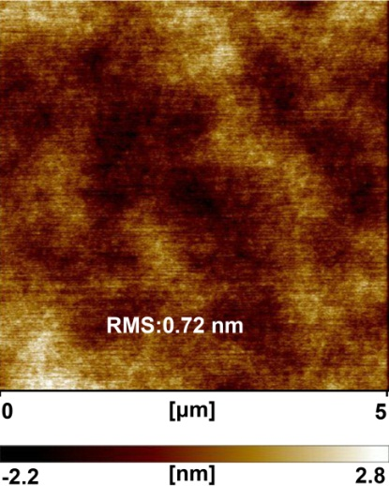
Figure S2. AFM image (5μm × 5 μm) of PTZMes₂B.

Table S1. PLQY of doped films.
Doping concentration  (weight ratio) | 5% | 10% | 20% | 30% | 50% | 80% | 100%
PLQY (%) | 86 | 93 | 91 | 89 | 78 | 77 | 65

Figure S3. PLQY of doped films.

Figure S4. Transient PL spectra of doped and neat films.

Figure S5. Phosphorescence of Mes₂BBr and PTZP.

Figure S6. Temperature-dependent steady state PL spectra of (a) wt. 10% doped and (b) neat films from 80 K to 290 K under vacuum condition.

Figure S7. Device configuration and chemical structure.

Figure S8. (a) I-V-L (b) luminescence efficiency and (c) power efficiency of PTZMes₂B devices; EL spectra of (d) wt. 5% (e) wt. 10% (f) wt. 20% (g) wt. 30% (h) wt. 50% (i) wt. 80% and (j) nondoped devices.

Figure S9. Device performance of PTZMes₂B-mCBP doped devices: (a) I-V-L, (b) EQE-Luminescence, (c) current efficiency-luminescence, (d) power efficiency-luminescence and (e) PL spectra at driving voltage of 7 V.

Figure S10. Device performance of PTZMes₂B-DPEPO doped devices: (a) I-V-L, (b) EQE-Luminescence, (c) current efficiency-luminescence, (d) power efficiency-luminescence and (e) PL spectra at driving voltage of 7 V.

Table S2. EL performance of PTZMes₂B-mCBP based doped devices.
Device | V_{on}^{a)}  [V] | L_{max}^{b)}  [cd m⁻²] | CE_{max}^{c)}  [cd A⁻¹] | EQE^{d)} [%] | EL λ_{max}^{e)}  [nm] | CIE^{f)}  [x, y]
 |  |  |  | max/100/1000
wt. 10% | 4.0 | 22847 | 41.96 | 13.30/11.35/7.88 | 518 | 0.32, 0.58
wt. 20% | 3.4 | 25094 | 53.87 | 17.33/16.55/11.35 | 522 | 0.32, 0.58
wt. 50% | 3.0 | 29459 | 60.41 | 19.03/19.03/16.98 | 529 | 0.34, 0.58
wt. 80% | 2.8 | 37378 | 66.81 | 20.63/19.91/18.36 | 533 | 0.36, 0.58

Table S3. EL performance of PTZMes₂B-DPEPO based doped devices.
Device | V_{on}^{a)}  [V] | L_{max}^{b)}  [cd m⁻²] | CE_{max}^{c)}  [cd A⁻¹] | EQE^{d)} [%] | EL λ_{max}^{e)}  [nm] | CIE^{f)}  [x, y]
 |  |  |  | max/1000/10000
wt. 10% | 5.0 | 512 | 17.10 | 5.73/2.11/- | 522 | 0.32, 0.54
wt. 20% | 3.8 | 1771 | 30.72 | 10.29/7.77/2.99 | 526 | 0.34, 0.56
wt. 50% | 3.2 | 11910 | 50.26 | 16.27/16.27/12.33 | 534 | 0.37, 0.57
wt. 80% | 2.8 | 29803 | 60.62 | 18.99/18.99/16.13 | 534 | 0.37, 0.57
Abbreviations: ^{a)}V_{on}: turn-on voltage at the luminescence of ~ 1 cd m⁻²; ^{b)}L_{max}: maximum luminescence; ^{c)}CE_{max}: maximum current efficiency; ^{d)}EQE max/1000/10000: EQE of maximum / at 1000 cd m⁻² / 10000 cd m⁻²; ^{e)}EL λ_{max}: emission peak of EL spectrum at 7 V; ^{f)}CIE coordinates at 7 V.

Table S4. Crystal data and structure refinement for PTZMes₂B.

Empirical formula | C₃₆H₃₄BNS
Formula weight | 523.51
Temperature | 293(2) K
Wavelength | 0.71073 A
Crystal system, space group | Orthorhombic, Pca2(1)
Unit cell dimensions | a = 34.6477(16) A α = 90°  b = 8.5153(4) A β = 90°  c = 9.9114(4) A γ = 90°
Volume | 2924.2(2) A³
Z, Calculated density | 4, 1.189 mg m⁻³
Absorption coefficient | 0.136 mm⁻¹
F(000) | 1112
Crystal size | 0.130 x 0.120 x 0.100 mm
θ range for data collection | 2.972°-28.276°
Limiting indices | -46<=h<=46, -11<=k<=11, -13<=l<=9
Final R indices [I>2σ(I)] | R1 = 0.0483, wR2 = 0.1266
R indices (all data) | R1 = 0.0598, wR2 = 0.1355

