Supplementary information

Figure S1A. Test questionnaire for Grades 1 to 3 students. Tick marks () indicate the correct answers for the knowledge questions
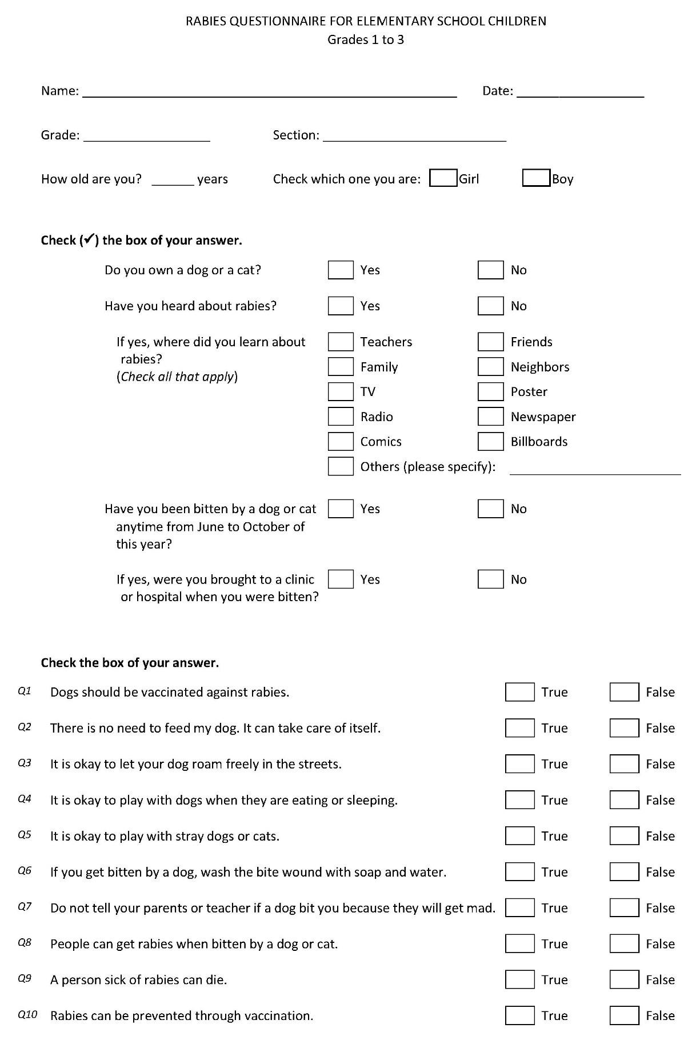

Figure S1B. Test questionnaire for Grades 4 to 6 students. Tick marks () indicate the correct answers for the knowledge questions
