Supplementary Material

Supplementary Figures
TCGA (N=145)
Our data (N= 31)
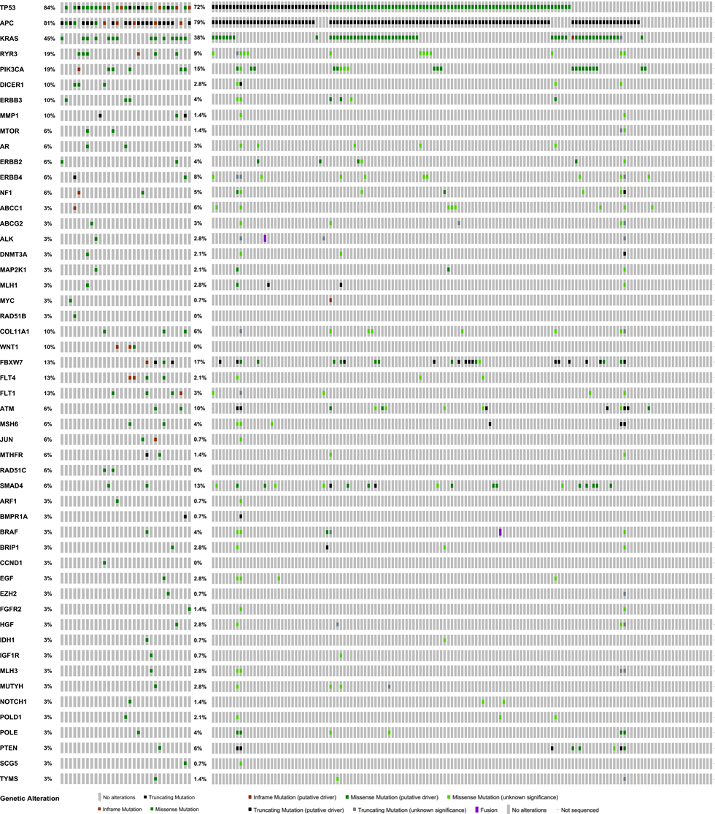

Supplementary Figure S3. Frequency of mutations in 51 genes in rectal cancer. Left side, our 31 cases analyzed by targeted-NGS; right side, 145 cases from TCGA Colorectal Adenocarcinoma (TCGA, Nature 2012) and Rectum Adenocarcinoma (TCGA, PanCancer Atlas).

