Supplementary Material

Supplementary Figures
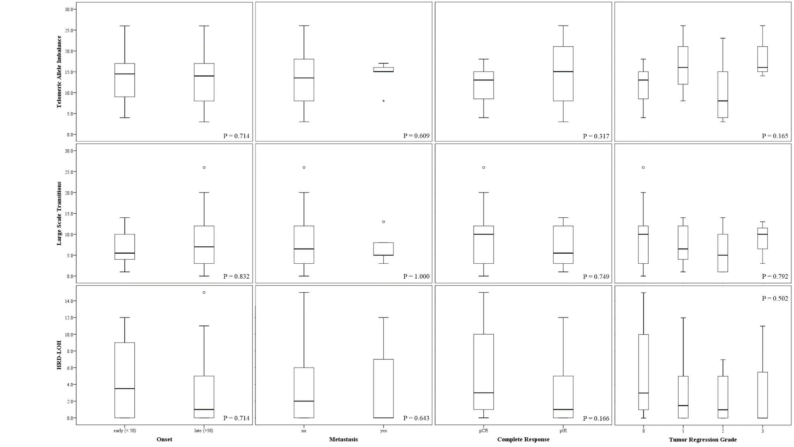
A

B

C

Supplementary Figure S2. Homologous Recombination Deficiency Scores (A: tAI, B: LST and C: HRD-LOH) in rectal cancer according to clinical characteristics.

