Supplementary Material

Supplementary Figures

Supplementary Figure 1
Supplementary Figure 1: PtGFT is predicted to be a transmembrane protein in agreement with the expected topology described for the nucleotide sugar transporters. Prediction of the transmembrane helices with the TMHMM Server v 2.0 (http://www.cbs.dtu.dk/services) (right panel) and Phobius Server (http://phobius.sbc.su.se/) (left panel)

Supplementary Figure 2

Supplementary Figure 2: PtGFT is expressed in the diatom cells. Analysis of the PtGFT gene expression by PCR amplification using a specific primer pair as described in the material and methods section. Lane 1: Ladder in bp (GeneRuler 50 bp DNA Ladder, Thermo Fisher Scientific); Lane 2: cDNA; lane 3: gDNA; lane 4: water used as a negative control.
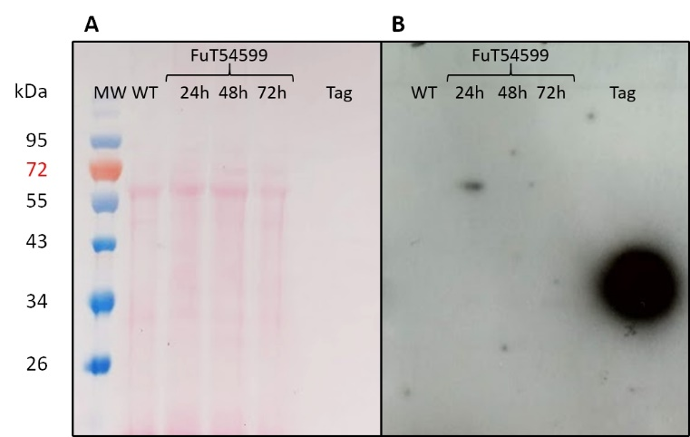

Supplementary Figure 3: The V5-tagged FuT54599 is overexpressed 24h after induction in the membrane fraction of Phaeodactylum tricornutum. Western Blot analysis of the membrane fraction proteins from the WT (lane 1) and P. tricornutum cells expressing the V5-tagged FuT54599 using a specific V5-tag antibody (lane 2 to 4). Proteins from the membrane fraction have been extracted from the P. tricornutum cells expressing the V5-tagged FuT54599 24h after induction (lane 2); 48h after induction (lane 3); 72h after induction (lane 4) and a V5-tagged protein expressed in E. Coli (Abcam) called Tag used a positive control (lane 6). In parallel, molecular weight markers (PageRuler Plus Prestained Protein Ladder, Thermofisher) are reported and expressed in kDa. Panel A: Ponceau red staining of the membrane. Panel B: Revelation of the membrane using the specific rabbit anti-V5 antibody (Invitrogen) as described in the material and method section.

Supplementary Figure 4: Negative controls for the immunocytochemical localization of V5-tagged FuT54599 and V5-tagged GnT I in the Golgi apparatus of P. tricornutum illustrating the specificity of the labelling with the anti-V5-tag antibody.
Transmission Electron micrographs of HPF/FS P. tricornutum cells expressing the V5-tagged GnT I (A) and V5-tagged FuT54599 (B) which were embedded in LRW resin. Views showing a Golgi apparatus of P. tricornutum oriented as previously described for algae cells in (Donohoe et al., 2007; Donohoe et al., 2013) after immunolabelling with the secondary antibody coupled to 10 nm gold beads (dilution 1/20) and then contrasted with uranyl acetate and lead citrate. N: nucleus; G: Golgi apparatus with the Cis and Medial/trans cisternae; p: pyrenoid; C: chloroplast. Scale bar: 0.5 µm and 1 µm respectively.

