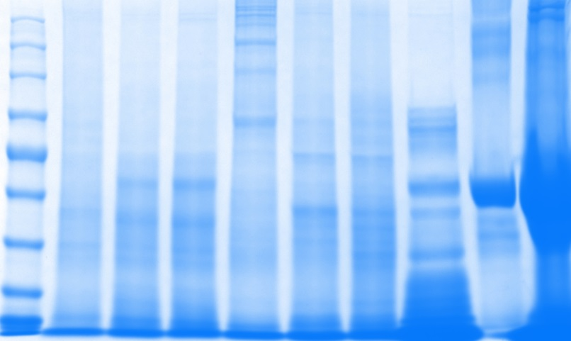
1 2 3 4 5 6 7 8 9 10
A
B
MW (kDa)
100 -
80 -
245 -
190 -
135 -
58 -
46 -
32 -
25 -
100 -
80 -
245 -
190 -
135 -
58 -
46 -
32 -
25 -

Supplementary Figure 1 – Screening of proteins from Amblyomma maculatum for α-gal. Unfed and partially-fed gut tissue and salivary gland tissue homogenates and saliva were run using A) 12.5% SDS-PAGE, and B) western blot using anti-gal IgM antibody. Lane 1: A broad range (11–245 kDa) pre-stained protein standard, Lane 2: Am. maculatum unfed midgut tissue, Lane 3: Am. maculatum 3D partially-fed midgut tissue, Lane 4: Am. maculatum partially-fed 8D midgut tissue, Lane 5: Am. maculatum unfed salivary glands, Lane 6: Am. maculatum 3D partially-fed salivary glands, Lane 7: Am. maculatum 8D partially-fed salivary glands, Lane 8: Am. maculatum 8D saliva, Lane 9: Bovine serum albumin and, Lane 10: Diluted sheep blood.

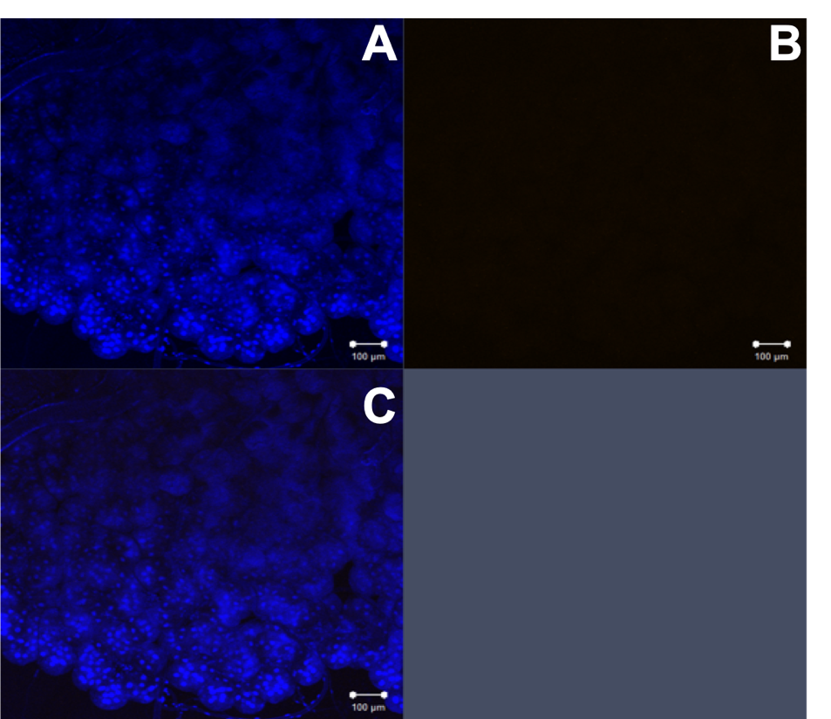

Supplementary Figure 2 – α-gal immunolocalization in partially-fed De. Variabilis salivary glands. De. variabilis salivary gland images (20×) using DAPI (A), alpha-gal IgM (B), and merged images (C).

