Supplementary Material
Supplementary Table 1. Sequences of the primers used for the real-time PCR.
Gene | Forward (5’-3’) | Reverse (5’-3’) | Reference
VEL 1 | CGAGGAGGGCAAGGACATTAC | GCAGGAACACCAGTCAGGATG | (Bazafkan et al., 2017)
TMK | CCAGCCCGACCATCATGTCTC | CGCATAATCTCTTGGTAAATCAGTTG | (Mukherjee et al., 2003)
GPR 1 | TTGATCCAGACCTTCATGCCAGC | CATAAAAGGCCGCGACACGAA | (Brunner et al., 2008)
BLR 1 | GGGATGACAGCCGAAC | TCAGCTCCCGCGTGAC | (Casas-Flores et al., 2004)
BLR 2 | CATTGCGGCTGCTAGG | GTCCCTTTCGCCATTC
ENV1 | GCCCTCTCGACTGCTCCGTC | CGACCCATGATCTCGGGGGC | (Bazafkan et al., 2017)
NAG 1 | TCATTGGCGGTGAACTCG | TCGTCCCGACCACCAGAT | (Yang, 2017)
NAG 2 | CAAGAGGACCATTGACGC | GCTTAGGCAGTGAAGGGAT
BGN13 | GCAGCCCTCAACAAGGTG | AGAGCCAACGGGAACCAC
BGN 16 | ATGAGTCTCCTGGAATGG | GTTGGGATGTAGTTGAGGT
EG1 | CTACTTCGGCCCCGGAGA | GGTGATGCTGACGAGGTTG
ECH | AGTACCCTGCCGATGACA | TAGCCTGGAGCGTATTGC
PAP A | TGGACAGCATCAACACCG | ACTGAGCAGATGAGACCTGGCCGTAGT | (Chet et al., 2004)
PAP B | GACAGGACATTGCCTGGACT | GACTGGAC TCCTCCGTACCA
AF | ATGGAGCTTAAAGCACTCAG | TCAGCGCTGGAGAGTTAGC
NOX | CACCACCTGTTCATCCC | GTCAAATGGCGAGAATCC | (Montero-Barrientos et al., 2011)
CAT | ACTGCATTGTCCGTTTCT | AGTTGCCCTCCTCTGTG
ACC | GACCTGCTCCACCATCTTCC | CAGTGGAGTTGCCGACAAAG | (Viterbo et al., 2010)
NP1 | GCGAATCAGAACAACAGCC | CATAGCCGTTCAGCCCATC | (Mukherjee and Kenerley, 2010)
NP2 | CGTCCGTGGATATCCAGGC | GCCATCCGTATAGCCTGAC
NP3 | CAAGACGCGTTTCACCTTCTTG | CGCTGTCCATTTGATCTCGC
Tri 13 | CATGGATGCAATCTGGGCCATTGT | TGGCCGCCCATAATAAATCCGAGA
OMT | CACTGTTGCACAGGCTGTTCCATT | AAGTTGTACCACTGCTCCTCGGTT
PK1 | AAGACAATCCAACCTATCGGGCCA | TCTGCAACATCACAAGGCACAACG
PK2 | CGCGCAACTTCAACGCTCTTACAA | TCATAGGCACAAATACCTCCCGCA
18S rRNA | GGTGGAGTGATTTGTCTG | CTTACTAGGGATTCCTCG | (Tisch et al., 2011)
LoaP | GCAGGCTCTCTACTCAATCATAC | CAGCACATATCCCGGAAACA | (Goodson et al., 2017)
DfnA | CCCATTACCTATGCCGAAAGA | TCTTCGTTCCCTAATCTCATTCC
DfnG | ACAGCGAACTGACGGAATAC | GGCTGAGCTCAAGCTGATAA
DfnM | GGGCTGTCAGAAGAGTTTGT | ATTTCCGTAACCCGTCAGAAG
DlnA | TGATGCTGTTGCAGGACATAG | CTCGGAAGCCTCACTCATTAAC
DlnD | TTGGAAACGGAAGAAGGGATAG | ACGAACCGGAAGCGTATTT
DlnI | GAAGGCACCTTCTCACATCTT | ACGGCATGAGGATGAAACTC
16S rRNA | TCGCGGTTTCGCTGCCCTTT | AAGTCCCGCAACGAGCGCAA | (Cui et al., 2018)

Supplementary Table 2. The metabolites identified from the axenic and co- culture of T.asperellum and B. amyloliquefaciens Using GC-MS.
Retention Time | Compound | TA | BA | TA+BA | Classification
11.895 | Cyclobutane, methylene - |  |  | + | Nitrogen containing compounds
16.496 | Undecanoic acid, 11-amino- |  |  | + | Amino fatty acids
17.528 | 4-Spirohexanone, 5,5-dichloro- |  |  | + | Hetrocyclic compounds
18.242 | 2-Butenethioic acid, S-[2-(acetylamino)ethyl] ester |  |  | + | Sulphur containing compounds
19.273 | Ethylene oxide |  |  | + | Ethers
19.590 | 1,5-Pentanediol |  |  | + | Alcohols
20.780 | Propane |  |  | + | Alkanes
21.256 | 1-Hexanamine |  |  | + | Amines
22.446 | Hexanenitrile, 6-amino- |  |  | + | Cyclic peptide
23.002 | Dimetridazole |  |  | + | Hetrocyclic compounds
25.644 | 2-Coumaranone | ₊ | + | + | Hetrocyclic compounds
26.437 | 4-Methoxycarbonyl-4- butanolide | + |  |  | Hetrocyclic compounds
27.127 | 1,3-Dioxolane, 2-ethyl-2,4,5-trimethyl- |  | + | + | Hetrocyclic compounds
27.921 | Ethylene oxide |  |  | + | Ethers
28.341 | dl-Mevalonic acid lactone |  | + |  | Hetrocyclic compounds
28.555 | Benzenepropanamide, N-(4-aminobutyl)-3,4-dihydroxy- |  |  | + | amines
29.134 | 4(1H)-Pyridone |  | + |  | Hetrocyclic compounds
29.349 | 4H-[1,2,4]Triazolo[1,5-a]pyrimidin-7-one, 5-methyl- |  |  | + | Hetrocyclic compounds
29.904 | 1-Piperazinecarboxylic acid, 4-(2-furanylcarbonyl)-, ethyl ester |  |  | + | Nitrosamines
30.063 | 3-Methyl-3,5--(cyanoethyl)tetrahydro-4-thiopyranone |  |  | + | Hetrocyclic compounds
30.166 | Cyclohexasiloxane, dodecamethyl- |  | + |  | Polymers
30.483 | Phenol, 2-methyl- | + |  | + | Aromatic hydrocarbon
31.038 | Phenol, 2,6-dimethoxy- |  | + |  | Aromatic hydrocarbons
31.435 | 2H-Pyran-2-one, 3-acetyl-4-hydroxy-6-methyl- |  | + |  | Hetrocyclic compounds
31.594 | 6-Pentyl-2H-Pyran-2-One | + |  | + | Pyrone derivative
31.911 | Benzenepropanoic acid, .alpha.-hydroxy-, methyl ester | + | + | + | Aromatic hydrocarbon
32.149 | 8-Dodecenoic acid, 11-hydroxy-, methyl ester, [s-(E)]- |  | + |  | Fatty acid esters
32.387 | 3-Hydroxy-1,7-dioxaspiro[5.5]undecane | + |  | ₊ | Polyketides
32.863 | Phenelzine |  |  | + | Amine
33.316 | Silane, 9-anthracenyltrimethyl- |  |  | + | Halogenated hydrocarbons
33.815 | 5,7-Dimethylenebicyclo[2.2.2]oct-2-ene |  |  | + | Fatty acid ester
34.847 | Piperidine, 1-methyl- | + |  | + | Hetrocyclic compounds
35.402 | trans-7-Carboxy-bicyclo[4.3.0]non-3-ene | + |  |  | Hetrocyclic compounds
35.378 | (1R,4R,4aS,8aR)-4,7-Dimethyl-1-(prop-1-en-2-yl)-1,2,3,4,4a,5,6,8a-octahydronaphthalene |  |  | + | Terpenes
36.251 | alpha.-Cuprenene |  |  | + | Hetrocyclic compounds
36.354 | Phthalic acid, hexyl 2,2,2-trifluoro-1-phenylethyl ester |  | + |  | Hetrocyclic compounds
36.751 | Cyclohexene, 3-bromo- | + |  |  | Alkane
36.886 | 1H-3a,7-Methanoazulene, 2,3,4,7,8,8a-hexahydro-3,6,8,8-tetramethyl-,[3R-(3. alpha., 3a. beta., 7.beta., 8a. alpha.)]- |  |  | + | Terpenes
37.703 | Phenol, 2,4-bis(1,1-dimethylethyl)- | + | + | + | Aromatic hydrocarbons
38.258 | Acetamide, N-(2-phenylethyl)- | + |  | + | Amines
38.575 | D-Alloisoleucine, N-acetyl- |  | + |  | Amino acid
39.028 | (3R,6S)-3-Hydroxy-1,7-dioxaspiro[5.5]undecane |  |  | - + | - Polyketides
39.765 | beta.-Bisabolene |  | + | + | Terpenes
40.162 | 1H-Cycloprop[e]azulene, 1a,2,3,5,6,7,7a,7b-octahydro-1,1,4,7-tetramethyl-, [1aR-(1a.alpha.,7.alpha.,7a.beta.,7b. alpha.)]- | + |  |  | Hetrocyclic compounds
40.638 | 5-Octadecene, (E)- | + |  |  | Alkenes
40.955 | N-Formylmorpholine |  | ₊ |  | hetrocyclic compounds
40.876 | Benzene, 1,2,4,5-tetramethyl- |  |  | + | hetrocyclic compounds
41.273 | 3-Hydroxy-4-methoxybenzoic acid | + |  |  | Ethers
41.590 | 2-Propen-1-ol, 3-phenyl- |  |  | + | Alcohols
41.408 | 1,3,5,7-Cyclooctatetraene |  |  | + | Aromatic hydrocarbon
41.884 | Phenol, 3,4,5-trimethoxy- |  |  | + | Ether
41.908 | Benzeneacetic acid, 4-hydroxy | ₊ | + |  | Hetrocyclic compounds
42.519 | 3-((1S,5S,6R)-2,6-Dimethylbicyclo[3.1.1]hept-2-en-6-yl)propanal |  |  | + | Aldehyde
42.836 | Benzofuran, 2,3-dihydro-2-methyl- |  |  | + | Peptide
43.098 | 2(3H)-Furanone, dihydro-5-(2-octenyl)-, (Z)- | + |  | + | Fatty acids
43.256 | L-Histidine, 1-methyl- |  | + |  | Amino acid
43.574 | Pyrrolidine, 3,3-dimethyl-4-[(2-methoxycarbonyl)ethyl]-2,5-dione- | + |  | + | Hetrocyclic compounds
43.709 | Benzene, 1-(1,5-dimethyl-4-hexenyl)-4-methyl |  |  | + | Terpenes
43.970 | Cyclohexanone, 3-(4-hydroxybutyl)-2-methyl- |  | + |  | Hetrocyclic compounds
44.288 | Methyl tetradecanoate |  | + |  | Fatty acid
44.526 | 9-Decenoic acid | + |  |  | Fatty acid
44.684 | N,N'-Di-p-tolyl-formamidine |  | + |  | Sulfenamides
44.843 | beta.-curcumene | + |  |  | Aliphatic compound
45.160 | L-Phenylalanine, N-acetyl-, methyl ester |  | + |  | Aminoacid
45.636 | Methyl tetradecanoate |  |  | + | Fatty acid
45.716 | 1,4-Benzenediol, 2,5-bis(1,1-dimethylethyl)- | ₊ |  | + | Aromatic hydrocarbon
46.351 | Naphthalene, 1,1'-(1,2-ethanediyl)bis[decahydro- | + |  |  | Aromatic hydrocarbons
46.327 | (6R,7R)-Bisabolone |  | + | + | Terpenes
47.065 | Anthracene | ₊ |  |  | Aromatic hydrocarbons
47.279 | Benzene, 1-(1,5-dimethyl-4-hexenyl)-4-methyl- |  |  | + | Terpenes
47.937 | 5-Octadecene, (E)- | + |  | + | Alkenes
48.37 | Methyl 9-methyltetradecanoate |  | + |  | Fatty acid
48.71 | 2,3-Diaminophenol |  | + |  | Halogen
48.810 | Benzonitrile, 4-[(2-hydroxyphenylimino)methyl]-benzylidenamino)- | + |  |  | Hetrocyclic compounds
50.214 | L-Proline, N-pivaloyl-, ethyl ester |  |  | + | Amino acid
50.397 | Pentadecanoic acid | + | + | + | Fatty acid
49.841 | Phenol, 3,5-dimethoxy- | + |  | + | Aromatic hydrocarbon
51.190 | Hexadecanoic acid, methyl ester |  | ₊ |  | Fatty acid ester
51.960 | Cyclohexanone, 5-methyl-2-(1-methyl-1-phenylethyl) |  |  | + | Hetrocyclic compounds
51.984 | 1,3-Dithiane, 2-octyl- | + |  |  | Halogens
52.277 | 2,5-Cyclohexadien-1-one, 2,6-bis(1,1-dimethylethyl)-4-ethylidene- |  |  | ₊ | Ketones
52.595 | Pentadecanoic acid, 14-methyl-, methyl ester |  |  | + | Compounds containing nitrogen
52.301 | 7,9-Di-tert-butyl-1-oxaspiro(4,5)deca-6,9-diene-2,8-dione | + |  |  | Lactone
52.697 | Methyl palmitate |  | + |  | Fatty acid
53.150 | Benzaldehyde, 4-methoxy-3-(4-methylphenylthiomethyl)- |  |  | + | Hetrocyclic compounds
53.174 | L-Proline, N-valeryl-, octyl ester |  |  | + | Hetrocyclic compounds
54.602 | n-Hexadecanoic acid | + | + | + | Fatty acid
55.316 | 3,5-Dimethoxytoluene | + |  |  | Ethers
55.950 | Heptadecanoic acid, methyl ester | + |  |  | Fatty esters
56.585 | Naphthalene, 6-decyl-1,2,3,4-tetrahydro- | + |  |  | Aromatic hydrocarbons
56.323 | Tetradecanoic acid |  |  | + | Fatty acid
57.14 | Heptadecanoic acid | + | + | + | Fatty acid
57.537 | 1-Octadecene |  |  | + | Alkenes
57.775 | 9-Octadecenoic acid, methyl ester, (E)- | + | + | + | Fatty acid ester
58.64 | Methyl stearate | + | + | + | Fatty acid ester
59.838 | 6-Octadecenoic acid |  | + | + | Fatty acid
59.20 | Oleic Acid | + |  |  | Fatty acid
59.83 | Octadecanoic acid | + |  | + | Fatty acid
61.34 | 1,3-Cyclohexadiene-1-carboxaldehyde, 2,6,6-trimethyl- | + |  | + | Acyclic hydrocarbons
62.13 | 2,5-Bis(1,1-dimethylbutyl)-4-methoxyphenol | + |  |  | Aromatic hydrocarbon
62.93 | Eicosanoic acid, methyl ester | + |  |  | Fatty acid ester
63.15 | Carbonic acid, octadecyl 2,2,2-trichloroethyl ester |  |  | + | Ester
63.42 | cis-4-Hydroxy-3-methyldecanoic acid lactone |  |  | + | Hetrocyclic compound
63.64 | n-Propyl 9,12-octadecadienoate |  | + |  | Fatty acid ester
63.72 | Eicosanoic acid | + |  | + | Fatty acid
64.28 | Cyclotetracosane | + |  |  | Carbo cyclic compounds
64.33 | 1,2-Benzisothiazol-3(2H)-one |  |  | + | Hetrocyclic compounds
65.20 | oxazepam, 2TMS derivative |  |  | + | Hetrocyclic compounds
65.60 | 5-Isoxazolepropanamide, 3-chloro-N-(2,3-dihydro-1,4-benzodioxin-6-yl)- |  |  | + | Hetrocyclic compounds
66.82 | 2(1H)-Phenanthrenone, 3,4,4a,9,10,10a-hexahydro-7-hydroxy-1,1,4a-trimethyl-8-(1-methylethyl)-, (4aS-trans)- | ₊ |  |  | Terpenes
66.87 | 1-(3,3-Dimethylbutyn-1-yl)-2,2-dimethylcyclopropene |  |  | + | Organophosphorus

Supplementary figure 1. Inhibitory activities of axenic and coculture of T. asperellum and B. amyloliquefaciens fermentation liquor against plant pathogenic fungi. Where (TA) culture filtrate of T. asperellum; (BA) culture filtrate of B. amyloliquefaciens, and (TA+BA) culture filtrate of T. asperellum and B. amyloliquefaciens.
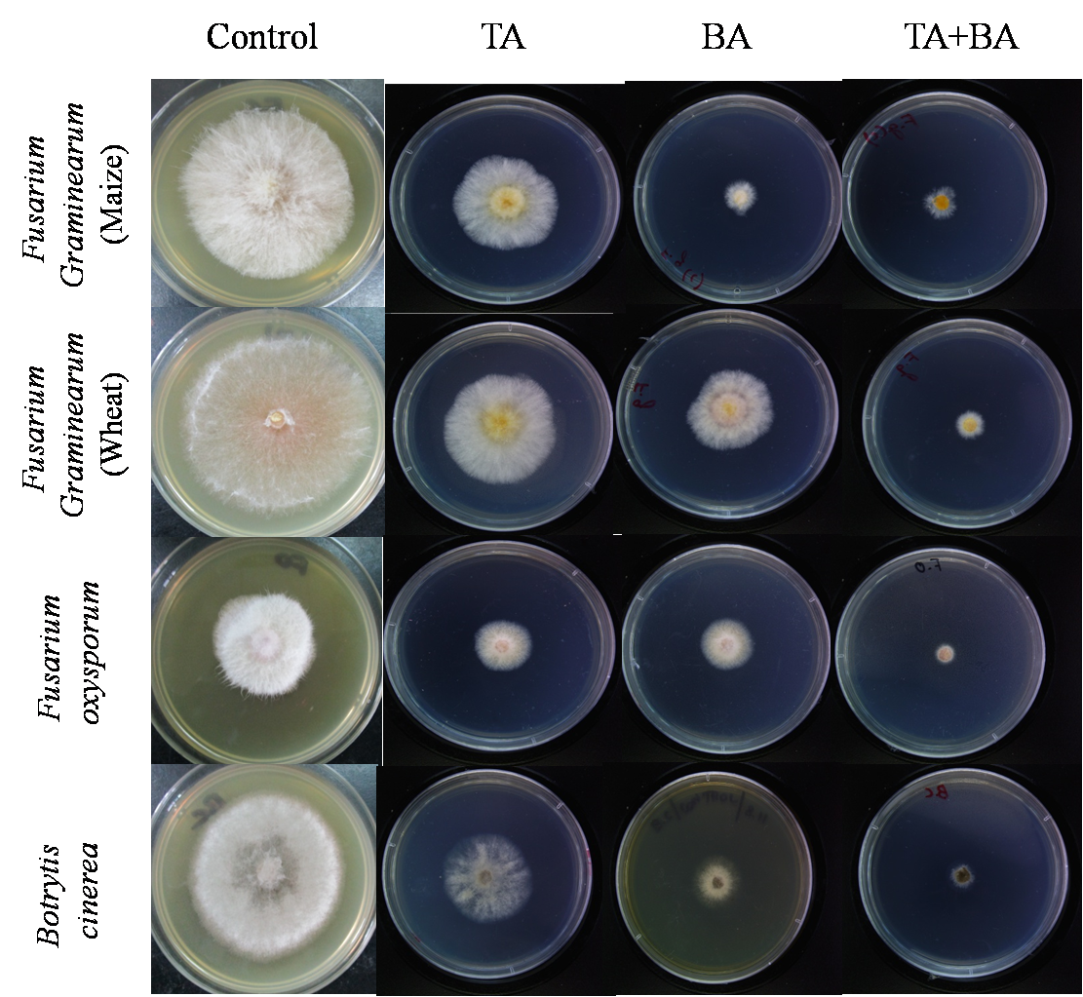

References
Bazafkan, H., Dattenböck, C., Stappler, E., Beier, S., and Schmoll, M. (2017). Interrelationships of VEL1 and ENV1 in light response and development in Trichoderma reesei. PLOS ONE 12, e0175946.
Brunner, K., Omann, M., Pucher, M.E., Delic, M., Lehner, S.M., Domnanich, P., Kratochwill, K., Druzhinina, I., Denk, D., and Zeilinger, S. (2008). Trichoderma G protein-coupled receptors: functional characterisation of a cAMP receptor-like protein from Trichoderma atroviride. Current genetics 54, 283-299.
Casas-Flores, S., Rios-Momberg, M., Bibbins, M., Ponce-Noyola, P., and Herrera-Estrella, A. (2004). BLR-1 and BLR-2, key regulatory elements of photoconidiation and mycelial growth in Trichoderma atroviride. Microbiology 150, 3561-3569.
Chet, I., Harel, M., and Viterbo, A. (2004). Isolation of two aspartyl proteases from Trichoderma asperellum expressed during colonization of cucumber roots☆. FEMS Microbiology Letters 238, 151-158.
Cui, W., Suo, F., Cheng, J., Han, L., Hao, W., Guo, J., and Zhou, Z. (2018). Stepwise modifications of genetic parts reinforce the secretory production of nattokinase in Bacillus subtilis. Microbial biotechnology 11, 930-942.
Goodson, J.R., Klupt, S., Zhang, C., Straight, P., and Winkler, W.C. (2017). LoaP is a broadly conserved antiterminator protein that regulates antibiotic gene clusters in Bacillus amyloliquefaciens. Nat Microbiol 2, 17003.
Montero-Barrientos, M., Hermosa, R., Cardoza, R.E., Gutiérrez, S., and Monte, E. (2011). Functional analysis of the Trichoderma harzianum nox1 gene, encoding an NADPH oxidase, relates production of reactive oxygen species to specific biocontrol activity against Pythium ultimum. Applied and environmental microbiology 77, 3009-3016.
Mukherjee, P.K., and Kenerley, C.M. (2010). Regulation of Morphogenesis and Biocontrol Properties in Trichoderma virens by a VELVET Protein, Vel1. Applied and Environmental Microbiology 76, 2345-2352.
Mukherjee, P.K., Latha, J., Hadar, R., and Horwitz, B.A. (2003). TmkA, a mitogen-activated protein kinase of Trichoderma virens, is involved in biocontrol properties and repression of conidiation in the dark. Eukaryotic cell 2, 446-455.
Tisch, D., Kubicek, C.P., and Schmoll, M. (2011). New insights into the mechanism of light modulated signaling by heterotrimeric G-proteins: ENVOY acts on gna1 and gna3 and adjusts cAMP levels in Trichoderma reesei (Hypocrea jecorina). Fungal Genetics and Biology 48, 631-640.
Viterbo, A., Landau, U., Kim, S., Chernin, L., and Chet, I. (2010). Characterization of ACC deaminase from the biocontrol and plant growth-promoting agent Trichoderma asperellum T203. FEMS Microbiology Letters 305, 42-48.
Yang, P. (2017). The gene task1 is involved in morphological development, mycoparasitism and antibiosis of Trichoderma asperellum. Biocontrol Science and Technology 27, 620-635.

