SUPPLEMENTARY MATERIAL

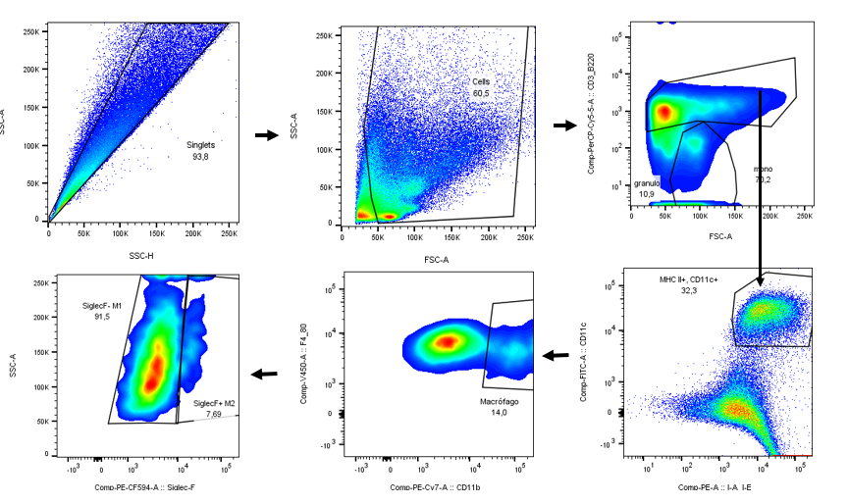 Supplementary Figure 1 - Analysis strategy for macrophages. Macrophages are considered FSC-A high and CD3/B220 intermediate/low. Type 1 macrophages were considered CD11c positive, MHC II positive and Siglec-F negative. Type 2 macrophages were considered CD11c positive, MHC II positive and Siglec-F positive.

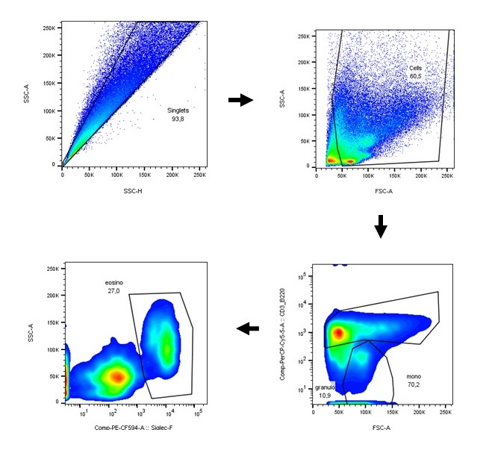

Supplementary Figure 2 - Analysis strategy for eosinophils in lung homogenate. Granulocytes are considered FSC-A low and CD3/B220 negative. Then, eosinophils were considered as Siglec-F positive cells.

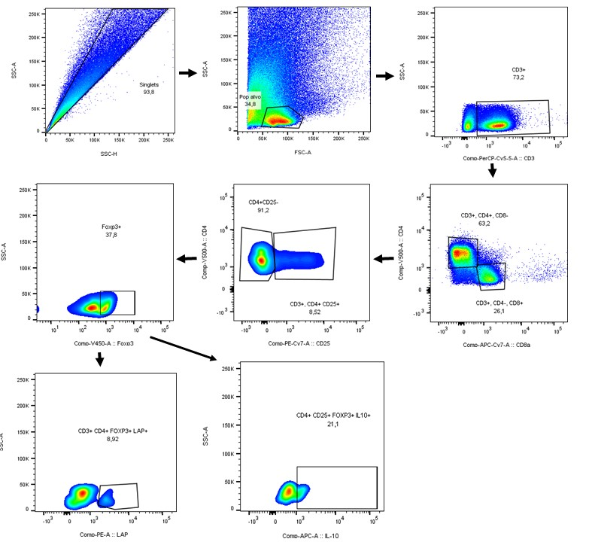

Figure 3 - Analysis strategy for T regs in the lung. All lymphocytes were considered positive for CD3. CD4+ T lymphocytes were considered activated when were positive for CD69. T regs were considered CD3, CD4, CD25 and Foxp3 positive. Then we gated Treg that expressed LAP, an indicator of TGF-β production, or IL-10.

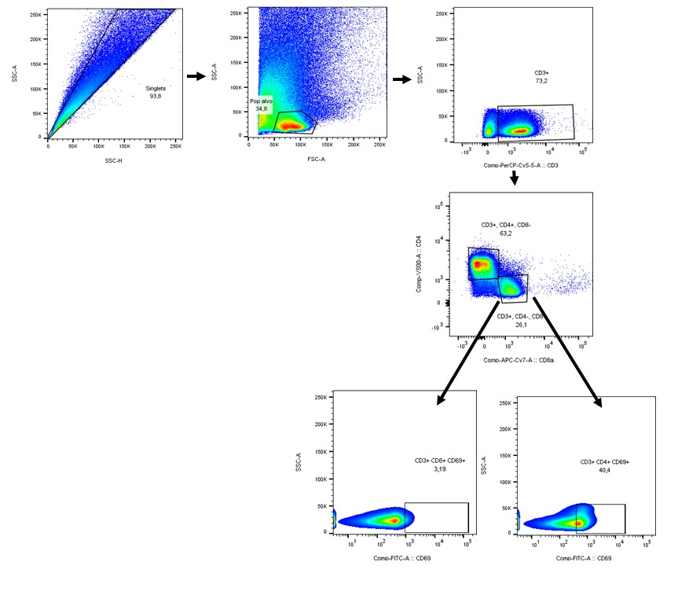 Figure 4 - Analysis strategy for CD4+ and CD8+ T lymphocytes and activation of CD8+ T lymphocytes by expression of CD69 in lung. All lymphocytes were considered positive for CD3. CD4+ or CD8+ T lymphocytes were considered activated when they were positive for CD69.

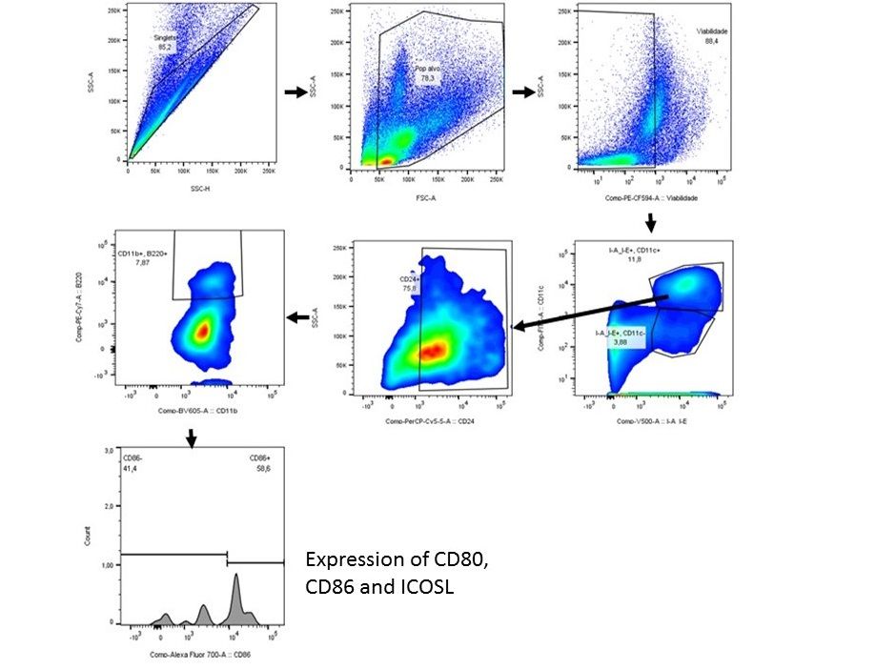
Figure 5 - Analysis strategy for common dendritic cells (cDCs) and activation by expression of CD80 in lung. cDCs were considered CD11c and MHC II high, positive for CD24, B220 and CD11b high. Cells were considered activated when positive for CD80.

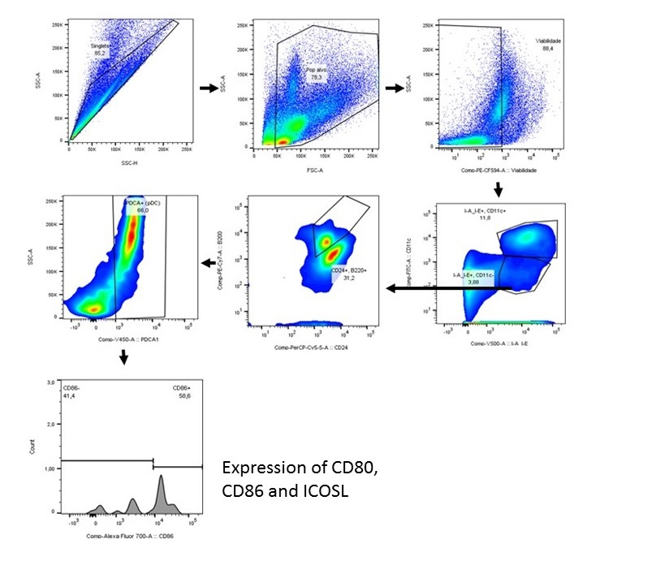
Figure 6 - Analysis strategy for plasmacytoid DCs (pDCs) and activation by expression of CD86, ICOSL and PDL2 in lung. pDCs were considered CD11c negative or low, MHC II low, positive for B220, CD24 and PDCA1. Cells were considered activated when positive for CD86, or ICOSL or PDL2.

