Supplementary Material

Aspects of invasiveness of Ludwigia and Nelumbo in shallow temperate fluvial lakes
Viktor R. Tóth ^{1*}, Paolo Villa ^{2*}, Monica Pinardi ², Mariano Bresciani ²
¹Balaton Limnological Institute, MTA Centre for Ecological Research, Hungarian Academy of Sciences, Tihany, Hungary
²Institute for Electromagnetic Sensing of the Environment, National Research Council, Milan, Italy
* Correspondence:
Viktor R. Tóth: toth.viktor@okologia.mta.hu
Paolo Villa: villa.p@irea.cnr.it

Supplementary table 1. Spectral indices derived from macrophyte leaf reflectance measurements used in this study.
Spectral Index | Acronym | Formula | Leaf parameters | Reference
Normalized Difference 750/705 | ND₇₀₅ | $$\frac{ρ_{750}-ρ_{705}}{ρ_{750}+ρ_{705}}$$ | Chlorophylls (a+b) | Sims and Gamon, 2002
modified Normalized Difference 750/705 | mND₇₀₅ | $$\frac{ρ_{750}-ρ_{705}}{ρ_{750}+ρ_{705}-2ρ_{445}}$$ | Chlorophylls (a+b) | Sims and Gamon, 2002
Chlorophyll Index | CI | $$\frac{ρ_{781}}{ρ_{700}}-1$$ | Chlorophylls (a+b) | Gitelson et al., 2003
Anthocyanin reflectance index 2 | ARI₂ | $$\left(\frac{1}{ρ_{550}}-\frac{1}{ρ_{700}}\right)ρ_{800}$$ | Anthocyanins, Carotenoids | Gitelson et al., 2001
Photochemical Reflectance Index | PRI | $$\frac{ρ_{531}-ρ_{570}}{ρ_{531}+ρ_{570}}$$ | RUE, Car/Chl ratio, xanthophyll EPS | Gamon et al., 1992
Photochemical Reflectance Index 515 | PRI₅₁₅ | $$\frac{ρ_{515}-ρ_{531}}{ρ_{515}+ρ_{531}}$$ | RUE, xanthophyll EPS (minimize canopy structure dependence) | Hernandez-Clemente et al., 2011
Revised Photochemical Reflectance Index 2 | PRI_{r2} | $$\frac{ρ_{531}-ρ_{570}}{{2ρ}_{550}-ρ_{531}-ρ_{570}}$$ | RUE | Wu et al., 2010
PRI combination with Chlorophyll Index | PRI*CI | $$\frac{ρ_{531}-ρ_{570}}{ρ_{531}+ρ_{570}}\left(\frac{ρ_{781}}{ρ_{700}}-1\right)$$ | RUE, Carotenoids | Garrity et al., 2011
Normalized Difference Spectral Index 546,551 | ND_{546,551} | $$\frac{ρ_{546}-ρ_{551}}{ρ_{546}+ρ_{551}}$$ | Apparent Chl fluorescence in LAS (Fs) | Stratoulias et al., 2015
Normalized Difference Spectral Index 539,560 | ND_{539,560} | $$\frac{ρ_{539}-ρ_{560}}{ρ_{539}+ρ_{560}}$$ | Maximum Chl fluorescence in LAS (Fm’) | Stratoulias et al., 2015
Normalized Difference Spectral Index 659,687 | ND_{659,687} | $$\frac{ρ_{659}-ρ_{687}}{ρ_{659}+ρ_{687}}$$ | effective quantum  yield of photosystem II (Y(II)) | Stratoulias et al., 2015
Normalized Difference Spectral Index 621,692 | ND_{621,692} | $$\frac{ρ_{621}-ρ_{692}}{ρ_{621}+ρ_{692}}$$ | Electron Transport Rate (ETR) | Stratoulias et al., 2015
Supplementary table 2. Summary of in situ samples collected for this study.
Date | Location within Mantua lakes system |  |  | Species | Samples
 | Lake | Lat (N) | Lon (E) |  | Fluorescence | Pigments | Leaf spectra
27/07/2016 | Superior | 45.16139 | 10.72444 | Nelumbo | 6 | - | 6
27/07/2016 | Superior | 45.16069 | 10.73469 | Nuphar | 6 | - | 6
27/07/2016 | Superior | 45.16081 | 10.73567 | Trapa | 6 | - | 6
27/07/2016 | Superior | 45.16111 | 10.73306 | Trapa | 6 | - | 6
28/07/2016 | Superior | 45.16238 | 10.70997 | Ludwigia | 6 | - | -
29/07/2016 | Middle | 45.17091 | 10.79712 | Ludwigia | 3 | - | 3
29/07/2016 | Middle | 45.16429 | 10.80396 | Trapa | 6 | - | 6
29/07/2016 | Middle | 45.16853 | 10.79289 | Trapa | 6 | - | 6
29/07/2016 | Inferior | 45.15126 | 10.81209 | Trapa | 6 | - | 6
29/05/2017 | Superior | 45.16244 | 10.71012 | Ludwigia | 12 | 9 | -
29/05/2017 | Superior | 45.16306 | 10.78186 | Nelumbo | 3 | - | 3
29/05/2017 | Superior | 45.16290 | 10.77687 | Nelumbo | 3 | - | 3
29/05/2017 | Superior | 45.16036 | 10.76704 | Nelumbo | 3 | - | 3
29/05/2017 | Superior | 45.16247 | 10.70917 | Nuphar | 12 | 12 | -
29/05/2017 | Superior | 45.16077 | 10.73465 | Nuphar | 4 | 4 | 4
29/05/2017 | Superior | 45.16889 | 10.78694 | Nuphar | 4 | - | 4
29/05/2017 | Superior | 45.16056 | 10.73583 | Trapa | 4 | - | 4
30/05/2017 | Middle | 45.17052 | 10.79286 | Nymphaea | 4 | 4 | 4
30/05/2017 | Middle | 45.16473 | 10.80586 | Trapa | 4 | 4 | 4
30/05/2017 | Middle | 45.16857 | 10.79258 | Trapa | 4 | 4 | 4
30/05/2017 | Inferior | 45.14895 | 10.81461 | Trapa | 4 | 4 | 4
30/05/2017 | Inferior | 45.15147 | 10.81282 | Trapa | 6 | 4 | 6
27/07/2017 | Superior | 45.16271 | 10.70921 | Ludwigia | 9 | 9 | 8
27/07/2017 | Superior | 45.16330 | 10.78280 | Nelumbo | 9 | 9 | 6
27/07/2017 | Superior | 45.16233 | 10.77392 | Nelumbo | 6 | 6 | 6
27/07/2017 | Superior | 45.16109 | 10.76820 | Nelumbo | 6 | 6 | 6
27/07/2017 | Superior | 45.16271 | 10.70921 | Nuphar | 3 | 3 | 3
27/07/2017 | Superior | 45.16325 | 10.74734 | Trapa | 9 | 8 | 9
28/07/2017 | Middle | 45.17044 | 10.79211 | Nuphar | 5 | 6 | 6
28/07/2017 | Middle | 45.17054 | 10.79266 | Nymphaea | 6 | 6 | 6
28/07/2017 | Middle | 45.16519 | 10.80533 | Trapa | 6 | 6 | 6
28/07/2017 | Middle | 45.16880 | 10.79127 | Trapa | 6 | 6 | 6
28/07/2017 | Inferior | 45.14952 | 10.81424 | Trapa | 6 | 6 | 6

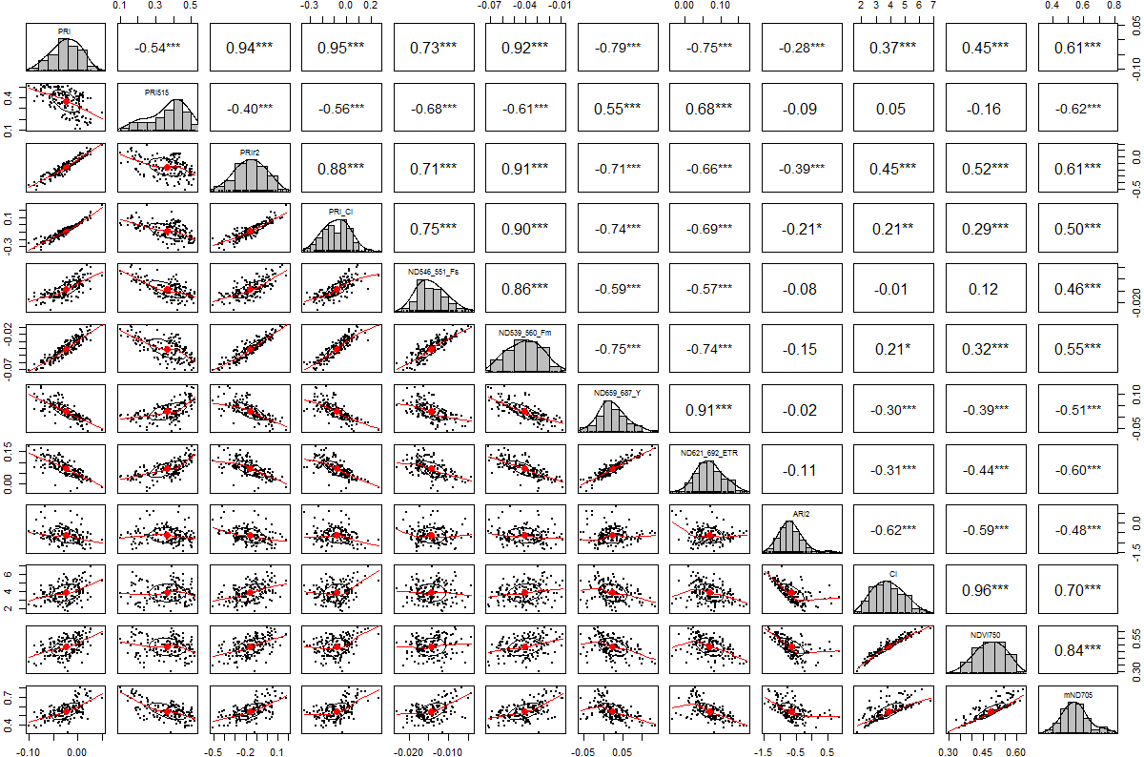
Supplementary Figure 1. Correlation matrix of spectral indices (SIs) derived from leaf reflectance measurements of macrophyte samples. Scatter plots of each SI pair are shown in the lower left half; histograms of each SI scores are shown on the diagonal; in the upper right half, the coefficient of correlation for each SI pair (Pearson’s r) is shown, together with its significance level (* p<0.05, ** p<0.01, *** p<0.001).

Supplementary Figure 2. Effect of light intensity (I) on the electron transport rate (ETR) of the studied macrophytes of the Mantua Lakes system.

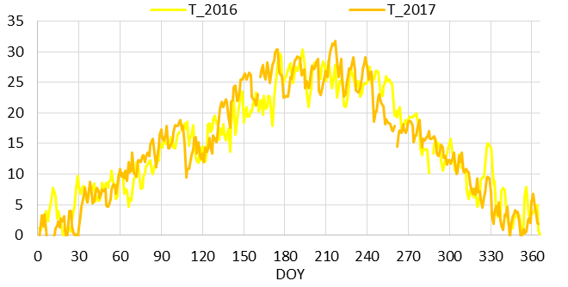a)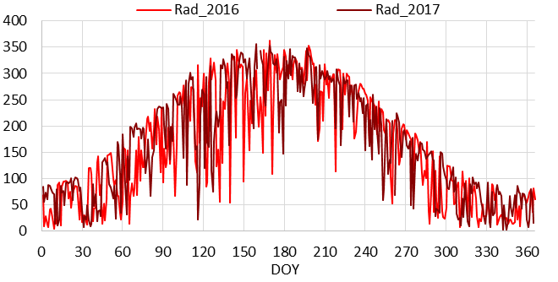b)
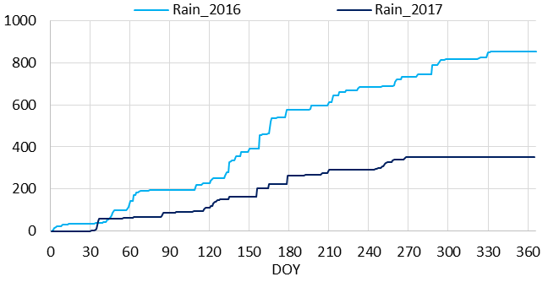c)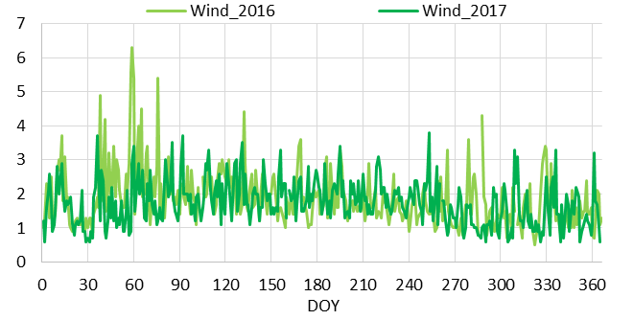d)
Supplementary Figure 3. Time series of meteorological parameters collected during 2016 and 2017 near the study area (45°09’06’’ N; 10°50’04’’ E): a) average daily air temperature (T; °C); b) average daily global incoming radiation (Rad; W m⁻²); c) cumulative precipitation from beginning of the year (Rain; mm); and d) average daily wind velocity (Wind; m s⁻¹). Data collected by the Environmental Protection Agency of Lombardy region (ARPA Lombardia), weather station ID: “Mantova Lunetta2 SMR”.

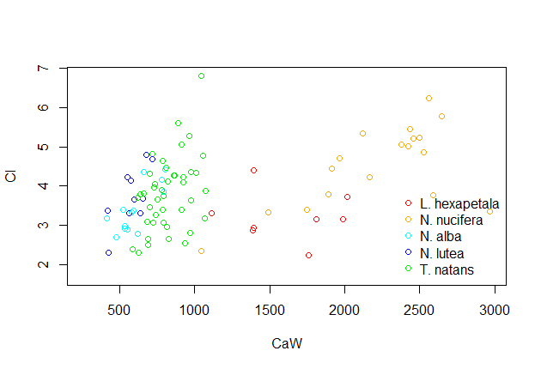a)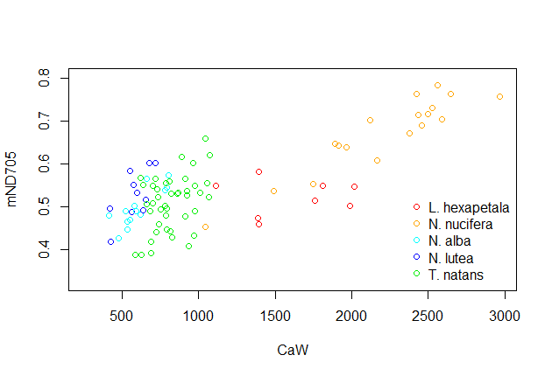b)
Supplementary Figure 4. Leaf Chl-a content (CaW; µg g_{fw}⁻¹) versus spectral indices found to be sensitive to chlorophyll content, developed and tested for terrestrial plants, and calculated here for the macrophyte species sampled: a) Chlorophyll Index (CI; Gitelson et al., 2003); b) modified Normalized Difference 750/705 (mND₇₀₅; Sims and Gamon, 2002).

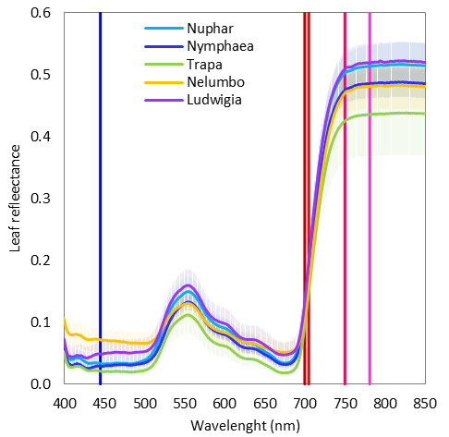a)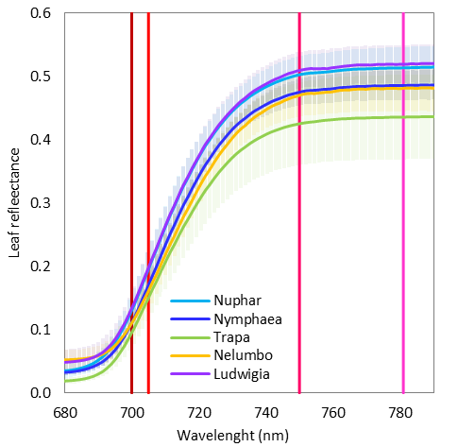b)
Supplementary Figure 5. Leaf spectral reflectance for sampled macrophyte species (average and standard deviation across all samples of each species): a) spectral response in visible to near infrared (VNIR) range; b) detail of spectral response across the red edge range. The plots include marks (vertical lines) at singular wavelengths used in the formulas of Spectral indices sensitive to chlorophyll content (ND₇₀₅, mND₇₀₅, CI). Compared to allochthonous species, the spectral response of Nelumbo and Ludwigia show specific features of in the red edge to near infrared range (around 690-790 nm), that could be attributed to the differences in mesophyll structure and dry matter: SLA values for these two species are in fact significantly lower than those of native ones. Differences in terms of mND₇₀₅ and chlorophyll content between Ludwigia and Nelumbo, highlighted in Supplementary Figure 4, could be attributed to peculiar reflectance features in the red edge spectral range (690-730 nm), where the average difference of leaf reflectance for Ludwigia and Nelumbo is quite stable (around 4-5%) and higher than what should be expected from chlorophyll content alone. The better performance in capturing general variability of leaf chlorophyll content in macrophyte samples by mND₇₀₅ (r=0.77) compared to CI (r=0.41) reveals the importance of taking into account structural properties and superficial effects (e.g. due to waxes) typical of aquatic plant leaves, which are expressed at shorter visible wavelengths (such as 445 nm included in calculation of mND₇₀₅).

