Supplementary Material

Table S1. Area (km²) of persistence, expansion, and contraction for showy milkweed, swamp milkweed, and monarch breeding distribution across Idaho under moderate and severe climate change scenarios.
Projection |  | Showy Milkweed | Swamp Milkweed | Monarch
Current Suitable |  | 15836 | 3125 | 11521
Moderate (RCP 4.5) | Persistence | 14576 | 3124 | 10963
 | Expansion | 29 | 3444 | 543
 | Contraction | 1259 | 1 | 558
Change in Suitable |  | -1230 | +3443 | -15
Severe (RCP 8.5) | Persistence | 14487 | 3125 | 10948
 | Expansion | 31 | 5830 | 859
 | Contraction | 1349 | 0 | 573
Change in Suitable |  | -1318 | +5830 | +286

Table S2. Area (km²) of projected persistence (P), expansion (E), and contraction (C) under a severe climate change scenario (RCP 8.5) for showy milkweed, swamp milkweed, and monarch breeding distribution in Idaho and selected managed areas across the state.
Agency¹ | Managed Area | Showy Milkweed |  |  | Swamp Milkweed |  |  | Monarch
 |  | P | E | C | P | E | C | P | E | C
 | Statewide | 14487 | 31 | 1349 | 3125 | 5830 | 0 | 10948 | 859 | 573
USFS National Grassland | Curlew | 32.8 | 0.0 | 0.9 | 0.1 | 66.5 | 0.0 | 24.0 | 11.2 | 0.0
USFWS National Wildlife Refuge | Bear Lake | 60.3 | 0.0 | 4.2 | 0.0 | 0.0 | 0.0 | 54.7 | 15.2 | 0.0
 | Camas | 23.4 | 0.0 | 4.5 | 0.0 | 0.9 | 0.0 | 24.1 | 0.6 | 0.0
 | Deer Flat | 17.4 | 0.0 | 0.0 | 14.5 | 1.8 | 0.0 | 16.7 | 0.0 | 0.2
 | Kootenai | 0.0 | 0.0 | 0.2 | 0.0 | 0.0 | 0.0 | 0.0 | 0.0 | 0.0
 | Minidoka | 43.0 | 0.0 | 2.7 | 7.5 | 41.7 | 0.0 | 42.1 | 1.0 | 0.0
 | Oxford Slough | 3.6 | 0.0 | 0.0 | 0.0 | 7.4 | 0.0 | 3.6 | 0.1 | 0.0
IDFG Wildlife Management Area | Big Cottonwood | 0.6 | 0.0 | 0.0 | 0.0 | 0.0 | 0.0 | 0.0 | 0.0 | 0.0
 | Billingsley Creek | 1.1 | 0.0 | 0.0 | 0.9 | 0.2 | 0.0 | 1.1 | 0.0 | 0.0
 | Boundary Creek | 1.2 | 0.0 | 1.6 | 0.0 | 0.0 | 0.0 | 0.7 | 0.0 | 1.4
 | Carey Lake | 2.5 | 0.0 | 0.0 | 0.0 | 0.0 | 0.0 | 2.3 | 0.0 | 0.1
 | Cartier Slough | 3.1 | 0.0 | 0.3 | 0.0 | 0.0 | 0.0 | 3.0 | 0.1 | 0.0
 | CJ Strike | 38.5 | 0.1 | 0.1 | 37.4 | 1.1 | 0.0 | 38.3 | 0.1 | 0.1
 | Fort Boise | 6.5 | 0.0 | 0.0 | 5.8 | 0.7 | 0.0 | 6.4 | 0.0 | 0.1
 | Montour | 6.3 | 0.0 | 0.0 | 2.7 | 2.6 | 0.0 | 6.2 | 0.0 | 0.0
 | Deer Parks | 1.8 | 0.0 | 0.1 | 0.0 | 3.6 | 0.0 | 2.0 | 1.0 | 0.0
 | Farragut | 0.0 | 0.0 | 0.1 | 0.0 | 0.0 | 0.0 | 0.0 | 0.0 | 0.0
 | Hagerman | 4.2 | 0.0 | 0.0 | 3.4 | 0.6 | 0.0 | 4.2 | 0.0 | 0.0
 | Market Lake | 6.6 | 0.0 | 2.6 | 0.0 | 7.9 | 0.0 | 8.0 | 1.0 | 0.0
 | Niagara Springs | 4.1 | 0.0 | 0.0 | 2.6 | 1.0 | 0.0 | 3.8 | 0.0 | 0.0
 | Payette River | 3.4 | 0.0 | 0.0 | 3.4 | 0.0 | 0.0 | 3.4 | 0.0 | 0.0
 | Cecil D Andrus | 4.0 | 0.0 | 0.4 | 1.4 | 2.0 | 0.0 | 3.3 | 0.0 | 0.1
 | Craig Mountain | 40.4 | 0.2 | 0.7 | 6.1 | 5.7 | 0.0 | 33.5 | 0.6 | 1.3
 | Mud Lake | 27.9 | 0.0 | 4.1 | 0.0 | 24.0 | 0.0 | 29.1 | 0.6 | 0.0
 | Sterling | 12.8 | 0.0 | 0.9 | 6.3 | 9.0 | 0.0 | 13.3 | 0.3 | 0.0
 | Coeur d’Alene River | 0.4 | 0.0 | 2.3 | 0.0 | 0.0 | 0.0 | 0.1 | 0.0 | 0.4
 | Pend Oreille | 0.0 | 0.0 | 0.4 | 0.0 | 0.0 | 0.0 | 0.0 | 0.0 | 0.0
 | Portneuf | 1.0 | 0.0 | 0.1 | 0.0 | 0.3 | 0.0 | 0.6 | 0.1 | 0.0
 | Boise River | 5.0 | 0.0 | 1.1 | 0.0 | 0.1 | 0.0 | 3.2 | 0.0 | 0.4
¹ US Forest Service (USFS), US Fish and Wildlife Service (USFWS), Idaho Department of Fish and Game (IDFG)

January  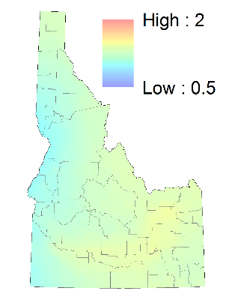 | February  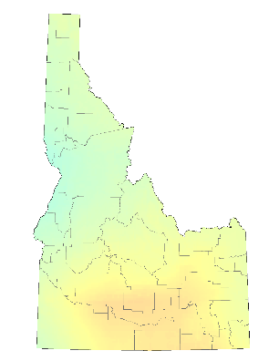 | March  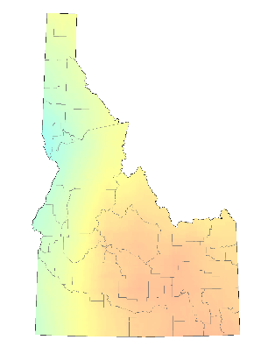
April  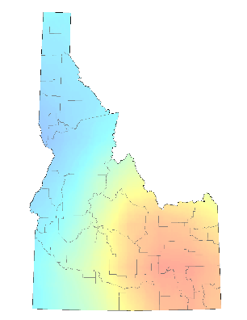 | May  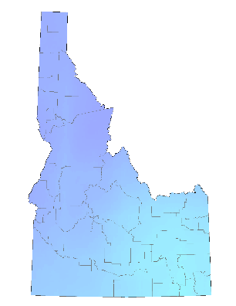 | June  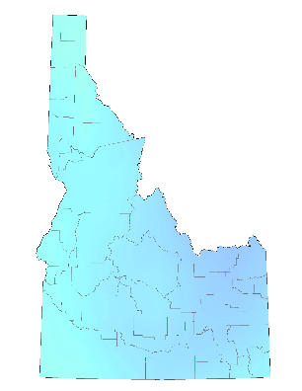
July  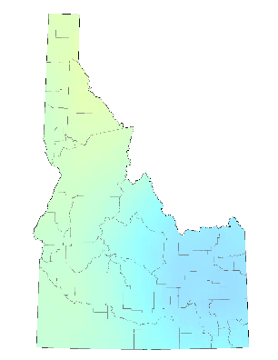 | August  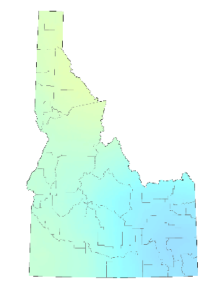 | September  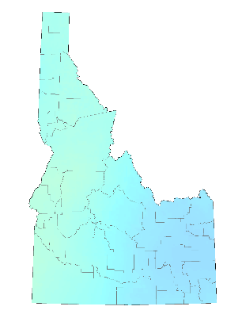
October  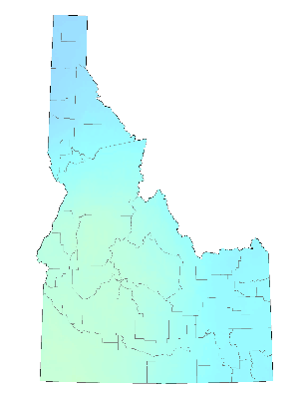 | November  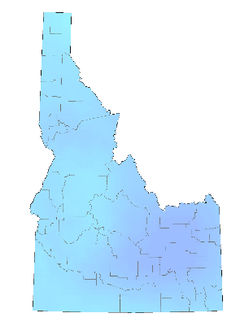 | December  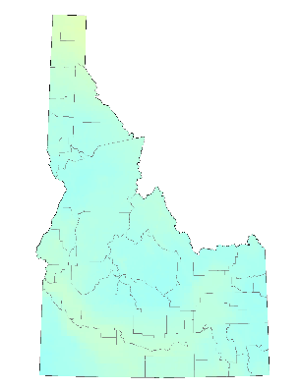
Figure S1. Monthly standard deviation of minimum temperature (°C) across 20 global climate models under a severe (RCP8.5) climate change scenario for mid-century. Color scales are standardized from 0.5 to 2.0 with warmer colors indicating the greatest variability among models while cooler colors show the most consistency.
January  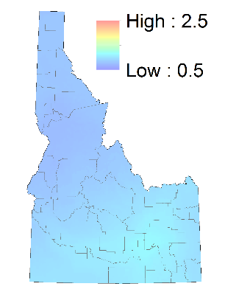 | February  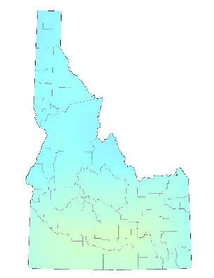 | March  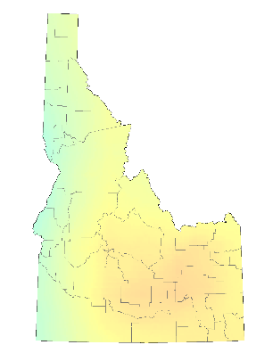
April  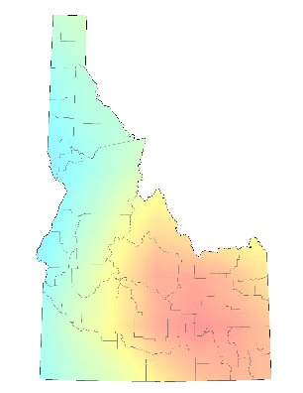 | May  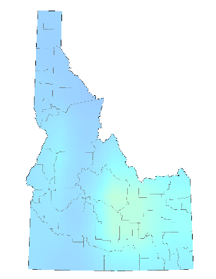 | June  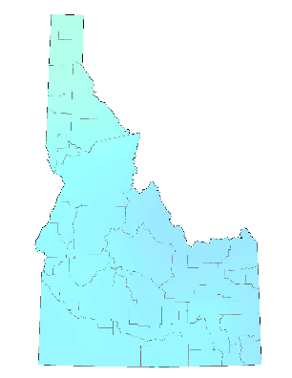
July  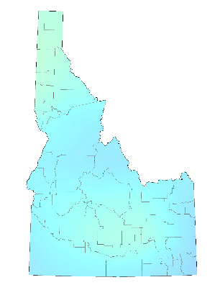 | August  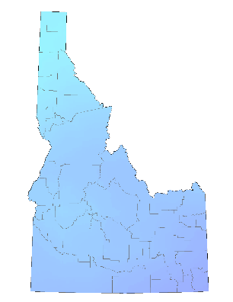 | September  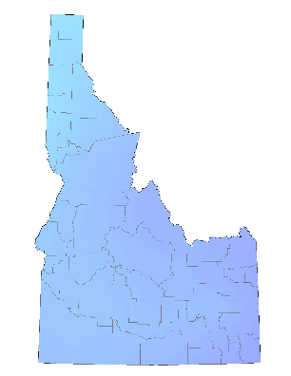
October  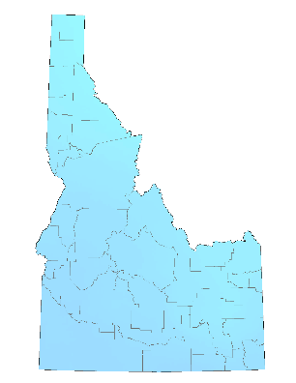 | November  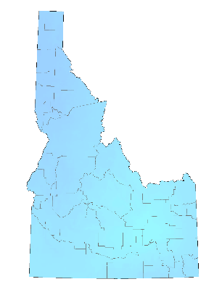 | December  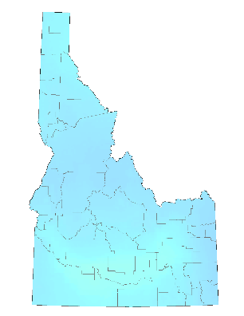
Figure S2. Monthly standard deviation of maximum temperature (°C) across 20 global climate models under a severe (RCP8.5) climate change scenario for mid-century. Color scales are standardized from 0.5 to 2.5 with warmer colors indicating the greatest variability among models while cooler colors show the most consistency.
January  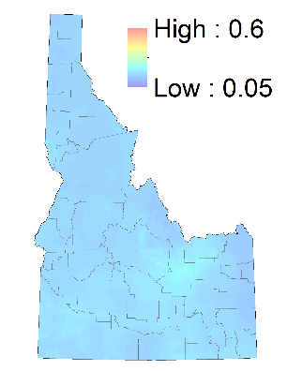 | February  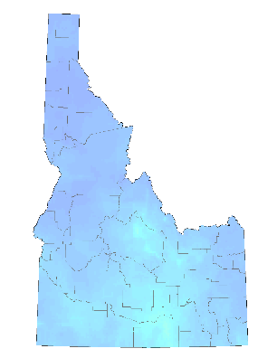 | March  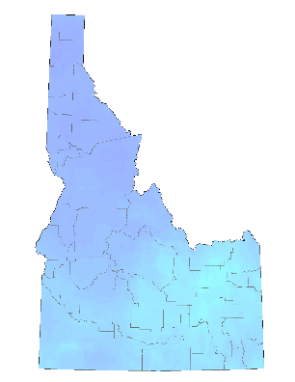
April  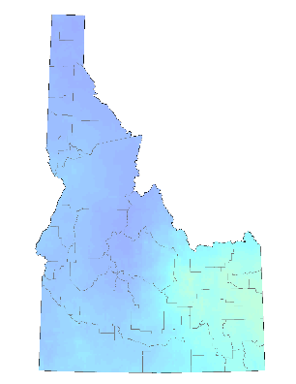 | May  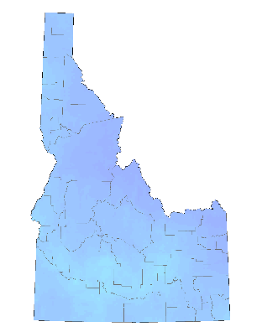 | June  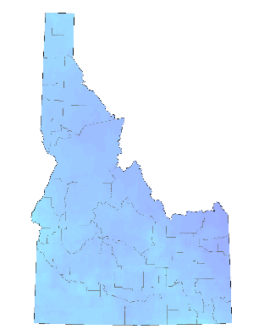
July  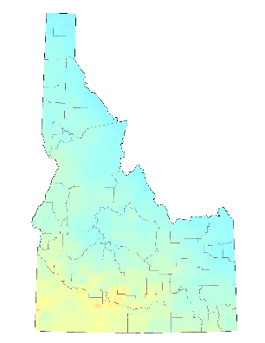 | August  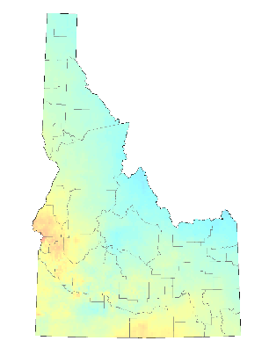 | September  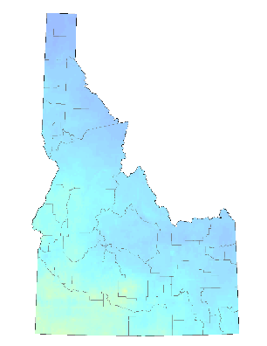
October  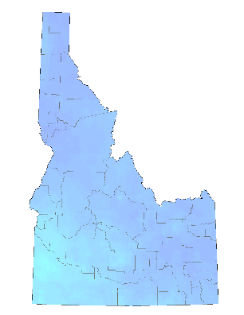 | November  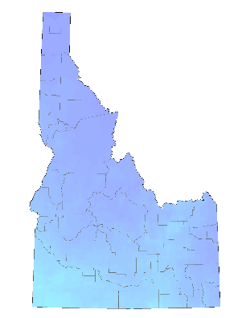 | December  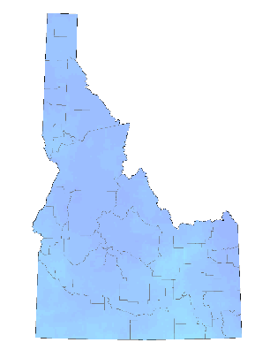
Figure S3. Monthly standard deviation of precipitation (expressed as percent of 1981-2010 normals) across 20 global climate models under a severe (RCP8.5) climate change scenario for mid-century. Color scales are standardized from 0.05 to 0.60 with warmer colors indicating the greatest variability among models while cooler colors show the most consistency.

