SUPPORTING INFORMATION
Biomass allocation in response to nitrogen and phosphorus availability: insight from experimental manipulations of Arabidopsis thaliana

Zhengbing Yan¹, Anwar Eziz¹, Di Tian², Xiuping Li¹, Xinghui Hou³, Huiyuan Peng⁴, Wenxuan Han⁴, Yalong Guo³, Jingyun Fang^{1*}

1 Department of Ecology, College of Urban and Environmental Sciences, Peking University, Beijing 100871, China
2 College of Life Sciences, Capital Normal University, Beijing, 100048, China
3 State Key Laboratory of Systematic and Evolutionary Botany, Institute of Botany, Chinese Academy of Sciences, Beijing 100093, China
4 Key Laboratory of Plant-Soil Interactions of the Ministry of Education, College of Resources and Environmental Sciences, China Agricultural University, Beijing, China

*Corresponding author J.Y. Fang
Email: jyfang@urban.pku.edu.cn
Tel: +86-10-6276 5578
FAX: +86-10-6275 6560

This file includes:
Table S1
Figures S1-S2

Table S1 Summary of the one-way analysis of variance (ANOVA) of biomass allocation fractions under N and P additions. Abbreviations: LMF, leaf mass fraction; SMF, stem mass fraction; FMF, fruit mass fraction; df, degrees of freedom; MS, mean squares.
 | LMF | SMF | FMF
N addition
df | 4 | 4 | 4
MS | 259.32 | 34.68 | 301.39
F value | 12.23 | 3.30 | 18.31
p value | <0.001 | 0.013 | <0.001
P addition
df | 4 | 4 | 4
MS | 223.91 | 97.29 | 46.41
F value | 6.78 | 8.37 | 2.46
p value | <0.001 | <0.001 | 0.050

Figure S1 Biomass allocation of Amaranthus mangostanus under different levels of N and P additions. Effects (F value) of N and P additions and their interaction (N×P) on biomass allocation were presented in each panel. F and p values (***p<0.001; **p<0.01; *p<0.05) were determined by two-way analysis of variance.
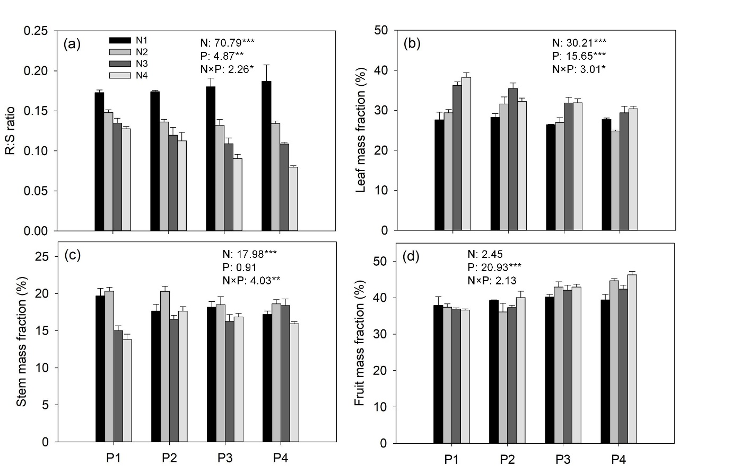

Figure S2 Changes in the flowering time of A. thaliana with the levels of N and P additions. Points and error bars denote the means and standard errors of flowering time, respectively. Different letters above the error bars indicate significant difference (p<0.05) among the five levels of N or P addition based on one-way analysis of variance (ANOVA) and the least significant difference post hoc test.
