The cell and the sum of its parts: patterns of complexity in biosignatures as revealed by DUV Raman spectroscopy

Authors: Sapers, Razzell Hollis, Bhartia, Beegle, Orphan, Amend

Supplementary Information

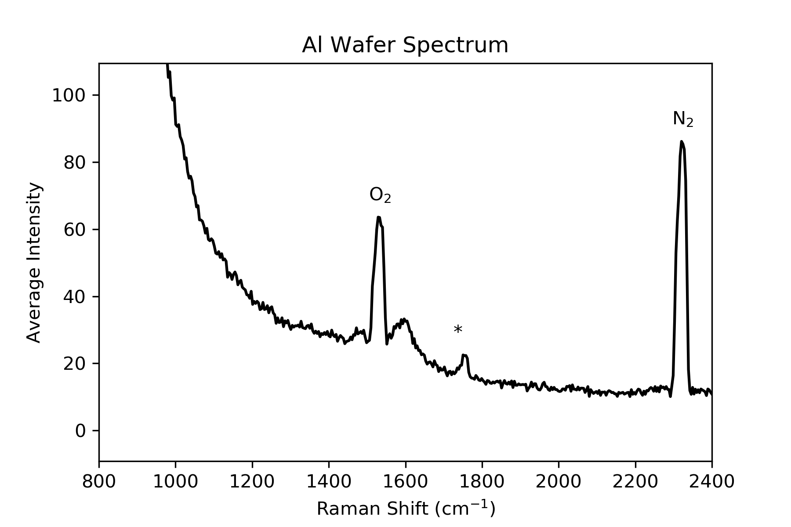
Figure S1: Raman spectrum of the Al wafer, averaged over 25 points with no further processing. No intrinsic peaks from the wafer are observed, only atmospheric N₂ and O₂ peaks, with satellite bands from rovibrational transitions of O₂, and a minor laser line at 1750 cm⁻¹ (*). Note that the intensities presented here are roughly an order of magnitude weaker than in the cellular and molecular standard spectra.

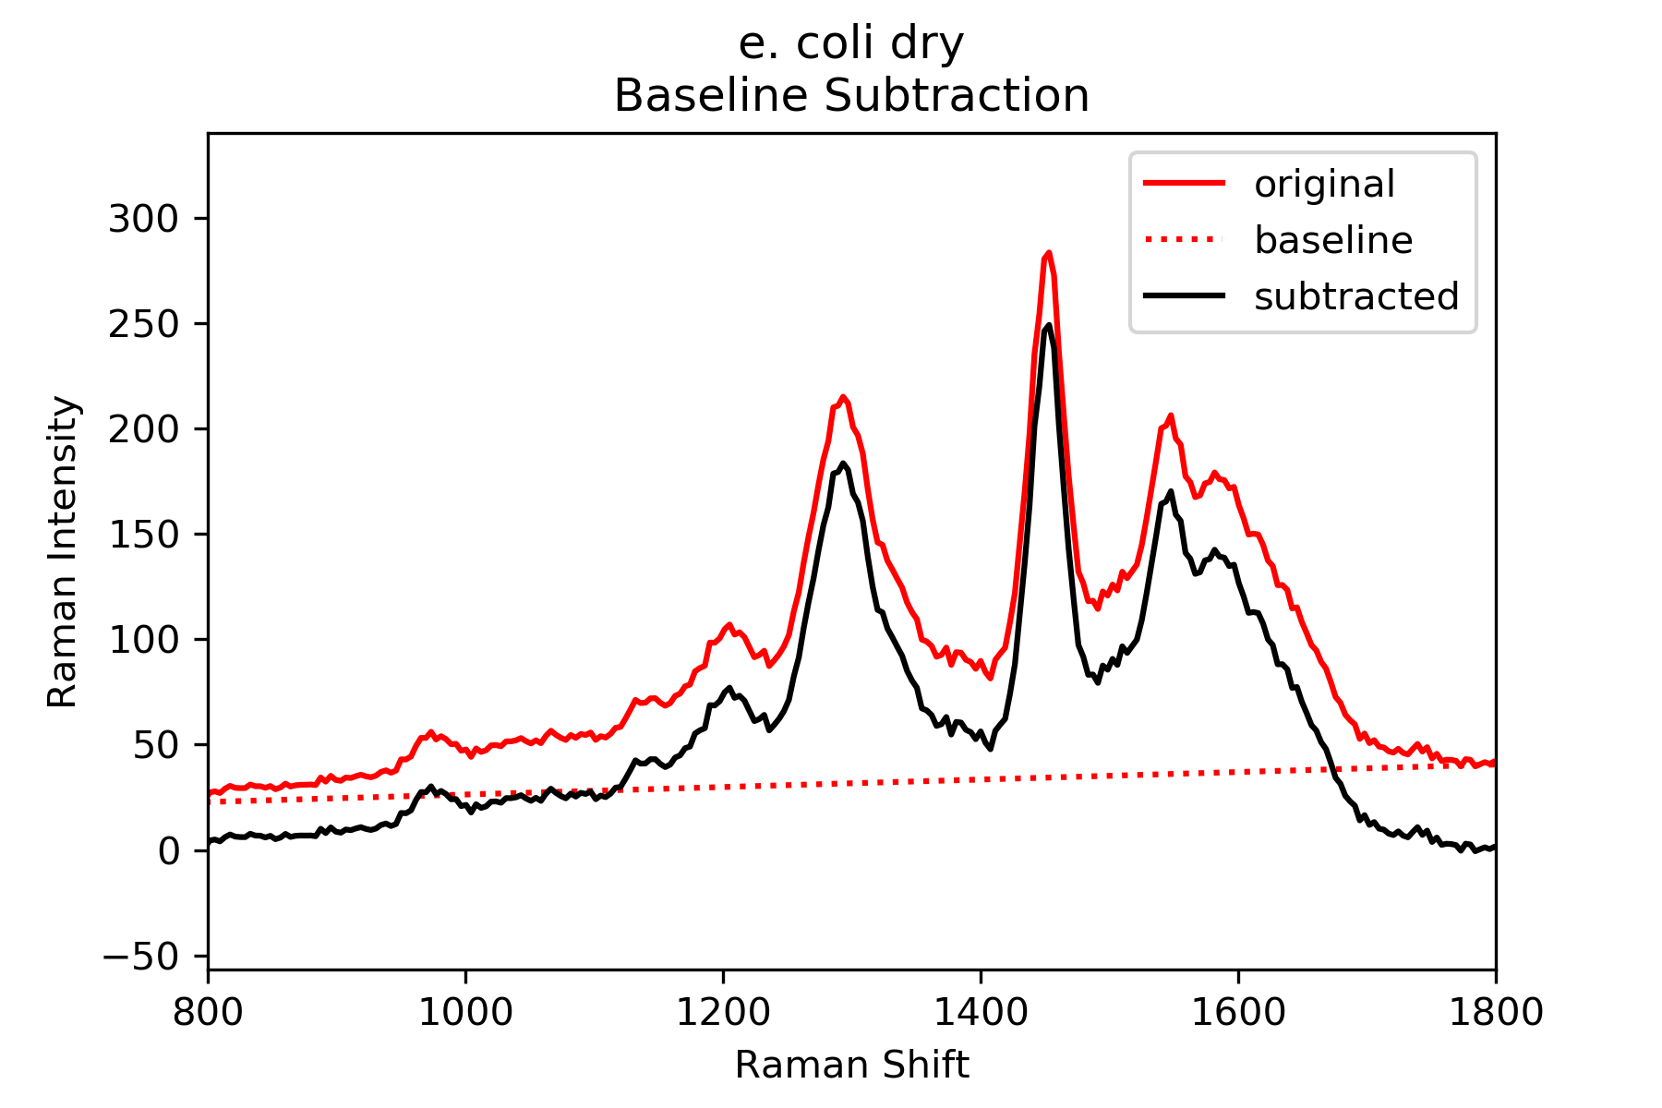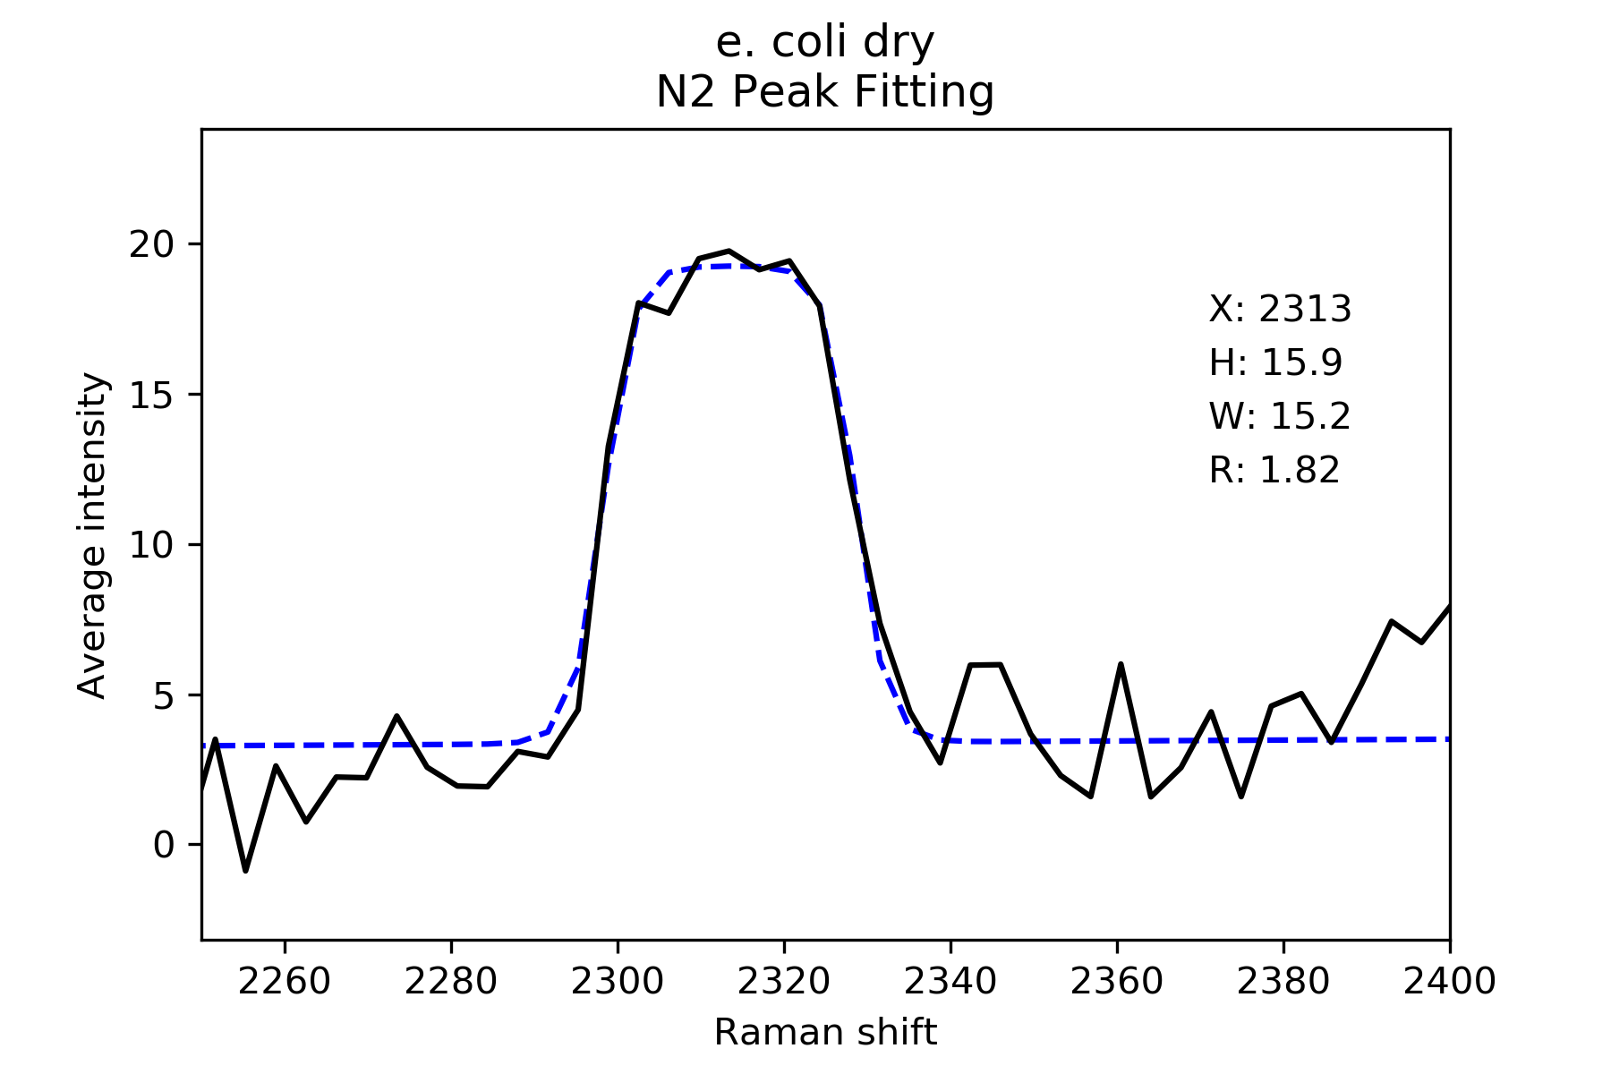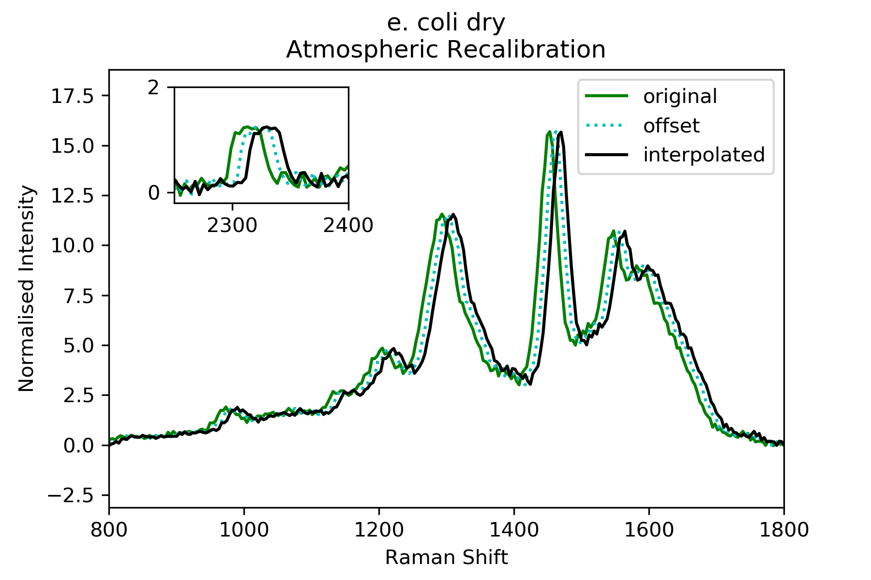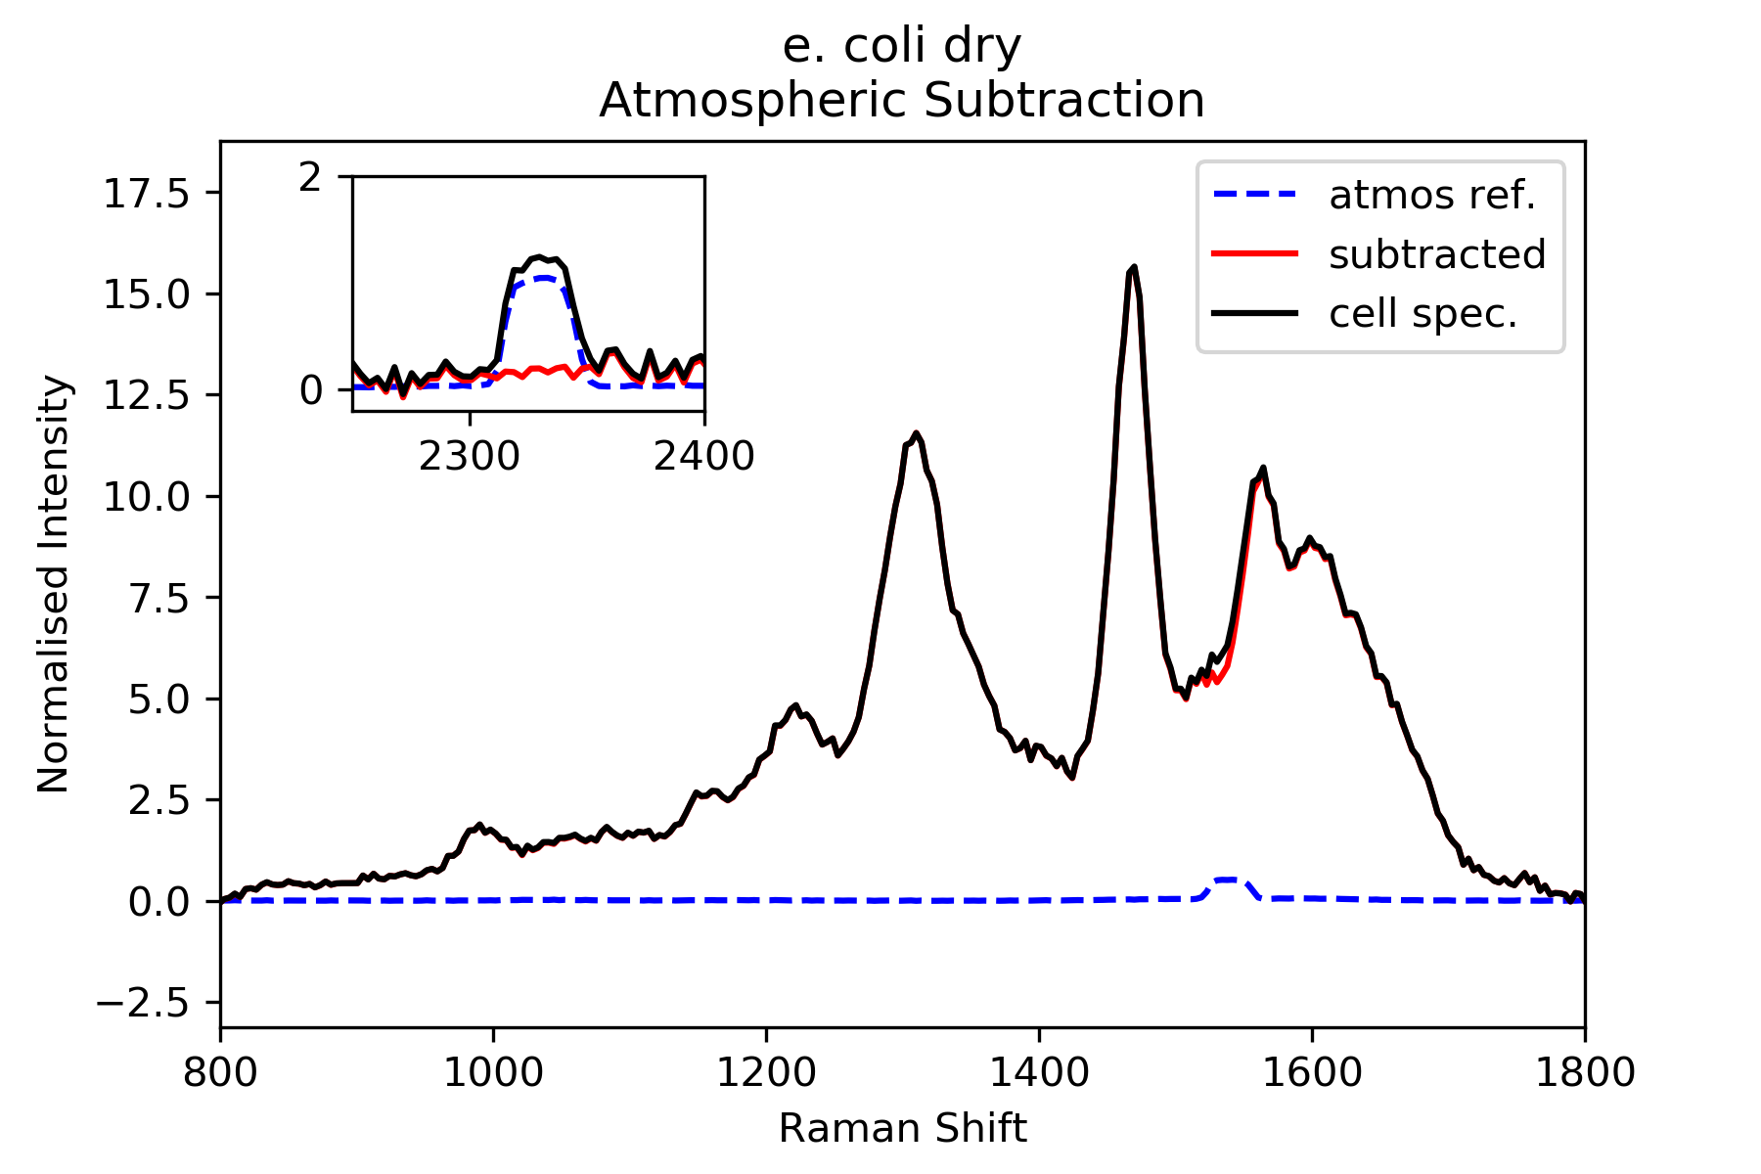
Figure S2: Post-processing of the DUV Raman spectrum of E. coli: linear baseline subtraction; N₂ peak fitting; recalibration to a standard N₂ peak position of 2331 cm⁻¹; atmospheric peaks subtraction.

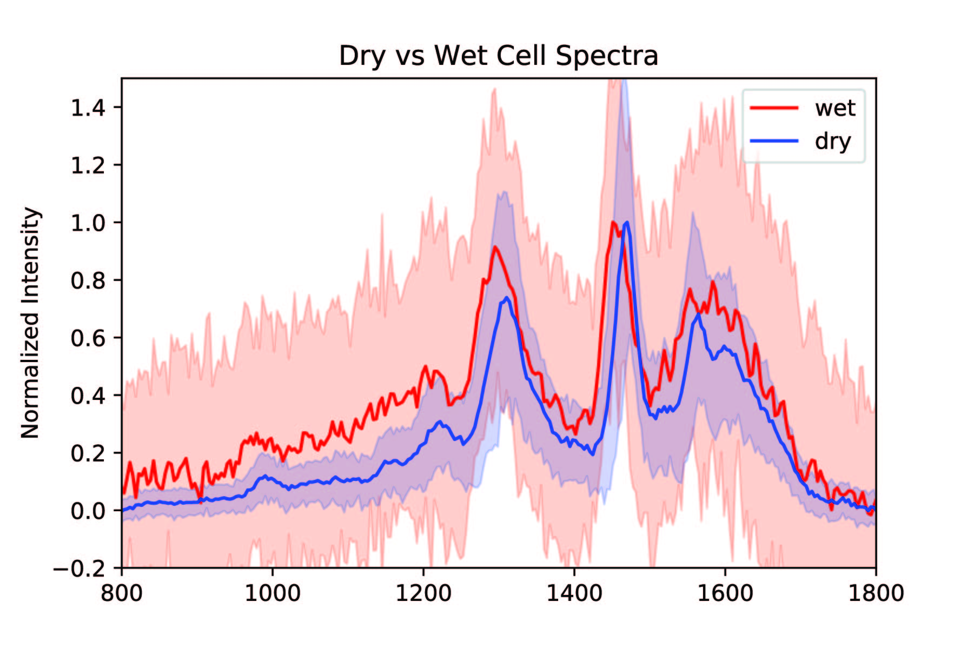
Figure S3: DUV Raman spectra for cells of E. coli during log phase, in solution and after being dried by spotting onto a sterile Al wafer. Shaded area indicates µ ± 2s.d..

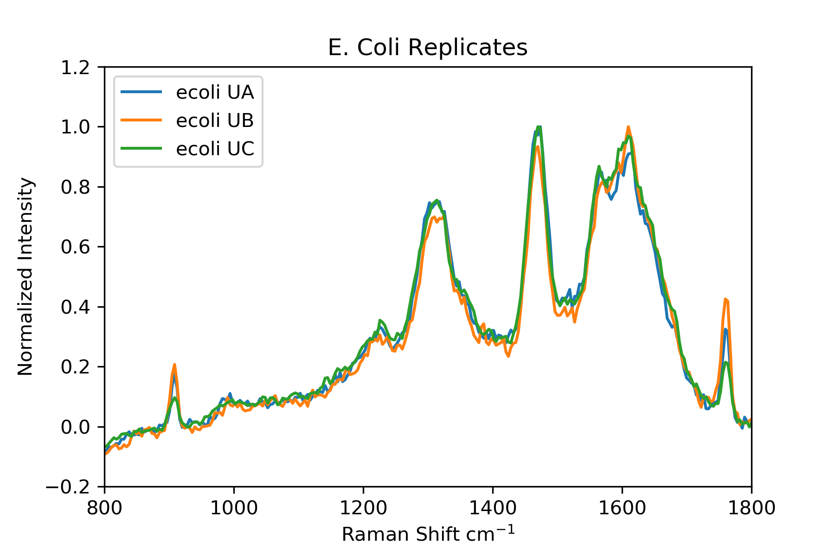
Figure S4: DUV Raman spectra for replicates of E. coli. Sharp peaks at ~910 and 1770 cm⁻¹ are secondary laser lines reflected by the substrate.

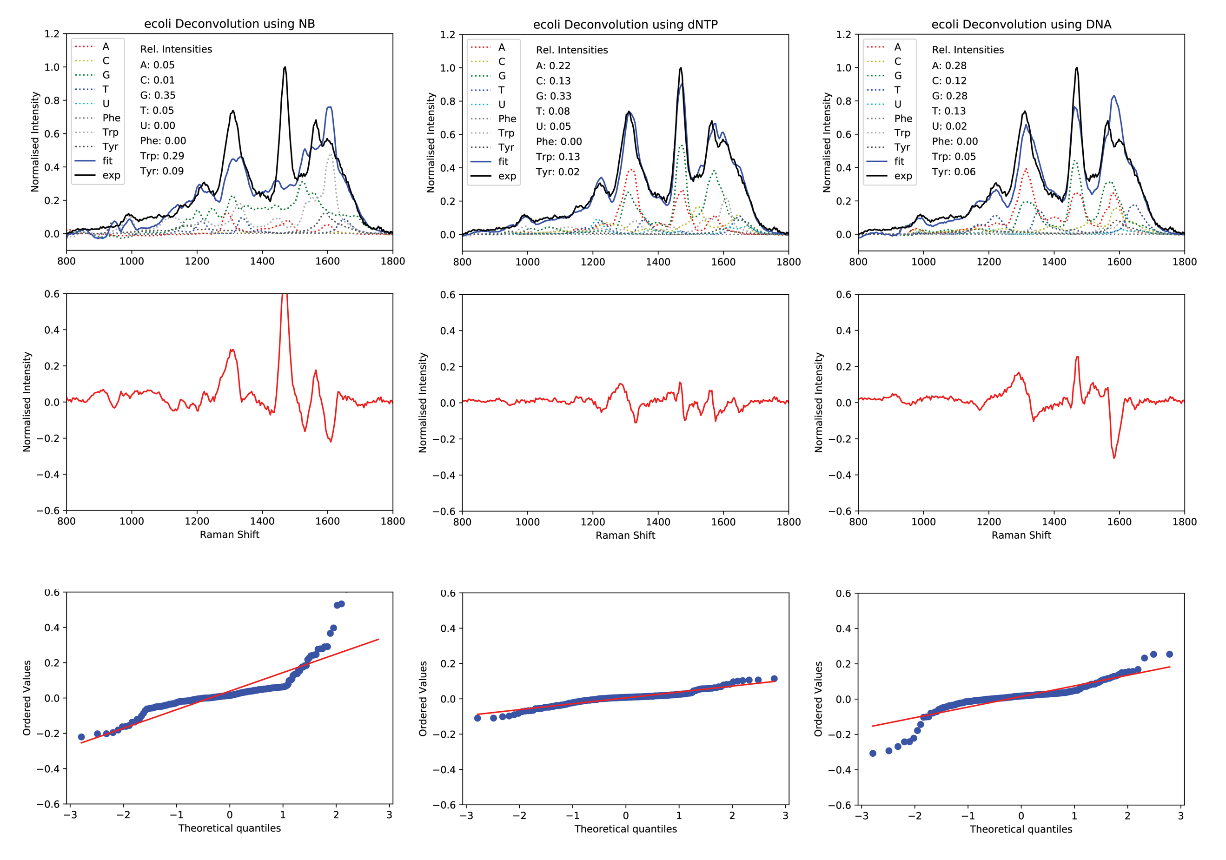
Figure S5: Residuals from deconvolution of the DUV Raman spectrum of E. coli, using nucleobase and amino acid spectra; using nucleotide and amino acid spectra; using ssDNA and amino acid spectra.

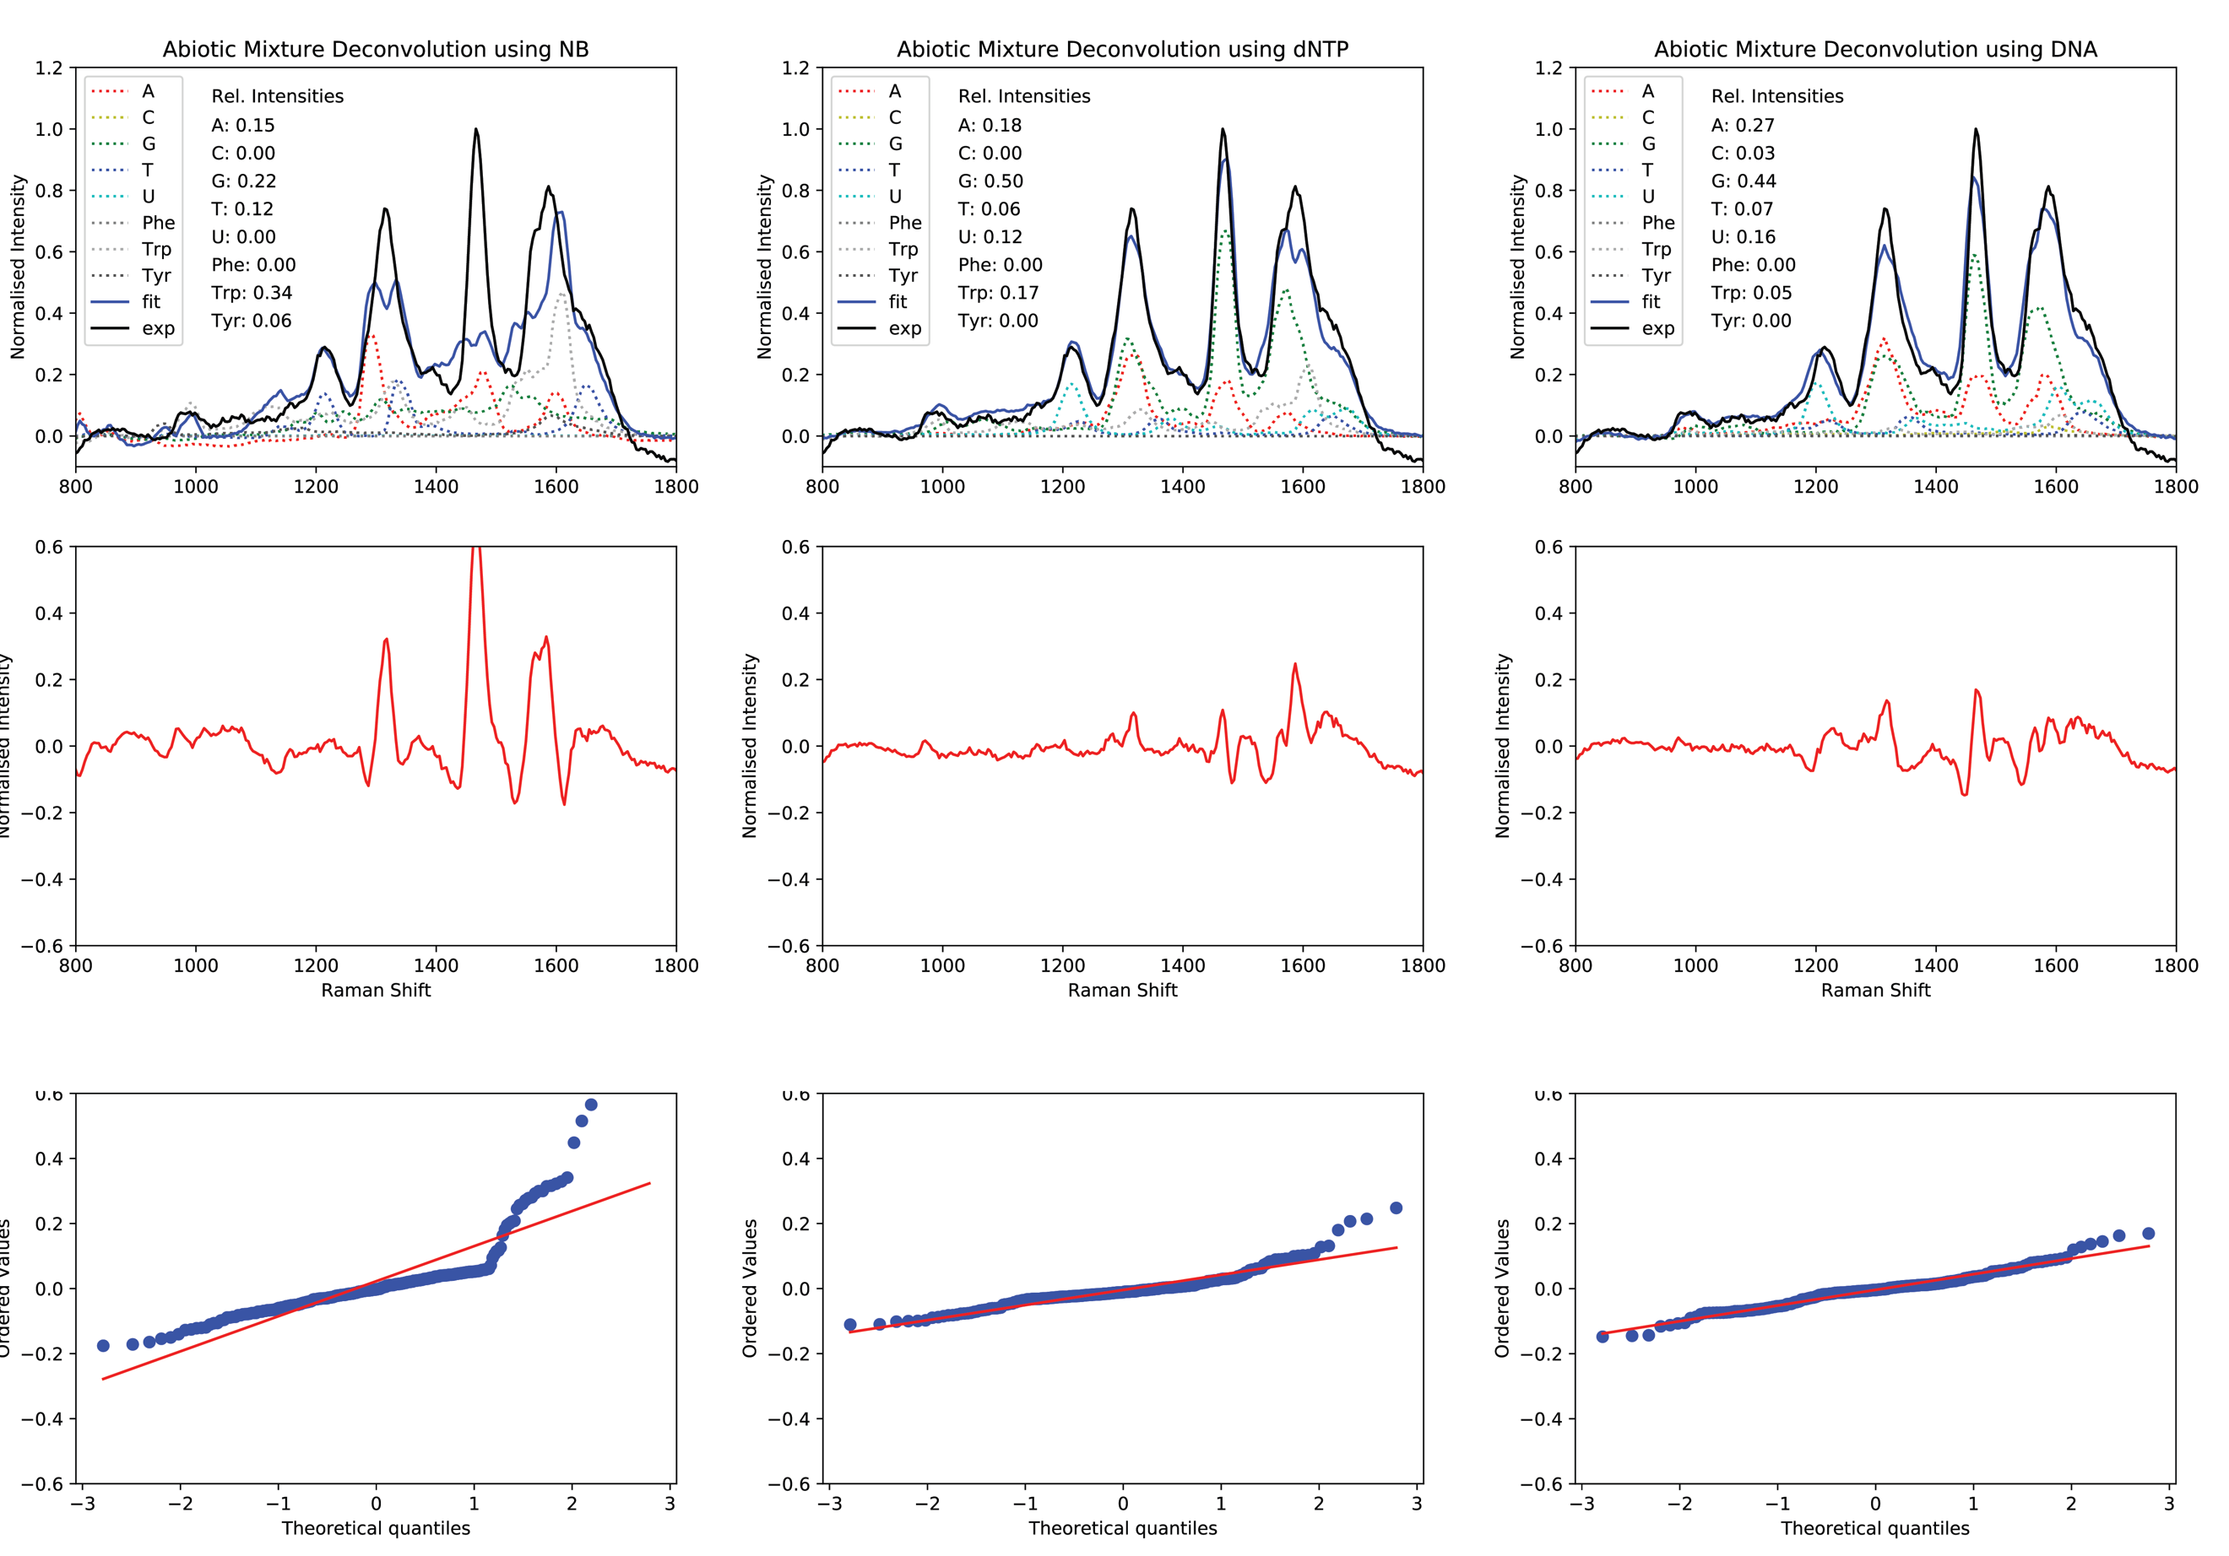
Artificial Mixture Deconvolution using DNA
Artificial Mixture Deconvolution using dNTP
Artificial Mixture Deconvolution using NB
Figure S6: Residuals from deconvolution of the DUV Raman spectra of the artificial mixture, using nucleobase and amino acid spectra; using nucleotide and amino acid spectra; using ssDNA and amino acid spectra.

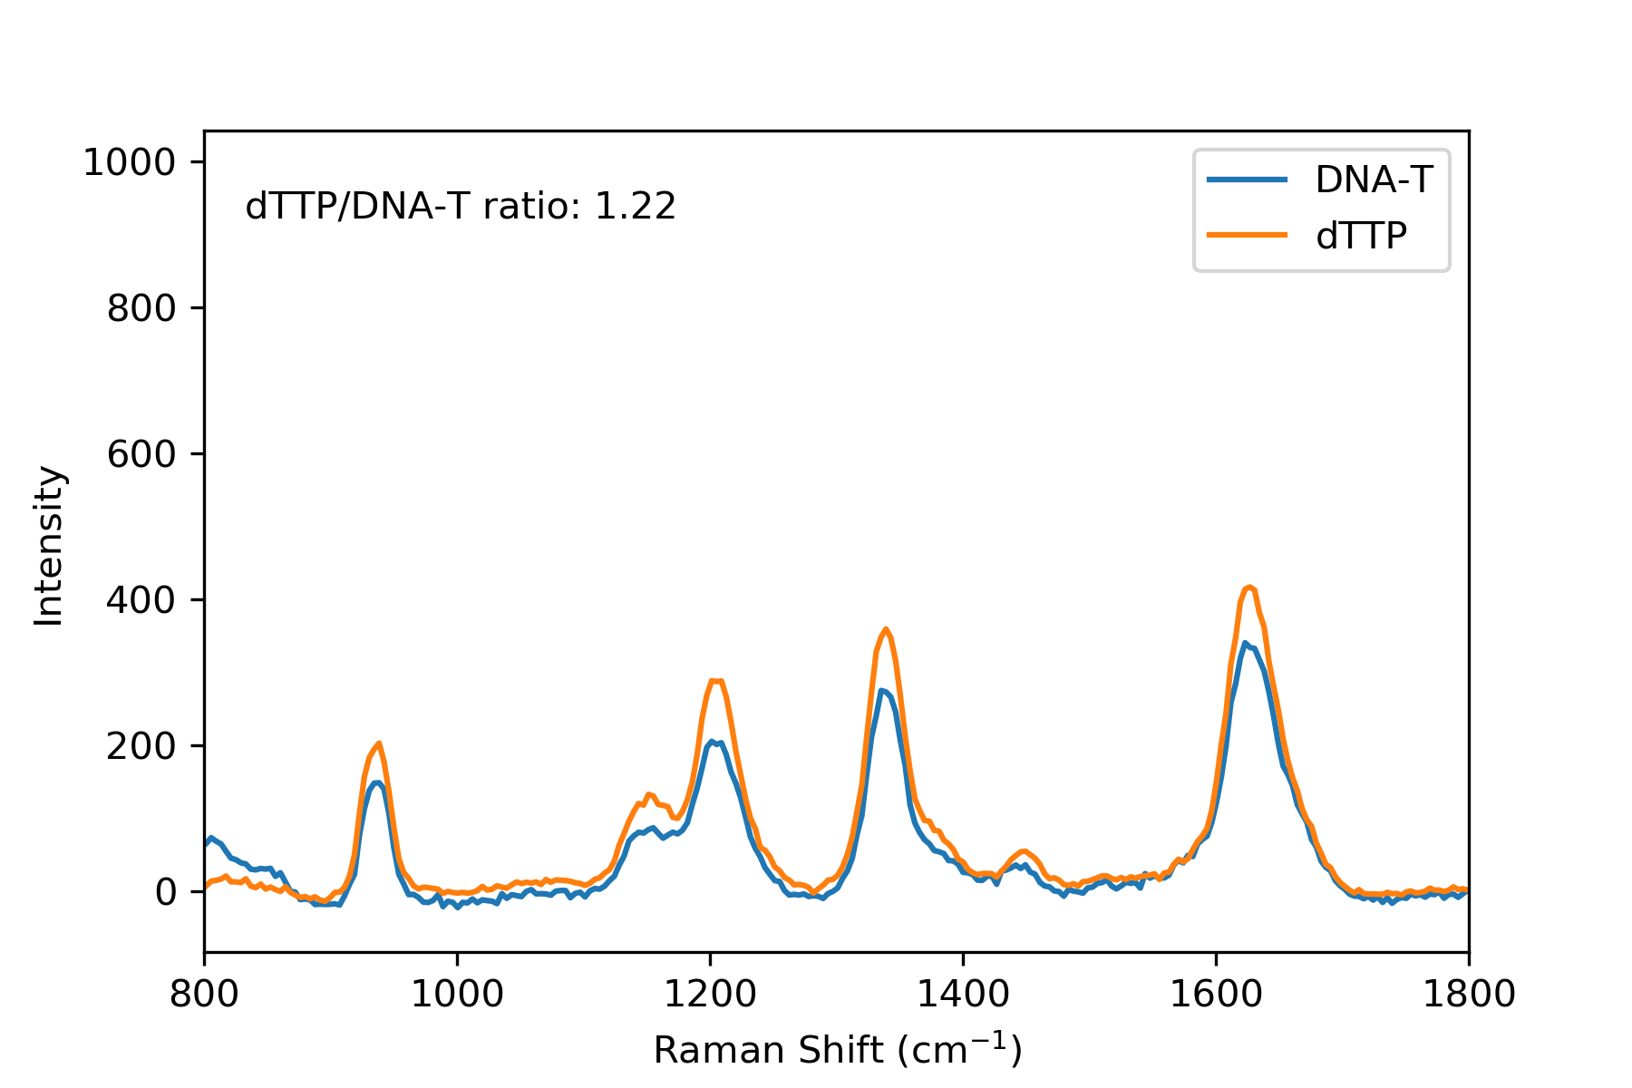
Figure S7: DUV Raman spectra of DNA-T and dTTP solutions with matching nucleotide concentrations of 0.5 mM, under 248 nm excitation and normalized to laser intensity, in order to compare the absolute intensities obtained from free nucleotide and nucleic acid at the same concentration.

Component | Peak Position (cm⁻¹)
Adenineª |  | C8H (b) C8N7 (s) | C1N9 (s) C6N7 (s) | C2H (s) N9C8 (s) | C4N3 (s) C5C4 (s)
A |  | 1291 |  | 1477 | 1594
dATP | 1233 | 1322 | 1413 | 1474 | 1576
DNA-A | 1222 | 1314 | 1398 | 1470 | 1583
Cytosineª |  |  |  |  |  | N3C4 (s) |  | C4=O (s) C5C6 (s)
C | 1087 | 1207 | 1268 | 1341 | 1421 | 1512 |  | 1628
dCTP | 1126 | 1237 |  | 1360 | 1405 | 1523 |  | 1643
DNA-C | 1118 | 1164 | 1241 | 1394 |  | 1508 | 1587
Guanineª |  |  |  |  | C8H (s) N9C8 (s) |  | N3C4 (s)
G | 1199 | 1245 | 1310 |  | 1440 | 1523 | 1561 | 1685
dGTP |  |  | 1306 | 1390 | 1474 |  | 1572
DNA-G |  |  | 1314 |  | 1462 |  | 1572
Thymineª |  |  | C2N3 (s) | C1N9 (s) C6N7 (s) | C4=O (s) C5C7 (s)
T | 1141 | 1214 | 1337 |  | 1647
dTTP | 1172 | 1226 | 1360 | 1462 | 1651
DNA-T | 1155 | 1209 | 1343 | 1449 | 1634
Uracil^{b} | C5H (b) N3C4 (s) | N3H (b) C6H (b) |  | C5C6 (s) C6H (b) | C4=O (s)
U | 1210 | 1367 |  |  | 1666
UTP | 1214 | 1383 | 1459 | 1617 | 1674
RNA-U | 1203 | 1367 | 1451 | 1602 | 1659
Phenylalanine^{c} | Symm. Ring (s) | Phenyl-C (s) |  |  |  |  | In-plane Ring (s)
Phe | 940 | 1153 | 1260 |  |  |  | 1595
Tryptophan^{c} | Symm. Purine (s) | Symm. Purine (s) |  | Pyrrole Ring (s) |  | Symm. Ring (s) | Benzene (s)
Trp | 990 | 1122 | 1226 | 1329 | 1447 | 1553 | 1610
Tyrosine^{c} |  | CH (b) Phenyl-C (s) |  |  |  |  | In-plane Ring (s)
Tyr | 947 | 1176 |  |  |  |  | 1591
Table S1: Peak positions (in cm⁻¹) for each molecular standard, arranged according to their assignments to known vibrational modes (s: stretching, b: bending) based on the literature: a) Wen et al., 1997, b) Sun et al., 2014, c) Asher et al., 1986. Dominant modes for each group are in bold.

Nucleobase + AAA | A | C | G | T | U | Phe | Trp | Tyr
A |  | -0.23 | -0.35 | 0.00 | -0.11 | 0.14 | 0.07 | 0.27
C |  |  | -0.30 | -0.36 | -0.13 | -0.10 | -0.25 | -0.15
G |  |  |  | 0.01 | 0.31 | -0.03 | -0.24 | -0.01
T |  |  |  |  | 0.68 | 0.01 | 0.06 | -0.01
U |  |  |  |  |  | 0.21 | -0.04 | 0.18
Phe |  |  |  |  |  |  | -0.22 | 0.86
Trp |  |  |  |  |  |  |  | -0.40
Nucleotide + AAA | A | C | G | T | U | Phe | Trp | Tyr
A |  | 0.12 | -0.61 | -0.25 | 0.08 | 0.22 | -0.11 | 0.23
C |  |  | -0.33 | -0.39 | -0.05 | 0.10 | -0.27 | 0.05
G |  |  |  | 0.13 | 0.03 | -0.22 | -0.23 | -0.20
T |  |  |  |  | -0.68 | -0.12 | 0.16 | -0.17
U |  |  |  |  |  | -0.19 | -0.11 | -0.14
Phe |  |  |  |  |  |  | -0.20 | 0.88
Trp |  |  |  |  |  |  |  | -0.36
DNA + AAA | A | C | G | T | U | Phe | Trp | Tyr
A |  | -0.10 | -0.64 | -0.14 | 0.07 | -0.15 | -0.17 | 0.14
C |  |  | -0.21 | -0.15 | -0.16 | 0.08 | -0.59 | -0.14
G |  |  |  | 0.05 | -0.01 | 0.10 | 0.00 | -0.03
T |  |  |  |  | -0.69 | -0.04 | 0.21 | 0.04
U |  |  |  |  |  | 0.33 | -0.10 | -0.34
Phe |  |  |  |  |  |  | 0.06 | -0.89
Trp |  |  |  |  |  |  |  | -0.16
Table S2: Correlation coefficients from deconvolution of the DUV Raman spectrum of E. coli, using nucleobase and amino acid spectra; using nucleotide and amino acid spectra; using ssDNA and amino acid spectra.

Group | Molecular mass  (g/mol) | weight per cell (fg) | %mol in macromolecule | molecules per cell (x10⁶) | % dry weight
Protein ¹ | 33,121 | 165 | 100 | 821 | 16.5
Ala | 89.094 | 11.6 | 9.52 | 78.1 | 3.2
Arg | 174.203 | 13.1 | 5.51 | 45.2 | 3.6
Asn | 132.119 | 7.1 | 3.95 | 32.4 | 2.0
Asp | 133.104 | 9.3 | 5.15 | 42.3 | 2.6
Cys | 121.154 | 1.9 | 1.16 | 9.5 | 0.5
Glu | 14.131 | 1.1 | 5.76 | 47.3 | 0.3
Gln | 146.146 | 8.8 | 4.44 | 36.4 | 2.5
Gly | 75.067 | 7.5 | 7.37 | 60.5 | 2.1
His | 155.156 | 4.8 | 2.27 | 18.6 | 1.3
Ile | 131.175 | 10.7 | 6.01 | 49.3 | 3.0
Leu | 131.175 | 19.1 | 10.67 | 87.6 | 5.3
Lys | 146.189 | 8.8 | 4.41 | 36.2 | 2.4
Met | 149.208 | 5.7 | 2.82 | 23.1 | 1.6
Phe | 165.192 | 8.8 | 3.89 | 31.9 | 2.4
Pro | 115.132 | 7.0 | 4.43 | 36.4 | 1.9
Ser | 105.093 | 8.3 | 5.8 | 47.6 | 2.3
Thr | 119.119 | 8.8 | 5.4 | 44.3 | 2.4
Trp | 204.228 | 4.3 | 1.53 | 12.6 | 1.2
Tyr | 181.191 | 7.0 | 2.85 | 23.4 | 2.0
Val | 117.148 | 11.3 | 7.07 | 58.0 | 3.2
RNA ² |  | 60 | 100 | 106 | 6
A | 347.22 | 15.1 | 24.8 | 26.2 | 4.2
C | 323.2 | 12.4 | 21.8 | 23.0 | 3.5
G | 363.22 | 20.6 | 32.4 | 34.2 | 5.8
U | 324.18 | 11.9 | 21.0 | 22.2 | 3.3
DNA ³ |  | 9 | 100 | 16.6 | 0.9
A | 330 | 2.2 | 24.5 | 4.07 | 0.6
C | 307 | 2.1 | 24.6 | 4.08 | 0.6
G | 347 | 2.5 | 26.2 | 4.35 | 0.7
T | 322 | 2.2 | 24.7 | 4.10 | 0.6
Metabolites ⁴ |  | 70 | conc. (mM) | 36.4 | 7
A | variable | 10.14 | 16.0 | 10.7 | 2.8
C | variable | 1.60 | 2.75 | 1.84 | 0.4
G | variable | 3.25 | 5.85 | 3.91 | 0.9
T | variable | 2.63 | 4.98 | 3.33 | 0.7
U | variable | 13.99 | 22.7 | 15.2 | 3.9
Phe | 165.192 | 0.0033 | 0.018 | 0.012 | 0.0009
Trp | 204.228 | 0.0027 | 0.012 | 0.0008 | 0.0008
Tyr | 181.191 | 0.0058 | 0.029 | 0.019 | 0.002
Non Raman-active | variable | 20.2 | 63.6 | 42.5 | 10.7
Other |  | 57 |  |  | 5.7
lipid | 800 | 27 |  | 20 | 9
Lipopolysaccharide | 8000 | 9 |  | 1 | 3
Peptidoglycan | (1000)_{n} | 9 |  | (1) | 3
Glycogen | 1,000,000 | 9 |  | 0.004 | 3
Inorganic Ions |  | 3 |  |  | 1
Total | 100 | 1000 |  | 224 | Total
Table S3: Detailed breakdown of the composition of an average cell of E. coli during exponential growth with a doubling time of 40 minutes, based on a cellular volume of 0.9 μm³ (Neidhardt et al., 1990; Neirlich et al., 1990; Weickert et al., 1998; Blattner et al., 1997; Bennett et al., 2009)

 | Stock Solution |  | Abiotic Mixture |  | Cell Equivalent
Component | Concentration (mM) | Volume (μL) | Concentration (mM) | Relative Concentration | Relative Concentration
Free Nucleotides |  | 68 | 0.135
dATP | 100 | 19.9 | 0.040 | 100% | 100%
dCTP | 100 | 3.9 | 0.008 | 20% | 19%
dGTP | 100 | 7.3 | 0.015 | 37% | 37%
dTTP | 100 | 6.2 | 0.012 | 31% | 31%
UTP | 100 | 30.6 | 0.061 | 154% | 153%
Nucleic Acids |  | 281 | 0.563
DNA-A | 0.1 | 69.7 | 0.139 | 350% | 350%
DNA-C | 0.1 | 62.5 | 0.125 | 314% | 313%
DNA-G | 0.1 | 88.9 | 0.178 | 447% | 446%
DNA-T | 0.1 | 9.4 | 0.019 | 47% | 47%
RNA-U | 0.1 | 51.1 | 0.102 | 257% | 256%
Amino Acids |  | 151 | 0.301
Phe | 25 | 73.4 | 0.147 | 369% | 368%
Trp | 13.7 | 22.5 | 0.045 | 113% | 113%
Tyr | 2.65 | 54.6 | 0.109 | 274% | 274%
Total |  | 500 | 1.000
Table S4: Composition of the abiotic mixture, prepared by combination of the molecular standards according to the relative concentration of their equivalent residues in an average cell of E. coli as reported in Table 3.

