Supplemental Material
New Metabolites from the Co-culture of Marine-derived Actinomycete Streptomyces rochei MB037 and Fungus Rhinocladiella similis 35
Meilin Yu ^{1,2,3}, Yingxin Li ¹, Shivakumar P. Banakar ¹, Lu Liu ^{2,3}, Changlun Shao ^{2,3}, Zhiyong Li^{*1}, Changyun Wang^{*2,3,4}
¹State Key Laboratory of Microbial Metabolism, School of Life Sciences and Biotechnology, Shanghai Jiao Tong University, Shanghai 201100, People’s Republic of China.
²Key Laboratory of Marine Drugs, the Ministry of Education of China, School of Medicine and Pharmacy, Ocean University of China, Qingdao 266003, People’s Republic of China.
³Laboratory for Marine Drugs and Bioproducts, Qingdao National Laboratory for Marine Science and Technology, Qingdao 266200, People’s Republic of China.
⁴Institute of Evolution & Marine Biodiversity, Ocean University of China, Qingdao 266003, People’s Republic of China

Correspondence
Prof. Dr. Zhi-Yong Li
School of Life Sciences & Biotechnology, Shanghai Jiao Tong University; State Key Laboratory of Microbial Metabolism, 800 Dongchuan Road, Minhang District, Shanghai, 200240, P.R.China
Tel: +86-21-34204036
Fax: +86-21-34204036
E-mail: zyli@sjtu.edu.cn

Prof. Dr. Chang-Yun Wang
School of Medicine and Pharmacy, Ocean University of China; Key Laboratory of Marine Drugs, the Ministry of Education, 5 Yushan Road, Qingdao, 266003, Shandong, P. R. China.
Tel: +86/532/82031536
Fax: +86/532/82031536
E-mail: changyun@ouc.edu.cn
_____________________________________________________________________
*Corresponding authors. Email: zyli@sjtu.edu.cn; changyun@ouc.edu.cn

Abstract
In our previous study, a sponge-derived actinomycete Streptomyces rochei MB037 was found to produce borrelidin. To mine its metabolic potential, co-culture of S. rochei MB037 with a gorgonian-derived fungus Rhinocladiella similis 35 was carried out to stimulate the production of new metabolites compared with single strain’s cultivation in this study. From the co-culture broth, five metabolites were isolated successfully, including two new fatty acids with rare nitrile group, borrelidins J and K (1 and 2), one chromone derivative as a new natural product, 7-methoxy-2,3-dimethylchromone-4-one (3), together with two known 18-membered macrolides, borrelidin (4) and borrelidin F (5). The structures of 1–3 were elucidated by using a combination of NMR and MS spectroscopy, ester hydrolysis, and optical rotation methods. Interestingly, 1 and 2 were obtained only through co-culture, but 3 was gained through either co-culture or single culture, while the production of which was increased significantly by co-culture. Compound 1 exhibited significant antibacterial activity against methicillin-resistant Staphylococcus aureus with a MIC value of 0.195 µg/mL.
Keywords: co-culture, actinomycete, fungus, borrelidin, antibacterial activity

List of supporting information
Figure S1. HR-ESI-MS spectrum of compound 1
Figure S2. ¹H NMR (600 MHz, pyridine-d₅) spectrum of compound 1
Figure S3. Partial ¹H NMR (600 MHz, pyridine-d₅) spectrum of compound 1
Figure S4. ¹³C NMR (150 MHz, pyridine-d₅) spectrum of compound 1
Figure S5. DEPT (150 MHz, pyridine-d₅) spectrum of compound 1
Figure S6. HMBC (pyridine-d₅) spectrum of compound 1
Figure S7. HSQC (pyridine-d₅) spectrum of compound 1
Figure S8. ¹H–¹H COSY (pyridine-d₅) spectrum of compound 1
Figure S9. NOSEY (pyridine-d₅) spectrum of compound 1
Figure S10. HR-ESI-MS spectrum of compound 2
Figure S11. ¹H NMR (600 MHz, pyridine-d₅) spectrum of compound 2
Figure S12. Partial ¹H NMR (600 MHz, pyridine-d₅) spectrum of compound 2
Figure S13. ¹³C NMR (150 MHz, pyridine-d₅) spectrum of compound 2
Figure S14. DEPT (150 MHz, pyridine-d₅) spectrum of compound 2
Figure S15. HSQC (pyridine-d₅) spectrum of compound 2
Figure S16. HMBC (pyridine-d₅) spectrum of compound 2
Figure S17. ¹H–¹H COSY (pyridine-d₅) spectrum of compound 2
Figure S18. NOSEY (pyridine-d₅) spectrum of compound 2
Figure S19. HR-ESI-MS spectrum of compound 3
Figure S20. ¹H NMR (600 MHz, DMSO-d₆) spectrum of compound 3
Figure S21. ¹³C NMR (150 MHz, DMSO-d₆) spectrum of compound 3
Figure S22. DEPT (150 MHz, DMSO-d₆) spectrum of compound 3
Figure S23. HMBC (DMSO-d₆) spectrum of compound 3
Figure S24. HSQC (DMSO-d₆) spectrum of compound 3
Figure S25. ¹H–¹H COSY (DMSO-d₆) spectrum of compound 3
New compound statistics

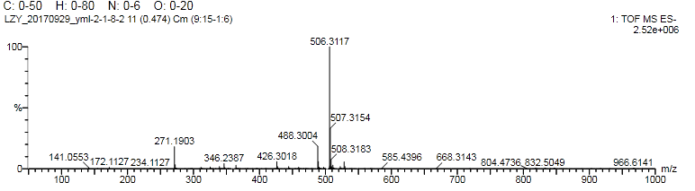
Figure S1. HR-ESI-MS spectrum of compound 1

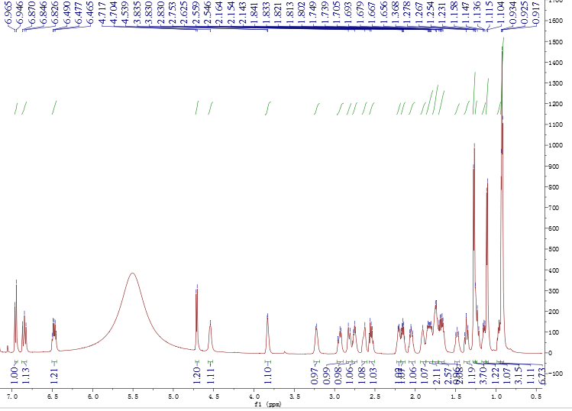
Figure S2. ¹H NMR (600 MHz, pyridine-d₅) spectrum of compound 1
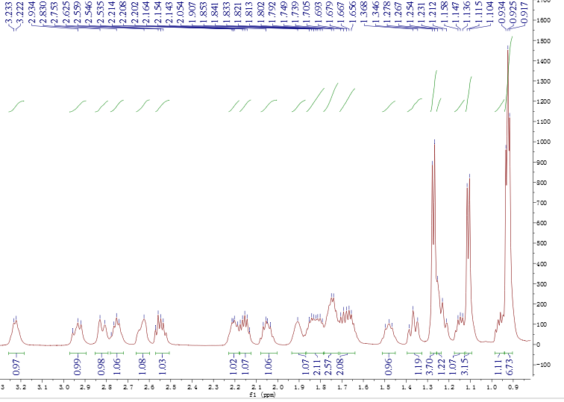
Figure S3. Partial ¹H NMR (600 MHz, pyridine-d₅) spectrum of compound 1

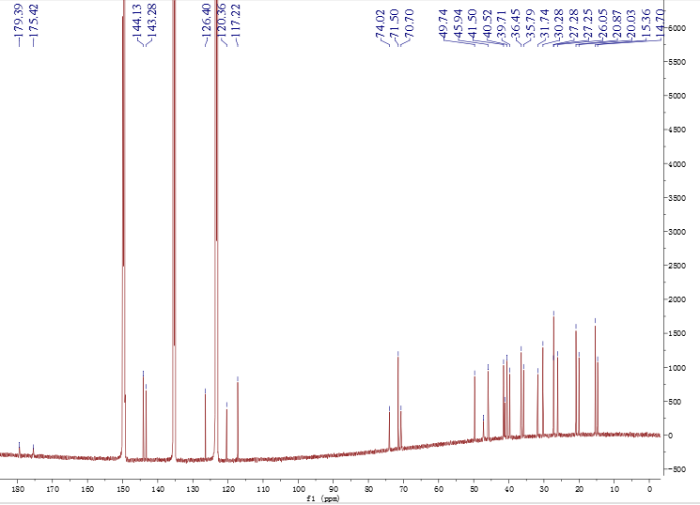
Figure S4. ¹³C NMR (150 MHz, pyridine-d₅) spectrum of compound 1
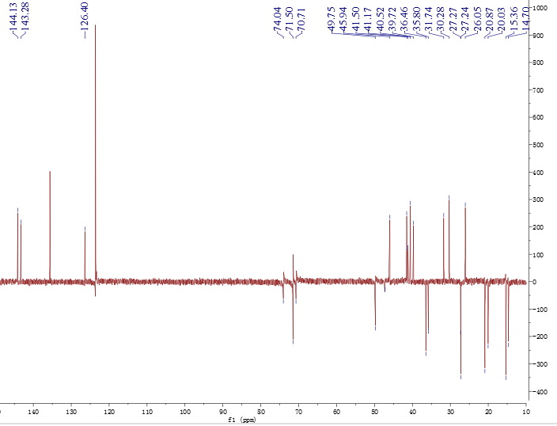
Figure S5. DEPT (150 MHz, pyridine-d₅) spectrum of compound 1 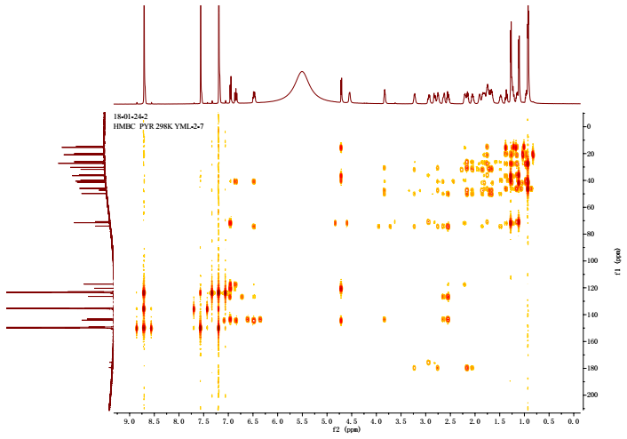
Figure S6. HMBC (pyridine-d₅) spectrum of compound 1
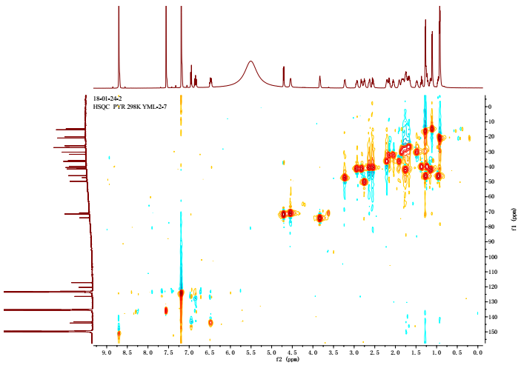
Figure S7. HSQC (pyridine-d₅) spectrum of compound 1

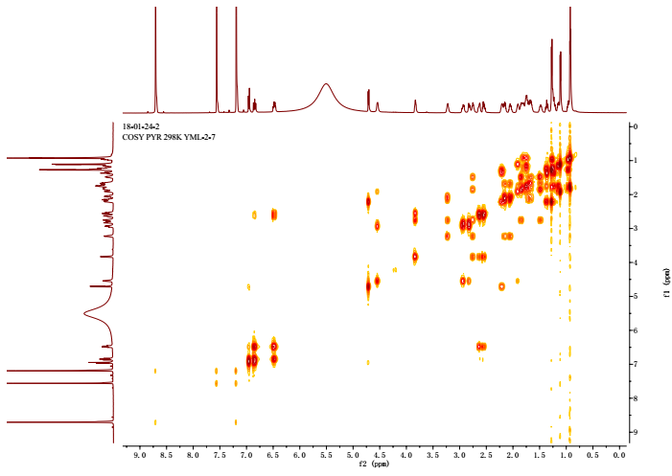
Figure S8. ¹H–¹H COSY (pyridine-d₅) spectrum of compound 1

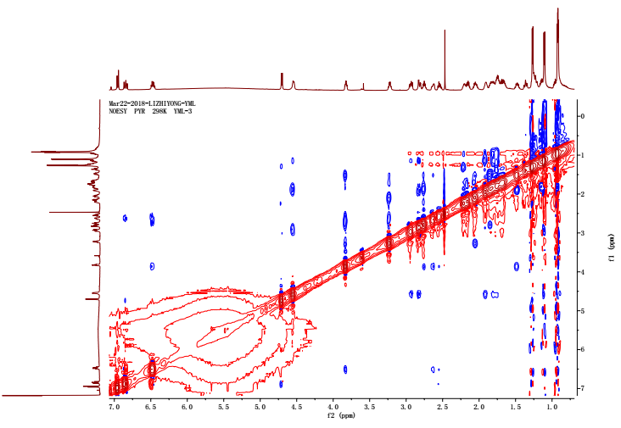
Figure S9. NOSEY (pyridine-d₅) spectrum of compound 1
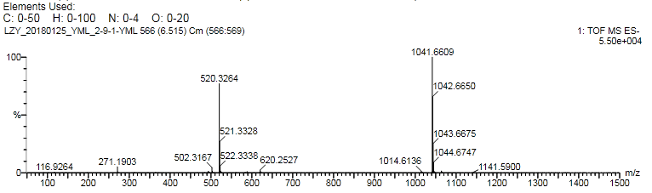
Figure S10. HR-ESI-MS spectrum of compound 2

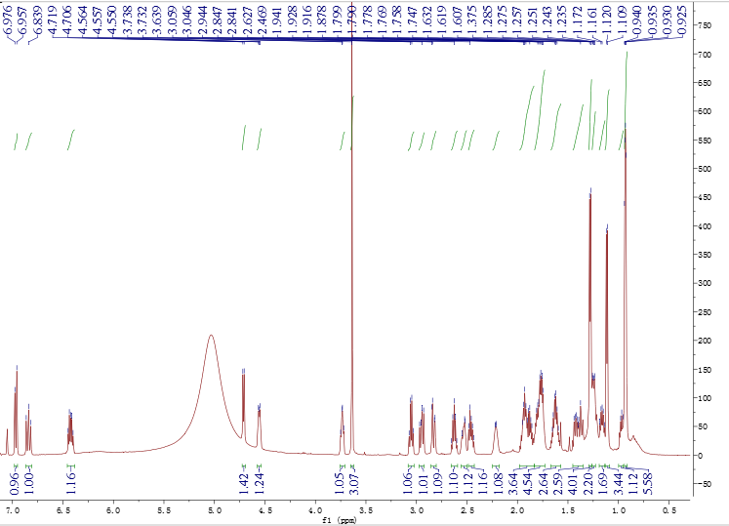
Figure S11. ¹H NMR (600 MHz, pyridine-d₅) spectrum of compound 2

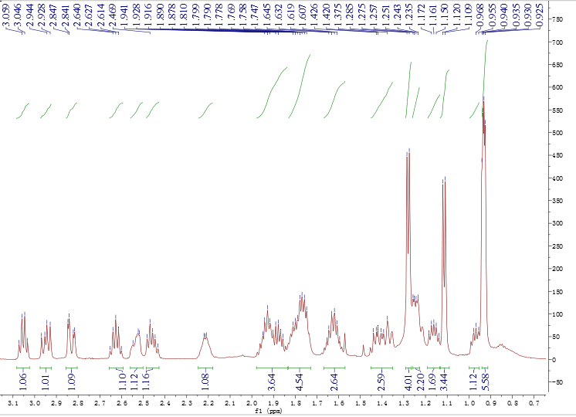
Figure S12. Partial ¹H NMR (600 MHz, pyridine-d₅) spectrum of compound 2

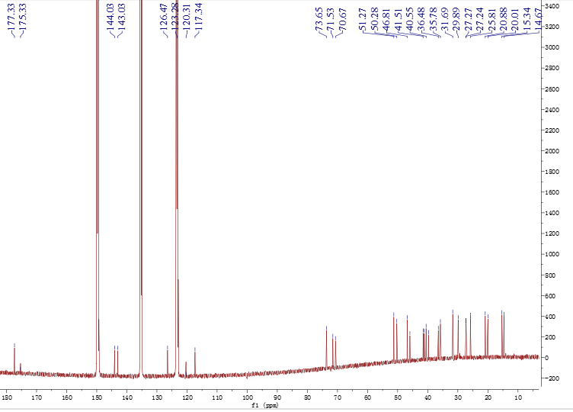
Figure S13. ¹³C NMR (150 MHz, pyridine-d₅) spectrum of compound 2
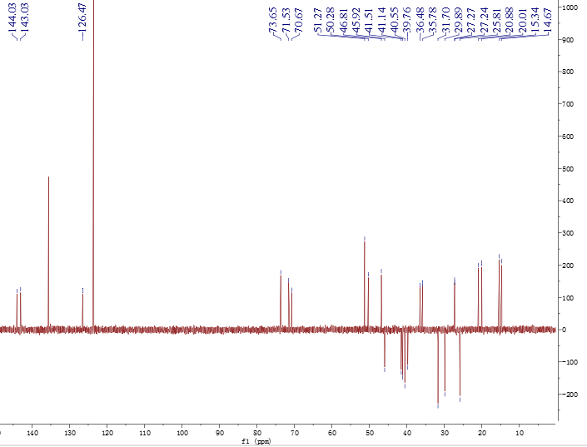
Figure S14. DEPT (150 MHz, pyridine-d₅) spectrum of compound 2

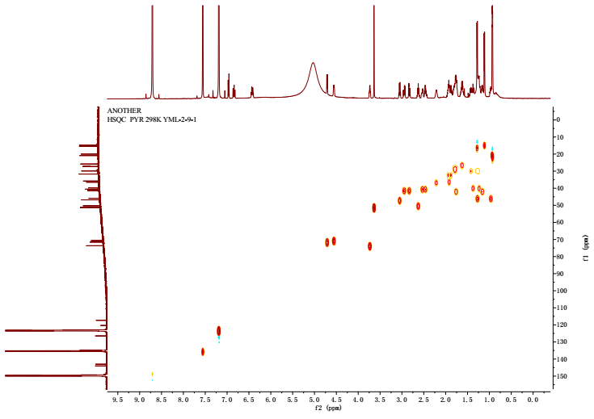
Figure S15. HSQC (pyridine-d₅) spectrum of compound 2 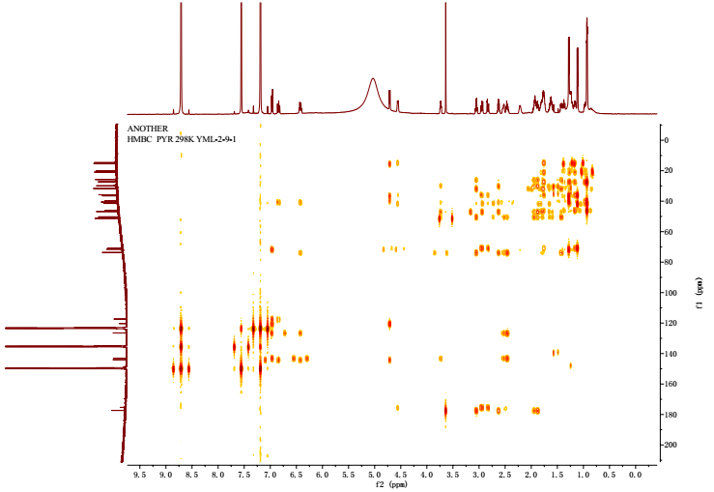
Figure S16. HMBC (pyridine-d₅) spectrum of compound 2

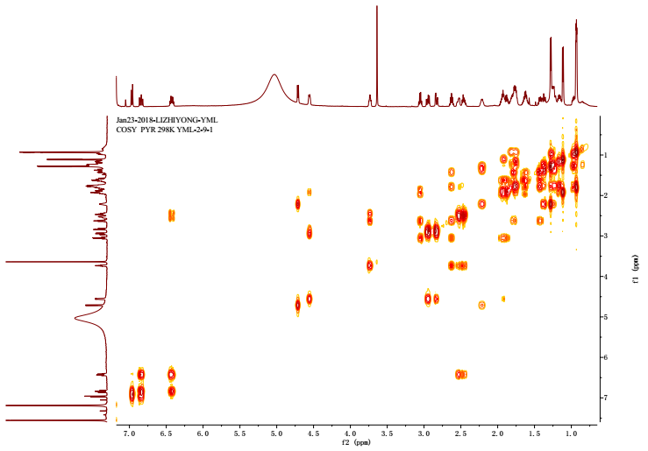
Figure S17. ¹H–¹H COSY (pyridine-d₅) spectrum of compound 2
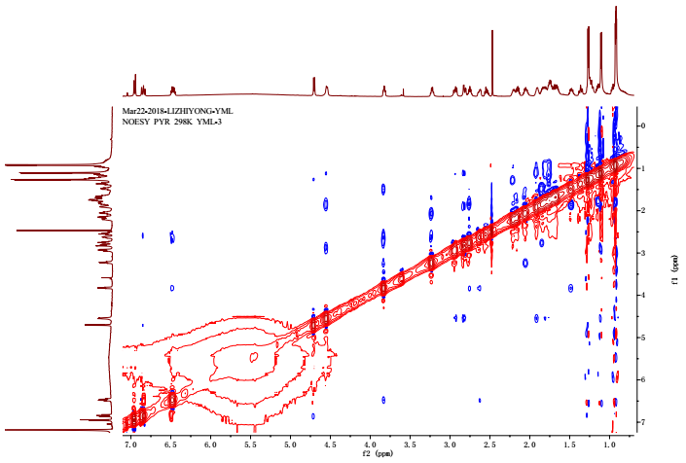
Figure S18. NOSEY (pyridine-d₅) spectrum of compound 2 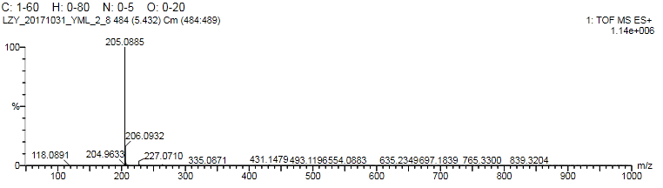
Figure S19. HR-ESI-MS spectrum of compound 3

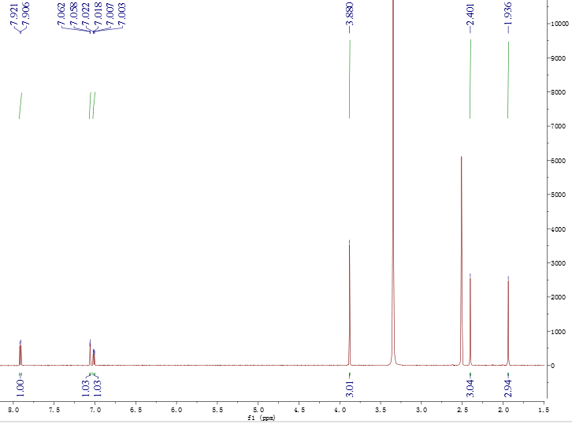
Figure S20. ¹H NMR (600 MHz, DMSO-d₆) spectrum of compound 3
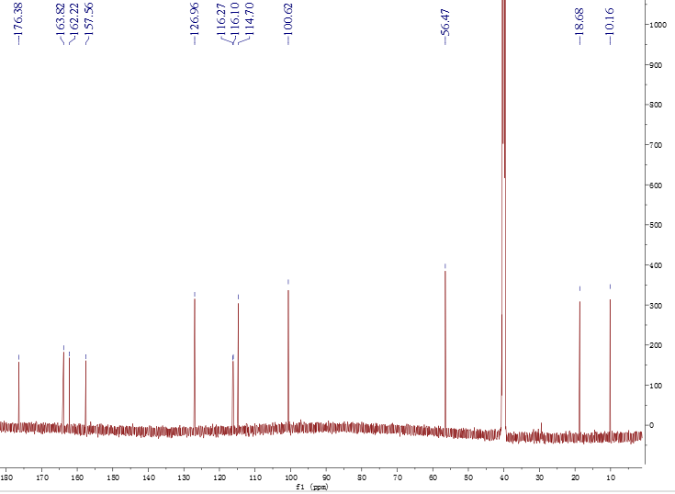
Figure S21. ¹³C NMR (150 MHz, DMSO-d₆) spectrum of compound 3
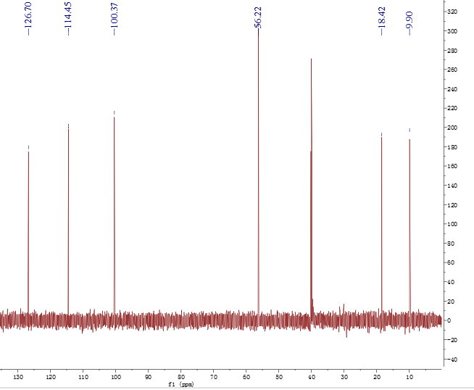
Figure S22. DEPT (150 MHz, DMSO-d₆) spectrum of compound 3 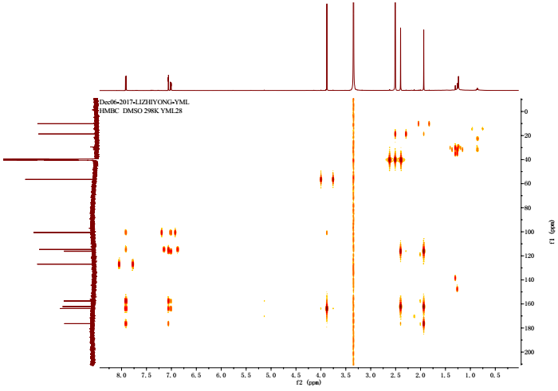
Figure S23. HMBC (DMSO-d₆) spectrum of compound 3

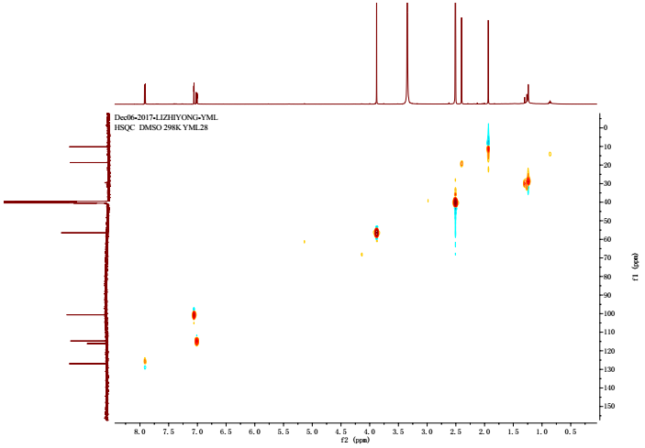
Figure S24. HSQC (DMSO-d₆) spectrum of compound 3
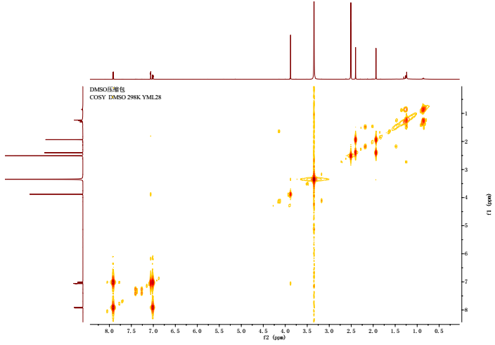
Figure S25. ¹H–¹H COSY (DMSO-d₆) spectrum of compound 3

New compound statistics
Borrelidin J (1): a light yellow oil; [α]²⁵_{D} –25.5 (c 4.0, MeOH); UV (λ_{max}, MeOH) log ε 257 (2.6) nm; IR (KBr) ν_{max} 3375, 3035, 2957, 2921, 2874, 2210, 1958, 1715, 1637, 1589, 1433, 1409, 1380, 1308, 1196, 1021, 952, 785, 705 cm^{–1}; ¹H NMR (pyridine-d₅, 600 MHz) 6.95 (1H, d, J = 11.0 Hz), 6.85 (1H, m), 6.48 (1H, m), 4.71 (1H, d, J = 8.0 Hz), 4.54 (1H, m), 3.83 (1H, m), 3.23 (1H, m), 2.93 (1H, m), 2.82 (1H, d, J = 13.5 Hz), 2.75 (1H, m), 2.63 (1H, m), 2.55 (1H, m), 2.21 (1H, m), 2.16 (1H, m), 2.05 (1H, m), 1.91 (1H, m), 1.84 (1H, m), 1.80 (1H, m), 1.75 (2H, m), 1.62 (2H, m), 1.48 (1H, m), 1.37 (1H, m), 1.27 (4H, m), 1.23 (1H, m), 1.15 (1H, m), 1.11 (3H, d, J = 6.5 Hz), 0.95 (1H, m), 0.93 (3H, d, J = 5.5 Hz), 0.92 (3H, d, J = 5.5 Hz); ¹³C NMR (pyridine-d₅, 150 MHz), 179.4 (C-23), 175.4 (C-1), 144.1 (C-13), 143.3 (C-15), 126.4 (C-14), 120.4 (C-28), 117.2 (C-12), 74.0 (C-17), 71.5 (C-11), 70.7 (C-3), 49.7 (C-18), 47.2 (C-22), 45.9 (C-7), 41.5 (C-5), 41.2 (C-2), 40.5 (C-16), 39.7 (C-9), 36.5 (C-4), 35.8 (C-10), 31.7 (C-21), 30.3 (C-19), 27.3 (C-6), 27.2 (C-8), 26.1 (C-20), 20.9 (C-26), 20.0 (C-25), 15.4 (C-27), 14.7 (C-24); HRESIMS [M - H]– m/z 506.3117 (C₂₈H₄₄NO₇–, calcd. 506.3114).
Borrelidin K (2): a light yellow oil; [α]²⁵_{D} –14.0 (c 2.5, MeOH); UV (λ_{max}, MeOH) log ε 257 (2.6) nm; IR (KBr) ν_{max} 3387, 3038, 2956, 2924, 2873, 2210, 1959, 1723, 1636, 1583, 1435, 1408, 1379, 1305, 1198, 1024, 973, 784, 706 cm^{–1}; ¹H NMR (pyridine-d₅, 600 MHz) 6.96 (1H, d, J = 11.0 Hz), 6.84 (1H, m), 6.42 (1H, m), 4.71 (1H, d, J = 8.0 Hz), 4.55 (1H, m), 3.72 (1H, m), 3.64 (3H, s), 3.05 (1H, dd, J = 8.0, 8.0 Hz), 2.94 (1H, m), 2.82 (1H, m), 2.62 (1H, m), 2.53 (1H, m), 2.45 (1H, m), 2.22 (1H, m), 1.92 (2H, m), 1.87 (1H, m), 1.78 (1H, m), 1.76 (1H, m), 1.75 (1H, m), 1.62 (2H, m), 1.42 (1H, m), 1.37 (1H, m), 1.28 (4H, m), 1.25 (1H, m), 1.23 (1H, m), 1.16 (1H, m), 1.11 (3H, d, J = 6.5 Hz), 0.96 (1H, m), 0.94 (3H, d, J = 6.0 Hz), 0.93 (3H, d, J = 6.0 Hz); ¹³C NMR (pyridine-d₅, 150 MHz), 177.3 (C-23), 175.3 (C-1), 144.0 (C-13), 143.0 (C-15), 126.5 (C-14), 120.3 (C-12), 117.3 (C-23), 73.7 (C-17), 71.5 (C-11), 70.7 (C-3), 51.3 (C-24), 50.3 (C-18), 46.8 (C-22), 45.9 (C-7), 41.5 (C-5), 41.1 (C-2), 40.5 (C-16), 39.8 (C-9), 36.5 (C-4), 35.8 (C-10), 31.7 (C-21), 29.9 (C-19), 27.3 (C-6), 27.2 (C-8), 25.8 (C-20), 20.9 (C-26), 20.0 (C-27), 15.3 (C-28), 14.7 (C-25); HRESIMS [M - H]– m/z 520.3264 (C₂₉H₄₆NO₇–, calcd. 520.3261).
7-Methoxy-2,3-dimethylchromone-4-one (3): a brown yellow solid; UV (λ_{max}, MeOH) log ε 224 (4.3), 291 (3.3) nm; IR (KBr) ν_{max} 3049, 3007, 2955, 2925, 2851, 2357, 1969, 1708, 1634, 1604, 1500, 1440, 1403, 1351, 1276, 1242, 1202, 1181, 1110, 1029, 930, 855, 822, 779, 765, 688; ¹H NMR (DMSO, 600MHz) 7.91 (1H, d, J = 8.9 Hz), 7.06 (1H, d, J = 2.4 Hz), 7.01 (1H, dd, 8.9, J = 2.4 Hz), 3.88 (3H, s), 2.40 (3H, s), 1.93 (3H, s); ¹³C NMR (DMSO, 150 MHz), 176.4 (C-1), 163.8 (C-7), 162.2 (C-2), 157.6 (C-10), 127.0 (C-9), 116.3 (C-5), 116.1 (C-3), 114.7 (C-8), 100.6 (C-6), 56.5 (C-13), 18.7 (C-12), 10.2 (C-11); HRESIMS [M + H]⁺ m/z 205.0885 (C₁₂H₁₃O₃⁺, calcd. 205.0888).

