Supplementary Material
Supplementary Figures and Tables
Supplementary Figures

Supplementary Figure 1. PolyI:C does not affect macrophage infiltration in the caerulein-induced AP mice. (A) Flow cytometry detection of the infiltrated macrophages in the pancreas from Saline, Caerulein-AP, and PolyI:C+Caerulein-AP WT mice. CD11b⁺F4/80⁺ cells were considered as macrophages. Data are representative of three independent experiments. (B) The percentage of macrophages from indicated groups was calculated and compared. Data are shown as mean ± SEM from three independent experiments. **p<0.01, n.s.: not significant, one-way ANOVA test.

Supplementary Figure 2. PolyI:C administration alone is safe. (A) Mice were administrated intraperitoneally with saline or polyI:C (10 mg/kg) 8 h prior to 10 hourly injections of saline. (B) Histology of pancreatic sections from saline injected mice treated with saline or polyI:C; H&E staining, 200X magnification. Histology scores of pancreatitis were evaluated and compared after observing five separate fields, data are shown as mean ± SD (n=5) from one representative experiment. (C) Activities of the serum amylase (left) and lipase (right) from saline or polyI:C pretreated WT mice were compared via enzymatic methods. (D) mRNA expression levels of Il1b, Cxcl1, and Cxcl2 genes in the pancreatic tissue from saline or polyI:C pretreated WT mice were detected by RT-qPCR and normalized to Rpl32. (E) Neutrophil infiltrations in the pancreases from saline or polyI:C pretreated WT mice were measured and compared by MPO staining. 200X magnification (left panel). MPO⁺ cells were counted and compared after observing five separate fields (right panel), data are shown as mean ± SD (n=5) from one representative experiment. (F) Neutrophils and macrophages in the pancreases from saline or polyI:C pretreated WT mice were analyzed by flow cytometry. CD11b⁺Ly6G⁺ cells were considered as neutrophils, and CD11b⁺F4/80⁺ cells were considered as macrophages. (G) The percentage of neutrophils (left panel) and macrophages (right panel) from indicated groups were calculated and compared. Data of (B), (E), and (F) are representative of three independent experiments. Data of (C), (D), and (F) are shown as mean ± SEM from at least three independent experiments. n.s.: not significant, unpaired student t test.

Supplementary Figure 3. PolyI:C prevents L-arginine-induced AP in mice. (A) Schematic diagram of the L-Arginine-induced experimental AP mouse model. Saline or polyI:C (10 mg/kg) was intraperitoneally administrated 8 h prior to the induction of AP. (B) Histopathological examination of the effect of polyI:C on L-Arginine-induced experimental AP WT mouse models by H&E staining. Top panel: 100X magnification; bottom panel: 200X magnification. (C) Histology scores of pancreatitis were evaluated and compared after observing five separate fields; data are shown as mean ± SD (n=5) from one representative experiment. (D) and (E) Activities of the serum amylase (D) and lipase (E) from Saline, L-Arginine-AP, and PolyI:C+L-arginine-AP WT mice were compared via enzymatic methods. Data of (B) are representative of three independent experiments. Data of (D) and (E) are shown as mean ± SEM (n≥3) from at least three independent experiments. *p<0.05, **p<0.01, one-way ANOVA test.

Supplementary Figure 4. Short time pretreatment of polyI:C also prevents caerulein-induced AP in mice. (A) Schematic diagram of the caerulein-induced experimental AP mouse model with 1 h pretreatment of polyI:C. (B) Histological examination of the effect of polyI:C (10 mg/kg, intraperitoneally administrated 1 h prior to the induction of AP on WT caerulein-induced experimental AP mouse models by H&E staining. Top panel: 100X magnification; bottom panel: 200X magnification. Histology scores of pancreatitis were evaluated and compared after observing five separate fields; data are shown as mean ± SD (n=5) from one representative experiment. (C) Activities of the serum amylase (left panel) and lipase (right panel) from Saline, Caerulein-AP, and PolyI:C+Caerulein-AP WT mice were measured via enzymatic methods. Data of (B) is representative of three independent experiments. Data of (C) are shown as mean ± SEM from at least three independent experiments. **p<0.01, one-way ANOVA test.

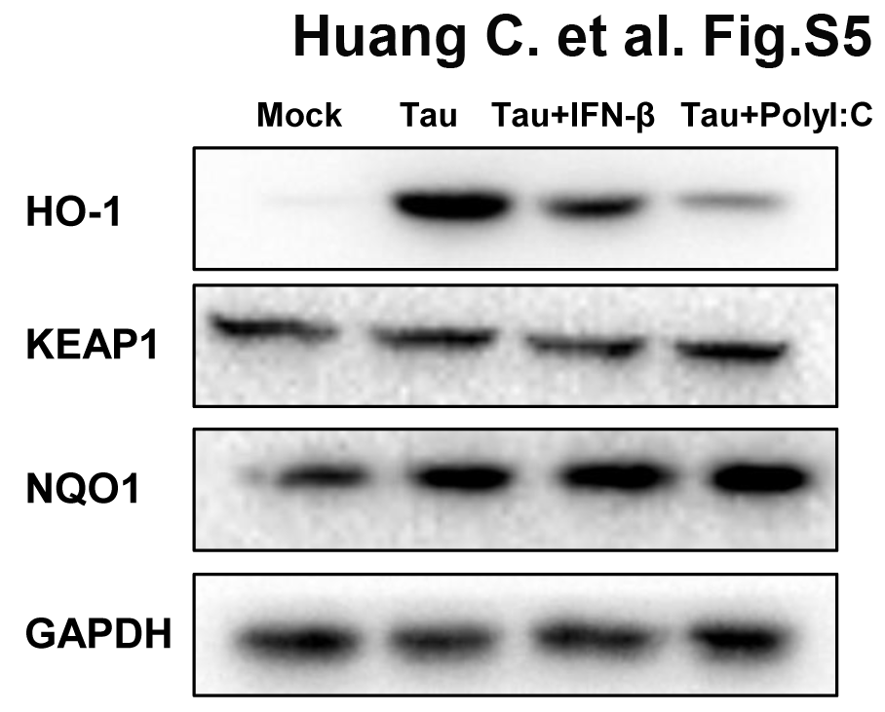
Supplementary Figure 5. Anti-oxidant protein HO-1 is an indicator of the protective effect of polyI:C in the taurocholate-induced pancreatic acinar cell injury model. 266-6 cells were stimulated with 0.5 mM taurocholate in the absence or presence of IFN-β (200 U/ml) or polyI:C (1 μg/ml), 24 h later, anti-oxidant protein levels (HO-1 KEAP1, NQO1) in the cells were measured by Western blotting, GAPDH was shown as a loading control. Data are representative of three independent experiments.

Supplementary Figure 6. Knockout of Tlr4 does not abolish the protective effects of polyI:C on the caerulein-induced AP mouse model. (A) Schematic diagram of the caerulein-induced experimental AP mouse model. Saline or polyI:C (10 mg/kg) was intraperitoneally administrated 8 h prior to the induction of AP in Tlr4^{-/-} mice. (B) Histopathological examination of the effect of polyI:C on Tlr4^{-/-} caerulein-induced experimental AP mouse models by H&E staining. Top panel: 100X magnification; bottom panel: H&E staining, 200X magnification. Histology scores of pancreatitis were evaluated and compared after observing five separate fields; data are shown as mean ± SD (n=5) from one representative experiment. (C) Activities of the serum amylase (left panel) and lipase (right panel) from Saline, Caerulein-AP, and PolyI:C+Caerulein-AP Tlr4^{-/-} mice were compared via enzymatic methods. Data of (B) are representative of three independent experiments. Data of (C) are shown as mean ± SEM from at least three independent experiments. **p<0.01, one-way ANOVA test.

Supplementary Tables

Supplementary Table 1. Sequences of the primers used for quantitative real-time PCR.
Gene | Primer list（5'-->3'）
L32 | Forward | GAAGTTCATCAGGCACCAGTC
 | Reverse | GAGCAATCTCAGCACAGTAAGA
Il1b | Forward | GACAGAACATAAGCCAACAA
 | Reverse | ACACAGGACAGGTATAGATTC
Cxcl1 | Forward | AGACAGTGGCAGGGATTC
 | Reverse | TTCTTGAGTGTGGCTATGAC
Cxcl2 | Forward | GCTCCTCAATGCTGTACT
 | Reverse | GAGTGGCTATGACTTCTGT
Ccl2 | Forward | ATTCTGTGACCATCCCCTCAT
 | Reverse | TGTATGTGCCTCTGAACCCAC
Ccr2 | Forward | ATCCACGGCATACTATCAACATC
 | Reverse | CAAGGCTCACCATCATCGTAG
C5ar1 | Forward | ATGGACCCCATAGATAACAGCA
 | Reverse | GAGTAGATGATAAGGGCTGCAAC
Mrc1 | Forward | CTCTGTTCAGCTATTGGACGC
 | Reverse | CGGAATTTCTGGGATTCAGCTTC
Ccr5 | Forward | TTTTCAAGGGTCAGTTCCGAC
 | Reverse | GGAAGACCATCATGTTACCCAC
Hck | Forward | TCCTCCGAGATGGAAGCAAG
 | Reverse | ACAGTGCGACCACAATGGTAT
Tyrobp | Forward | GAGTGACACTTTCCCAAGATGC
 | Reverse | CCTTGACCTCGGGAGACCA
Procr | Forward | AATGCCTACAACCGGACTCG
 | Reverse | ACCAGTGATGTGTAAGAGCGA
Fgr | Forward | CGGCTGAAGAACGCTATTACC
 | Reverse | GGGCGACGAATATGGTCACTC
 | Reverse | TGTATGTGCCTCTGAACCCAC

Supplementary Table 2. Histology scoring of pancreatitis
Edema | Acinar necrosis
0=absent | 0=absent
0.5=focal expansion of interlobular septae | 0.5=focal occurrence of 1–4 necrotic cells/HPF
1=diﬀuse expansion of interlobular septae | 1=diﬀuse occurrence of 1–4 necrotic cells/HPF
1.5=same as1+focal expansion of interlobular septae | 1.5=same as 1+focal occurrence of 5–10necrotic cells/HPF
2=same as 1+diﬀuse expansion of interlobular septae | 2=diﬀuse occurrence of 5–10 necrotic cells/HPF
2.5=same as2+focal expansion of interacinar septae | 2.5=same as 2+focal occurrence of 11–16 necrotic cells/HPF
3=same as 2+diﬀuse expansion of interacinar septae | 3 conﬂuent necrosis =diﬀuse occurrence of 11–16 necrotic cell~HPF or foci of
3.5=same as 3+focal expansion of intercellular septae | 3.5=same as 3+focal occurrence of >16 necrotic cells/HPF
4=same as3+diﬀuse expansion of intercellular septae | 4=>16 necrotic cells/HPF (extensive conﬂuent necrosis)
Inﬂammation | Intrapancreatic hemorrhage
0=0–1 intralobular or perivascular leucocytes/HPF | 0=absent
0.5=2–5 intralobular or perivascular leucocytes/HPF | 2=Focal occurrence in HPF
1=6–10 intralobular or perivascular leucocytes/HPF | 4=Diﬀuse occurrence
1.5=11–15 intralobular or perivascular leucocytes/HPF
2=16–20 intralobular or perivascular leucocytes/HPF
2.5=21–25 intralobular or perivascular leucocytes/HPF
3=26–30 intralobular or perivascular leucocytes/HPF
3.5=more than 30 leucocytes/HPF or focal microabscesses
4=more than 35 leucocytes/HPF or conﬂuent microabscesses

