Supplementary Material

Day-length is involved in flooding tolerance response in wild type and variant genotypes of rootstock Prunus cerasifera L.
Calogero Iacona^{1,*}, Laura Pistelli^{1,*}, Marco Cirilli^{2,3}, Lorenzo Gatti², Roberto Mancinelli², Maria Nicolina Ripa² and Rosario Muleo²⁺
¹Department of Agriculture, Food and Environment, University of Pisa, Pisa, Italy
²Laboratory of Molecular Ecophysiology of Woody Plant, Department of Agricultural and Forestry Sciences, University of Tuscia, Viterbo, Italy;
³Department of Agricultural and Environmental Sciences, University of Milan, Milan, Italy

Supplementary Figure S.1: Effects of flooding and photoperiod on the photosynthetic assimilation (A_{CO2}) in leaves of plum plants rootstock Mr.S. 2/5-WT (a, b), and its S.1 (c, d) and S.4 (e, f) variant genotypes. The A_{CO2} values were detected at 1st and 4th leaves, excepted for WT and S.1 genotypes at Day 14 after flooding. Values are means ± SD of five biological replications.

Supplementary Figure S.2: Effects of flooding and photoperiod on the stomatal conductance (gs) in leaves of plum plants rootstock Mr.S. 2/5-WT (a, b), and its S.1 (c, d) and S.4 (e, f) variant genotypes. The gs values were detected at 1st and 4th leaf, excepted for WT and S.1 genotypes at Day 14 after flooding. Values are means ± SD of five biological replications.

Supplementary Figure S.3: Effects of flooding and photoperiod on the internal CO2 concentration (Ci) in leaves of plum plants rootstock Mr.S. 2/5-WT (a, b), and its S.1 (c, d) and S.4 (e, f) variant genotypes. The Ci values were detected at 1st and 4th leaf, excepted for WT and S.1 genotypes at Day 14 after flooding. Values are means ± SD of five biological replications.

Supplementary Figure S.4: Effects of flooding and photoperiod on the transpiration (E) in leaves of plum plants rootstock Mr.S. 2/5-WT (a, b), and its S.1 (c, d) and S.4 (e, f) variant genotypes. The E values were detected at 1st and 4th leaf, excepted for WT and S.1 genotypes at Day 14 after flooding. Values are means ± SD of five biological replications.

Supplementary Figure S.5: Effects of flooding and photoperiod on the Leaf water use efficiency (LWUE) in leaves of plum plants rootstock Mr.S. 2/5-WT (a, b), and its S.1 (c, d) and S.4 (e, f) variant genotypes. The LWUE values were calculated for the 1st and 4th leaf, excepted for WT and S.1 genotypes at Day 14 after flooding. Values are means ± SD of five biological replications.

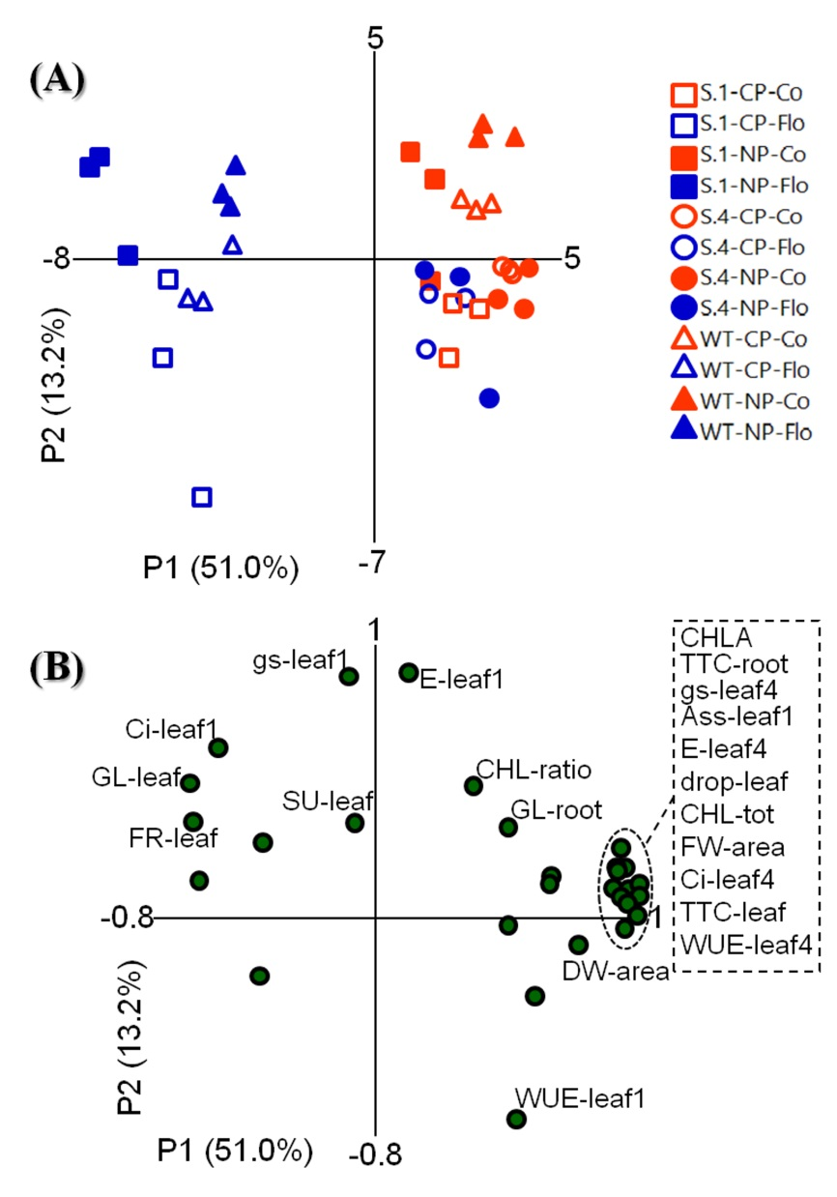

Supplementary Figure S.6: Multigroup discriminant analysis (MDA, A) of plants of WT, S.4 and S.1 Prunus cerasifera genotypes grown under natural photoperiod (NP) and constant photoperiod (CP), both exposed to anoxic (Flo) and normoxic (Co) conditions. Principal component analysis (PCA, B) on morphological, physiological parameters and carbohydrate concentrations of the three genotypes, in the figure only the mains contributors are highlighted. Ass-leaf1: net CO₂ assimilation of the 1st leaf (apical leaf); CHLA: chlorophyll a; CHL-ratio: chlorophyll a/b ratio; CHL-tot: total amount of chlorophylls; Ci-leaf1: intercellular CO₂ concentration of the 1st ^{l} leaf; Ci-leaf4: intercellular CO₂ concentration of the 4th leaf; drop-leaf: percentage of dropped leaves; DW-area: dry weight per unit of leaf area; E-leaf1: transpiration rate of the 1st leaf; E-leaf4: transpiration rate of the 4th leaf; FR-leaf: leaf fructose concentration; FW-area: fresh weight per unit of leaf area; GL-leaf: leaf glucose concentration; GL-root: root glucose concentration; gs-leaf1: stomatal conductance of the 1st leaf; gs-leaf4: stomatal conductance of the 4th leaf; SU-leaf: leaf sucrose concentration; TTC-leaf: TTC reactivity test of leaf; TTC-root: TTC reactivity test of root; WUE-leaf1: water use efficiency of the 1st leaf; WUE-leaf4: water use efficiency of the 4th leaf.

