Supplementary Material

Transcriptome changes in relation to manic episode

Ya-Chin Lee1,Yu-Lin Chao2, Chiao-Erh Chang1, Ming-Hsien Hsieh3, Kuan-Ting Liu1, Hsi-Chung Chen3, Mong-Liang Lu4,5, Wen-Yin Chen6, Chun-Hsin Chen4,5, Mong-Hsun Tsai7, Tzu-Pin Lu1, Ming-Chyi Huang5,6,\*, Po-Hsiu Kuo1,8,\*

1Institute of Epidemiology and Preventive Medicine, College of Public Health, National Taiwan University, Taipei, Taiwan

2Department of Psychiatry, Buddhist Tzu Chi General Hospital and Tzu Chi University, Hualien, Taiwan

3Department of Psychiatry, National Taiwan University Hospital, Taipei, Taiwan

4Department of Psychiatry, Wang-Fang Hospital, Taipei Medical University, Taipei, Taiwan

5Department of Psychiatry, School of Medicine, College of Medicine, Taipei Medical University, Taipei, Taiwan

6Department of Psychiatry, Taipei City Psychiatric Center, Taipei City Hospital, Taipei, Taiwan

7Institute of Biotechnology, National Taiwan University, Taipei, Taiwan

8Department of Public Health, National Taiwan University, Taipei, Taiwan

**\* Correspondence:**Dr. Po-Hsiu Kuo and Dr. Ming-Chyi Huang  
E-mail: phkuo@ntu.edu.tw (PH Kuo); mch@tpech.gov.tw (MC Huang)

Keywords: bipolar disorder1, manic-episode2, microarray3, RNA-Sequencing4, transcriptome5, non-coding RNAs6, state-markers7

**Supplementary Figure S1 Correlation between p-value of YMRS and Manic Stage under linear model**

../../../../R/Supplementary_Fig_1.pdf

In our linear model for DEGs detection, we put YMRS score and Stage in the model. The correlation of p-value between these 2 variable showed that they have highly correlation.

**Supplementary Figure S2 The DEGs heatmap of different platforms**

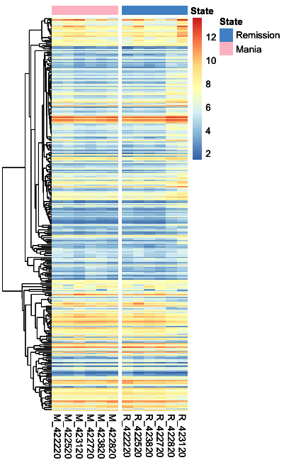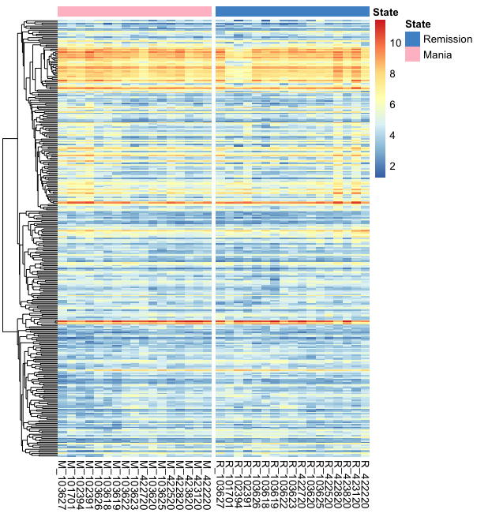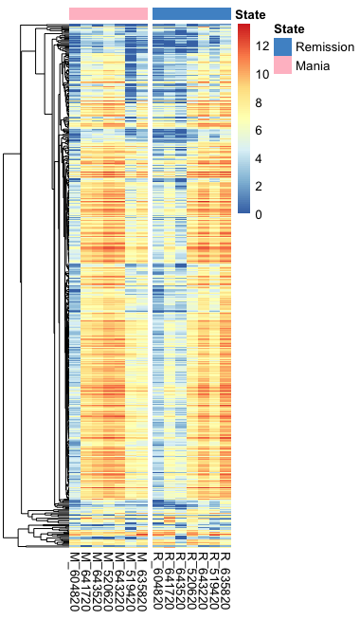

**A**

**B**

**C**

Supplementary Figure S2A showed the heatmap of 306 DEGs among the discovery samples with HTA array.

Supplementary Figure S2B showed the heatmap of 321 DEGs among the mega-analysis

Supplementary Figure S2C showed the heatmap of 491 DEGs among RNA-Seq

**Supplementary Figure S3 The distribution of DEGs in RNA-Seq**

****

In the DEGs of RNA-Seq, most of the genes belongs to protein-coding genes. The legend of “others” including: pseudogenes, snRNA, snoRNA, process transcript and unclassified.

**Supplementary Table S1 RNA integrity number (RIN) of each samples**

|  |  |  |
| --- | --- | --- |
| ID | Manic State | Remission State |
| 422220 | 9.4 | 9.6 |
| 422520 | 6.4 | 9.3 |
| 422720 | 9.3 | 9.1 |
| 422820 | 8.9 | 9.7 |
| 423120 | 9.4 | 9.5 |
| 423820 | 9.4 | 8.8 |
| 520620 | 8.8 | 7.9 |
| 519420 | 8.7 | 9.1 |
| 604820 | 9.2 | 9.3 |
| 635820 | 9.4 | 8.5 |
| 641720 | 8.8 | 9.4 |
| 643220 | 8.9 | 8.6 |
| 643520 | 7.8 | 6.3 |

The mean of the total RIN was around 8.8 and there was no significance difference between RIN of manic state and remission state (p>0.05 with pair t-test and wilcoxon signed-rank test).

**Supplementary Table S2 The information of samples for qRT-PCR**

|  |  |
| --- | --- |
|  | **qRT-PCR Sample** |
| **Samples** | 10 |
| **Male (%)** | 5(50) |
| **Age (Mean±SD)** | 44.3±11.2 |
| **YMRS in acute state (Mean±SD)** | 28.1±7.7 |
| **YMRS in remission (Mean±SD)** | 1.6±1.2 |
| **HAMD in acute state (Mean±SD)** | 2.5±1.8 |
| **HAMD in remission (Mean±SD)** | 2.8±1.8 |

**Supplementary Table S3 DEGs and GWAS Enrichment analysis results of manic-related modules**

|  |  |  |  |  |  |  |
| --- | --- | --- | --- | --- | --- | --- |
| **Modules** | **DEGs** | | | **GWAS Signals** | | |
| **Gene Name** | **Ensemble ID** | **Enrichment P** | **Gene Name** | **Ensemble ID** | **Enrichment P** |
| **Royalblue** | NA | NA | 1 | *SRPK2* | ENSG00000135250 | 5.35\*10-1 |
| **Brown** | *TAS2R5*  *PPP2R5E*  *CENPS*  *CES1*  AF131215.4  *RNA5SP465* | ENSG00000127366  ENSG00000154001  ENSG00000175279  ENSG00000198848  ENSG00000254936  ENSG00000212497 | 3.89\*10-1 | *SLC25A17*  *CUL4A*  *NRF1*  *UTP18*  *SP4*  *ADD3*  *VAV3*  *PDE3B* | ENSG00000100372  ENSG00000139842  ENSG00000106459  ENSG00000011260  ENSG00000105866  ENSG00000203876  ENSG00000134215  ENSG00000152270 | 1 |
| **Darkred** | *RNU6-441P*  *MIR4675*  RP1-290I10.3 | ENSG00000207275  ENSG00000265372  ENSG00000228478 | 4.50\*10-2 | NA | NA | 1 |
| **Darkgrey** | *GATA1* | ENSG00000102145 | 5.06\*10-1 | NA | NA | 1 |
| **Lightcyan** | *SMG1P5*  *LINC02100* | ENSG00000183604  ENSG00000248693 | 3.71\*10-1 | *CD47* | ENSG00000196776 | 1 |
| **Cyan** | *MIR147A*  *LTB*  *LINC00377* | ENSG00000207814  ENSG00000227507  ENSG00000229246 | 4.50\*10-1 | NA | NA | 2.70\*10-1 |

The DEGs enrichment analysis were conducted with 137 DEGs that significant in primary analysis and meta-analysis also. The GWAS signal were obtained from the latest PGC BD analysis, published on BioRxiv.

**Supplementary Information: The qRT-PCR probes of overlapping DEGs**

|  |  |  |
| --- | --- | --- |
| Ensembl Gene ID | Gene Name | Sequence |
| ENSG00000166928 | *MS4A14* | F: GATATCCATTCTGGGGAGCA R: TCCGAAGGCAAGAAAAACAG |
| ENSG00000163564 | *PYHIN1* | F: ATCAGCTCCACCCAACACTT R: GCGTAGCCACTGTAGCATGA |
| ENSG00000152818 | *UTRN* | F: AAAGCATTGACGGAAACAGG R: ACTGGAGCTGTAAGGCTGGA |
| ENSG00000104093 | *DMXL2* | F: ATTCCTGGTGCTAAGCATGG R: TTTAAGCCACTGGCACTTGA |
| ENSG00000127366 | *TAS2R5* | F: GAGTCTCTGGTGCCTTCTGG R: AAGGACTTCAGCGCAGTGAT |

**Supplementary Information: The equation of paired sample comparison using limma**

design<-model.matrix(~ID+State+YMRS)

fit<-lmFit(eset, design)

fit<-eBayes(fit)

Here, we followed the tutorial of “limma” (1) to construct the intra-individual comparison model. In the above code: “eset” stood for the normalized expression data of microarray (log 2 expression transformation), “ID” was the sample ID, “State” was the states of the episode (mania or remission) and “YMRS” was the evaluation of symptom severity.

**Reference**

1. Smyth GK. Linear Models and Empirical Bayes Methods for Assessing Differential Expression in Microarray Experiments. *Statistical Applications in Genetics and Molecular Biology* (2004) **3**:1–25. doi:10.2202/1544-6115.1027