Alterations of the Gut Microbiota Associated with Promoting Efficacy of Prednisone by Bromofuranone in MRL/lpr Mice
Zhixing He⁺, Xiangyu Kong⁺, Tiejuan Shao, Yun Zhang*, Chengping Wen*
Institute of Basic Research in Clinical Medicine, College of Basic Medical Science, Zhejiang Chinese Medical University, Hangzhou, 310053, China;

*Corresponding author. Address: College of Basic Medical Science, Zhejiang Chinese Medical University, Hangzhou 310053, China.
“+”: these authors contributed equally to this work.
Tel.: 086-571-86613587.
E-mail address: wengcp@yeah.net (Chengping Wen), Yunzhang2018@yeah.net (Yun Zhang)
Summary of supporting information:
A. SUPPORTING FIGURES S1-S5

Figure S1 Renal HE staining pathological (x 40) section analysis. A: MT; B: PT; C: BT; D: PBT. MT: the model group; PT: the prednisone-treated group; BT: the bromofuranone-treated group; PBT: the combined drugs-treated group.

Figure S2 LEfSe identified the differential microbial taxa between control MRL/lpr mice (MT) and prednisone-treated MRL/lpr mice (PT) (A), and between bromofuranone-treated MRL/lpr mice (BT) and combined drug-treated MRL/lpr mice (PBT) (B). Significant differences are shown (LDA score >2).

Figure S3 Abundance of AI-2 signals in the stool samples of MRL/lpr mice. MT: the model group; PT: the prednisone-treated group; BT: the bromofuranone-treated group; PBT: the combined drugs-treated group.“**”: represents the adjusted p value <0.01 between two groups.

Figure S4 LEfSe identified the differential microbial taxa between control MRL/lpr mice (MT) and bromofuranone-treated MRL/lpr mice (BT) (A), and between bromofuranone-treated MRL/lpr mice (PT) and combined drug-treated MRL/lpr mice (PBT) (B). Significant differences are shown (LDA score >2).

Figure S5 LEfSe identified the differential microbial taxa between control MRL/lpr mice (MT) and combined drug-treated MRL/lpr mice (PBT). Significant differences are shown (LDA score >2).

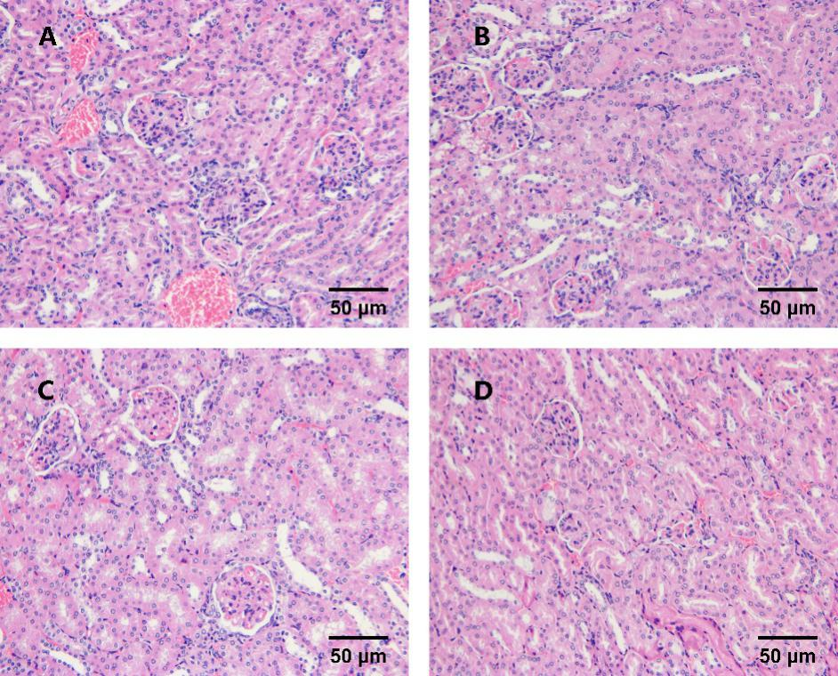

Figure S1 Renal HE staining pathological (x 40) section analysis. A: model group; B: prednisone group; C: bromofuranone group; D: combination group.

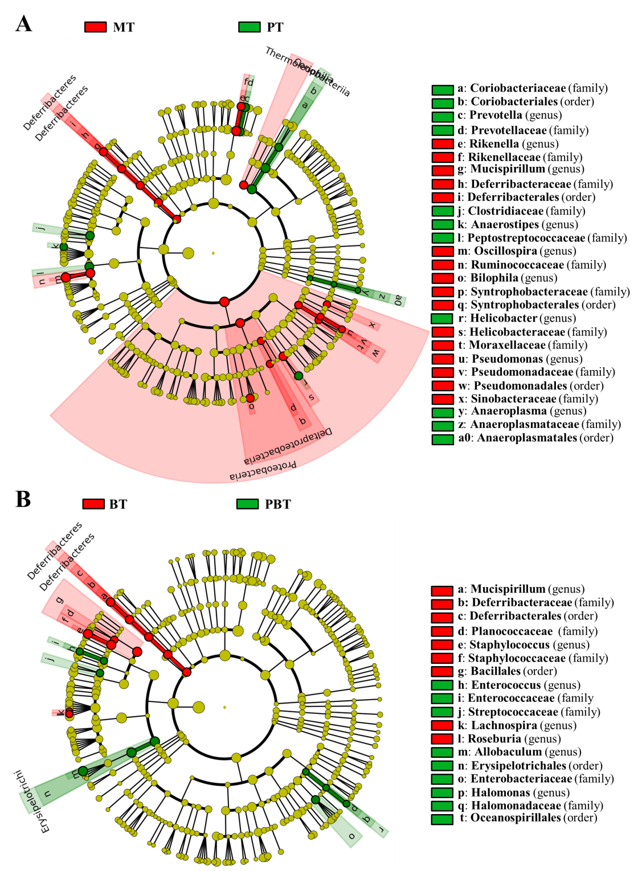

Figure S2 LEfSe identified the differential microbial taxa between control MRL/lpr mice (MT) and prednisone-treated MRL/lpr mice (PT) (A), and between bromofuranone-treated MRL/lpr mice (BT) and combined drug-treated MRL/lpr mice (PBT) (B). Significant differences are shown (LDA score >2).

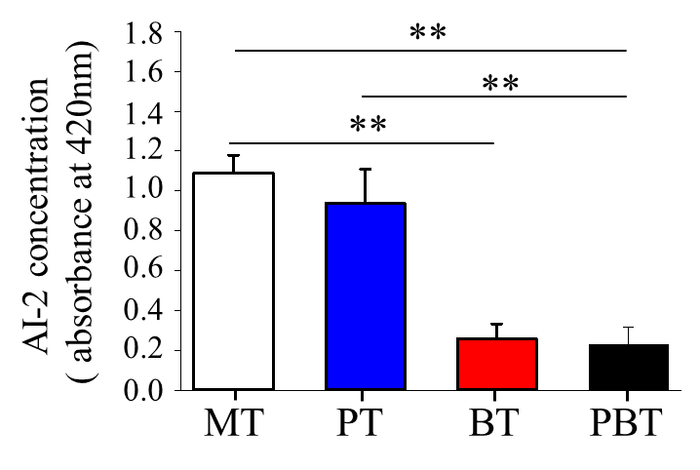
Figure S3 Abundance of AI-2 signals in the stool samples of MRL/lpr mice. MT: the model group; PT: the prednisone-treated group; BT: the bromofuranone-treated group; PBT: the combined drugs-treated group.“**”: represents the adjusted p value <0.01 between two groups.

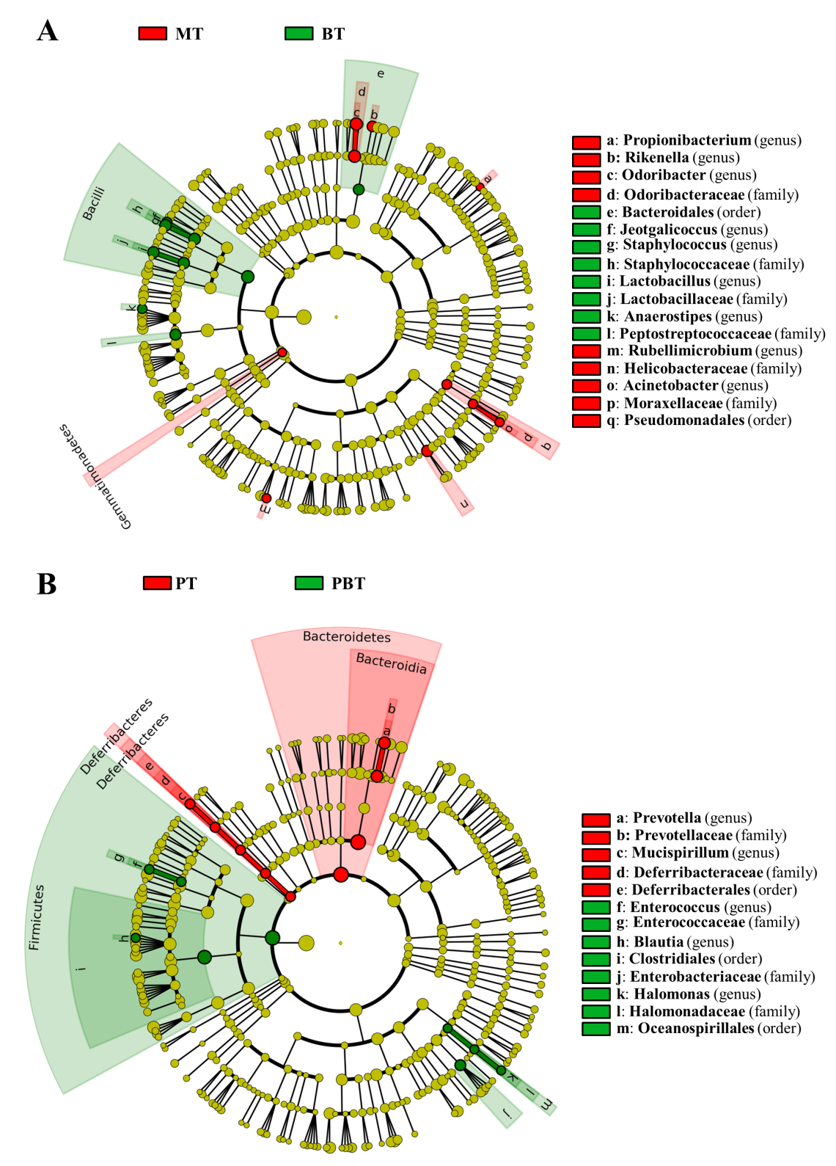
Figure S4 LEfSe identified the differential microbial taxa between control MRL/lpr mice (MT) and bromofuranone-treated MRL/lpr mice (BT) (A), and between bromofuranone-treated MRL/lpr mice (PT) and combined drug-treated MRL/lpr mice (PBT) (B). Significant differences are shown (LDA score >2).

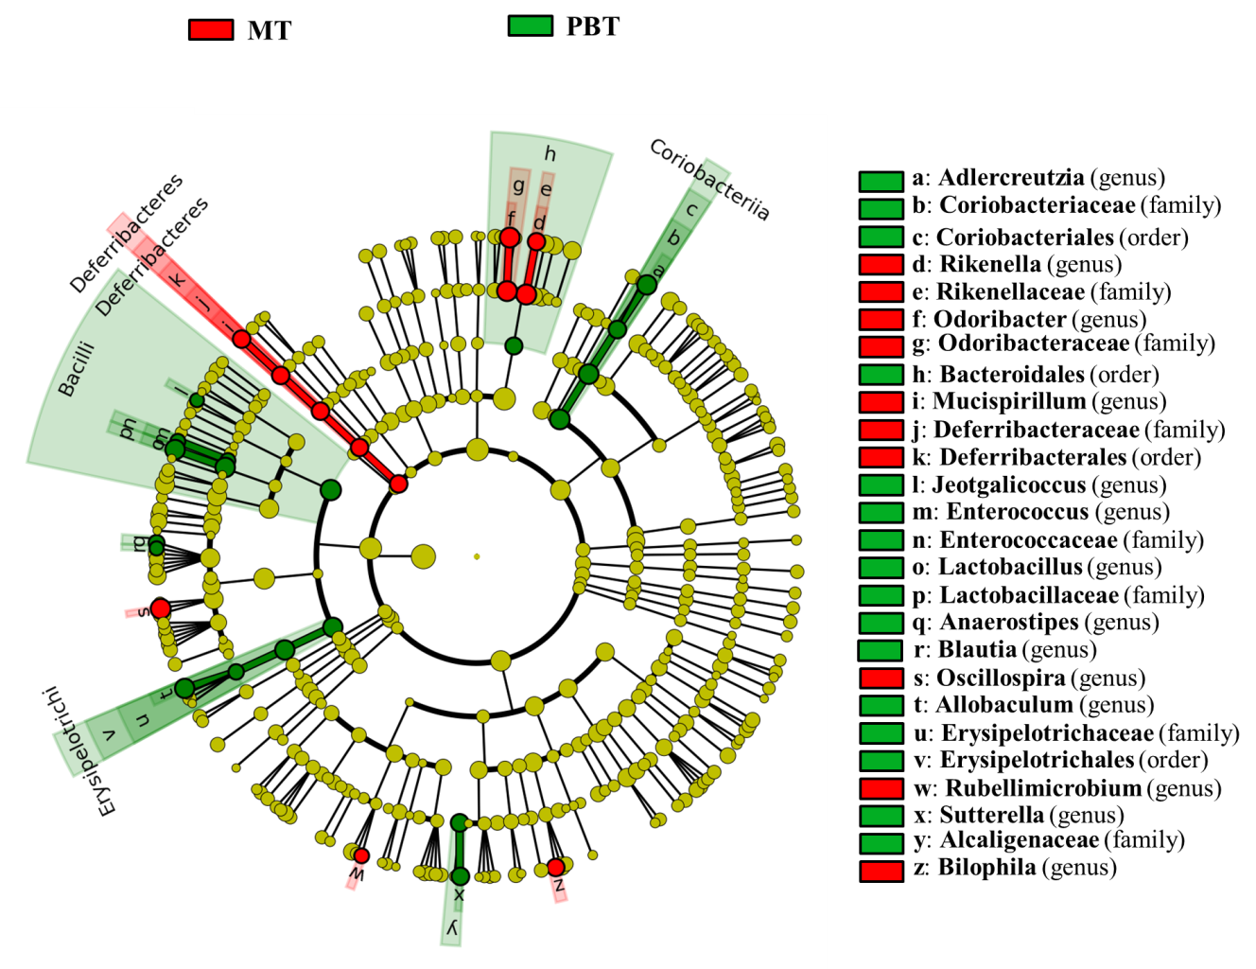
Figure S5 LEfSe identified the differential microbial taxa between control MRL/lpr mice (MT) and combined drug-treated MRL/lpr mice (PBT). Significant differences are shown (LDA score >2).

