Supplementary Table 1. Biochemical reactions as well as atom transitions involved in xylose metabolism of C. acetobutylicum.

Reaction ID | Reaction with atom transition
v1 | Xyl(abcde) => X5P(abcde)
v2 | X5P(abcde) => AcP(ba)+GAP(cde)
v3 | X5P(abcde) <=> Ru5P(abcde)
v4 | Ru5P(abcde) <=> R5P(abcde)
v5 | X5P(abcde) <=> TK(ab) + GAP(cde)
v6 | F6P(abcdef) <=> TK(ab) + E4P(cdef)
v7 | S7P(abcdefg) <=> TK(ab) + R5P(cdefg)
v8 | F6P(abcdef) <=> TA(abc) + GAP(def)
v9 | S7P(abcdefg) <=> TA(abc) + E4P(defg)
v10 | F6P(abcdef) => FBP(abcdef)
v11 | FBP(abcdef) <=> DHAP(cba)+GAP(def)
v12 | DHAP(abc) <=> GAP(abc)
v13 | GAP(abc) <=> G3P(abc)
v14 | G3P(abc) <=> PEP(abc)
v15 | PEP(abc) => Pyr(abc)
v16 | Pyr(abc) => AcCoA(bc) + CO₂(a)
v17 | AcCoA(ab) <=> AcP(ab)
v18 | AcP(ab) => AC(ab)
v19 | AcCoA(ab) => EtOH(ab)

(A) (B)
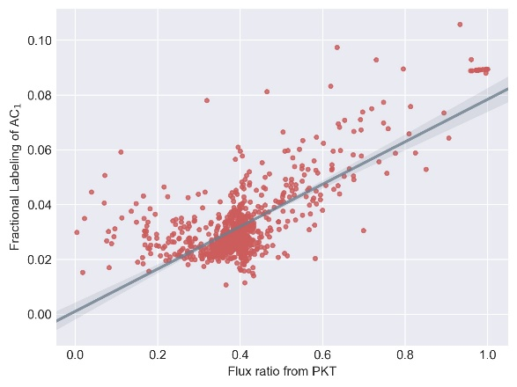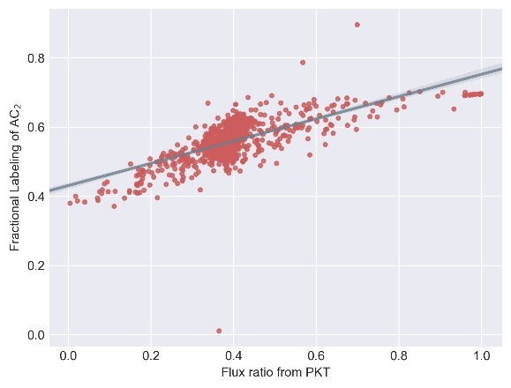
(C) (D)
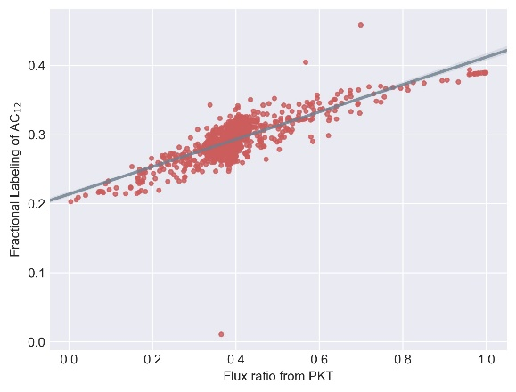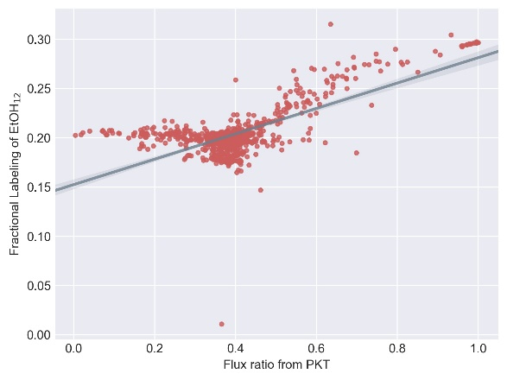
(E) (F)
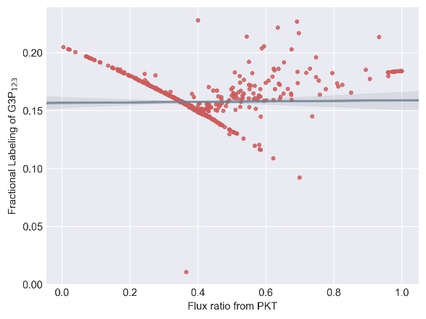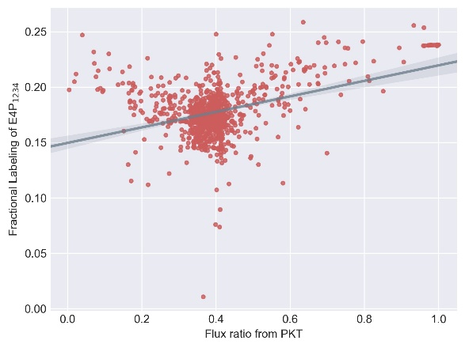
(G)
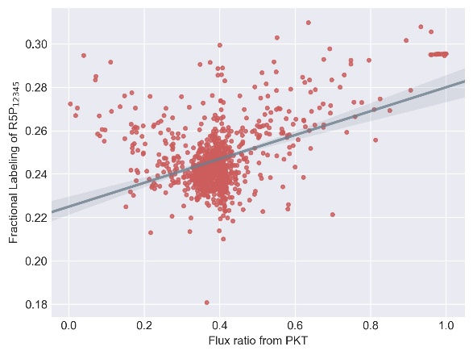

Supplementary Figure 1.
Simulated FL of metabolites at different flux ratio from PKT with 100% 1-¹³C xylose as substrate. Random fluxes are generated 1000 times subjecting to xylose metabolism network. MDVs of (A) AC₁, (B) AC₂, (C) AC₁₂, (D) EtOH₁₂, (E) G3P₁₂₃, (F) E4P₁₂₃₄ and (G) R5P₁₂₃₄₅ are simulated using adjacency matrix based EMU decomposition method proposed in this work. Metabolite FLs and flux ratio from PKT are subsequently calculated and plotted correspondingly. Regression line and 95% confidence intervals are also plotted.

(A) (B)
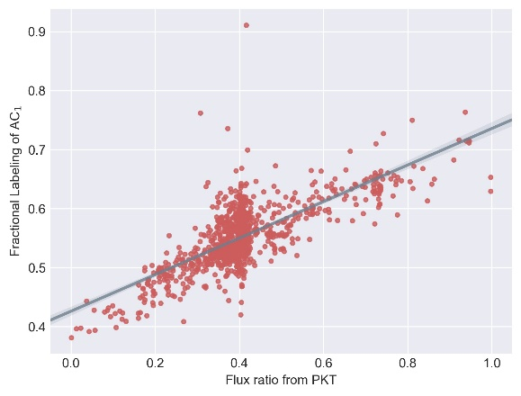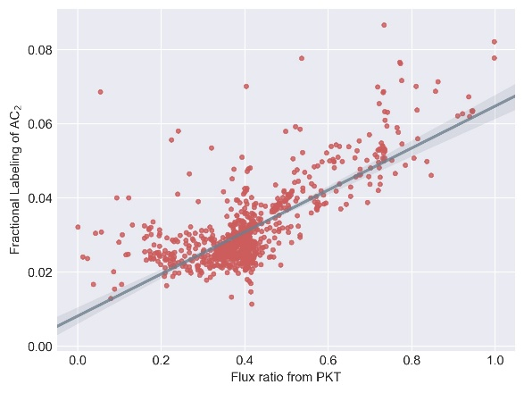
(C) (D)
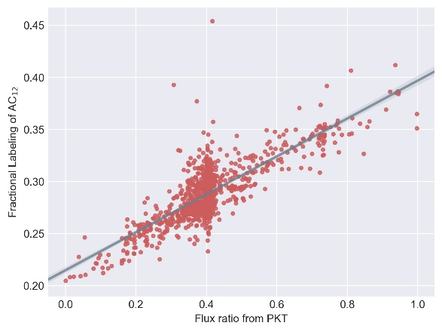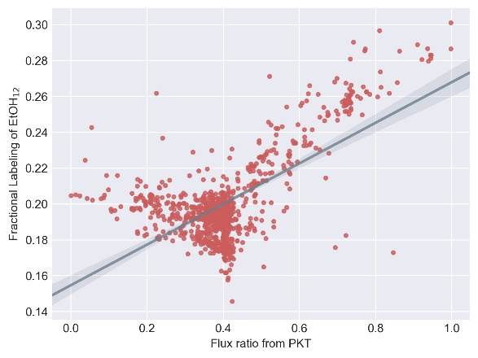
(E) (F)
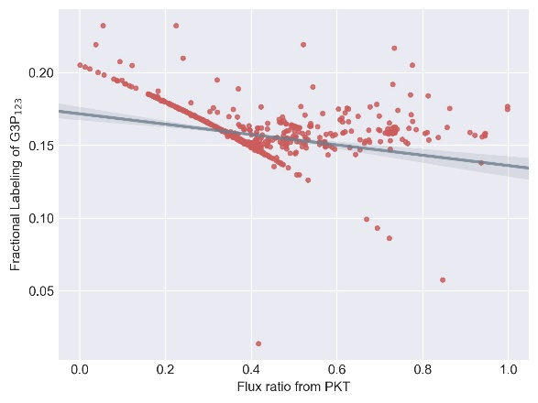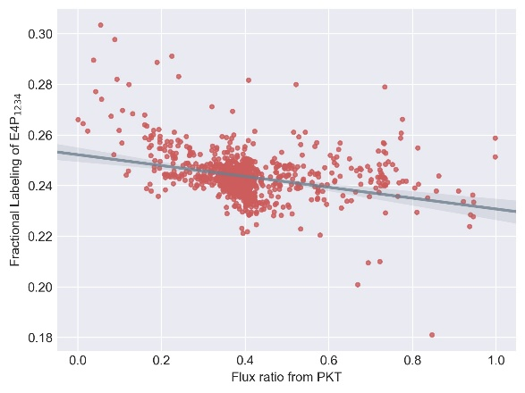
(G)
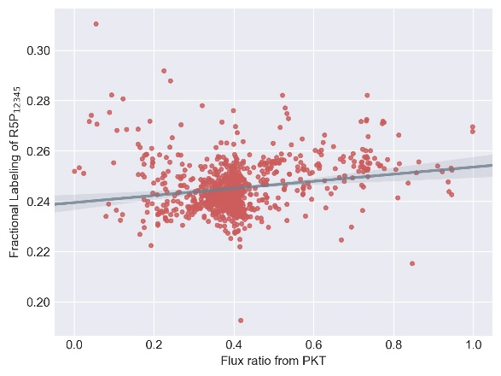

Supplementary Figure 2.
Simulated FL of metabolites at different flux ratio from PKT with 100% 2-¹³C xylose as substrate. Random fluxes are generated 1000 times subjecting to xylose metabolism network. MDVs of (A) AC₁, (B) AC₂, (C) AC₁₂, (D) EtOH₁₂, (E) G3P₁₂₃, (F) E4P₁₂₃₄ and (G) R5P₁₂₃₄₅ are simulated using adjacency matrix based EMU decomposition method proposed in this work. Metabolite FLs and flux ratio from PKT are subsequently calculated and plotted correspondingly. Regression line and 95% confidence intervals are also plotted.

(A) (B)
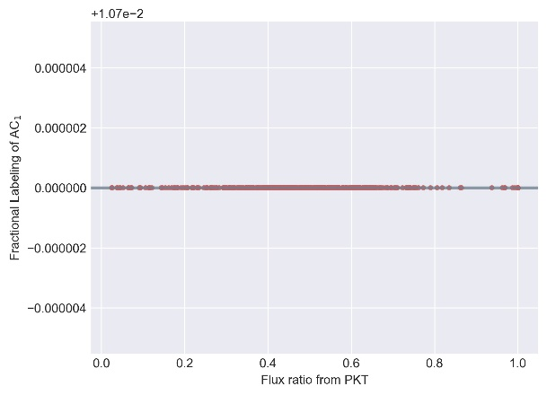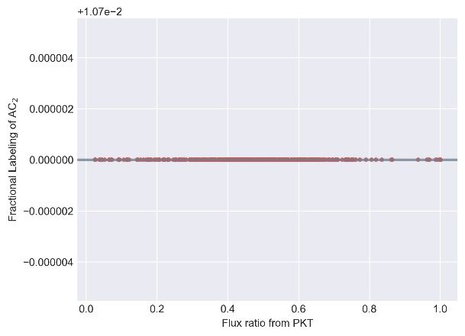
(C) (D)
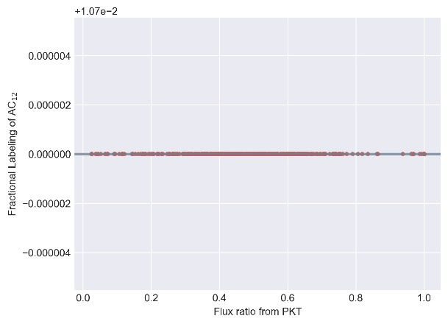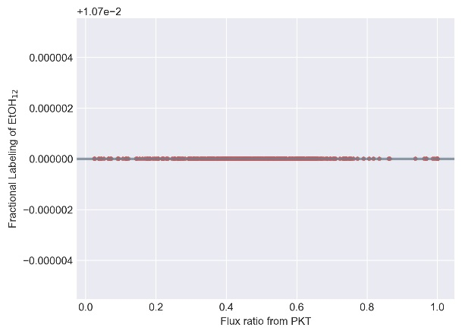
(E) (F)
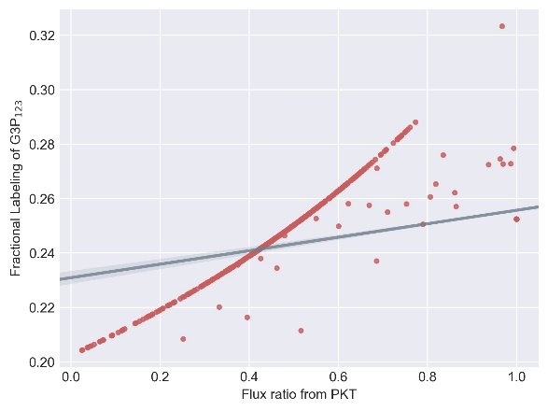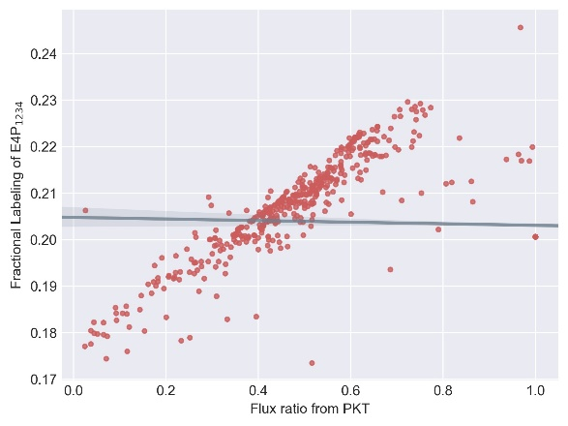
(G)
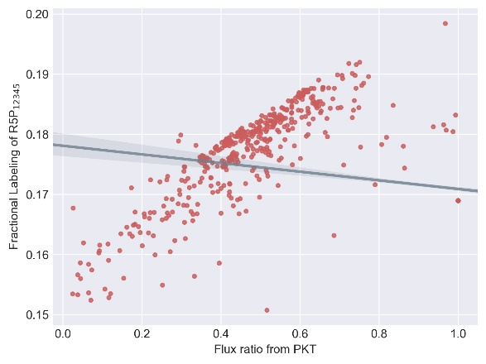

Supplementary Figure 3.
Simulated FL of metabolites at different flux ratio from PKT with 100% 3-¹³C xylose as substrate. Random fluxes are generated 1000 times subjecting to xylose metabolism network. MDVs of (A) AC₁, (B) AC₂, (C) AC₁₂, (D) EtOH₁₂, (E) G3P₁₂₃, (F) E4P₁₂₃₄ and (G) R5P₁₂₃₄₅ are simulated using adjacency matrix based EMU decomposition method proposed in this work. Metabolite FLs and flux ratio from PKT are subsequently calculated and plotted correspondingly. Regression line and 95% confidence intervals are also plotted.

(A) (B)
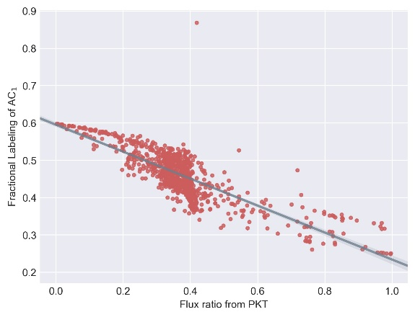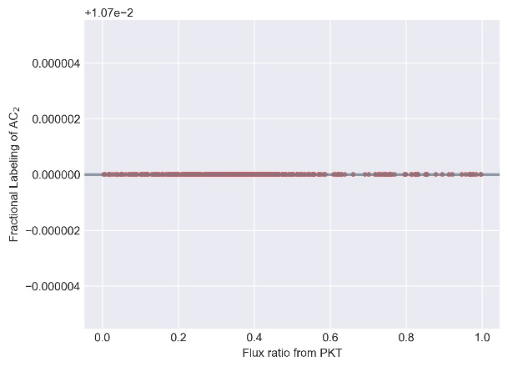
(C) (D)
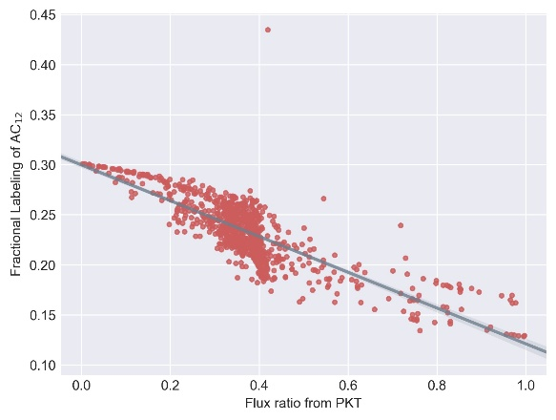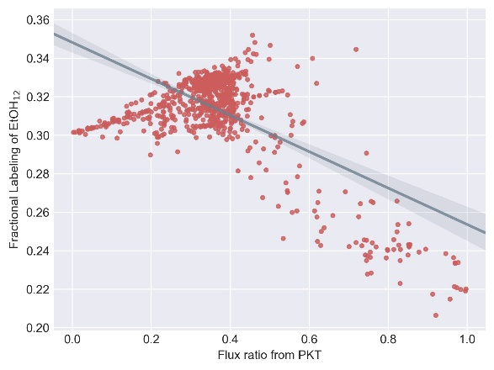
(E) (F)
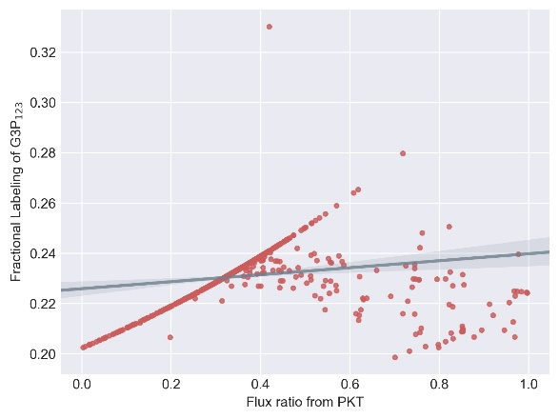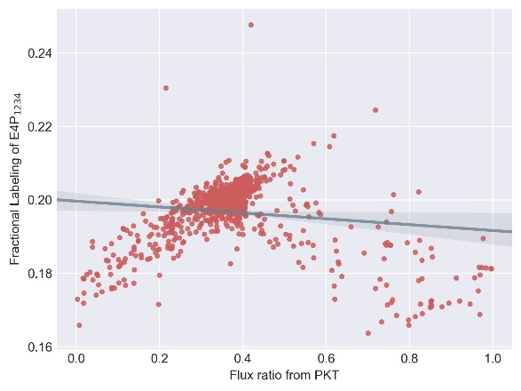
(G)

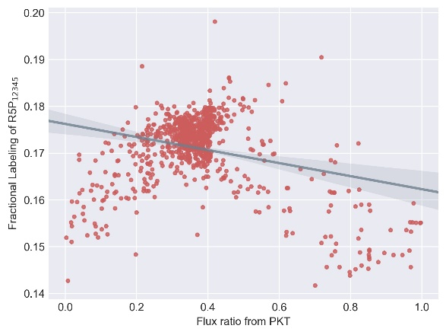
Supplementary Figure 4.
Simulated FL of metabolites at different flux ratio from PKT with 100% 4-¹³C xylose as substrate. Random fluxes are generated 1000 times subjecting to xylose metabolism network. MDVs of (A) AC₁, (B) AC₂, (C) AC₁₂, (D) EtOH₁₂, (E) G3P₁₂₃, (F) E4P₁₂₃₄ and (G) R5P₁₂₃₄₅ are simulated using adjacency matrix based EMU decomposition method proposed in this work. Metabolite FLs and flux ratio from PKT are subsequently calculated and plotted correspondingly. Regression line and 95% confidence intervals are also plotted.

(A) (B)
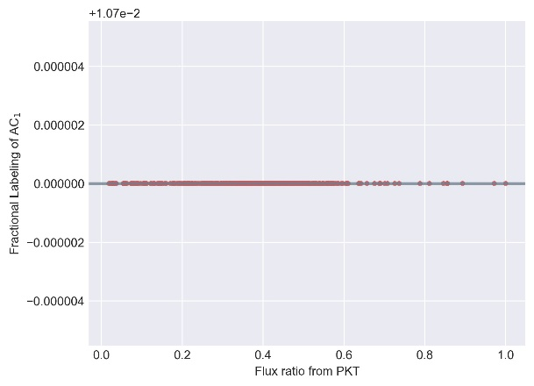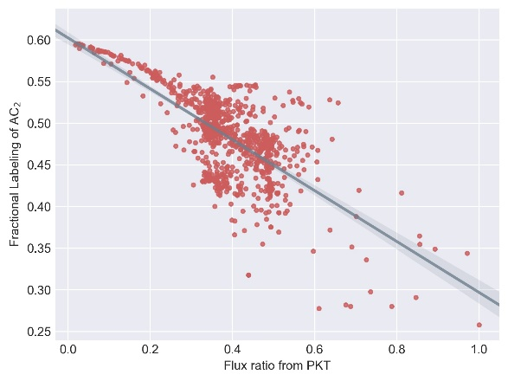
(C) (D)
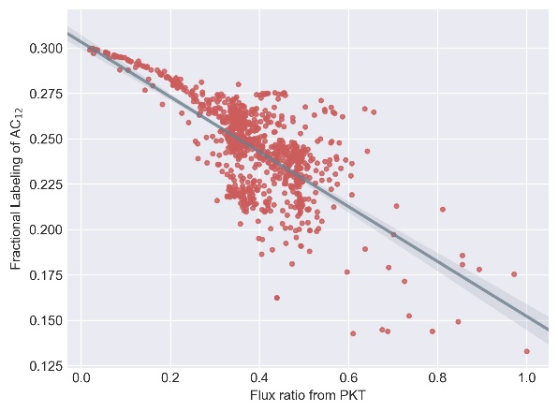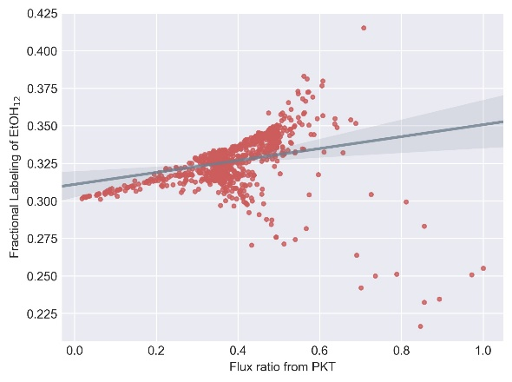
(E) (F)
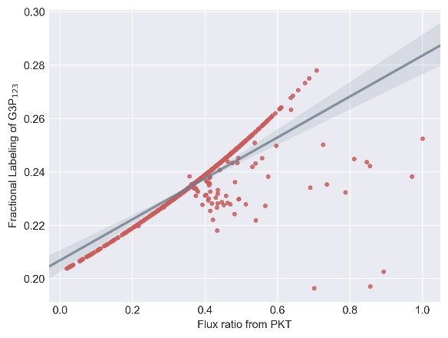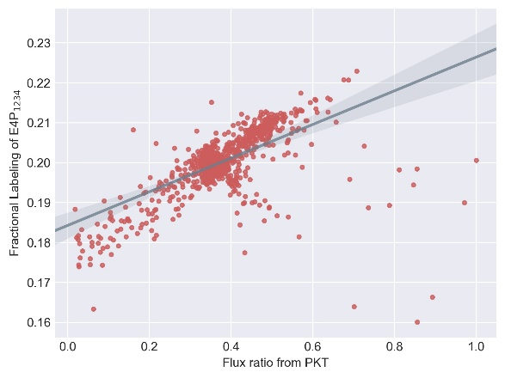
(G)
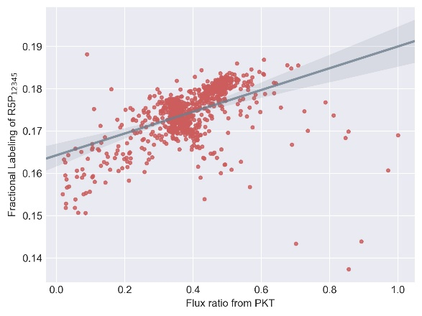
Supplementary Figure 5.
Simulated FL of metabolites at different flux ratio from PKT with 100% 5-¹³C xylose as substrate. Random fluxes are generated 1000 times subjecting to xylose metabolism network. MDVs of (A) AC₁, (B) AC₂, (C) AC₁₂, (D) EtOH₁₂, (E) G3P₁₂₃, (F) E4P₁₂₃₄ and (G) R5P₁₂₃₄₅ are simulated using adjacency matrix based EMU decomposition method proposed in this work. Metabolite FLs and flux ratio from PKT are subsequently calculated and plotted correspondingly. Regression line and 95% confidence intervals are also plotted.

(A) (B)
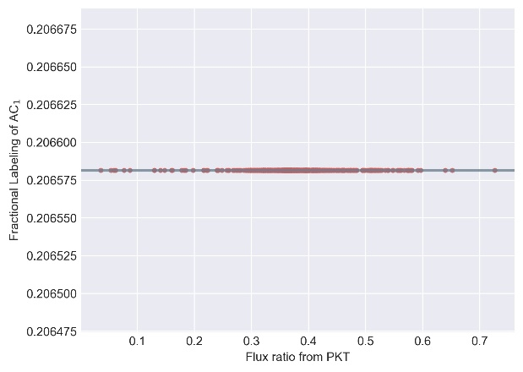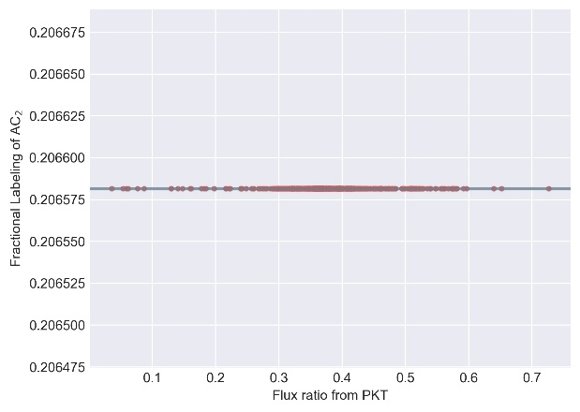
(C) (D)
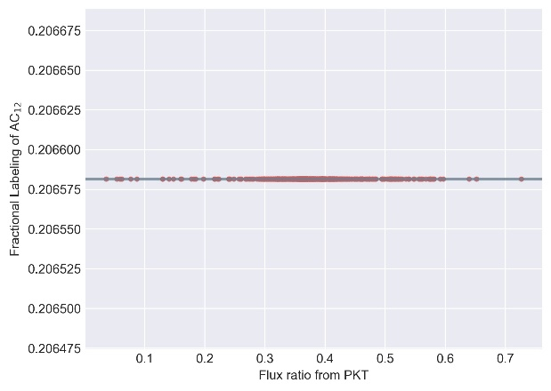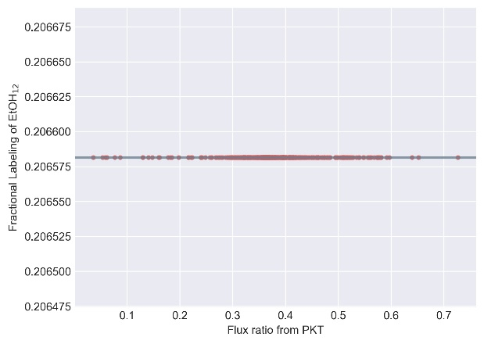
(E) (F)
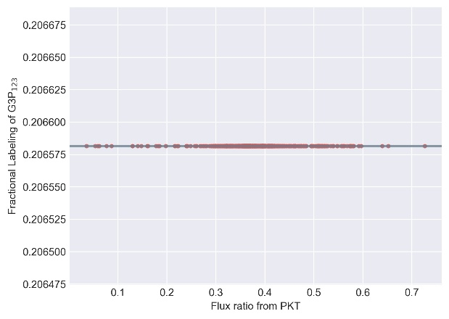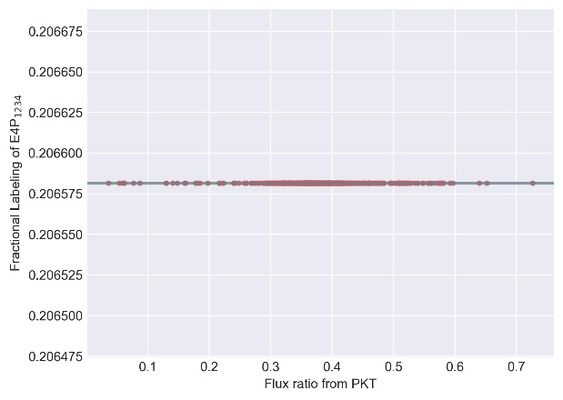
(G)
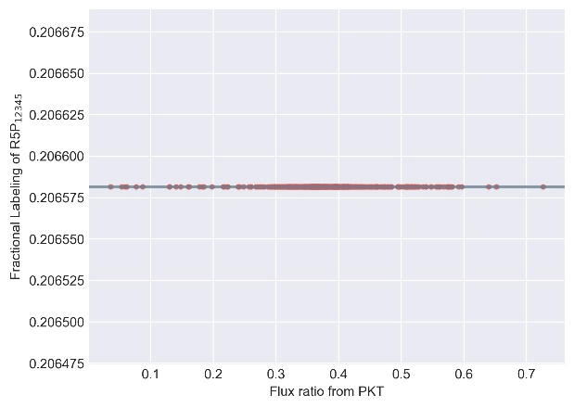

Supplementary Figure 6.
Simulated FL of metabolites at different flux ratio from PKT with mixture of 20% U-¹³C xylose and 80% natural xylose as substrate. Random fluxes are generated 1000 times subjecting to xylose metabolism network. MDVs of (A) AC₁, (B) AC₂, (C) AC₁₂, (D) EtOH₁₂, (E) G3P₁₂₃, (F) E4P₁₂₃₄ and (G) R5P₁₂₃₄₅ are simulated using adjacency matrix based EMU decomposition method proposed in this work. Metabolite FLs and flux ratio from PKT are subsequently calculated and plotted correspondingly. Regression line and 95% confidence intervals are also plotted.

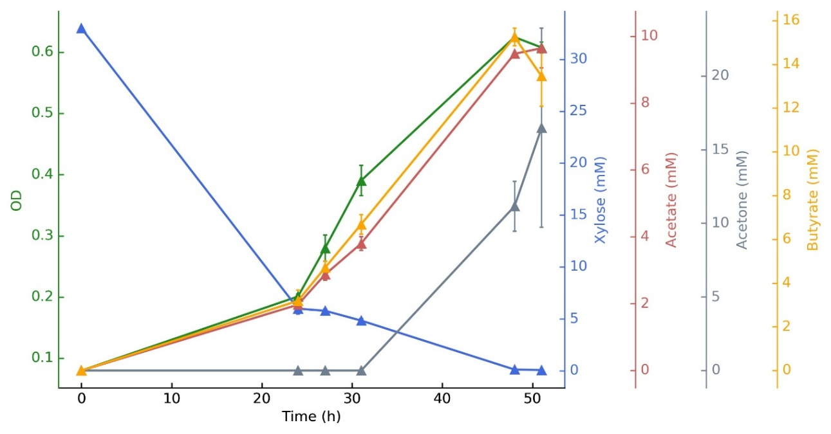

Supplementary Figure 7.
Cell Growth, substrate consumption and products formation of C. acetobutylicum at an initial xylose concentration of 5 g L⁻¹. OD (green), xylose (blue), acetate (red), acetone (grey) and butyrate (yellow) are determined during cultivation. Data points represent the mean of three replicates.

