Table S1. Cameras & Settings.
Survey Year | 2010 | 2012 | 2015 & 2016
Camera | Canon PowerShot  SD1200 IS | Canon PowerShot  SD1200 IS | Canon PowerShot  S110
Image size (px.) | 1.93 MB | 3.37 MB | 4.45 - 5.7 MB

Table S2. Hierarchy of CoralNet Classification Schemes. Human analyzed imagery using the ‘ORIGINAL’ scheme, in which corals were classified to genus and growth form, macroalgae to genus where possible, and other benthos into broad functional groups. CoralNet was separately trained and tested for the three classification schemes here. For example, the 3 growth forms of Montipora were pooled to a single classification ‘Montipora’ for the SIMPLER scheme, and all types of hard coral were pooled to ‘Coral’ for the BASE scheme. Note that Hawaii and American Samoa had non-identical ‘ORIGINAL’ schemes, largely due to differences in benthic communities – such as that many genera of coral recorded in American Samoa were not present in MHI.
BASE | SIMPLER | ORIGINAL
Coral | Acropora | Acropora branching^{S}, Acropora tabulate^{S}
 | Montipora | Montipora branching, Montipora encrusting, Montipora foliose
 | Pocillopora | Pocillopora
 | Porites | Porites branching, Porites encrusting, Porites foliose, Porites massive
 | Branching HC | Branching hard coral, Stylophora^{S}
 | Columnar HC | Columnar hard coral
 | Encrusting HC | Encrusting hard coral, Coscinaraea, Cyphastrea, Leptastrea, Leptoseris, Pavona encrusting, Psammocora, Acanthastrea^{S}, Astreopora^{S}, Echinophyllia^{S}, Echinopora^{S}, Galaxea^{S}, Goniopora/Alveopora^{S}, Isopora^{S}
 | Foliose HC | Foliose hard coral, Pavona foliose, Merulina^{S}, Pachyseris^{S}, Turbinaria^{S}
 | Free-living HC | Free-living hard coral, Fungia
 | Massive hard coral | Massive hard coral, Pavona massive, Diploastrea^{S}, Favia^{S}, Favites^{S}, Goniastrea^{S}, Hydnophora^{S}, Lobophyllia^{S}, Leptoria^{S}, Montastraea^{S}, Oulophyllia^{S}, Platygyra^{S}, Symphyllia^{S}
CCA | Crustose Coralline Alg | CCA growing on hard substrate, CCA growing on rubble
EMA | Encrusting Macro | Encrusting macroalgae, Peyssonnelia, Lobophora
Blue-Green | Blue-green algae | Blue-green algae
Upright Macro | Brown Macroalgae | Brown macroalgae, Dictyopteris/Dictyota, Padina
 | Green Macroalgae | Green macroalgae, Dictyosphaeria, Microdictyon, Avrainvillea^{M}; Caulerpa, Neomeris^{S}
 | Halimeda | Halimeda
 | Red Macroalage | Red macroalgae, Asparagopsis
 | Seagrass | Seagrass^{M}
 | Nonspecific Macro | Upright macroalga
Sand | Sand | Fine sediment, Sand
Turf | Turf-Hard | Hard substrate, Turf growing on hard substrate
 | Turf-Rubble | Rubble substrate, Turf growing on rubble
Mobile Fauna | Mobile Fauna | Mobile fauna
NS Hard Coral | Non-scleractinian | Heliopora^{S}, Hydrocoral^{S}, Millepora^{S}
Sessile Invert | Bivalve | Bivalve^{M}
 | Giant Clam | Giant clam^{S}
 | Sponge | Sponge
 | Other Sessile Invert | Anemone, Tunicate, Zoanthid, Octocoral, Unclassified sessile invertebrate Unclassified soft coral^{M}
Tape | Tape | Tape
Wand | Wand | Wand
Shadow | Shadow | Shadow
Unknown | Unknown | Unclassified/Unknown
S=American Samoa only, M=MHI only
Figure S1. Site-level cover by human analyst and CoralNet for algal groups in American Samoa. Each point represents mean cover at a single site (30 images, 10 points per image). Images were analyzed and CoralNet trained using the SIMPLER scheme (Table S2). ‘r’ values shown are Pearson correlation coefficients. Total number of sites is 468. Correlations are significant (p<0.0001) in all cases.

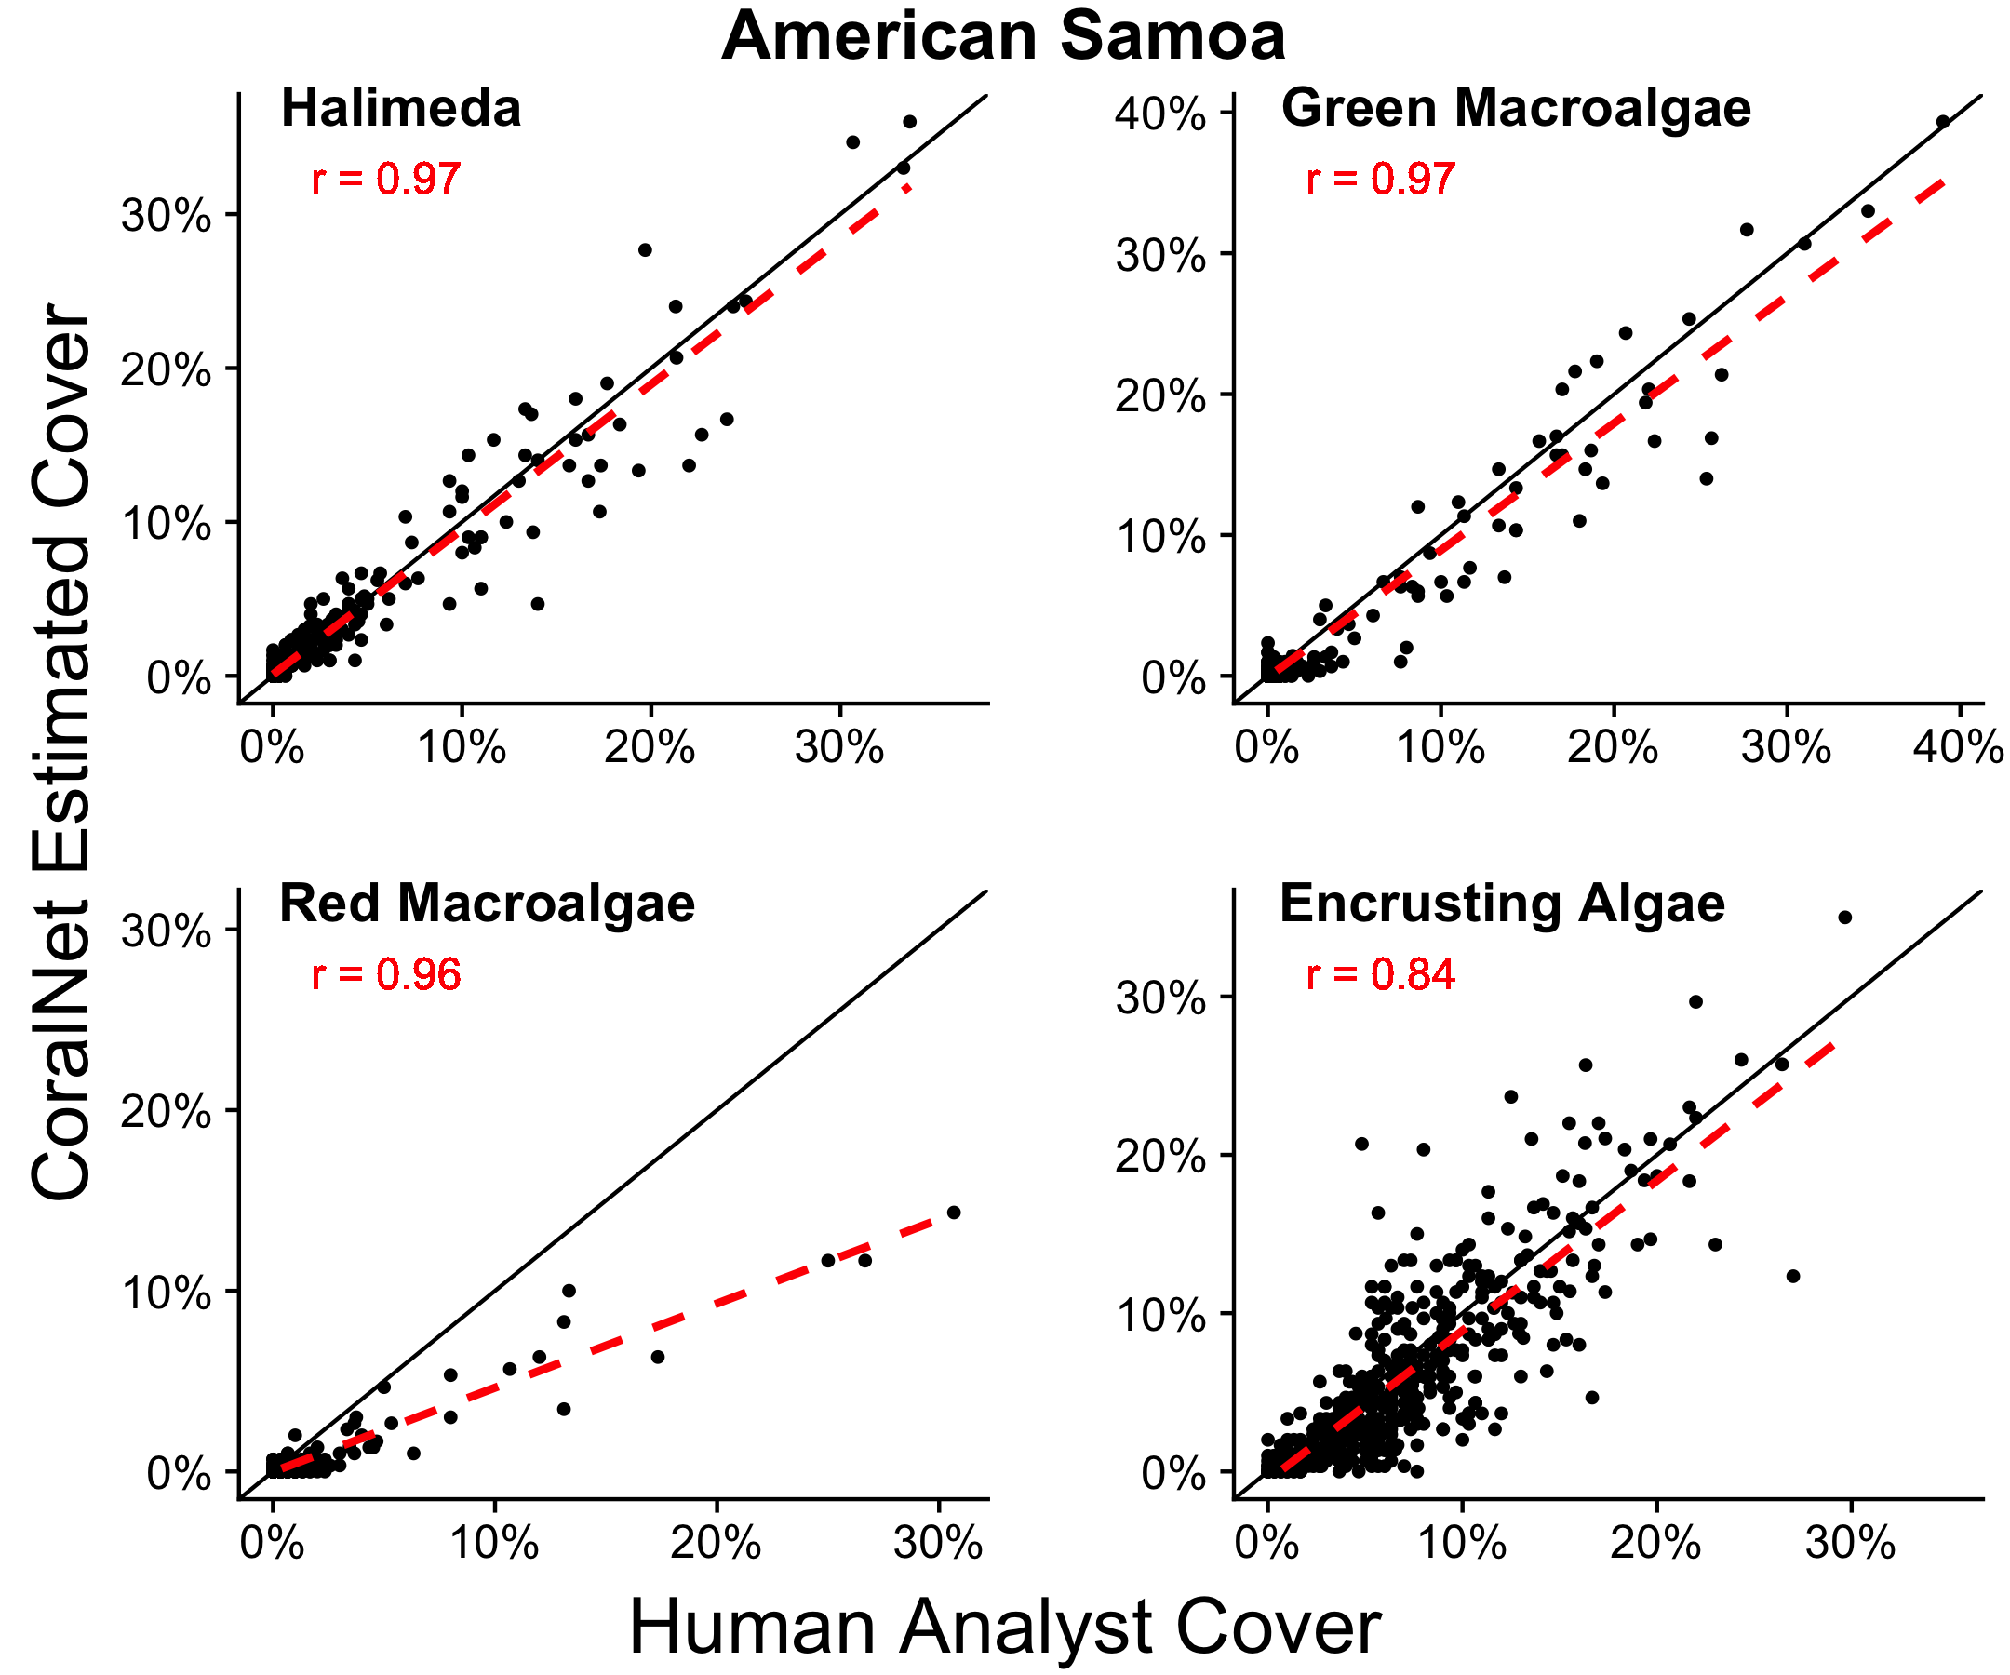

Figure S2. MHI Island- scale coral cover by three common genera per year from human analysts and CoralNet. Columns represent annual mean and SE of coral cover by island and year CoralNet estimates are for the ‘SIMPLER’ classification and filtering scheme (details in Table S2). MHI imagery from 2010-12 not shown, as those were not manually analyzed in CoralNet, and hence human-analyst values are not available for those years.

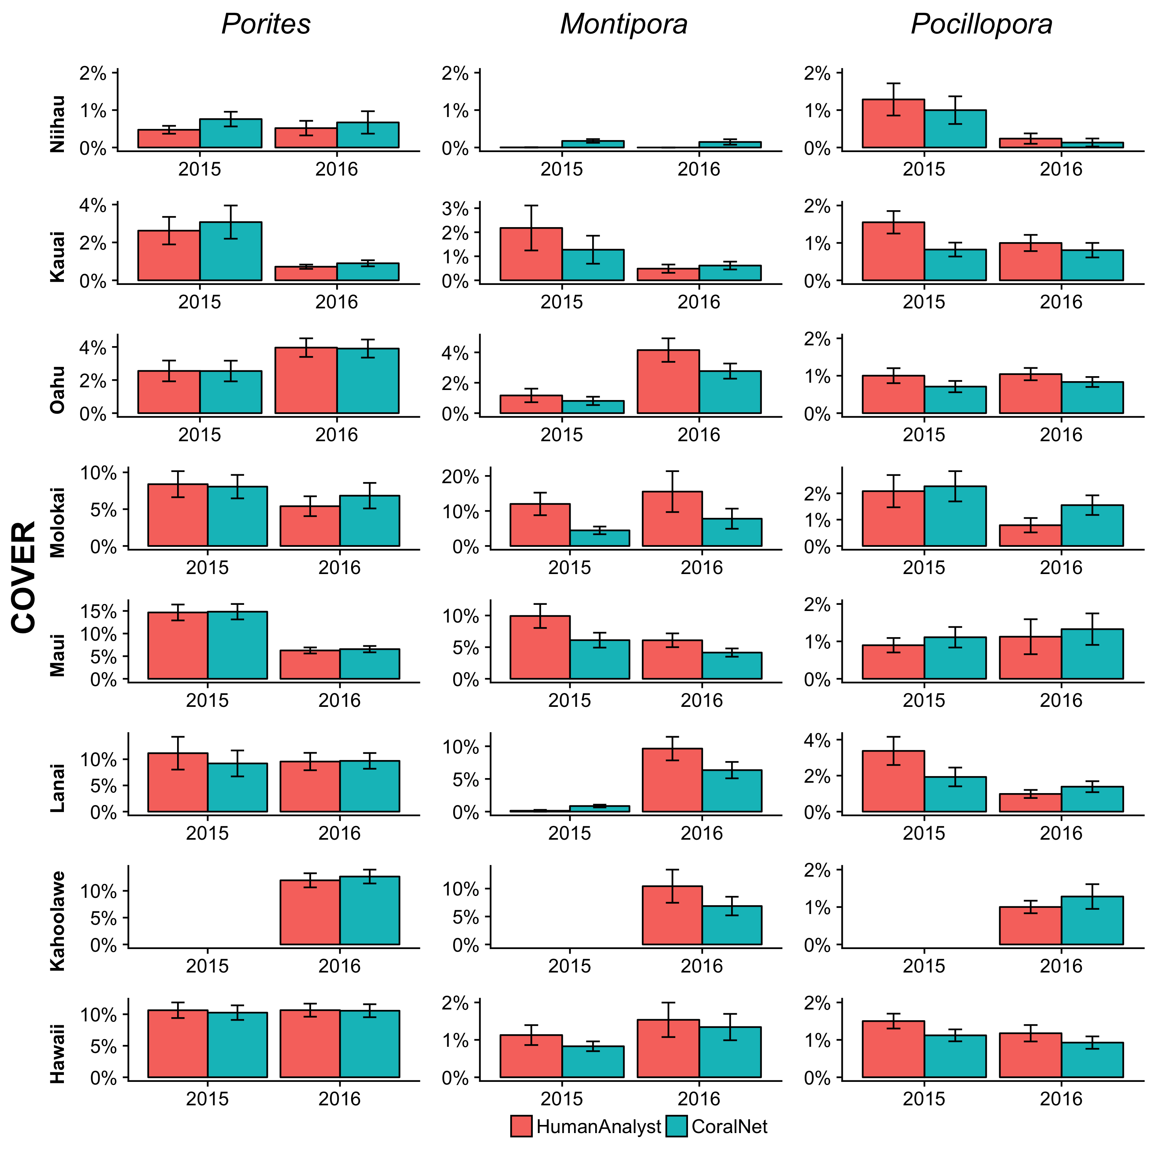

Figure S3. American Samoa Island-scale coral cover by four common genera per year from human analysts and CoralNet. Columns represent annual mean and SE of coral cover by island and year. CoralNet estimates are for the ‘SIMPLER’ classification and filtering scheme (details in Table S2).

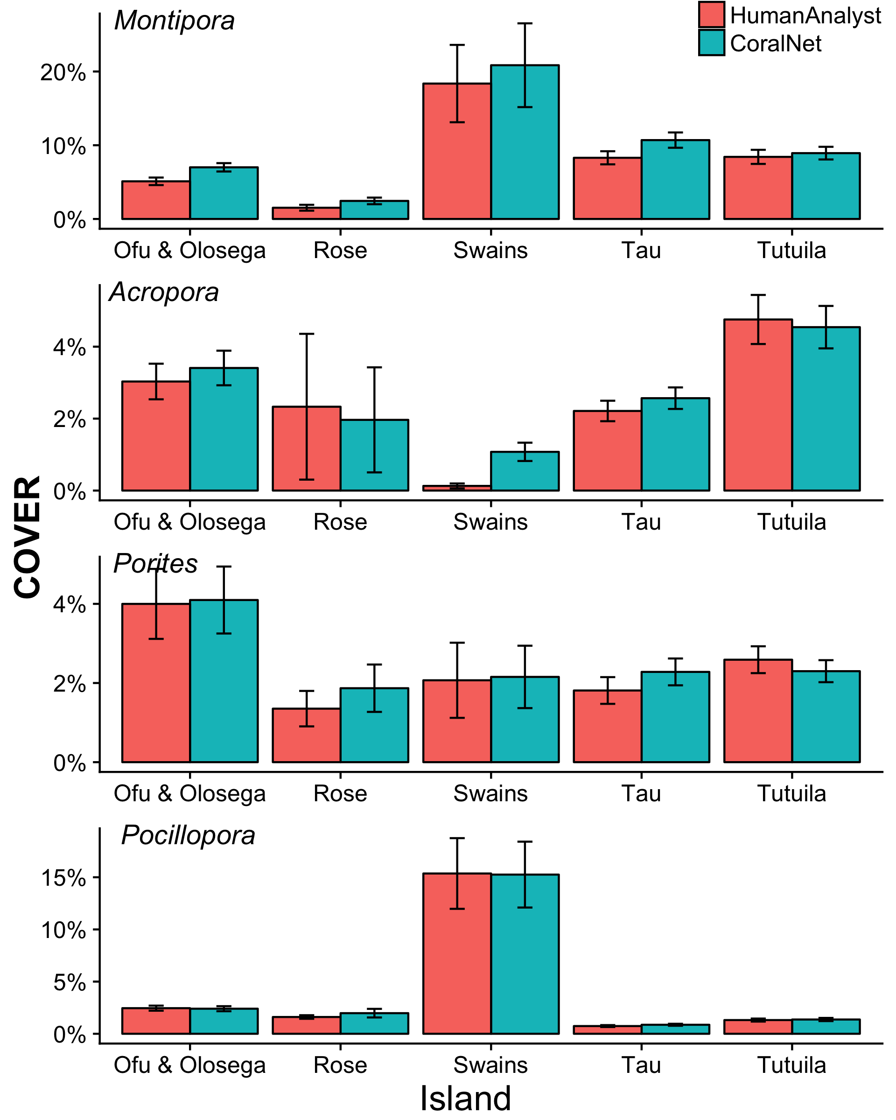

Figure S4. American Samoa Island-scale cover of common algal groups per year from human analysts and CoralNet. Columns represent annual mean and SE of coral cover by island and year. CoralNet estimates are for the ‘SIMPLER’ classification and filtering scheme (details in Table S2).

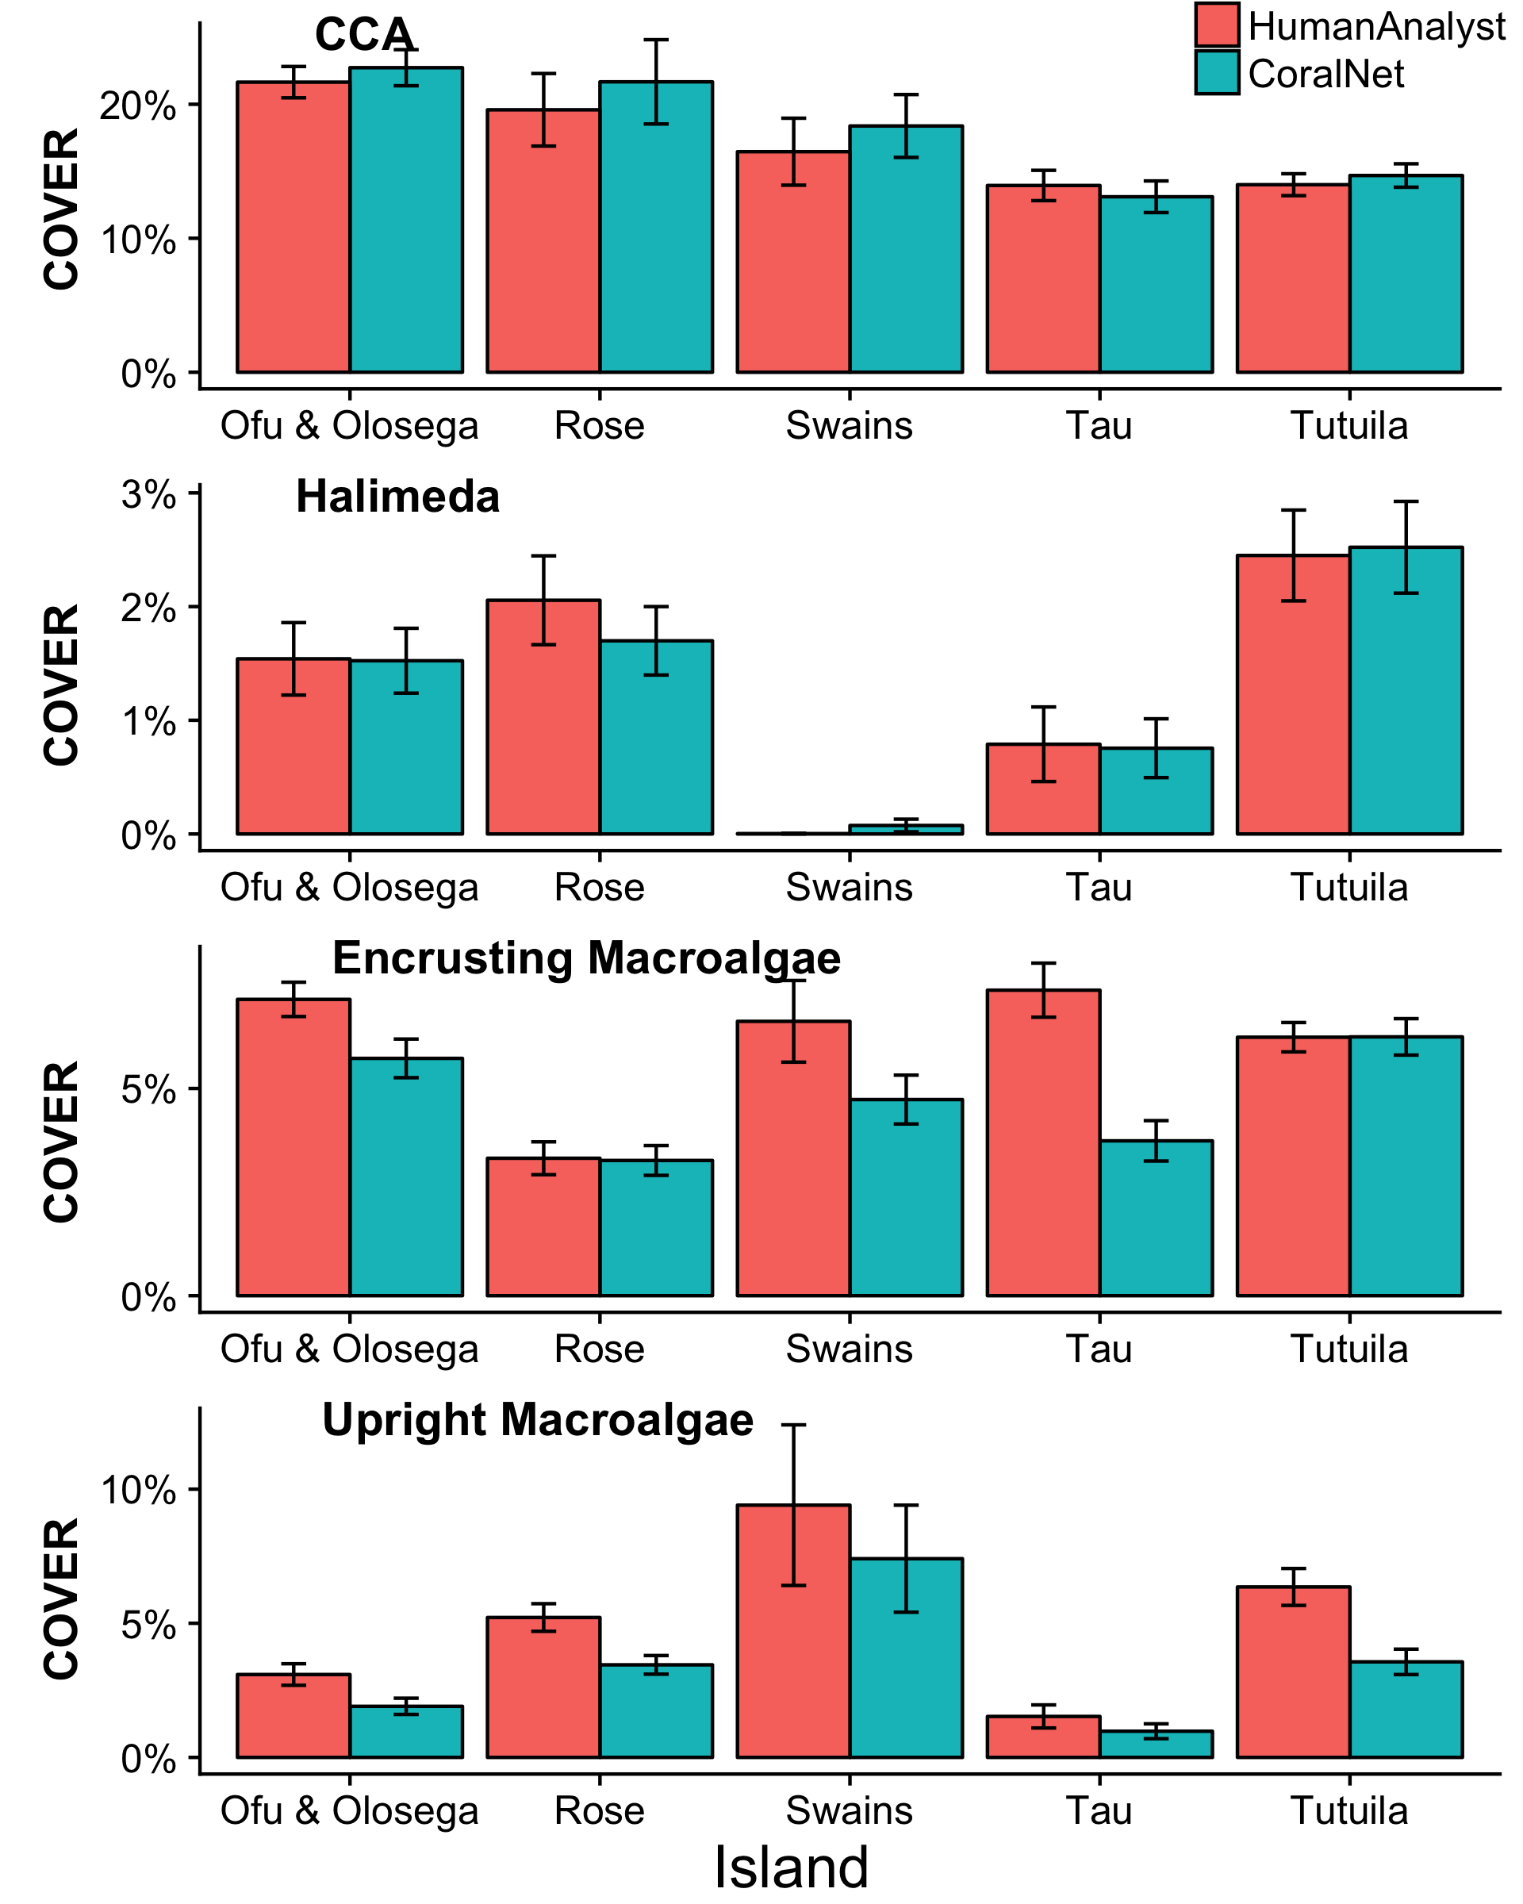

Figure S5. Coral cover site-level consistency between human-analyst and CoralNet against size of training set (i.e., the number of points CoralNet was trained on per run). Points in cyan are for American Samoa runs (the ‘BASE-ISLAND’ scheme and filtering), and points in red are MHI runs (the ‘BASE-HABITAT’ scheme). Values are mean and standard deviation of absolute difference between human-analyst and CoralNet coral cover estimate per site.

