Genome-wide DNA methylation map of testis in pigs for study of complex trait in epigenetics

Xiao Wang^{1,2}, Haja N. Kadarmideen^{1,2*}
¹Quantitative Genomics, Bioinformatics and Computational Biology Group, Department of Bio and Health Informatics and ²Department of Applied Mathematics and Computer Science, Technical University of Denmark, Richard Petersens Plads, Building 324, 2800, Kongens Lyngby, Denmark

Supplementary table 1. Total number of aligned cytosine methylation in different contexts.
Sample | Raw read pair | Removal of RRBS adapters pollution | Removal of reads less than 20 bases long pollution | Uniquely aligned read pair | Total methylated cytosine in CpG context | Total methylated cytosine in CHG context | Total methylated cytosine in CHH context | Total unmethylated cytosine in CpG context | Total unmethylated cytosine in CHG context | Total unmethylated cytosine in CHH context
1 | 16,698,176 | 16,676,459 | 16,505,578 | 7,626,224 | 25,285,774 | 533,874 | 613,446 | 25,954,263 | 58,429,002 | 99,676,221
2 | 95,226,092 | 94,982,628 | 93,817,089 | 47,664,062 | 176,804,459 | 4,035,546 | 4,935,839 | 157,691,156 | 403,645,743 | 710,921,851
3 | 38,428,786 | 38,398,933 | 38,026,074 | 17,805,056 | 56,793,321 | 1,183,759 | 1,405,332 | 67,690,550 | 139,729,393 | 241,165,963
4 | 76,547,112 | 76,492,906 | 75,769,839 | 38,737,948 | 138,976,823 | 2,832,374 | 3,546,545 | 126,425,365 | 322,401,427 | 567,481,702
5 | 58,288,942 | 58,203,032 | 57,267,890 | 29,233,916 | 101,157,611 | 1,824,688 | 2,734,279 | 99,455,692 | 265,705,802 | 523,404,400
6 | 69,409,837 | 69,277,350 | 68,607,455 | 31,560,762 | 99,474,166 | 2,177,276 | 2,680,962 | 116,309,843 | 241,862,604 | 418,560,859
7 | 85,946,536 | 85,848,515 | 85,068,927 | 41,686,025 | 139,527,755 | 3,118,644 | 3,983,459 | 143,670,905 | 336,163,467 | 594,334,671
8 | 76,287,408 | 76,091,969 | 75,438,276 | 38,315,536 | 134,584,159 | 3,001,451 | 4,062,527 | 128,653,677 | 324,817,894 | 599,275,112
9 | 17,120,606 | 17,100,153 | 16,940,690 | 7,873,386 | 26,155,846 | 568,832 | 672,578 | 26,163,882 | 59,605,482 | 101,298,534
Mean | 59,328,166 | 59,230,216 | 58,604,646 | 28,944,768 | 99,862,213 | 2,141,827 | 2,737,219 | 99,112,815 | 239,151,202 | 428,457,701
SD | 28,981,902 | 28,919,705 | 28,617,798 | 14,688,316 | 53,712,269 | 1,216,332 | 1,555,183 | 48,724,247 | 125,615,280 | 227,796,188

Supplementary table 2. Statistics of coverage and methylation rates in CpG context.
Sample | 1 | 2 | 3 | 4 | 5 | 6 | 7 | 8 | 9 | Mean | SD
Coverage | 7.82 | 28.38 | 14.91 | 24.07 | 19.61 | 25.61 | 32.18 | 28.43 | 7.90 | 20.99 | 9.01
Methylated | 3.86 | 15.00 | 6.80 | 12.61 | 9.89 | 11.80 | 15.86 | 14.53 | 3.95 | 10.48 | 4.64
Unmethylated | 3.96 | 13.38 | 8.11 | 11.47 | 9.72 | 13.80 | 16.33 | 13.89 | 3.95 | 10.51 | 4.44
Methylated rate (%) | 49.35% | 52.85% | 45.61% | 52.39% | 50.43% | 46.08% | 49.29% | 51.11% | 50.01% | 49.92% | 51.51%
Site in total | 6,555,417 | 11,786,693 | 8,350,750 | 11,024,632 | 10,230,855 | 8,427,406 | 8,799,356 | 9,259,657 | 6,619,706 | 9,006,052 | 1,798,552
Trimmed coverage | 16.52 | 50.31 | 26.71 | 40.83 | 27.13 | 40.20 | 44.95 | 38.83 | 17.10 | 33.62 | 12.17
Trimmed methylated | 7.34 | 25.57 | 11.01 | 20.59 | 13.46 | 17.83 | 21.76 | 19.26 | 7.86 | 16.08 | 6.45
Trimmed unmethylated | 9.19 | 24.74 | 15.70 | 20.24 | 13.67 | 22.37 | 23.19 | 19.58 | 9.24 | 17.55 | 5.87
Trimmed methylated rate (%) | 44.41% | 50.82% | 41.22% | 50.43% | 49.61% | 44.35% | 48.41% | 49.60% | 45.98% | 47.20% | 3.35%
Trimmed site in total | 1,740,792 | 5,716,743 | 3,517,675 | 5,490,560 | 6,415,652 | 4,577,586 | 5,559,731 | 5,942,865 | 1,792,367 | 4,528,219 | 1,776,393

Supplementary table 3. Regression and correlation analysis of densities of genes, CpG islands and CpG island shores on methylation levels, all counted by 1 Mb windows.
Sample ID | Gene |  | CpG island |  | CpG island shore
 | Regression coefficient | Correlation coefficient | Regression coefficient | Correlation coefficient | Regression coefficient | Correlation coefficient
1 | -2.22 | -0.13 | 44.84 | 0.21 | 53.07 | 0.18
2 | -2.03 | -0.12 | 59.09 | 0.26 | 74.61 | 0.24
3 | -2.09 | -0.12 | 58.49 | 0.27 | 72.99 | 0.24
4 | -1.97 | -0.10 | 63.64 | 0.26 | 80.71 | 0.24
5 | -2.21 | -0.11 | 74.26 | 0.28 | 95.72 | 0.27
6 | -2.33 | -0.13 | 56.34 | 0.25 | 69.24 | 0.22
7 | -2.04 | -0.11 | 71.31 | 0.29 | 90.87 | 0.27
8 | -2.44 | -0.13 | 60.32 | 0.25 | 75.58 | 0.23
9 | -2.46 | -0.14 | 43.04 | 0.19 | 50.06 | 0.16

Supplementary table 4. Significant pathways (P < 0.01).
Term | Gene | Count | % | P value | Fold Enrichment | Bonferroni | Benjamini | FDR
ssc04910:Insulin signaling pathway | PHKG2, FASN, PHKG1, ACACA, IKBKB, FBP1, GYS1, PRKCZ, PRKAA2, PRKAG1, PCK1, ACACB, PIK3R5, SREBF1, AKT2, MAP2K1 | 16 | 5.41 | 9.89E-7 | 4.77 | 2.24E-4 | 2.24E-4 | 0.00127
ssc04152:AMPK signaling pathway | FASN, ACACA, FBP1, GYS1, ADRA1A, PPP2R2B, CPT1B, CPT1A, PRKAA2, PRKAG1, PCK1, FOXO3, PIK3R5, SREBF1, AKT2 | 15 | 5.07 | 1.35E-6 | 5.01 | 3.06E-4 | 1.53E-4 | 0.00173
ssc04390:Hippo signaling pathway | GLI2, BMP7, BMP6, SOX2, TEAD3, BMPR1B, TEAD4, TEAD1, PRKCZ, PPP2R2B, TGFB1, LATS2, ITGB2, TGFB3, CCND2, WNT4 | 16 | 5.41 | 1.76E-6 | 4.56 | 3.99E-4 | 1.33E-4 | 0.00225
ssc04931:Insulin resistance | IKBKB, GYS1, PRKCZ, NOS3, CPT1B, PRKAG1, PRKAA2, CPT1A, PCK1, ACACB, PIK3R5, SREBF1, AKT2 | 13 | 4.39 | 2.47E-5 | 4.533 | 0.00559 | 0.00140 | 0.0316
ssc05212:Pancreatic cancer | EGFR, JAK1, TGFB3, PIK3R5, TGFA, IKBKB, RB1, AKT2, MAP2K1, TGFB1 | 10 | 3.38 | 2.66E-5 | 6.20 | 0.00603 | 0.00121 | 0.0341
ssc04068:FoxO signaling pathway | IKBKB, USP7, TGFB1, PRKAA2, PRKAG1, EGFR, PCK1, FOXO3, TGFB3, PIK3R5, AKT2, MAP2K1, CCND2 | 13 | 4.39 | 1.35E-4 | 3.82 | 0.0301 | 0.00508 | 0.172
ssc04922:Glucagon signaling pathway | CPT1B, CPT1A, PRKAA2, PHKG2, PRKAG1, PCK1, ACACB, PHKG1, ACACA, GYS1, AKT2 | 11 | 3.72 | 1.38E-4 | 4.52 | 0.0309 | 0.00448 | 0.177
ssc04611:Platelet activation | COL5A1, ITGB1, ORAI1, PIK3R5, AKT2, GUCY1A1, STIM1, NOS3, FYN, PRKCZ, PRKG1, VWF | 12 | 4.05 | 4.49E-4 | 3.61 | 0.0969 | 0.0127 | 0.5738
ssc04921:Oxytocin signaling pathway | NFATC2, CACNB4, RYR1, CAMK1D, KCNJ5, CACNG1, GUCY1A1, NOS3, PRKAG1, PRKAA2, EGFR, PIK3R5, MAP2K1 | 13 | 4.39 | 7.04E-4 | 3.19 | 0.148 | 0.0176 | 0.897
ssc05223:Non-small cell lung cancer | EGFR, FOXO3, PIK3R5, TGFA, RB1, AKT2, MAP2K1 | 7 | 2.36 | 0.00174 | 5.36 | 0.327 | 0.0388 | 2.21
ssc04920:Adipocytokine signaling pathway | CPT1B, CPT1A, PRKAA2, PRKAG1, PCK1, ACACB, IKBKB, AKT2 | 8 | 2.70 | 0.00208 | 4.40 | 0.376 | 0.0420 | 2.63
ssc00620:Pyruvate metabolism | PC, PCK1, ACACB, MDH2, ACACA, ALDH2 | 6 | 2.03 | 0.00228 | 6.33 | 0.404 | 0.0422 | 2.88
ssc04350:TGF-beta signaling pathway | ACVR2A, ACVR1B, TGFB3, BMP7, BMPR1B, BMP6, BAMBI, TGFB1 | 8 | 2.70 | 0.00331 | 4.06 | 0.529 | 0.0562 | 4.15
ssc04022:cGMP-PKG signaling pathway | NFATC2, PIK3R5, ATP1A2, AKT2, GUCY1A1, ADRA1A, NOS3, ADRB2, MAP2K1, ATP1A1, PRKG1, VDAC1 | 12 | 4.05 | 0.00346 | 2.81 | 0.544 | 0.0546 | 4.33
ssc04151:PI3K-Akt signaling pathway | COL5A1, JAK1, FGF9, IKBKB, GYS1, NOS3, PPP2R2B, VWF, PRKAA2, PCK1, EGFR, FOXO3, ITGB1, PIK3R5, TNXB, AKT2, MAP2K1, CCND2 | 18 | 6.08 | 0.00378 | 2.16 | 0.577 | 0.0557 | 4.73
ssc01212:Fatty acid metabolism | CPT1B, CPT1A, HADHA, FASN, ACACA, FADS2 | 6 | 2.03 | 0.00542 | 5.21 | 0.709 | 0.0742 | 6.72
ssc05211:Renal cell carcinoma | TGFB3, PIK3R5, TGFA, AKT2, EPAS1, MAP2K1, TGFB1 | 7 | 2.36 | 0.00553 | 4.27 | 0.716 | 0.0714 | 6.85
ssc04550:Signaling pathways regulating pluripotency of stem cells | ACVR2A, BMI1, JAK1, ACVR1B, PIK3R5, BMPR1B, SOX2, AKT2, MAP2K1, WNT4 | 10 | 3.38 | 0.00577 | 3.00 | 0.731 | 0.0703 | 7.13
ssc04917:Prolactin signaling pathway | FOXO3, LHB, PIK3R5, AKT2, ELF5, MAP2K1, CCND2 | 7 | 2.365 | 0.00643 | 4.14 | 0.769 | 0.0741 | 7.92
ssc00020:Citrate cycle (TCA cycle) | PC, PCK1, MDH2, ACO2, ACLY | 5 | 1.69 | 0.00664 | 6.51 | 0.780 | 0.0728 | 8.17
ssc04380:Osteoclast differentiation | CYBA, TYK2, JAK1, NFATC2, PIK3R5, IKBKB, AKT2, FYN, MAP2K1, TGFB1 | 10 | 3.38 | 0.00668 | 2.94 | 0.782 | 0.0699 | 8.22
ssc04071:Sphingolipid signaling pathway | CTSD, PIK3R5, S1PR2, AKT2, NOS3, FYN, PRKCZ, MAP2K1, PPP2R2B | 9 | 3.04 | 0.00756 | 3.14 | 0.821 | 0.0753 | 9.25
ssc05220:Chronic myeloid leukemia | TGFB3, PIK3R5, IKBKB, RB1, AKT2, MAP2K1, TGFB1 | 7 | 2.36 | 0.00797 | 3.96 | 0.837 | 0.0759 | 9.73

Supplementary figure 1. Histograms of log10 of read coverage per CpG site
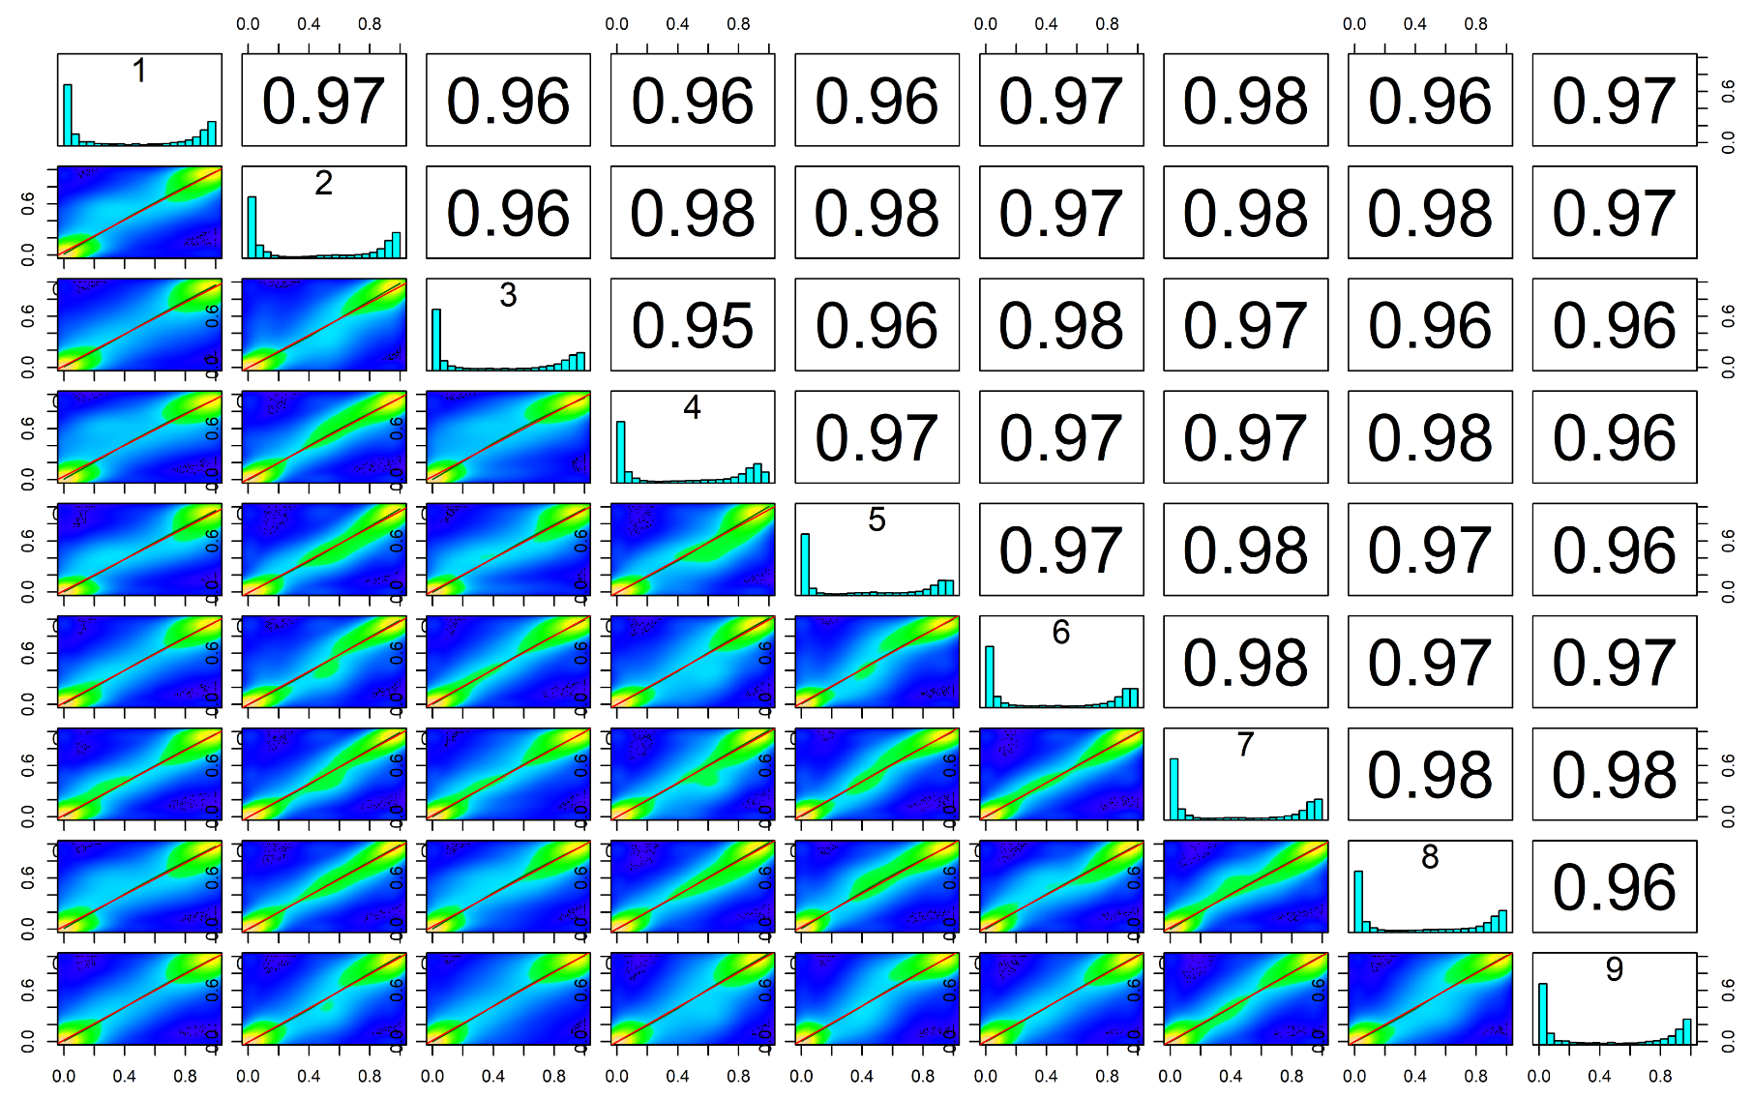
Supplementary figure 2. Correlation analysis of the global CpG methylation patterns among nine samples. Note: Colors in the scatter plot indicate the number of CpG sites with identical methylation pattern (methylated or non-methylated): yellow denotes many correlations, blue denotes lack of correlation and green denotes different methylation patterns. Numbers in the upper right side represent the pairwise Pearson's correlation scores. Histograms on the diagonal are methylation distribution per CpG site for each sample.
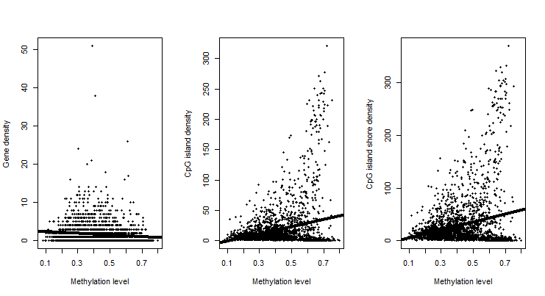
Supplementary figure 3. Regression of densities of genes, CpG islands and CpG island shores on methylation levels from one sample, all counted by 1 Mb windows.

