Supplementary figures and tables

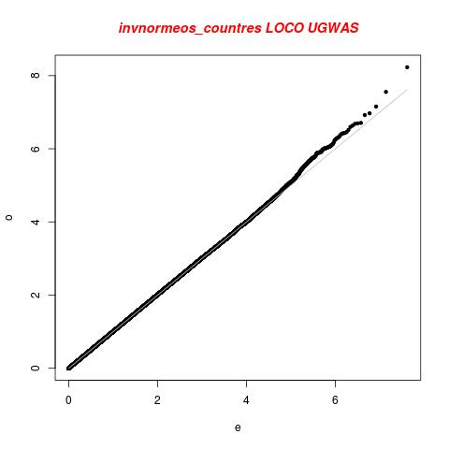
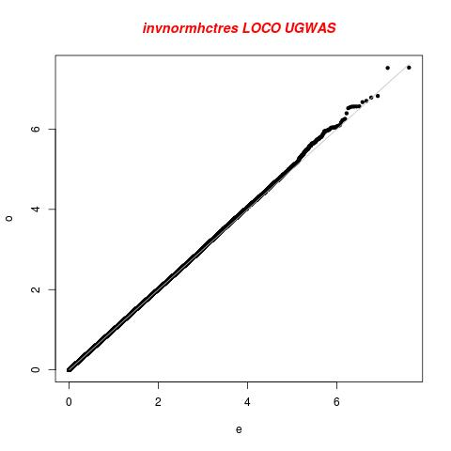
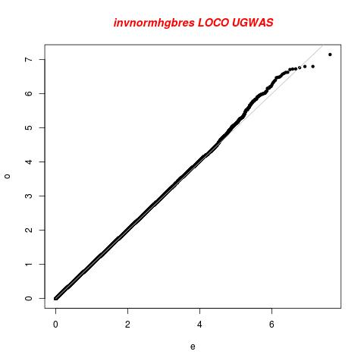
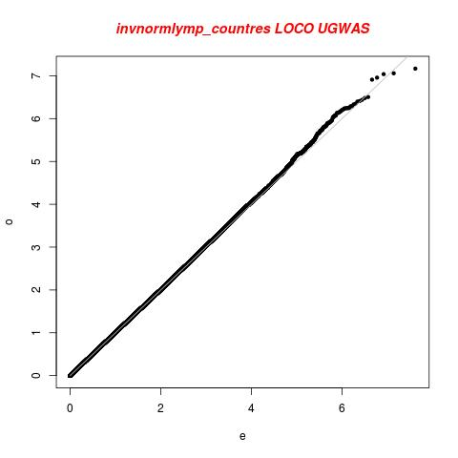
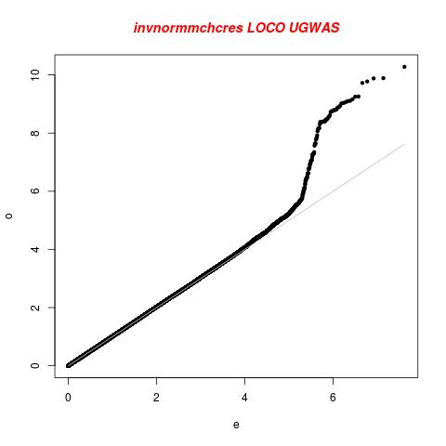
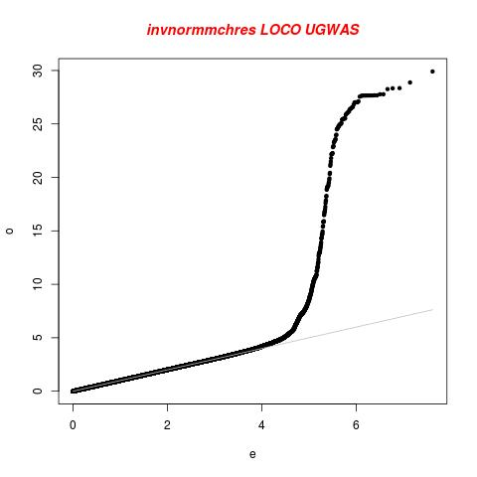
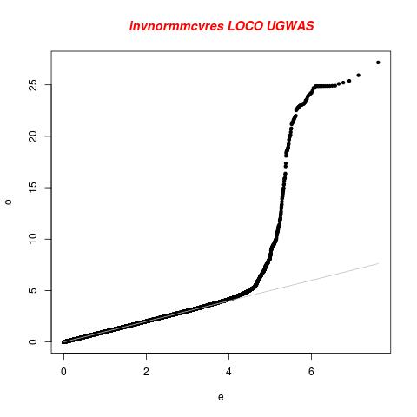
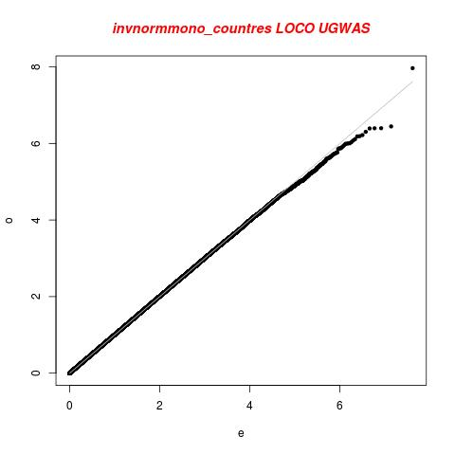
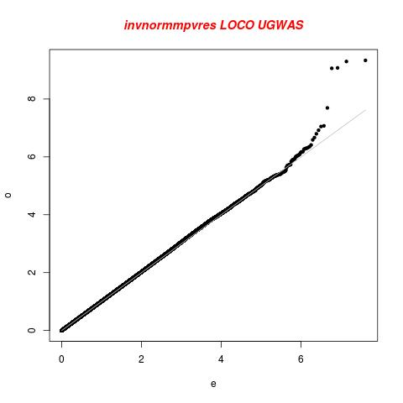
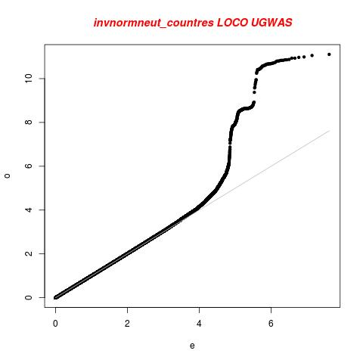
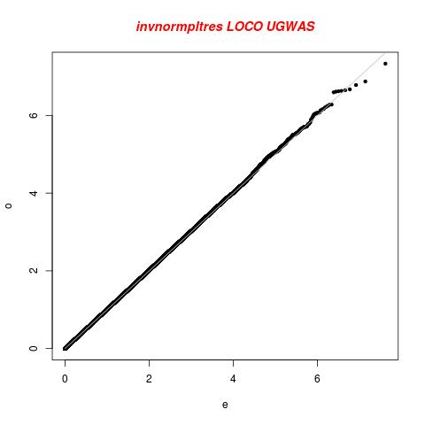
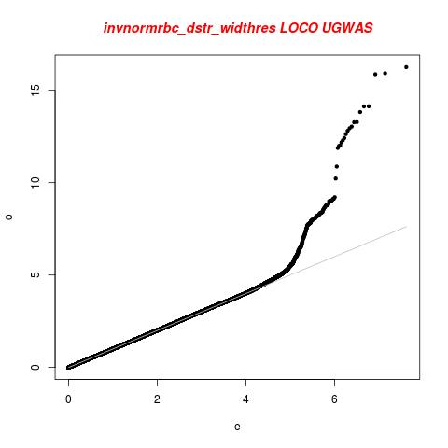
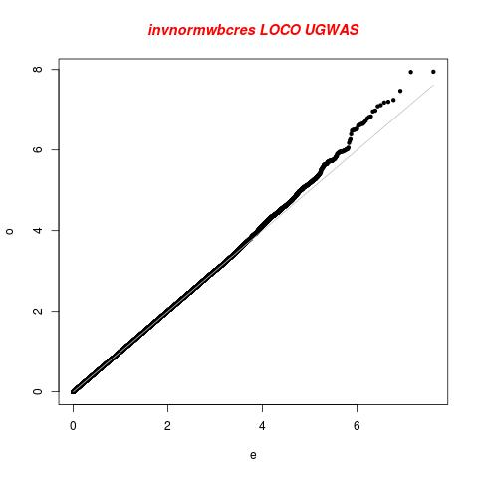
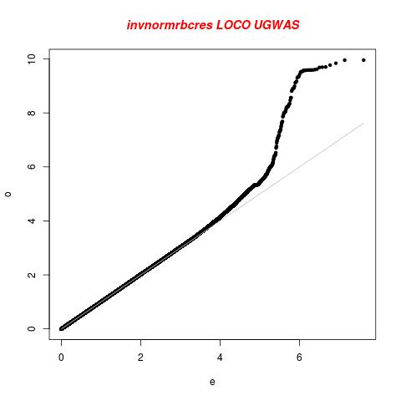
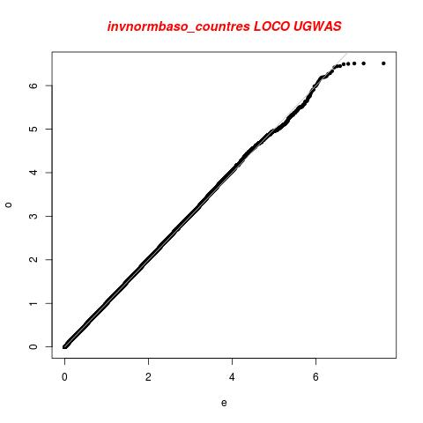
Supplementary Figure 1: QQ plots of fifteen FBC traits analysed individually (univariate) showing the distribution of association P-values

 | WBC | NEU | EOS | BASO | MONO | LYMPH | RBC | HGB | HCT | MCV | MCH | MCHC | RDW | PLT | MPV
WBC | 1 | 0.08 | 0.1 | 0.17 | -0.17 | -0.17 | 0.14 | 0.11 | 0.14 | -0.03 | -0.07 | -0.11 | -0.01 | -0 | -0.03
NEU | 0.08 | 1 | -0.36 | -0.19 | 0.05 | -0.78 | -0.06 | -0.11 | -0.11 | -0.05 | -0.04 | 0.01 | 0.08 | -0 | -0.01
EOS | 0.1 | -0.4 | 1 | 0.06 | -0.19 | -0.17 | 0.02 | 0.02 | 0.04 | 0.02 | 0 | -0.04 | -0.05 | -0 | -0.04
BASO | 0.17 | -0.2 | 0.06 | 1 | -0.02 | 0.13 | 0.19 | 0.2 | 0.27 | 0.05 | -0.03 | -0.19 | -0.03 | -0 | -0.04
MONO | -0.17 | 0.05 | -0.19 | -0.02 | 1 | -0.07 | -0.07 | -0.08 | -0.08 | 0 | 0 | -0.01 | -0.02 | 0 | 0.02
LYMPH | -0.17 | -0.8 | -0.17 | 0.13 | -0.07 | 1 | 0.07 | 0.1 | 0.09 | 0.02 | 0.02 | 0.02 | -0.05 | 0 | 0.03
RBC | 0.14 | -0.1 | 0.02 | 0.19 | -0.07 | 0.07 | 1 | 0.67 | 0.75 | -0.55 | -0.54 | -0.17 | 0.07 | 0.1 | 0.13
HGB | 0.11 | -0.1 | 0.02 | 0.2 | -0.08 | 0.1 | 0.67 | 1 | 0.94 | 0.16 | 0.24 | 0.27 | -0.29 | 0 | 0.03
HCT | 0.14 | -0.1 | 0.04 | 0.27 | -0.08 | 0.09 | 0.75 | 0.94 | 1 | 0.12 | 0.07 | -0.06 | -0.29 | 0 | 0.04
MCV | -0.03 | -0.1 | 0.02 | 0.05 | 0 | 0.02 | -0.55 | 0.16 | 0.12 | 1 | 0.92 | 0.18 | -0.46 | -0.1 | -0.13
MCH | -0.07 | -0 | 0 | -0.03 | 0 | 0.02 | -0.54 | 0.24 | 0.07 | 0.92 | 1 | 0.53 | -0.41 | -0.1 | -0.13
MCHC | -0.11 | 0.01 | -0.04 | -0.19 | -0.01 | 0.02 | -0.17 | 0.27 | -0.06 | 0.18 | 0.53 | 1 | -0.07 | -0 | -0.03
RDW | -0.01 | 0.08 | -0.05 | -0.03 | -0.02 | -0.05 | 0.07 | -0.29 | -0.29 | -0.46 | -0.41 | -0.07 | 1 | 0.1 | 0.05
PLT | -0.03 | -0 | -0.04 | -0.04 | 0.02 | 0.03 | 0.13 | 0.03 | 0.04 | -0.13 | -0.13 | -0.03 | 0.05 | 1 | -0.5
MPV | -0.03 | -0 | -0.04 | -0.04 | 0.02 | 0.03 | 0.13 | 0.03 | 0.04 | -0.13 | -0.13 | -0.03 | 0.05 | -0.5 | 1
Supplementary Table 1a: Correlation coefficient of all Full Blood traits in UGWAS. Correlations above +/-0.75 are highlighted in red

Supplementary Table 1b: Description of highly correlated traits
Trait 1 | Trait 2 | Correlation coefficient (r2)
HGB | PCV | 0.94
MCH | MCV | 0.92
PCV | RBC | 0.75
LYN | NEU | -0.78

Supplementary Table 2: Description of genomic infation factor and proportion of variance for each PC
 | PCA | Genomic inflation factor | Proportion of variance
 | PCA1 | 1.00 | 0.2342
 | PCA2 | 1.01 | 0.1805
 | PCA3 | 1.01 | 0.1631
 | PCA4 | 1.01 | 0.09376
 | PCA5 | 1.02 | 0.07265
 | PCA6 | 1.01 | 0.06573
 | PCA7 | 1.01 | 0.0514
 | PCA8 | 1.01 | 0.04288
 | PCA9 | 1.01 | 0.03695
 | PCA10 | 1.01 | 0.02877
 | PCA11 | 1.00 | 0.02652
 | PCA12 | 1.02 | 0.00175
 | PCA13 | 1.01 | 0.00118
 | PCA14 | 1.00 | 0.00041
 | PCA15 | 1.00 | 0.00025

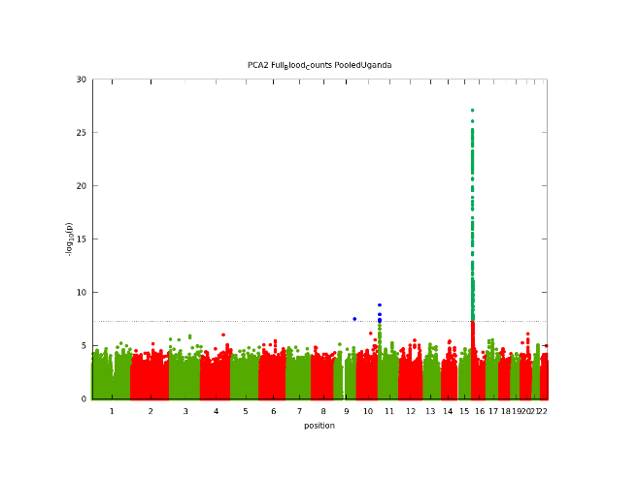
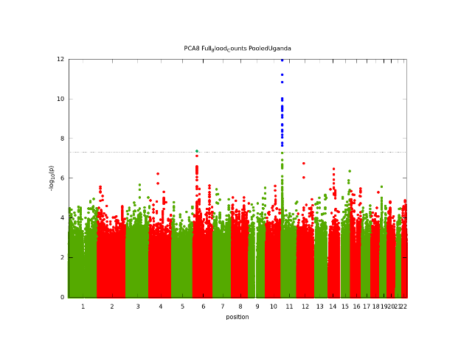
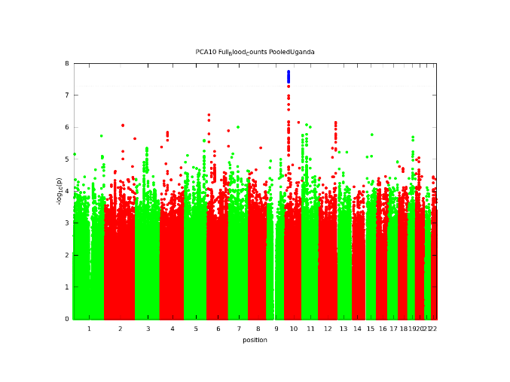
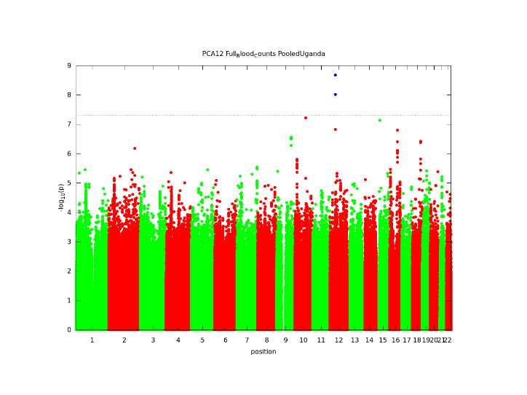
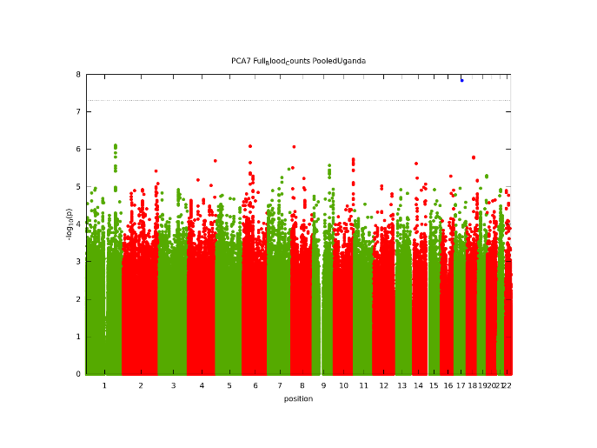
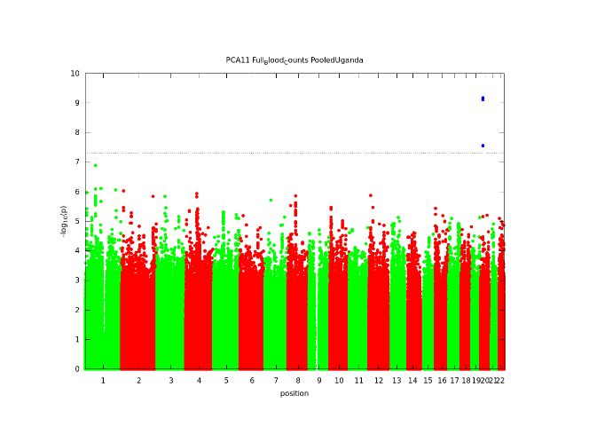
Supplementary Figure 2: Manhattan plots of genome-wide associations using the PC-GWAS approach. Manhattan plots shown here have at least one genome-wide significant variant. At Principal Components 2, 7, 8, 10, 11, 12.
PC 8
PC 7
PC 2
PC 12
PC 11
PC 10

