Supplementary Table 1 Mathematical expressions for the considered inhibition types and their description.
Inhibition type | Equation | Description
Competitive | $$V_{0}=\frac{V_{max}*\left[S\right]}{K_{m}(1+\frac{I}{K_{i}})+[S]}$$ | Inhibitor binds on the same active site as substrate
Partial competitive | $$V_{0}=\frac{V_{max}*[S]}{K_{m}\frac{1+\frac{I}{K_{i}}}{1+\frac{I}{{αK}_{i}}}+[S]}$$ | Competitive inhibition with residual activity and different affinity for the substrate towards the enzyme and enzyme-inhibitor complex
Non-competitive | $$V_{0}=\frac{V_{max}*\left[S\right]}{\left(K_{m}+\left[S\right]\right)*(1+\frac{I}{K_{i}})}$$ | Inhibitor binds on an allosteric site of the enzyme.
Partial non-Competitive | $$V_{0}=\frac{V_{max}*\left[S\right]*(1+\frac{βI}{K_{i}})}{\left(K_{m}+\left[S\right]\right)*(1+\frac{I}{K_{i}})}$$ | Non-competitive inhibition with residual activity but equal affinity of the substrate towards the enzyme and enzyme-inhibitor complex
Uncompetitive | $$V_{0}=\frac{V_{max}*\left[S\right]}{K_{m}+[S](1+\frac{I}{K_{I}})}$$ | Inhibitor binds only to the enzyme-substrate complex
Partial uncompetitive | $$V_{0}=\frac{V_{max}*[S]}{K_{m}+[S]\frac{1+\frac{I}{{αK}_{i}}}{1+\frac{I}{K_{i}}}}$$ | Uncompetitive inhibition with residual activity and affinity for the substrate towards the enzyme-inhibitor complex
Mixed | $$V_{0}=\frac{V_{max}*\left[S\right]}{K_{m}(1+\frac{I}{K_{i}})+[S](1+\frac{I}{αK_{I}})}$$ | Inhibitor has different affinity to the enzyme and enzyme-substrate complex but without residual activity.
Partial Mixed | $$V_{0}=\frac{V_{max}*\left[S\right]*(1+\frac{βI}{{αK}_{i}})}{K_{m}(1+\frac{I}{K_{i}})+[S](1+\frac{I}{αK_{I}})}$$ | Inhibitor has different affinity to the enzyme and enzyme-substrate complex with residual activity.
V₀, biotransformation rate; V_{max}, maximal biotranformation rate; K_{m}, Michaelis-Menten constant; Ki, inhibition constant; [S], substrate concentration; α affinity constant modulator for enzyme-inhibitor complex; β catalytic rate constant modulator for enzyme-inhibitor-substrate complex

Supplementary Table 2 Used substrate and mycotoxin concentrations for the investigation of inhibition type in porcine hepatic microsomes. Only substrates (corresponding to a specific CYP enzyme) for which residual CYP enzyme activity is <80% in the orientation experiment were selected
Substrate concentrations (µM)
TB (CYP2C) | 5 | 10 | 50 | 100 | 200 | 400
DXM (CYP2D) | 0.1 | 0.5 | 1 | 5 | 20 | 100
MDZ (CYP3A) | 0.5 | 2 | 5 | 10 | 20 | 50
CM (CYP2A) | 0.25 | 0.5 | 2 | 5 | 20 | 100
Mycotoxin concentrations for each substrate (µM)
ZEA-DXM | 0 | 1 | 10 | 100
ZEA-TB | 0 | 0.1 | 1 | 10
ZEA-MDZ | 0 | 0.5 | 5 | 20
T-2-TB | 0 | 1 | 10 | 50
T-2-MDZ | 0 | 1 | 10 | 100
FB1-CM | 0 | 0.1 | 1 | 5
ZEA, zearalenone; T-2, T-2 toxin; FB1, fumonisin B1; TB, tolbutamide; CM, coumarin; MDZ, midazolam; DXM, dextromethorphan

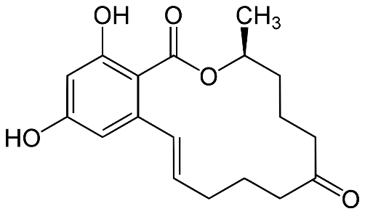 | 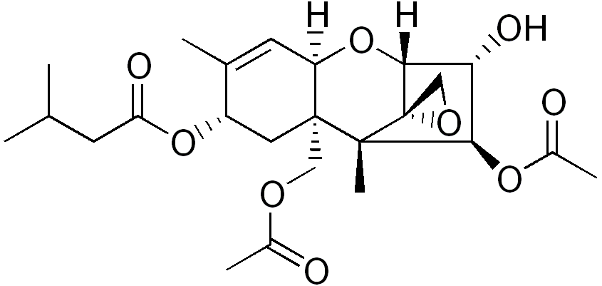
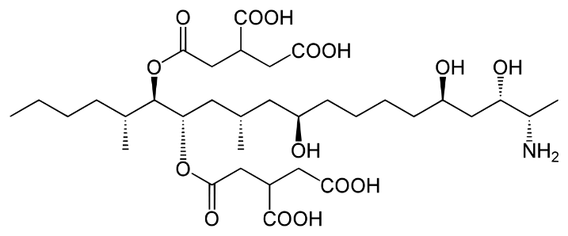 | 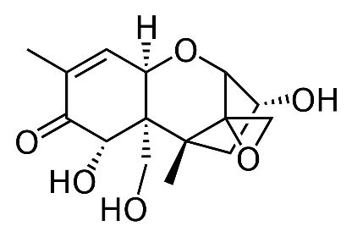
Supplemental Figure 1. Chemical structures of the investigated mycotoxins. Upper left, zearalenone; upper right T-2 toxin; lower left, fumonisin b1; lower right, deoxynivalenol

