**Appendix 1. Delphi survey explanatory material**

Dear scientist,

As part of WP5 we are aiming to identify the **risks and pressures** to **ecosystem services** in the North Atlantic from existing and potential future economic activity. To achieve this we are carrying out a Delphi study among scientists to probe for information on risks to ecosystem services that the ocean provides.

The Delphi method relies on a panel of experts to gather information; this is often due to limited knowledge regarding the service or good. The technique gathers expert opinion, usually in an iterative, anonymous survey with feedback. The objective is to allow information produced by an expert group to be evaluated, building consensus over time.

The survey is therefore sent around twice or more. In the second round the information regarding the results of the first round are distributed in order to allow the expert to re-evaluate their previous assessment and to see if there may be some more agreement or convergence regarding the issue surveyed.

We realize that you may not have detailed knowledge regarding parts of the survey. Note however that the survey is an attempt to assess expert *opinion*, especially where knowledge is limited, as in the deep sea. This is therefore a survey of your personal opinion.

The risk assessment matrix is the central part of the survey, but the table of ecosystem services in case study areas, and the follow-up questions are also central to different deliverables in WP5.

Attached is an explanation of the survey.

**THE SURVEY EXPLAINED**

1. Please enter the relevant personal information.

Example:

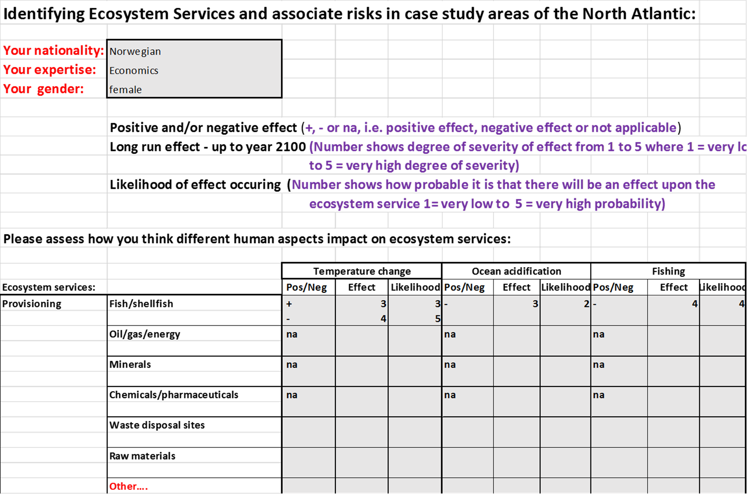

1. Ecosystem services are listed along the side of the risk matrix and the table of case study ecosystem services. If you feel central services are missing, please add to the Other box.



Note that in the risk assessment matrix we are asking you to refer to the **North Atlantic** overall (i.e. not just your case study area). Associated human pressures are shown in the top row of the matrix. Additional risks or pressures can be added to the ‘Other’ box at the end.

The first four human activity/impacts in the risk matrix:



The different human activity/impacts are to be assessed using the three measures below:

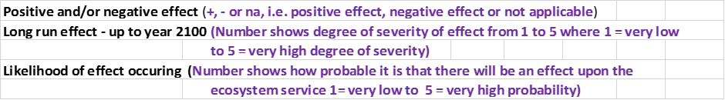

I. e. identify whether each activity / impact will have a positive or negative effect on the different ecosystem service. If you think there may be both positive and negative effects, then you can put this in on the separate lines in the relevant boxes (see example below).

Then rank both the *effect* and the *likelihood* of the effect occurring on scales of 1 to 5.

Example of filling in the matrix (note: If you think some activities/impacts are not applicable in relation to some ecosystem services, then just write na in the Pos/Neg box):



After you have filled in the matrix, please assess your personal *certainty* with regard to your assessment (on a scale from 1 to 5), and state which aspects you are most certain and uncertain about.

Example:



In the Ecosystem service table, we ask you to state the case study area (or areas) you are referring to, and then tick the cell if the relevant ecosystem service is present.

Example using the LOVE and Azorean case study areas:



The final open-ended questions in the survey are valuable input for WP5, and give you an opportunity to comment.

Please remember to send to **claire.armstrong@uit.no**

Thank you very much!

**Appendix 2. The Delphi survey – version 1**

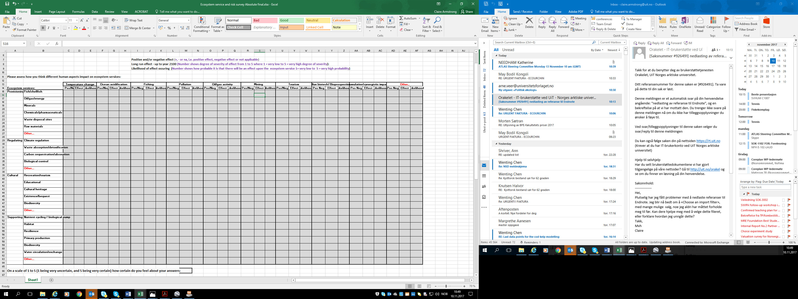

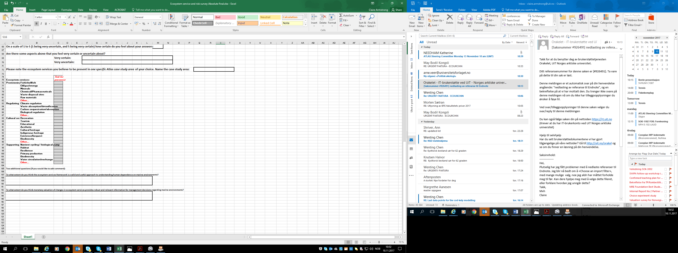

**Appendix 3. Text in the 2nd Delphi survey about results from the 1st Delphi survey. Assessing the risk in the Delphi survey – first round**

For Tables 1 and 2 below we computed median scores for all negative effects and likelihoods that experts scored for the ecosystem services in Round 1 of the ATLAS Delphi survey. These median scores were used to classify the effects and likelihoods into five classes ranging from “very low” effects and likelihoods to “very high” effects and likelihoods. The colour coding is given in the tables below.

Table 1. The negative effect of human activities on ecosystem services

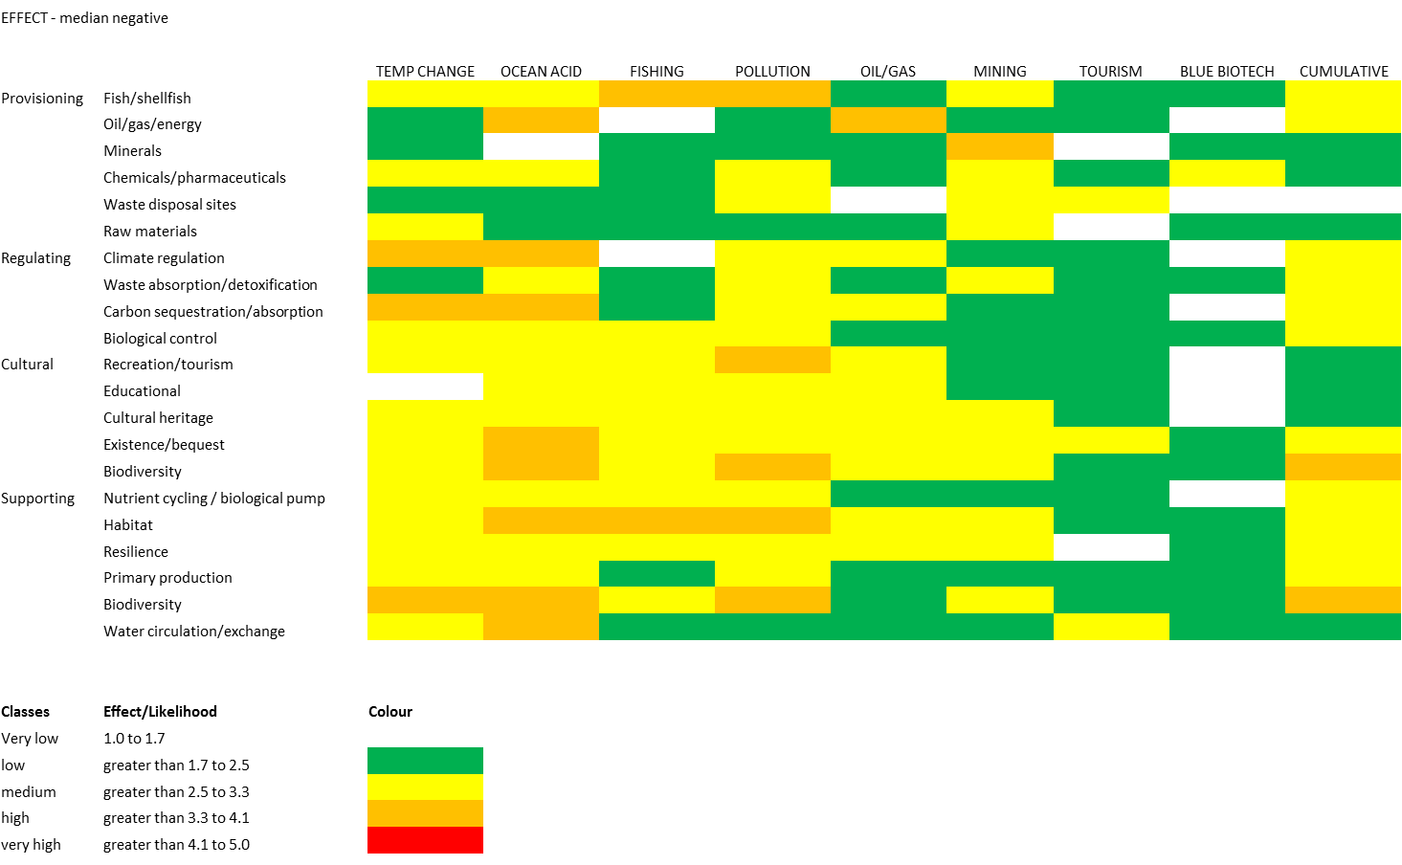

**Table 2 The likelihood of negative effects on ecosystem services**

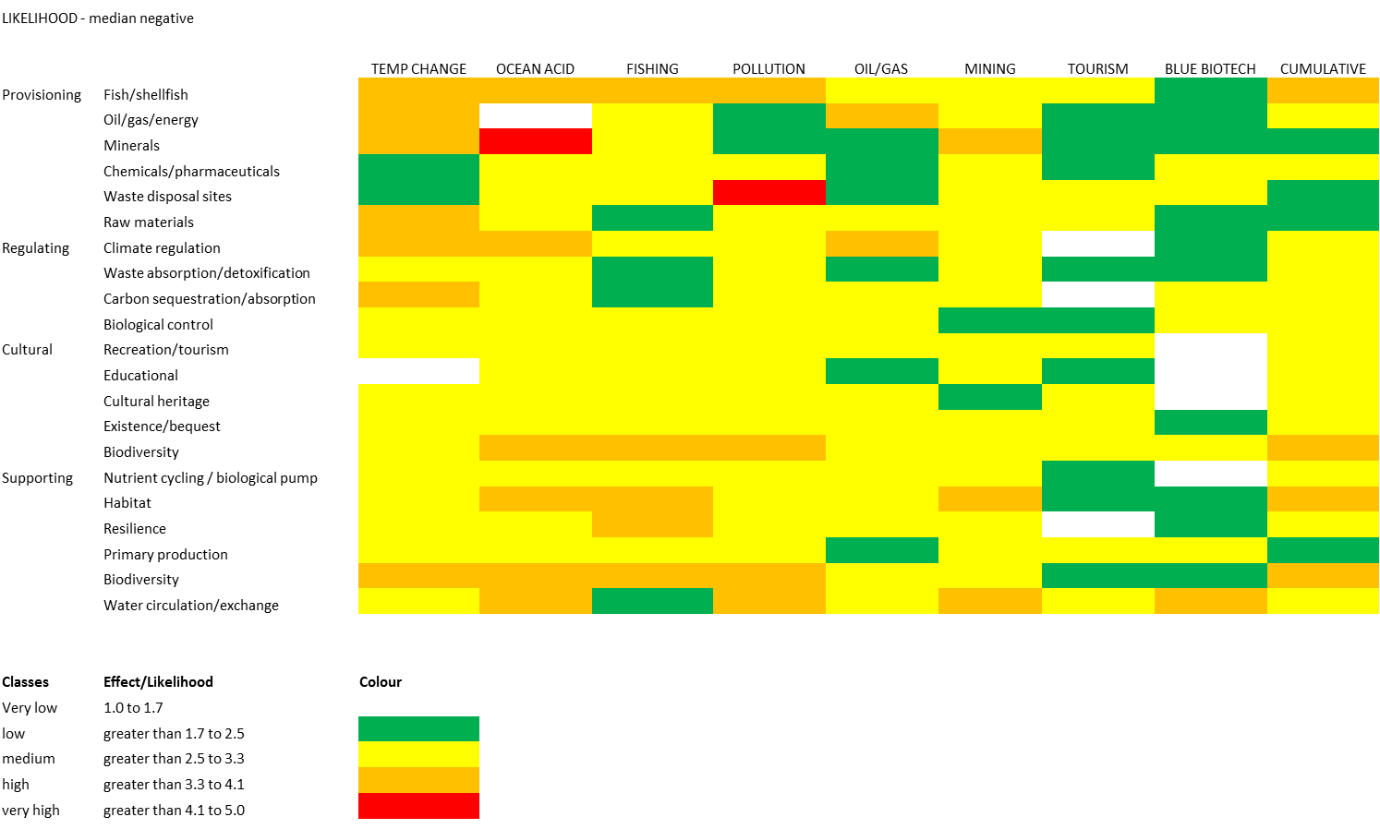

**Median Effect and Likelihood on all Ecosystem Services**

In these bubble plots we graph the median effect and likelihood of all human impacts upon all ecosystem services. The sizes of the bubbles are determined by the number of services in each median category. The green bubbles are the number of services that are positively impacted, while the red are the services that are negatively impacted. For instance. When looking at the top left bubble plot, it presents the median effect and likelihood of temperature change on ecosystem services. Here we observe that there is a large number of services with a median of about 3 for both effect and likelihood, but a few services with high negative risk, i.e., the red bubble at point ( 4,4).

We created these plots by first dividing responses into positive and negative effects on ecosystem services. We then computed frequencies for each coordinate of effects and their corresponding likelihood scores. The coordinates of effects and likelihoods were plotted as bubbles and the sizes of the bubbles are determined by the frequencies. We performed the above two procedures for negative and positive effects separately.

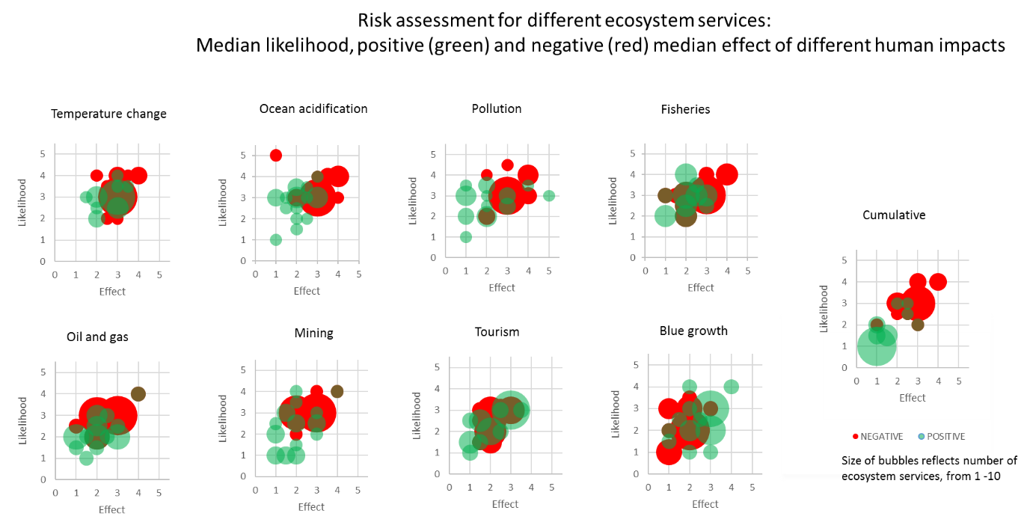

**Figure 1. The risk connected to human impacts on ecosystem services**

**Ecosystem Services Risk Assessment Matrix**

The median scores we presented for both effects and likelihoods separately in Tables 1 and 2 above, were combined for risk assessment using the risk assessment matrix in Figure 2 below. In the risk assessment matrix, high effects and high likelihoods indicate high risk and low effect and low likelihoods indicate low risk. If we use a risk reporting matrix such as the one given in Figure 2 below, we find that there are only services at high risk level in our study where the median likelihood and effect are (4,4). I.e. there are no cases of the remaining red areas in the figure below.

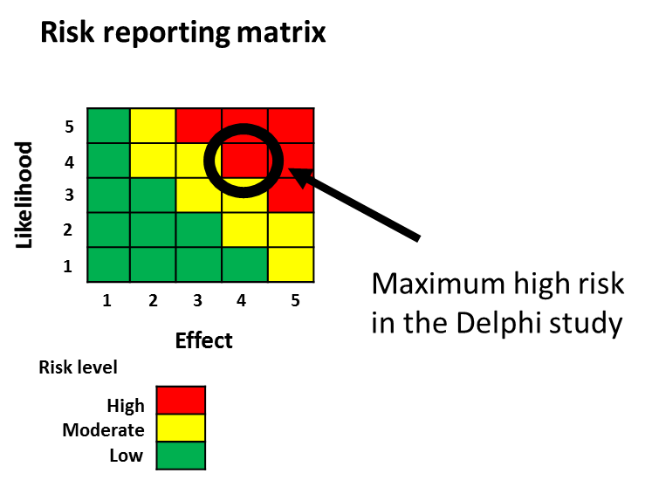

Figure 2. Risk reporting matrix

**Appendix 4. Example page of SurveyMonkey 2nd Delphi survey**

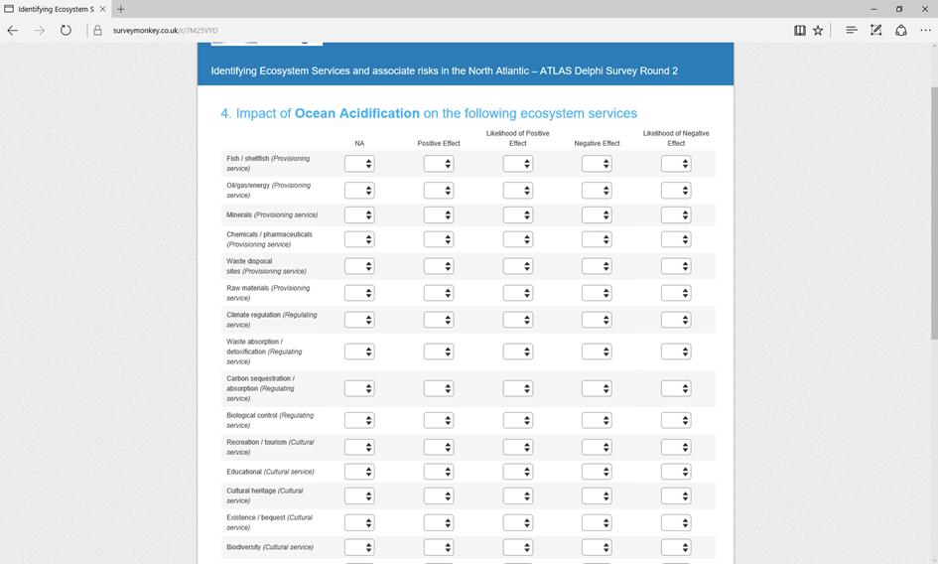

**Appendix 5. Figures from the 2nd Delphi survey, equivalent to those presented in the first survey (in Appendix 3), and figures from the first round equivalent Figures 3 and 4.**

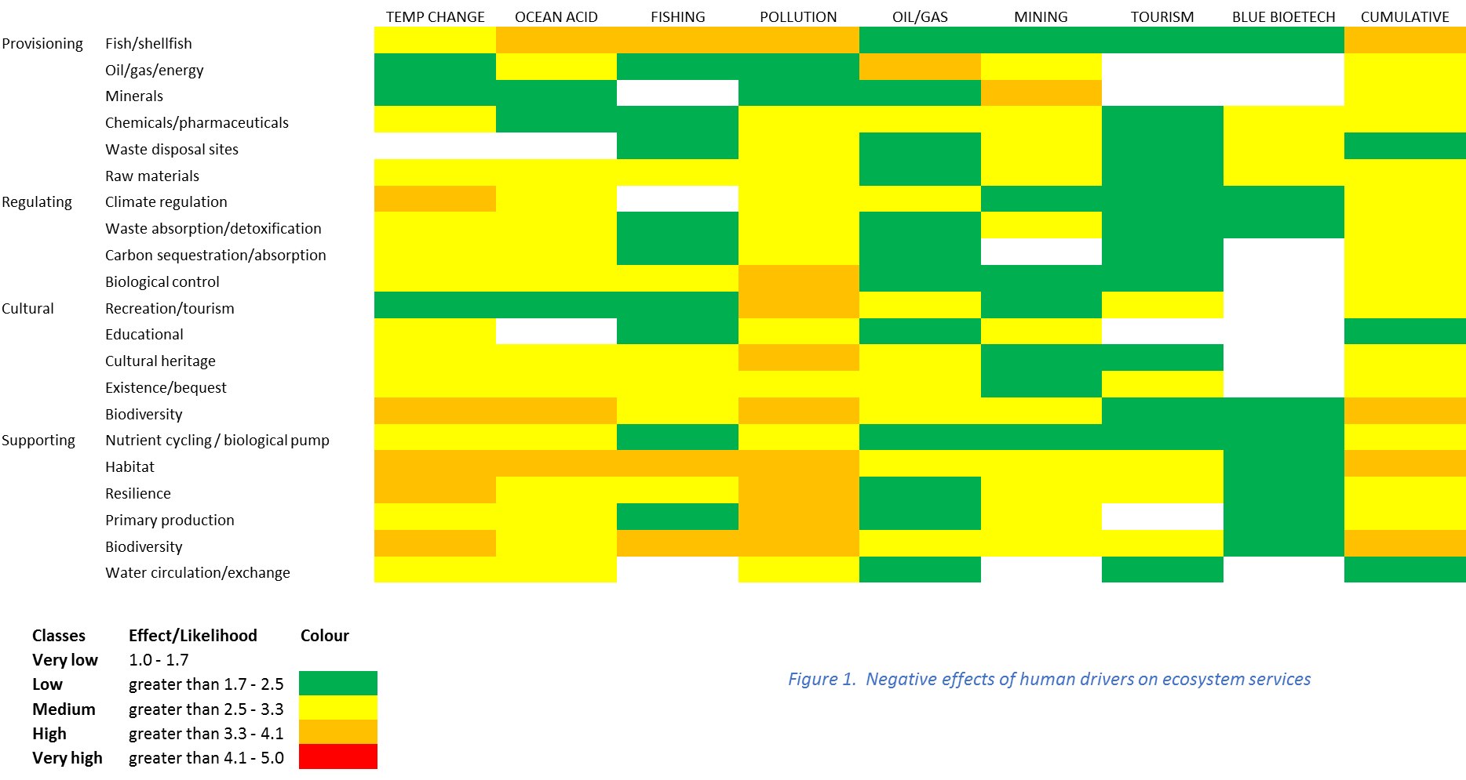

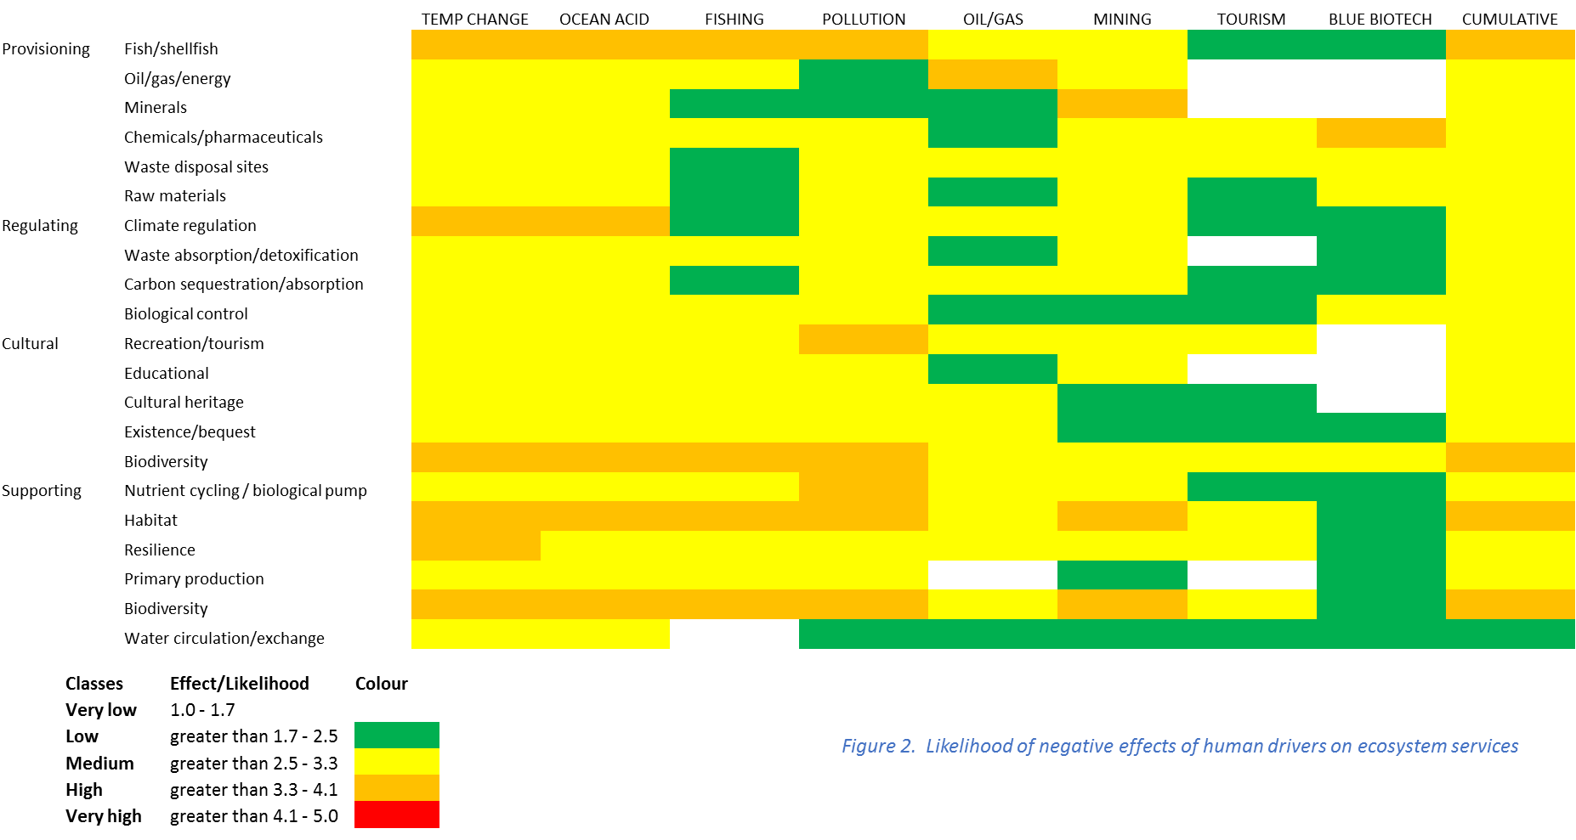

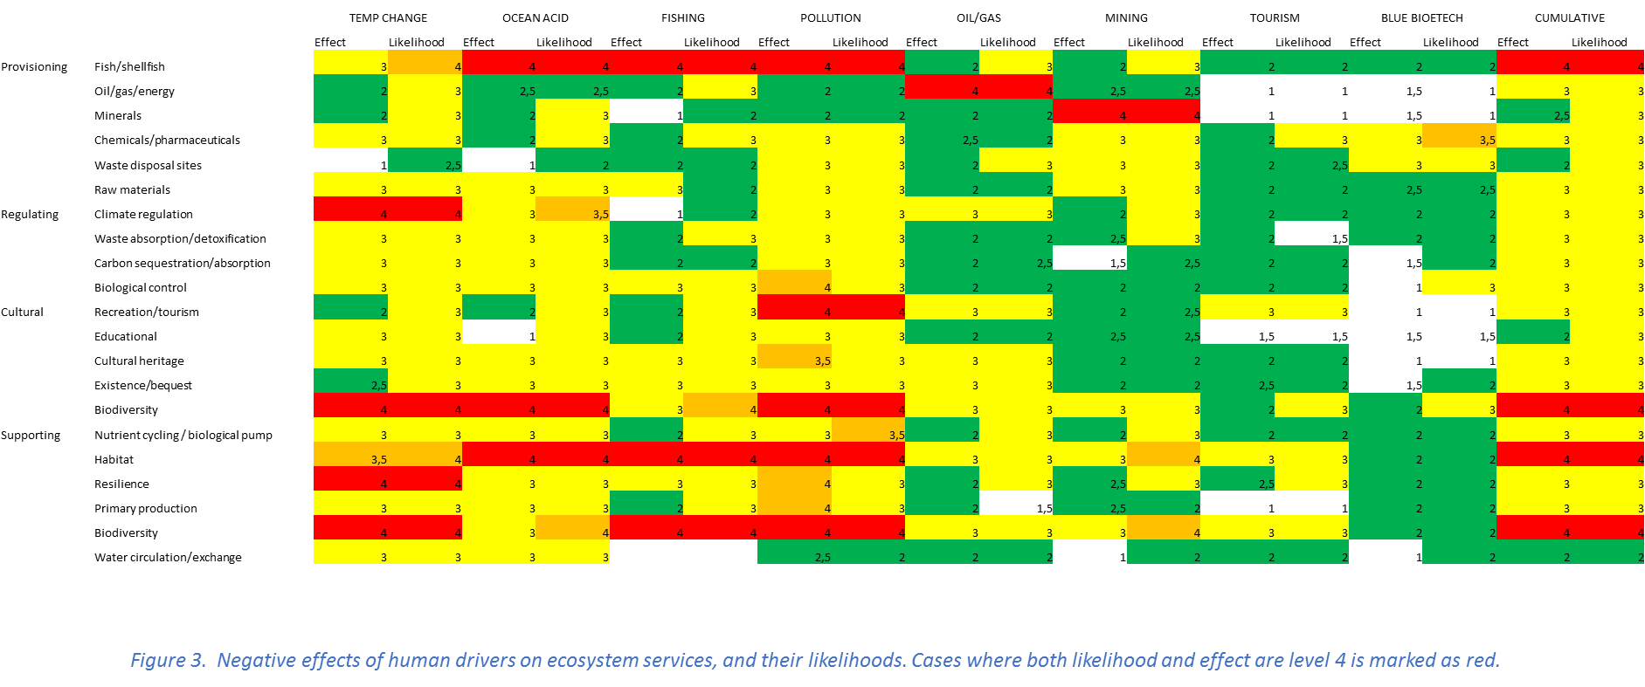

Figure 4: Ecosystem service risk levels from the negative effects of different human drivers from first survey (equivalent to Figure 3 from the second survey).

Figure 5: Human drivers risk levels upon ecosystem services. From the assessment of negative effects of human drivers on ecosystem services for first survey (equivalent to Figure 4 from the second survey).