Supplementary Information
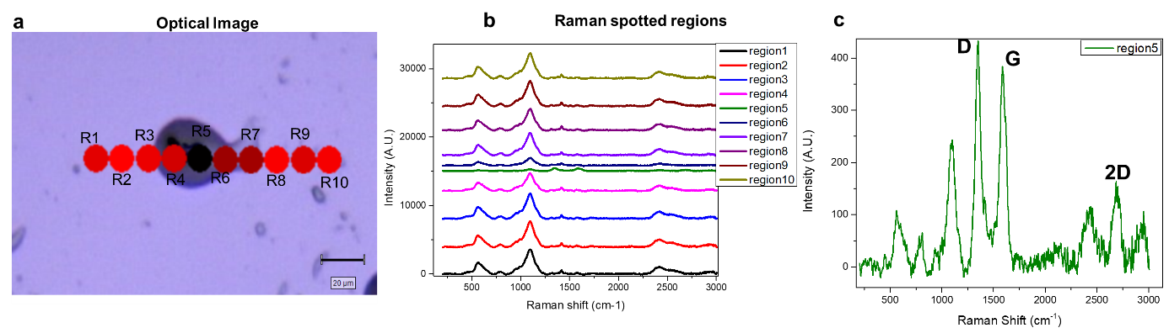
Figure S1: (a) Optical image of RS/CNT marked with different regions R1-R10 over glass substrate. (b) Raman spectrum correspond to the regions marked in panel (a). (c) Region 5 (green colour) is showing the presence of CNT peaks along with Silk fibroin.

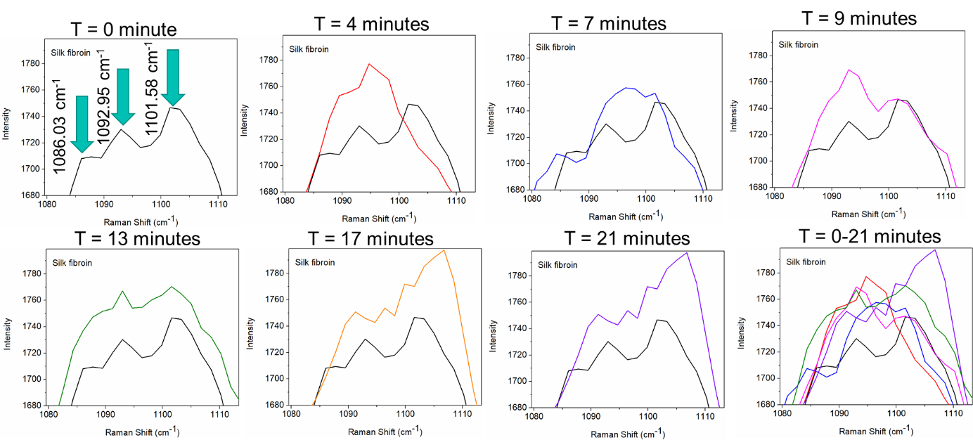
Figure S2: Peak positions range between 1080 cm⁻¹ to 1110 cm⁻¹ of silk fibroin varies at different time interval from 0 minute to 21 minutes. The spectra obtained at t = 0 minute is used as reference for other panels distinctly indicating transformation in the silk fibroin with time.
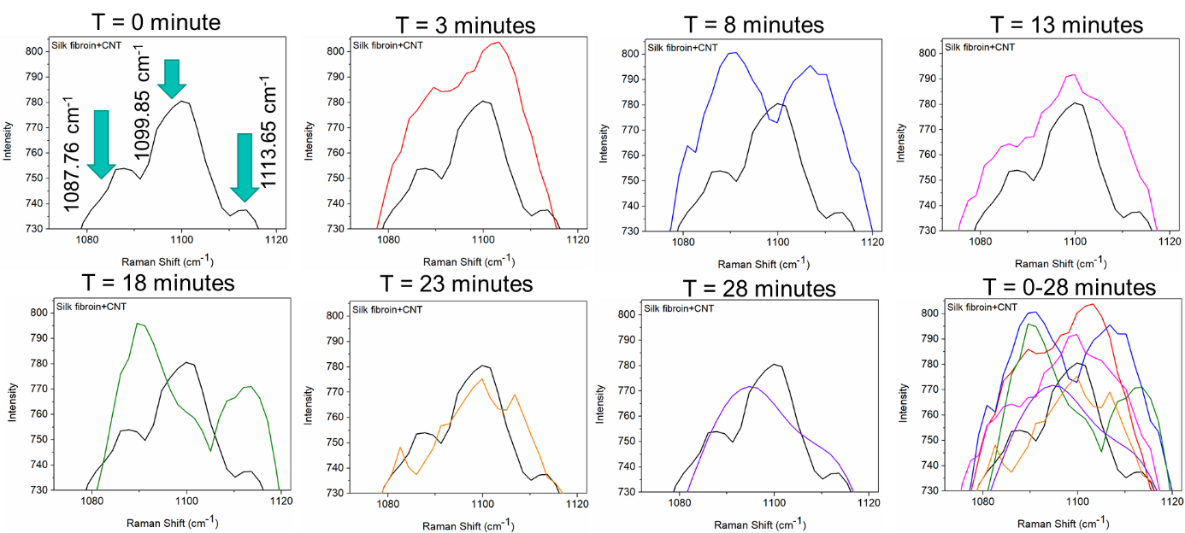
Figure S3: Peak positions range between 1080 cm⁻¹ to 1115 cm⁻¹ of silk fibroin+CNT varies at different time interval from 0 minute to 28 minutes. The spectra obtained at t = 0 minute is used as reference for other panels.

