Supplementary Material

- List of Supplementary Data

Table S1: iGEM Registry IDs for sequences and constructs used in this study
Figure S1: Induction over time of receivers with sender supernatant
Figure S2: Sender-Receiver induction map based on results from assays with cell-free, HSL-enriched liquid media
Figure S3: Sender-Receiver induction map based on results from assays on solid agar

- Supplementary Tables

Supplementary Table S1. iGEM Registry IDs for sequences and constructs used in this study. “Antiquity” indicates that no specific team is known to have contributed the DNA sequence to the Registry. Entries can be accessed at http://parts.igem.org/. Normalized (GFP/OD₆₀₀) GFP signal data from 96-well plate time course experiments with synthetic HSLs and HSL-enriched Sender media are available for each Receiver in Microsoft Excel format. To access the data, please visit http://parts.igem.org/, search for the iGEM Registry part number (e.g. BBa_K2357000), navigate to “experience”, and find the Excel file under “Applications of…” (a) BBa_K2357021 is a derivative of BBa_F2620. An ORF encoding GFP-mut3b (BBa_E0040) was cloned downstream of BBa_F2620.
Part name | iGEM Registry part number | Contributing iGEM Team
LasR Receiver | BBa_K2357000 | iGEM17_Arizona _State
TraR Receiver | BBa_K2357028 | iGEM17_Arizona _State
AubR Receiver | BBa_K2357014 | iGEM17_Arizona _State
BjaR Receiver | BBa_K2357007 | iGEM17_Arizona _State
LuxR Receiver^{(a)} | BBa_K2357021 | iGEM17_Arizona _State
RpaR Receiver | BBa_K2357001 | iGEM17_Arizona _State
RhlR Receiver | BBa_K2357002 | iGEM17_Arizona _State
RpaI | BBa_K1421006 | iGEM14_CAU_China
BraI | BBa_K2033004 | iGEM16_Arizona_State
RhlI | BBa_C0170 | Antiquity
BjaI | BBa_K2033002 | iGEM16_Arizona_State
EsaI | BBa_K1670004 | iGEM15_Manchester-Graz
LuxI | BBa_C0161 | Antiquity
SinI | BBa_K2033008 | iGEM16_Arizona_State
AubI | BBa_K2033000 | iGEM16_Arizona_State
LasI | BBa_C0078 | Antiquity
CerI | BBa_K2033006 | iGEM16_Arizona_State

- Supplementary Figures

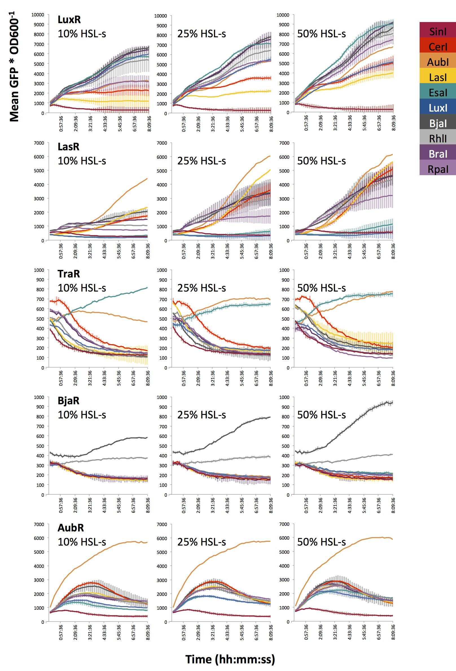

Supplementary Figure S1. Induction over time of receivers with sender supernatant. Average GFP/OD₆₀₀ over time. Receivers cells were diluted to OD₆₀₀ = 0.4 in fresh LB and inoculated with filtered, HSL-enriched supernatant (HSL-s). Percent HSL is calculated based on the fraction of HSL-enriched supernatant in the total volume of treated Receiver culture (see Figure 4). Cells were incubated at 37℃ with constant orbital rotation with GFP (excitation 485, emission 515). GFP and OD₆₀₀ were measured every 10 minutes over 8 hours. Error bars represent standard deviation of three wells.

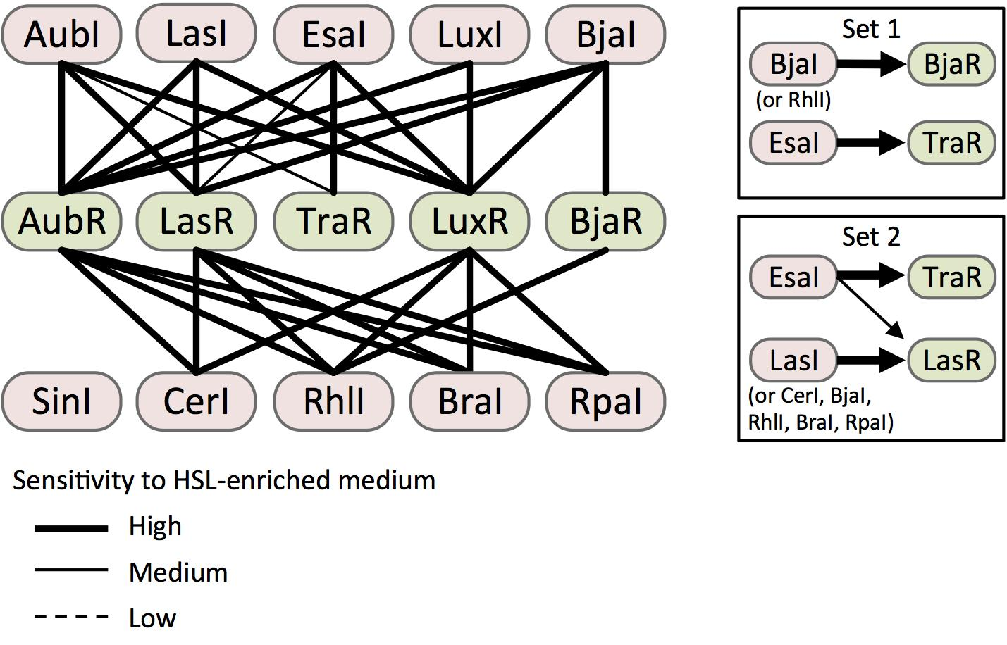

Figure S2. Sender-Receiver induction map based on results from assays with cell-free, HSL-enriched liquid media. Cells are represented as nodes (ovals) linked by edges that are formatted to represent the sensitivity of each Receiver (green) to the HSL-enriched supernatant produced by each Sender (pink). High, medium, and low sensitivity represent inductions where 10%, 25%, or 50% HSL-enriched medium significantly increased GFP signal from a Receiver compared to mock-enriched medium (p < 0.05, Student’s one-tailed t-test). Sets 1 and 2 (boxes) represent Sender/Receiver pairs that are expected to operate without crosstalk. Set 2 is predicted to exhibit no crosstalk at low HSL concentrations (i.e. 10% HSL-enriched medium).

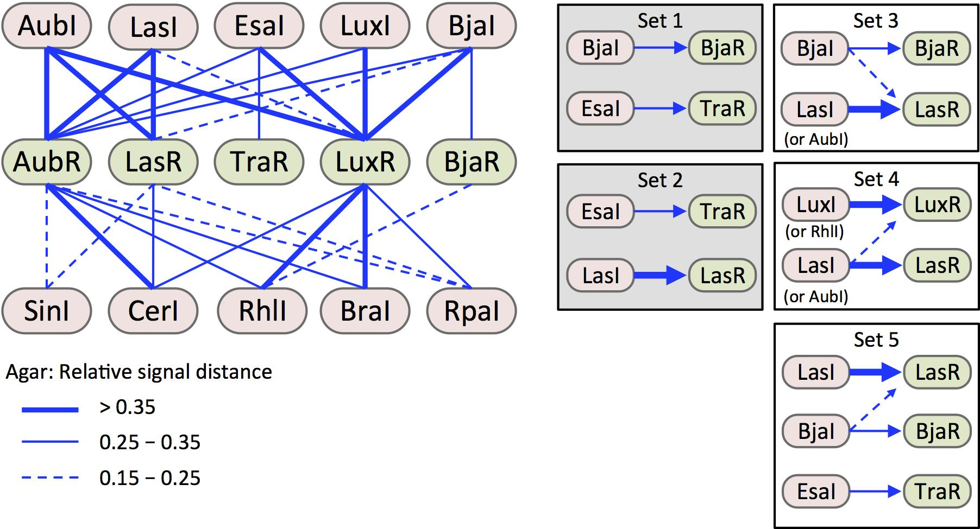

Figure S3. Sender-Receiver induction map based on results from assays on solid agar. As in Figure S2, Sender (pink) and Receiver (green) cells are represented as nodes (ovals) linked by edges that are formatted to represent the strength of induction. Here, induction strength is represented by relative induction distance across a lawn of Receiver cells, which was determined as described in Figure 5. Strong, medium, and low induction strengths, are classified by distance thresholds shown in the legend (bottom left). Shaded boxes indicate orthogonal sets that are also predicted by induction with HSL-enriched media in liquid cultures (sets 1 and 2 from Figure S2).

