Supplementary Material
Title: The Associations of Emotion Coping Appraisal with both the Cue-Outcome Contingency and Perceived Verbal Abuse Exposure
Dong Woo Shin, Taekeun Yoon, and Bumseok, Jeong*
* Correspondence: Bumseok Jeong: bs.jeong@kaist.ac.kr

Supplementary Figures and Tables

Supplementary Figures
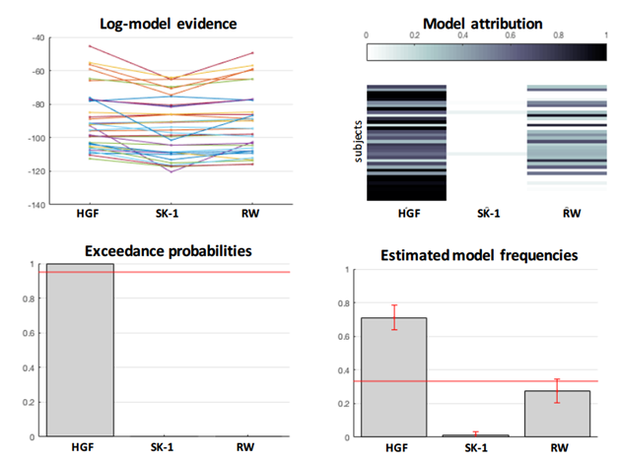
Supplementary Figure 1. The results of RFX-BMS. We compared four models (HGF, SK-1, and RW) in RFX-BMS. RFX-BMS yields an EP of 0.9952 and a PEP of 0.9785 for HGF, indicating that the HGF model was the best model for this task.
RFX-BMS: random-effects model comparison, HGF: hierarchical Gaussian filter, SK-1: Sutton K1, RW: Rescorla-Wagner, EP: exceedance probability, PEP: protected exceedance probability.

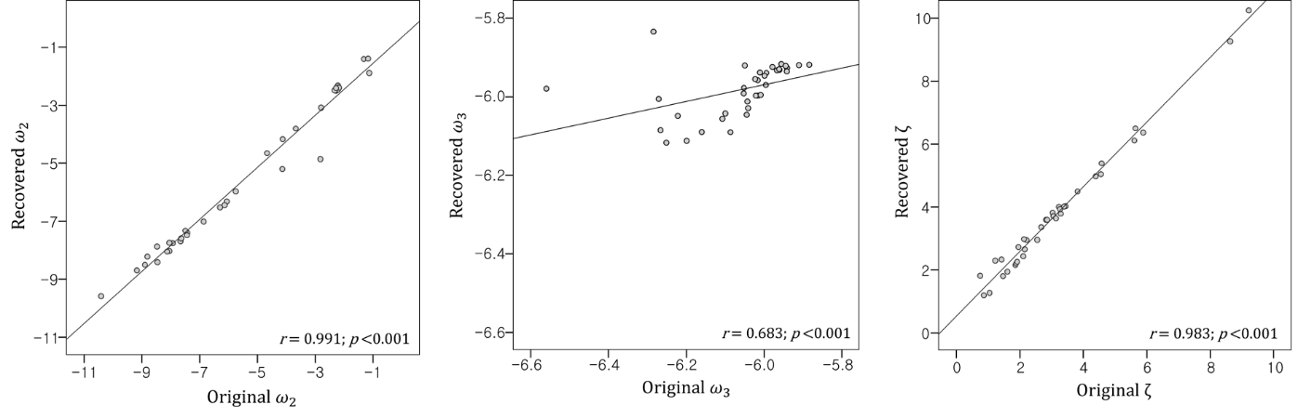
Supplementary Figure 2. Parameter recovery. A parameter recovery simulation was performed by simulating 100 responses using estimated parameters from each subject and subsequently re-estimating the parameters from these simulated responses. We evaluated the relationship between the original parameters and the mean of the recovered parameters 100 times. The original parameter is shown on the x-axis and the recovered parameter is shown on the y-axis. Parameters of the original model were significantly correlated with the mean of recovered parameters (Spearman’s correlation analysis), indicating that the parameters were reliably estimated.
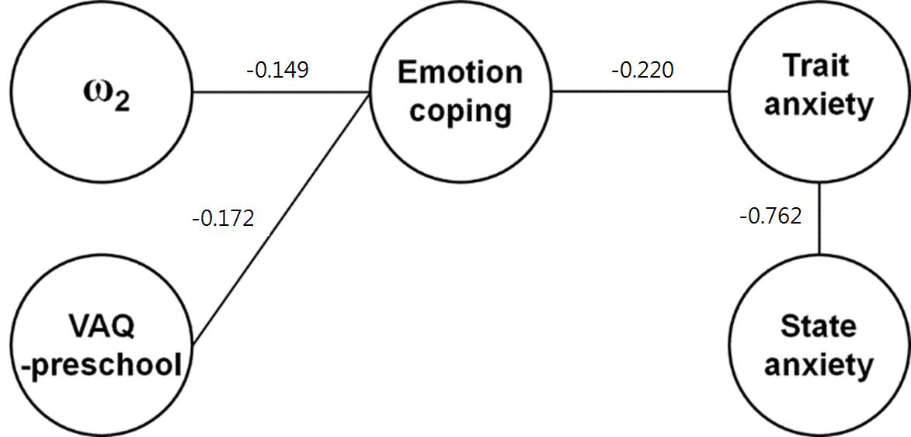
Supplementary Figure 3. Mixed graphical model of RAS-emotion coping with propensity score matching. We extracted data from 13 men and 13 women with propensity score matching of age and IQ to clarify whether a gender effect exists. We tested the mixed graphical model with the gender-matched subgroup consisting of 26 subjects. The mixed graphical model described the correlations of the RAS-emotion coping score with ω₂ and VAQ-preschool, and with trait anxiety. These results are consistent with the data shown in Figure 4 in our main manuscript. The gender factor was removed from the figure because it was not associated with any parameters. The estimates using the mixed graphical model function are displayed above the connecting line.

Supplementary Tables
Supplementary Table 1. Mean and variance of Gaussian priors used in HGF parameter estimation.
HGF parameter | Prior mean | Prior variance
Tonic volatility (level 2: ω₂) | -3 | 16
Tonic volatility (level 3: ω₃) | -6 | 16
Decision noise (ζ) | log_{e}48 (= 3.8712) | 1
HGF: hierarchical Gaussian filter

Supplementary Table 2. VIF value derived from multicollinearity test for proposed models using the RAS-total score as the dependent variable.
Predictor  Regression model | VAQ-preschool (T) | ω₂ | VAQ-preschool (T) × ω₂
Simple model | 1.00 | 1.00 | -
Full model | 9.24 | 3.88 | 11.61
Partial model with ω₂ | - | 1.26 | 1.26
Partial model with VAQ-preschool | 3.00 | - | 3.00
VIF: variance inflation factor, RAS: Resilience Appraisal Scale, VAQ: Verbal Abuse Questionnaire, (T): Tukey’s ladder of powers transformation.
VAQ-preschool (T) × ω₂: interaction of VAQ-preschool (T) and ω₂

Supplementary Table 3. The results of random-effects model comparison (RFX-BMS).
Model  Estimate | HGF | SK-1 | RW
Estimated model frequencies | 0.7104 | 0.0151 | 0.2745
Exceedance probabilities | 0.9952 | 0 | 0.0048
Protected exceedance probabilities | 0.9785 | 0.0084 | 0.0131
HGF: hierarchical Gaussian filter, SK-1: Sutton K1, RW: Rescorla-Wagner.

Supplementary Table 4. Model fit and LOOCV result of the multiple linear regression analysis of ‘Partial model with ω₂’, ‘VAQ-preschool only model’ and ‘ω₂ only model’.
 | Linear model fit |  |  |  |  | Predicted value |  |  | Model comparison
Regression model | Adjusted R² | RMSE | AIC |  |  | Q² |  | RMSE | (ANOVA)
RAS-total (dependent variable)
Partial model with ω₂ | 0.170 | 5.091 | 227.3 |  |  | 0.134 |  | 5.587
VAQ-preschool only model | 0.101 | 5.379 | 229.3 |  |  | 0.093 |  | 5.719 | F(1,33) = 3.847, p-value = 0.0583
ω₂ only model | 0.063 | 5.492 | 230.8 |  |  | 0.029 |  | 5.916 | F(1,33) = 5.405, p-value = 0.0263
RAS-emotion coping (dependent variable)
Partial model with ω₂ | 0.168 | 2.204 | 167.1 |  |  | 0.142 |  | 2.405
VAQ-preschool only model | 0.105 | 2.320 | 168.8 |  |  | 0.103 |  | 2.458 | F(1,33) = 3.567, p-value = 0.0677
ω₂ only model | 0.085 | 2.346 | 169.6 |  |  | 0.054 |  | 2.524 | F(1,33) = 4.382, p-value = 0.0441
LOOCV: leave-one-out cross-validation, VAQ: Verbal Abuse Questionnaire, RAS: Resilience Appraisal Scale, adjusted R²: adjusted squared correlation coefficient, RMSE: root mean square error, AIC: Akaike information criterion, Q²: predictive squared correlation coefficient, ANOVA: analysis of variance.
Partial model with ω₂: RAS ~ VAQ-preschool (T) × ω₂ + ω₂
VAQ-preschool only model: RAS ~ VAQ-preschool (T)
ω₂ only model: RAS ~ ω₂
(T): Tukey’s ladder of powers transformation
VAQ-preschool (T) × ω₂: interaction of VAQ-preschool (T) and ω
Supplementary Table 5. Multiple linear regression analysis of the ‘Partial model with ω₂’ with the dependent variable for each RAS subscale
 | RAS Subscale (dependent variable)
 | RAS-emotion coping | RAS-social support | RAS-situation coping
ω₂ (estimate, 95% CI) | -0.445 (-0.748, -0.142)** | -0.232 (-0.497, 0.034) | -0.319 (-0.580, -0.057)*
VAQ-preschool (T) × ω₂ (estimate, 95% CI) | 0.119 (0.008, 0.231)* | 0.101 (0.003, 0.199) | 0.086 (-0.010, 0.182)
Constant (estimate, 95% CI) | 13.851 (12.195, 15.507)*** | 16.498 (15.048, 17.948)*** | 15.223 (13.797, 16.649)***
Adjusted R² | 0.168 | 0.076 | 0.109
Residual standard error (df = 33) | 2.302 | 2.015 | 1.982
F (2,33), p-value | 4.528* (0.0183) | 2.445 (0.1023) | 3.135 (0.0567)
RAS: Resilience Appraisal Scale, VAQ: Verbal Abuse Questionnaire, CI: confidence interval, (T): Tukey’s ladder of powers transformation, adjusted R²: adjusted squared correlation coefficient.
VAQ-preschool (T) × ω₂: interaction of VAQ-preschool (T) and ω₂
*p < 0.05, **p < 0.01, and ***p < 0.001
Supplementary Table 6. LOOCV result for each model.
Regression model | Q² | RMSE
RAS-total (dependent variable)
Simple model | 0.117 | 5.640
Partial model with VAQ-preschool | 0.065 | 5.805
Partial model with ω₂ | 0.134 | 5.587
RAS-emotion coping (dependent variable)
Simple model | 0.156 | 2.385
Partial model with VAQ-preschool | 0.125 | 2.429
Partial model with ω₂ | 0.142 | 2.405
LOOCV: leave-one-out cross-validation, Q²: predictive squared correlation coefficient, RMSE: root mean square error, RAS: Resilience Appraisal Scale, VAQ: Verbal Abuse Questionnaire.
Simple model: RAS-emotion coping ~ VAQ-preschool (T) + ω₂
Partial model with ω₂: RAS-emotion coping ~ ω₂ + VAQ-preschool (T) × ω₂
Partial model with VAQ-preschool: RAS-emotion coping ~ VAQ-preschool (T) + VAQ-preschool (T) × ω₂
VAQ-preschool (T) × ω₂: interaction of VAQ-preschool (T) and ω₂
(T): Tukey’s ladder of powers transformation
Supplementary Table 7. Various multiple linear regression models using RAS-total as the dependent variable
 | RAS-total (dependent variable)
 | Model 1 | Model 2 | Model 3 | Partial model with ω₂
VAQ-preschool (T) (estimate, 95% CI) | -1.411 (-4.146, 1.324)
VAQ-childhood  (estimate, 95% CI) | 0.033 (-0.261, 0.327)
VAQ-adolescence  (estimate, 95% CI) | -0.116 (-0.444, 0.212)
ω₂ (estimate, 95% CI) | -0.851 (-1.849, 0.147) | -1.268 (-2.277, -0.260)* | -1.004 (-1.888, -0.121)* | -0.995 (-1.696, -0.295)**
ω₃ (estimate, 95% CI) | -2.535 (-21.865, 16.796) | -3.115 (-22.022, 15.791) | -0.647 (-19.087, 17.794)
ζ (estimate, 95% CI) | 0.065 (-1.185, 1.314) | -0.096 (-1.259, 1.066) | 0.041 (-1.133, 1.215)
ω₂ × VAQ-adolescence (estimate, 95% CI) |  | 0.018 (0.001, 0.036)*
ω₂ × VAQ-preschool (T) (estimate, 95% CI) |  |  | 0.308 (0.035, 0.581)* | 0.306 (0.048, 0.564)*
Constant (estimate, 95% CI) | 31.701 (-89.083, 152.484) | 25.127 (-93.556, 143.811) | 41.485 (-74.076, 157.046) | 45.572 (41.747, 49.397)***
Adjusted R² | 0.073 | 0.103 | 0.117 | 0.170
Residual standard error | 5.620 (df = 29) | 5.526 (df = 31) | 5.485 (df = 31) | 5.317 (df = 33)
F value, p-value | 1.458 (df = 6; 29), 0.2273 | 2.010 (df = 4; 31), 0.1176 | 2.157 (df = 4; 31), 0.0972 | 4.589* (df = 2; 33), 0.0174
RAS: Resilience Appraisal Scale, VAQ: Verbal Abuse Questionnaire, (T): Tukey’s ladder of powers transformation, CI: confidence interval, adjusted R²: adjusted squared correlation coefficient.
Model 1: RAS ~ VAQ-preschool (T) + VAQ-childhood + VAQ-adolescence + ω₂ (T) + ω₃ + ζ
Model 2: RAS ~ ω₂ + ω₃ + ζ + VAQ-adolescence × ω₂
Model 3: RAS ~ ω₂ + ω₃ + ζ + VAQ-preschool (T) × ω₂
Partial model with ω₂: RAS ~ VAQ-preschool (T) × ω₂ + ω₂
ω₂ × VAQ-adolescence: interaction of ω₂ and VAQ-preschool
ω₂ × VAQ-preschool (T): interaction of ω₂ and VAQ-preschool (T)
*p < 0.05, **p < 0.01, and ***p < 0.001

