Supplementary Material

Supplementary Figures
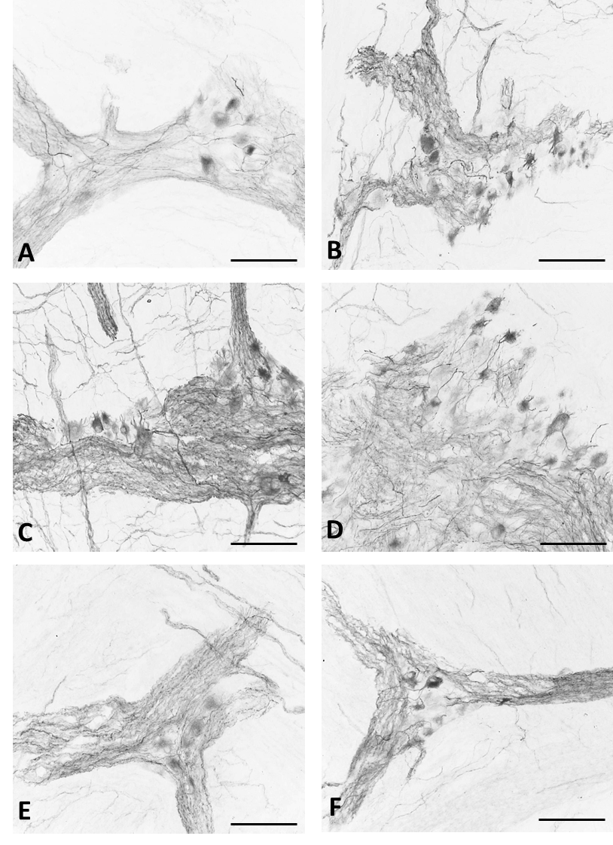
Supplementary Figure 1. (A-F) IHC on human ascending colon section using hpChAT antisera from individually immunized mice (dilution 1:20,000). IHC with H3 antiserum used in the present study is illustrated in C. All scale 100 μm.

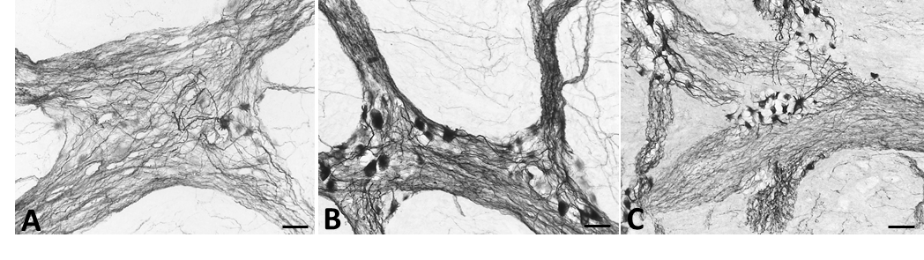
Supplementary Figure 2. Immunostaining using hpChAT antiserum in the human (A) duodenum, (B) ileum, and (C) ascending colon. All scales = 50 μm.

