Supplementary Material

Reviewing Vietnam’s National Determine Contribution: A New Perspective Using the Marginal Cost of Abatement
Daniel Escobar Carbonari^{1, 2, 7*}, Godefroy Grosjean², Peter Läderach ², Tran Dai Nghia³, Bjoern Ole Sander⁴, Justin McKinley ⁵, Leocadio Sebastian⁴, Jeimar Tapasco⁶
¹Stockholm University, Department of Physical Geography, Stockholm, Sweden.
²Area of Decision and Policy Analysis, International Center for Tropical Agriculture (CIAT), CGIAR Research Program on Climate Change, Agriculture and Food Security (CCAFS), Hanoi, Vietnam
³The Institute of Policy and Strategy for Agriculture and Rural Development (IPSARD), Department of Natural Resources and Environmental Economics, Hanoi, Vietnam.
⁴International Rice Research Institute (IRRI), CGIAR Research Program on Climate Change, Agriculture and Food Security (CCAFS), Hanoi, Vietnam
⁵Monash University, Department of Economics, Clayton, Australia.
⁶ Area of Decision and Policy Analysis, International Center for Tropical Agriculture (CIAT), CGIAR Research Program on Climate Change, Agriculture and Food Security (CCAFS), Cali, Colombia
⁷Ecotonos Foundation, Cali, Colombia
* Correspondence:
Daniel Escobar Carbonari
dscovar90@gmail.com

Supplementary Figures and Tables

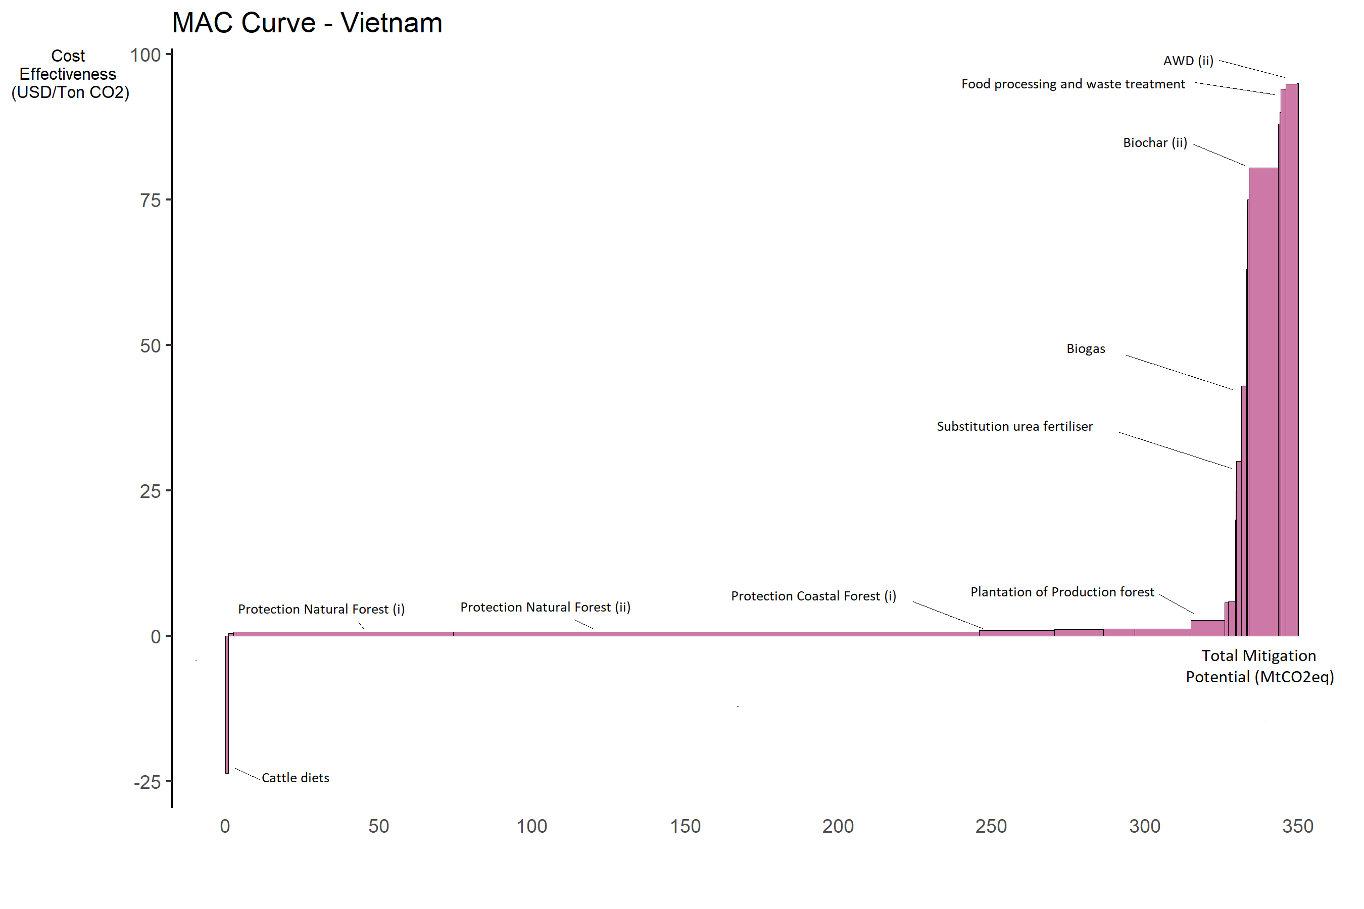

Supplementary Figure 1. Marginal abatement cost curve for the AFOLU sector based on Vietnam’s NDC technical reports (i) national goal with national effort and (ii) national goal with international support.

Name in the MAC curve | Unit | Goal | Abatement potential (tCO₂eq) | Total cost (USD) | Cost-effectiveness (USD/tCO₂eq)
Biogas | Units | 500000 | 3170000 | 136 310 000 | 43
Agricultural residues (i) | ha | 3500000 | 360000 | 22 680 000 | 63
Agricultural residues (ii) | ha | 2800000 | 290000 | 21 175 800 | 73.02
AWD (i) | ha | 200000 | 940000 | 82 720 000 | 88
AWD (ii) | ha | 1500000 | 7020000 | 666 198 000 | 94.9
Biochar (i) | ha | 200000 | 1070000 | 80 250 000 | 75
Biochar (ii) | ha | 3500000 | 18800000 | 1 512 460 000 | 80.45
Integrated mgmt rice | ha | 1000000 | 500000 | 10 000 000 | 20
Integrated mgmt crops | ha | 1000000 | 320000 | 8 000 000 | 25
Substitution urea fertilizer | ha | 2000000 | 3200000 | 96 000 000 | 30
Cattle diets | head | 22000000 | 1750000 | -41 352 500 | -23.63
Improve aquaculture | ha | 1000000 | 410000 | 36 900 000 | 90
Improve waste aquaculture | ha | 1000000 | 1210000 | 114 950 000 | 95
Food processing and waste treatment | ton | 21000000 | 3360000 | 315 840 000 | 94
Irrigation in coffee production | ha | 640000 | 3390000 | 1 559 400 | 0.46
Protection natural forest (i) | ha | 1000000 | 140380000 | 92 650 800 | 0.66
Protection natural forest (ii) | ha | 2200000 | 336630000 | 235 641 000 | 0.7
Protection coastal forest (i) | ha | 100000 | 47930000 | 45 533 500 | 0.95
Protection coastal forest (ii) | ha | 30000 | 4410000 | 25 930 800 | 5.88
Plantation coastal forest | ha | 10000 | 2290000 | 13 098 800 | 5.72
Natural forest regeneration | ha | 200000 | 31340000 | 36 981 200 | 1.18
Natural forest assisted regeneration | ha | 200000 | 20150000 | 24 180 000 | 1.2
Plantation of production forest | ha | 150000 | 21590000 | 57 645 300 | 2.67
Natural and production forest assisted regeneration | ha | 400000 | 35810000 | 42 972 000 | 1.2
Supplementary Table 1. Summary of relevant variables of the mitigations options in the MAC curve derived by Vietnams NDC technical report.

Name in MAC curve | Adaptation co-benefit | Sources
Acacia in bare land | Run-off control | (Douglas, 1999)
AWD Mekong 1 | Protection against water shortages due to precipitation extremes. | (Mohanty, Wassmann, Nelson, & Moya, 2013)
AWD Mekong 2
AWD red river 1
AWD red river 2
Bamboo protection 1 | Provision of resources in case of scarcity due to high resilient biology. | (Lobovikov, Schoene, & Yping, 2012)
Bamboo restoration 1
Bamboo restoration 2
Bamboo restoration 3
Bamboo restoration 4
Beef Diet Supplement | Reduce risk of shortages of animal feed by diversification of the cattle diet. | (Thornton & Herrero, 2014)
Biogas from pigs | Not found
Coffee and avocado | Protection against climate variability, creation of microclimates to maintain coffee suitability. | (Noordwijk, et al., 2014)
Coffee and cassia
Coffee and durian
Compost from pigs | Not found
Dairy TMR | Reduce risk of shortages of animal feed by diversification of the cattle diet. | (Thornton & Herrero, 2014)
Forest protection 1 | Protection against climate variability and climate extreme events. Provision of resources in case of scarcity. Water regulation. | (Locatelli, Evans, Wardell, Andrade, & Vignola, 2011)
Forest restoration 1
Forest restoration 2
Forest restoration 3
Low tillage (S & P) | Reduction of soil erosion, water regulation and nutrient retention. | (Wall & Smit, 2008), (Jeppesen, et al., 2009)
Maize AS | Not found
Maize compost | Reduction of soil erosion and increase water retention. | (Zougmoré, Jalloh, & Tioro, 2014)
Maize residues | Not found
Mangrove protection | Coastline stabilization, storm protection and provision of resources in case of scarcity. | (Alongi, 2008)
Mangrove restoration 1
Mangrove restoration 2
Rain forest protection 1 | Protection against climate variability and climate extreme events. Provision of resources in case of scarcity. Water regulation. | (Locatelli, Evans, Wardell, Andrade, & Vignola, 2011)
Rain forest protection 2
Rain forest restoration 1
Rain forest restoration 2
Rain forest restoration 3
Rain forest restoration 4
Rice transformed acacia | Not found
Rice transformed maize | Not found
Rice transformed rubber | Not found
Rice straw | Not found
Rubber in bare land | Run-off control | (Douglas, 1999)
Sugarcane AS | Not found
Compost Sugarcane | Reduction of soil erosion and increase water retention. | (Zougmoré, Jalloh, & Tioro, 2014)
Supplementary Table 2. Summary of climate change adaptation benefits of the mitigation options studied.

