Supplementary Material

Prioritising support for cost effective rare breed conservation using multi-criteria decision analysis

WARWICK WAINWRIGHT\*, BOUDA VOSOUGH AHMADI, ALISTAIR McVITTIE,GEOFF SIMM AND DOMINIC MORAN

**\* Correspondence:** Corresponding Author: [warwick.wainwright@sruc.ac.uk](mailto:warwick.wainwright@sruc.ac.uk)

# Supplementary figures and tables

## S1: Map showing geographical origin of 19 cattle NBAR used in this case study.

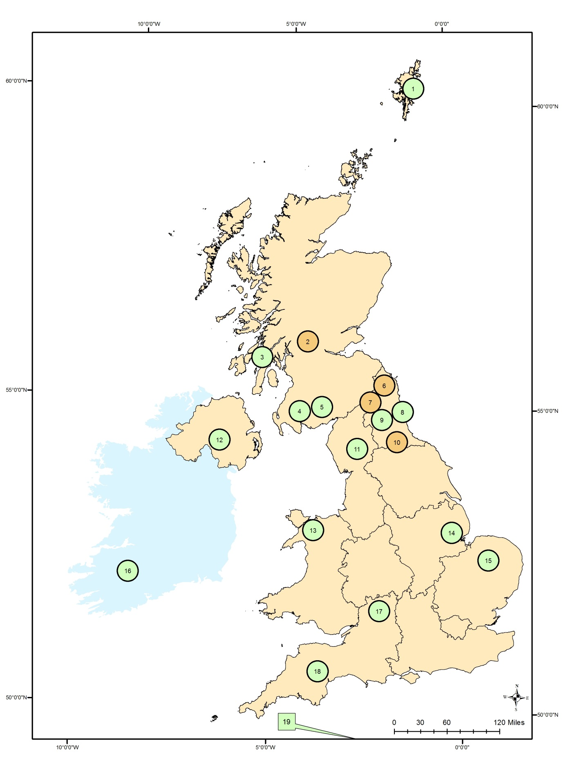

## S2: List of institutions and roles of participants attending both workshops

|  |  |
| --- | --- |
| **Person position** | **Institution** |
| *Initial workshop* |  |
| Chief exec | RBST |
| Field officer | RBST |
| Chair of Conservation Committee | FAnGR Comitee |
| Advisor | FAnGR Comitee |
| Associate Professor in Human Geography | Plymouth University |
| Breed society chief exec | Gloucester Beef Society |
| Specialist Breeding Advisor | Signet (ADHB) |
| Breed secretary | The Dexter Cattle Society |
| Chief Exec | British Pig Association & FAnGR Committee |
| Breed Census and Records rep | Traditional Herefords Breeders Group |
| PhD Student | SRUC |
| Reseach Economist | SRUC |
| *Final weighting and scoring workshop* | |
| Field officer | RBST |
| Field officer | RBST |
| Conservation Grazing | Natural England |
| RBST Chairman | RBST |
| Trainee Vet | AB Europe |
| Conservation officer | Natural England |
| Conservation Grazer | Pasture-Fed Livestock Association |
| PhD Student | SRUC |
| Reseach Economist | SRUC |

## S3: Summary of criteria and sub-criteria used in the MCDA model

|  |  |  |  |
| --- | --- | --- | --- |
| **Criteria** | **Sub-criteria** | **Scoring approach** | **Description** |
| Diversity | \* Effective population size (Ne) | Linear | Ne is a metric that takes account of the total number of animals in a population but importantly also their breeding structure. A low Ne signifies a greater risk of declining genetic diversity within breeding populations. |
| \* % change to Ne over last 5 years | Linear | This criterion determines % change to Ne over last 5 years. This is to determine the trend of Ne for each breed. |
| \* Geographic origin | Categorical | Work by multiple authors (e.g. Lenstra et al., 2017; Parker et al., 2017) reveals breeds are usually share similar genetic variation according to their region of origin and common ancestry. Maximising difference in geographic origin may therefore aid wider capture of genetic diversity. |
| Marketability (utility) | \* Product designations | Categorical | Product designations - e.g. Product Designation of Origin (PDO) may be used to promote production methods that employ traditional breeds. |
| \* Breed branded products | Categorical | The sale of breed specific products across the "big seven" major retailers in the UK. |
| \* Conservation grazing demand | Categorical | Demand for the breed in conservation grazing schemes. |
| Marketability (traits) | \* Adaptability and hardiness | Categorical | Is breed considered adaptive to different production environments and is it hardy. |
| \* Ability to graze wet sites | Categorical | Can the breed maintain condition while grazing wet/marshy sites? |
| \* Heat stress | Categorical | Does the breed harbour tolerance or susceptibility to heat stress? |
| Endangerment | \* No. of embryos collections stored in cryobank | Preference value | An embryo collection consists of two embryos collected per female. |
| \* No. of males collected from | Preference value | The number of different males with semen collected from and stored in cryobank. |
| \* No. of semen straws stored in cryobank | Preference value | Total number of semen straws stored from each breed. |
| Geographical concentration | Categorical | The percentage of a breed’s total population that is concentrated within a 65km from the mean centre of each breed. |
| \* No. of pedigree breeding females in 2016 | Preference value | Estimated by multiplying the average number of female registrations over the previous three complete years by standard Defra multipliers for each species. |
| \* No. of pedigree breeding males registering offspring in 2016 | Preference value | Number of pedigree sires which produced pedigree registered offspring in the most recent year. |
| \* % change in number of pedigree females during last 5 years | Preference value | Based on % change between in number of pedigree registered females during last 5 years. |
| \* No. of active herds | Preference value | Number of herds which have registered pedigree offspring in any of the past three years |

## S4: Criteria weights used for scoring the breeds.

|  |  |  |
| --- | --- | --- |
|  |  | Effective population size (Ne) - [40] - (12) |
| Diversity - [30] |  | % change to Ne - [40] - (12) |
|  |  | Geographic origin - [20] - (6) |
|  |  | Breed branded products - [40] - (4) |
|  | Utility - [50] - (10) | Conservation grazing demand - [40] - (4) |
| Current marketability - [20] |  | Product designations - [20] - (2) |
|  |  | Adaptability and hardiness - [33] - (3.3) |
|  | Traits - [50] - (10) | Ability to graze wet sites - [33] - (3.3) |
|  |  | Heat stress - [33] - (3.3) |
|  |  | No. of embryo collection stored - [5] - (2.5) |
|  | *Ex situ* - [15] - (7.5) | No. of semen straws stored - [5] - (2.5) |
|  |  | No. of males semen collected from - [5] - (2.5) |
| Endangerment - [50] |  | Geographical concentration - [20] - (10) |
|  |  | No. pedigree breeding females in 2016 - [15] - (7.5) |
|  | *In situ* - [85] - (42.5) | No. pedigree males registering offspring in the most recent year - [15] - (7.5) |
|  |  | % change in pedigree breeding females registered over last 5 years - [15] - (7.5) |
|  |  | No. active pedigree herds - [20] - (10) |

Key: [local weight scaling] and (global weight scaling).

## S5: Scatter plots showing breed endangerment and marketability (left) and endangerment and diversity scores (right) with trend line. The regression equation and r2 is also provided.

C:\Users\wwainwright\Documents\R\MCDA\Plots\MCDABreeds_XYPanel.tiff

## S6: Breed sensitivity analysis showing criteria sensitivity to an increase or decrease in cumulative weight and which breed would be next highest scoring.

|  |  |  |  |  |
| --- | --- | --- | --- | --- |
| **Breed** | **Decrease cum.weight** | **Criteria** | **Increase cum. weight** | **Breed** |
|  |  | Effective population size (Ne) | ++ | R.R Devon |
| Vaynol | ++ | % change to Ne | + | Luing |
|  |  | Geographic origin | ++ | Vaynol |
|  |  | Breed branded products | ++ | Gloucester |
|  |  | Conservation grazing demand | + | Vaynol |
|  |  | Product designations | ++ | Gloucester |
|  |  | Adaptability and hardiness | + | Red Poll |
|  |  | Ability to graze wet sites | + | Red poll |
|  |  | Heat stress | ++ | Red poll |
|  |  | No. of embryo collection stored | + | Red poll |
|  |  | No. of semen straws stored | ++ | B.White |
|  |  | No. of males semen collected from | + | Luing |
| B.Whitee | ++ | Geographical concentration | + | Vaynol |
|  |  | No. pedigree breeding females in 2016 | + | Vaynol |
|  |  | No. pedigree males registering offspring in the most recent year | ++ | Vaynol |
|  |  | % change in pedigree breeding females registered over last 5 years | + | Highland |
|  |  | No. active pedigree herds | + | Vaynol |
| Key: '+++' = cumulative weight change of >5 points would change preferred breed; '++' = cumulative weight change of 5-15 points would change preferred breed; '+' = cumulative change of <15 points to change preferred breed. | | | | |

## S7: Summary statistics for each principal component from the PCA for all the breed scoring criteria (top table) and criteria nodes (bottom table).

|  |  |  |  |  |  |  |  |
| --- | --- | --- | --- | --- | --- | --- | --- |
|  | PC1 | PC2 | PC3 | PC4 | PC5 | PC6 | PC7 |
| Eigen value | 4.874 | 2.800 | 2.507 | 1.510 | 1.171 | 0.976 | 0.866 |
| Proportion of Variance | 0.287 | 0.165 | 0.147 | 0.089 | 0.069 | 0.057 | 0.051 |
| Cumulative Proportion | 0.287 | 0.451 | 0.599 | 0.688 | 0.757 | 0.814 | 0.865 |
|  | PC8 | PC9 | PC10 | PC11 | PC12 | PC13 | PC14 |
| Eigen value | 0.685 | 0.500 | 0.478 | 0.251 | 0.192 | 0.107 | 0.040 |
| Proportion of Variance | 0.040 | 0.029 | 0.028 | 0.015 | 0.011 | 0.006 | 0.002 |
| Cumulative Proportion | 0.905 | 0.935 | 0.963 | 0.978 | 0.989 | 0.995 | 0.998 |
|  | PC15 | PC16 | PC17 |  |  |  |  |
| Eigen value | 0.025 | 0.017 | 0.001 |  |  |  |  |
| Proportion of Variance | 0.001 | 0.001 | 0.000 |  |  |  |  |
| Cumulative Proportion | 0.999 | 1.000 | 1.000 |  |  |  |  |

|  |  |  |  |  |  |
| --- | --- | --- | --- | --- | --- |
|  | PC1 | PC2 | PC3 | PC4 | PC5 |
| Eigen value | 2.208 | 1.285 | 0.712 | 0.515 | 0.280 |
| Proportion of Variance | 0.442 | 0.257 | 0.142 | 0.103 | 0.056 |
| Cumulative Proportion | 0.442 | 0.699 | 0.841 | 0.944 | 1.000 |

## S8: The variable loadings (rotations) for each principal component with eigen values > 1 derived from the PCA for all breed scoring criteria (top table) and criteria nodes (bottom table).

|  |  |  |  |  |  |
| --- | --- | --- | --- | --- | --- |
|  | PC1 | PC2 | PC3 | PC4 | PC5 |
| Ne | -0.290 | 0.355 | 0.004 | 0.084 | -0.154 |
| ChangeNe | -0.035 | -0.245 | -0.323 | 0.333 | -0.135 |
| GO | -0.115 | -0.034 | 0.295 | 0.169 | 0.581 |
| BP | 0.086 | 0.248 | 0.234 | -0.519 | 0.018 |
| CG | -0.239 | -0.384 | 0.315 | 0.005 | -0.043 |
| PD | 0.226 | 0.246 | 0.302 | -0.017 | -0.292 |
| AH | -0.249 | -0.415 | 0.070 | 0.010 | 0.073 |
| GWS | -0.325 | -0.183 | 0.094 | -0.052 | -0.181 |
| HS | -0.148 | 0.140 | 0.136 | -0.145 | 0.483 |
| NEC | -0.287 | -0.080 | 0.175 | -0.233 | -0.192 |
| NSS | -0.258 | 0.101 | -0.289 | -0.405 | 0.068 |
| NMSC | -0.080 | -0.342 | -0.239 | -0.488 | -0.135 |
| GC | 0.139 | -0.057 | 0.382 | 0.060 | -0.413 |
| PBF | 0.373 | -0.255 | 0.087 | -0.031 | 0.124 |
| PBM | 0.342 | -0.167 | 0.147 | -0.300 | 0.078 |
| CPBF | -0.215 | -0.072 | 0.429 | 0.084 | -0.028 |
| NAH | 0.347 | -0.289 | -0.022 | -0.048 | 0.096 |

|  |  |  |
| --- | --- | --- |
|  | PC1 | PC2 |
| Diversity | 0.520 | -0.257 |
| Utility | -0.098 | 0.781 |
| Traits | 0.452 | 0.433 |
| Ex.situ | 0.469 | 0.294 |
| In.situ | -0.544 | 0.227 |

Note*:* the loadings are essentially the coefficients of the PCs and show how the variables relate to the principal components.

## S9: Hypothetical allocation of a ‘breed improvement fund’ across breed societies for the 19 breeds. The sensitivity of the budget allocation to the different scenarios is also provided.

|  |  |  |  |  |  |
| --- | --- | --- | --- | --- | --- |
| **Breed** | **Budget: S1** | **Budget: S2** | **Budget: S3** | **Budget: S4** | **High/low difference** |
|
| B.Galloway | 499,457 | 487,515 | 535,332 | 465,839 | 69,493 |
| B.White | 597,177 | 582,640 | 631,692 | 579,710 | 51,982 |
| D.Shorthorn | 53,720 | 53,720 | 53,720 | 53,720 | 0 |
| N.D.Shorthorn | 85,053 | 85,053 | 85,053 | 85,053 | 0 |
| R.R.Devon | 553,746 | 618,312 | 546,039 | 517,598 | 100,713 |
| Dexter | 477,742 | 523,187 | 513,919 | 393,375 | 129,812 |
| Galloway | 510,315 | 463,734 | 524,625 | 538,302 | 74,569 |
| Gloucester | 500,640 | 463,734 | 500,640 | 500,640 | 36,906 |
| Guernsey | 510,315 | 511,296 | 503,212 | 527,950 | 24,738 |
| Highland | 597,177 | 558,859 | 674,518 | 517,598 | 156,920 |
| I.Moiled | 597,177 | 594,530 | 578,158 | 610,766 | 32,608 |
| L.Red | 423,453 | 463,734 | 385,439 | 445,135 | 78,295 |
| Longhorn | 412,595 | 463,734 | 374,732 | 414,079 | 89,001 |
| Luing | 618,893 | 689,655 | 620,985 | 559,006 | 130,649 |
| Red.P | 651,466 | 642,093 | 663,812 | 631,470 | 32,342 |
| Shetland | 564,604 | 570,749 | 581,467 | 548,654 | 32,812 |
| Vaynol | 9,693 | 9,693 | 9,693 | 9,693 | 0 |
| W.Park | 488,599 | 463,734 | 481,799 | 517,598 | 53,865 |
| W.Shorthorn | 250,893 | 250,893 | 250,893 | 250,893 | 0 |
| **Total** | **8,402,714** | **8,496,863** | **8,515,728** | **8,167,081** | **348,647** |
| Stdev | 191,564 | 195,021 | 199,757 | 184,698 | - |
| High/low difference | 641,772 | 679,962 | 664,825 | 621,777 | - |
| In 'S1' the weights are equal; in 'S2' the diversity node was weighted 50 while endangerment and marketability were each weighted 25; in 'S3' marketability was weighted 50 while diversity and endangerment were each weighted 25; in 'S4' endangerment was weighted 50, diversity 30 and marketability 20. | | | | | |
|
|
|