Supplementary Material

Association of leptin gene DNA methylation with diagnosis and treatment outcome of anorexia nervosa
Alexandra Neyazi, Vanessa Buchholz, Alexandra Burkert, Thomas Hillemacher, Martina de Zwaan, Wolfgang Herzog, Kirsten Jahn, Katrin Giel, Stephan Herpertz, Christian A. Buchholz, Andreas Dinkel, Markus Burgmer, Almut Zeeck, Stefan Bleich, Stephan Zipfel, Helge Frieling*
* Correspondence: Prof. Dr. med. Helge Frieling; Frieling.helge@mh-hannover.de

Supplemental Table S1A. Primer sets and cycler conditions for nested PCR of the LEP promoter on Chromosome 7: 128240654 to 128241479*
 | Primer | Primer sequence | PCR thermal profile | No. of cycles
PCR I | LEP_F1  LEP_R1 | TTT GGG GTG TTA GTT AGA GAT  GAT AAC CTT CTA TCT AAC TAA AAC | 95°C - 15min  97°C - 1min  95°C - 30sec  72°C - 45sec  68°C - 1min  95°C - 30sec  57°C - 45sec  65°C - 1.5min  65°C - 5min  12°C - ∞ | 15x  25x
PCR II | LEP_F2  LEP_R2 | TTAGAGAAGGGGTGGGATTTTAG  TACATCCCTCCTAACTCAATTTCC | „ | „
seqPCR | LEP_R2 | TACATCCCTCCTAACTCAATTTCC | 96°C 1min  96°C 10sec  50°C 5sec  60°C 4min  12°C ∞ | 28x
* According to GRCh38.p10 Primary Assembly (Genome Reference Consortium Human Build 38
patch release 10; Date: 2017/01/06) GenBank assembly accession: GCA_000001405.25 (latest)

Supplemental Table S1b. Primer sets and cycler conditions for nested PCR of the LEPR promoter and exon I on Chromosome 1: 65420297 to 65420951*
 | Primer | Primer sequence | PCR thermal profile | No. of cycles
PCR I | LEPR_F1  LEPR_R1 | GGATTAGTAGGGGAGGTTTT  CTCCACCCACACCCCAAA | 95°C - 15min  95°C - 30sec  65°C - 1.5min  72°C - 2.5min  95°C - 30sec  65°C - 45sec  72°C - 1min  72°C - 4min  12°C - ∞ | 5x  28x
PCR II | LEPR_F2  LEPR_R2 | GGAGGAGTTTTGTATTGTTTG  AAAATAACAACCCCACCACA | „ | „
seqPCR | LEPR_R2 |  | 96°C 1min  96°C 10sec  50°C 5sec  60°C 4min  12°C ∞ | 28x
* According to GRCh38.p7 Primary Assembly (Genome Reference Consortium Human Build 38
patch release 7; Date: 2016/03/21) GenBank assembly accession: GCF_000001405.33 (latest)

Supplemental Statistical Tables S2. Testing best model fit for different covariance structures for CpGs as repeated measures

(A) Baseline (patients and controls)

- LEP Empty model; CpG within subject as repeated measure

SPSS-Syntax: MIXED meth
/CRITERIA=CIN(95) MXITER(100) MXSTEP(10) SCORING(1) SINGULAR(0.000000000001) HCONVERGE(0,
ABSOLUTE) LCONVERGE(0, ABSOLUTE) PCONVERGE(0.000001, ABSOLUTE)
/FIXED=| SSTYPE(3)
/METHOD=REML
/PRINT=SOLUTION
/REPEATED=CpG | SUBJECT(subject) COVTYPE(xy)

Covariance structure(xy) | AIC | No of parameters
AD1 | 6074.30 | 64
AR1 | 3506.18 | 3
ARMA11 | 3782.76 | 4
CS | 3237.92 | 3
DIAG | 3388.10 | 42
FA1 | 2923.56* | 43
HF | 1668.90* | 43
ID | 2774.55 | 2
TP | 4800.14 | 42
UN | 8403.48 | 529
AIC. Akaike’s information criterion. AD1. First-order ante-dependence. AR1. First-order autoregressive. ARMA11. Autoregressive moving average (1,1). CS. Compound symmetry. DIAG. Diagonal. FA1. First-order factor analytic with constant diagonal offset (d≥0).; HF. Huynh-Feldt. ID. Identity. TP. Toeplitz. UN. Unstructured. *no convergence reached

Scaled identity (ID) was chosen for the following analyses, as it was the model with the lowest AIC and the least parameters reaching convergence within 100 iterations. We tested, if increasing the number of iterations up to 500 lead to a converging model for the HF covariance structure, which did not succeed.

- LEPR Empty model; CpG within subject as repeated measure
SPSS-Syntax: MIXED meth
/CRITERIA=CIN(95) MXITER(100) MXSTEP(10) SCORING(1) SINGULAR(0.000000000001) HCONVERGE(0,
ABSOLUTE) LCONVERGE(0, ABSOLUTE) PCONVERGE(0.000001, ABSOLUTE)
/FIXED=| SSTYPE(3)
/METHOD=REML
/PRINT=SOLUTION
/REPEATED=CpG | SUBJECT(subject) COVTYPE(xy)

Covariance structure(xy) | AIC | No of parameters
AD1 | 15 747.18 | 66
AR1 | 11 922.34 | 3
ARMA11 | 12 033.79 | 4
CS | 11 471.03 | 3
DIAG | 15 185.71 | 34
FA1 | 11 371.10* | 35
HF | 11 588.04* | 35
ID | 11 269.95 | 2
TP | 12 255.90 | 34
UN | 16 152.58* | 562
AIC. Akaike’s information criterion. AD1. First-order ante-dependence. AR1. First-order autoregressive. ARMA11. Autoregressive moving average (1,1). CS. Compound symmetry. DIAG. Diagonal. FA1. First-order factor analytic with constant diagonal offset (d≥0).; HF. Huynh-Feldt. ID. Identity. TP. Toeplitz. UN. Unstructured. *no convergence reached

Scaled identity (ID) was chosen for the following analyses, as it was the model with the lowest AIC and the least parameters reaching convergence.

(B) Three timepoints (patients only)

- LEP Empty model; timepoint*CpG within subject as repeated measure

SPSS-Syntax: MIXED methylation By timepoint
/CRITERIA=CIN(95) MXITER(100) MXSTEP(10) SCORING(1) SINGULAR(0.000000000001) HCONVERGE(0,
ABSOLUTE) LCONVERGE(0, ABSOLUTE) PCONVERGE(0.000001, ABSOLUTE)
/FIXED=| SSTYPE(3)
/METHOD=REML
/REPEATED=timepoint*CpG | SUBJECT(subject) COVTYPE(xy).

Covariance structure(xy) | AIC | No of parameters
AD1 | 3262.52 | 194
AR1 | 1297.96 | 5
ARMA11 | 1541.84 | 6
CS | 861.14 | 5
DIAG | 1434.09 | 99
FA1 | 342,16* | 100
HF | 666.80* | 100
ID | 528.28 | 4
TP | 2457.96 | 99
UN | #
AIC. Akaike’s information criterion. AD1. First-order ante-dependence. AR1. First-order autoregressive. ARMA11. Autoregressive moving average (1,1). CS. Compound symmetry. DIAG. Diagonal. FA1. First-order factor analytic with constant diagonal offset (d≥0).; HF. Huynh-Feldt. ID. Identity. TP. Toeplitz. UN. Unstructured. *no convergence reached. #too many parameters to estimate

Scaled identity (ID) was chosen for the following analyses, as it was the model with the lowest AIC and the least parameters reaching convergence.

- LEPR Empty model; timepoint*CpG within subject as repeated measure

SPSS-Syntax: MIXED methylation By timepoint
/CRITERIA=CIN(95) MXITER(100) MXSTEP(10) SCORING(1) SINGULAR(0.000000000001) HCONVERGE(0,
ABSOLUTE) LCONVERGE(0, ABSOLUTE) PCONVERGE(0.000001, ABSOLUTE)
/FIXED=| SSTYPE(3)
/METHOD=REML
/REPEATED=timepoint*CpG | SUBJECT(subject) COVTYPE(xy).

Covariance structure(xy) | AIC | No of parameters
AD1 | 12 189.35 | 133
AR1 | 9 361.58 | 4
ARMA11 | 9 410.38 | 5
CS | 9 186.75 | 4
DIAG | 11 938.99 | 68
FA1 | 8 999.55* | 69
HF | 9 015.55* | 69
ID | 9 147.55 | 3
TP | 9 516.93 | 68
UN | #
AIC. Akaike’s information criterion. AD1. First-order ante-dependence. AR1. First-order autoregressive. ARMA11. Autoregressive moving average (1,1). CS. Compound symmetry. DIAG. Diagonal. FA1. First-order factor analytic with constant diagonal offset (d≥0).; HF. Huynh-Feldt. ID. Identity. TP. Toeplitz. UN. Unstructured. *no convergence reached. #too many parameters to estimate

Supplemental Table S3. Comparison of baseline characteristics of patients remaining in the study until 12-month follow up and patients dropping out of the study/without PSR ratings at 12 month follow-up

 | 12-month follow-up completer (n=93) | Drop-out/no PSR rating at follow-up (n=36) | T/Χ² | df | P-value
Mean LEP  methylation | 0.317 ± 0.09 | 0.295 ± 0.07 | 1.258 | 127 | 0.21
Mean LEPR  methylation | 0.042 ± 0.024 | 0.044 ± 0.024 | -0.378 | 127 | 0.71
Age, years | 27.23 ± 7.5 | 27.50 ± 7.9 | -0.183 | 127 | 0.86
BMI, T0 | 16.86 ± 0.92 | 16.64 ± 0.98 | 1.193 | 127 | 0.235
Subtype, n (%) |  |  | 0.52 | 1 | 0.82
Binge-purge AN | 46 (49.5) | 17 (47.2)
Restrictive AN | 47 (50.5) | 19 (52.8)

Supplemental Table S4. Details of the mixed linear model (II) assessing the influence of timepoint and outcome on LEP DNA methylation

Predictor | F-value (fixed effect) | P-value | Categories | Parameter estimate | Standard error | T-value | df | P-value
Intercept | 61.70 | <0.001 |  | 43.54 | 6.18 | 7.05 | 5985 | <0.001
timepoint | 8.79 | <0.001 | Baseline | -8.71 | 2.16 | -4.04 | 5985 | <0.001
 |  |  | End of therapy | -2.76 | 1.95 | -1.42 | 5985 | 0.16
 |  |  | 12month FU* | 0
Outcome | 0.69 | 0.50 | full syndrome AN | -3.17 | 2.58 | -1.23 | 5958 | 0.22
 |  |  | partial syndrome | -1.68 | 1.94 | -0.86 | 5985 | 0.39
 |  |  | full recovery* | 0
Timepoint*outcome | 3.29 | 0.011 | baseline*full syndrome AN | 9.10 | 2.83 | 3.21 | 5985 | 0.001
 |  |  | baseline*partial syndrome | 6.16 | 2.29 | 2.70 | 5985 | 0.007
 |  |  | end of therapy * full syndrome AN | 3.92 | 2.66 | 1.48 | 5985 | 0.14
 |  |  | End of therapy * partial syndrome | 1.96 | 2.21 | 0.89 | 5985 | 0.37
age | 0.11 | 0.75 |  | 0.01 | 0.04 | 0.32 | 5985 | 0.75
BMI | 2.25 | 0.13 |  | -0.43 | 0.28 | -1.50 | 5985 | 0.13
LEP DNA methylation was the dependent variable. Categories marked with an asterisk (*) and interactions of categories not listed are redundant and parameter estimates were set to 0.
AIC: 23.96; No. of parameters: 12; No. of observations: 93; Estimated covariance parameter (repeated measurements): 5.75 (s.e.:1.1)

Supplemental Table S5. Details of the mixed linear model (II) assessing the influence of timepoint and outcome on LEPR DNA methylation

Predictor | F-value (fixed effect) | P-value | Categories | Parameter estimate | Standard error | T-value | df | P-value
Intercept | 11.52 | <0.001 |  | 7.25 | 2.52 | 2.87 | 6407 | 0.004
timepoint | 4.38 | 0.013 | Baseline | -0.34 | 0.87 | -0.39 | 6407 | 0.70
 |  |  | End of therapy | 0.35 | 0.79 | 0.44 | 6407 | 0.66
 |  |  | 12month FU* | 0 |  |  | 6407
Outcome | 0.064 | 0.94 | full syndrome AN | 0.29 | 1.01 | 0.28 | 6407 | 0.78
 |  |  | partial syndrome | -0.24 | 0.77 | -0.31 | 6407 | 0.76
 |  |  | full recovery* | 0 |  |  | 6407
Timepoint*outcome | 2.28 | 0.059 | baseline*full syndrome AN | -1.28 | 1.14 | -1.13 | 6407 | 0.26
 |  |  | baseline*partial syndrome | 0.73 | 0.92 | 0.79 | 6407 | 0.43
 |  |  | end of therapy * full syndrome AN | 0.19 | 1.06 | 0.18 | 6407 | 0.86
 |  |  | End of therapy * partial syndrome | 0.14 | 0.90 | 0.16 | 6407 | 0.88
age | 0.012 | 0.91 |  | 0.002 | 0.018 | 0.11 | 6407 | 0.91
BMI | 1.01 | 0. 32 |  | -0.12 | 0.12 | -1.01 | 6407 | 0.32
LEPR DNA methylation was the dependent variable. Categories marked with an asterisk(*) and interactions of categories not listed are redundant and parameter estimates were set to 0.
AIC: 23.96; No. of parameters: 12; No. of observations: 93; Estimated covariance parameter (repeated measurements): 5.75 (s.e.:1.1)

Supplemental Table S6. ANOVA table of PSR unclassified patients: Effect of LEP DNA methylation (cut-off A) on BMI trajectories

source | SS | DF | F (DFn, DFd) | P-value
Interaction | 11.66 | 2 | F (2.52) = 3.647 | P = 0.0330
timepoint | 1.048 | 2 | F (2.52) = 0.3279 | P = 0.7219
Cut-off A* | 10.29 | 1 | F (1.52) = 6.436 | P = 0.0142
Residual | 83.10 | 52
BMI was the dependent variable. ANOVA at the 12-months follow-up, *< 31.25% LEP DNA methylation rate vs. ≥ 31.25% LEP DNA methylation rate.

Supplemental Figure S1a. LEP gene structure and position of the promoter fragment

LEP F1 Primer
1 AGCCCTCCAGAGAGCGTGCACTCCCTGGGGTGCCAGCCAGAGACAACTTGCCCTGAGGCTTG
LEP F2 Primer
63 GAACTCGATTCTCCGCGTGCCAGAGAAGGGGTGGGACTTCAGAACCCCCAACCCCGCAATCT

125 GGGTCGGGGAGCCTGGCGCACTGCGGGCCGCTCCCTCTAACCCTGGGCTTCCCTGGCGTCCA

187 GGGCCGTCGGGGCCGAGTCCCGATTCGCTCCCACCCCGAAGCCGCGCCAGGACCAACGAGGG

249 CGCAGCCGTATGCCCCAGCCCGCTCCGCGGAGCCCCTCACAGCCACCCCCGCCCCGACCGCG

311 CCCCGCGCGGCTCGAAGCACCTTCCCAAGGGGCTGGTCCTTGCGCCATAGTCGCGCCGGAGC

373 CTCTGGAGGGACATCAAGGATTTCTCGCTCCTACCAGCCACCCCCAAATTTTTGGGAGGTAC

435 CCAAGGGTGCGCGCGTGGCTCCTGGCGCGCCGAGGCCCTCCCTCGAGGCCCCGCGAGGTGCA

497 CACTGCGGGCCCAGGGCTAGCAGCCGCCCGGCACGTCGCTACCCTGAGGGGCGGGGCGGGAG

559 CTGGCGCTAGAAATGCGCCGGGGCCTGCGGGGCAGTTGCGCAAGTTGTGATCGGGCCGCTAT
Exon 1
621 AAGAGGGGCGGGCAGGCATGGAGCCCCGTAGGAATCGCAGCGCCAGCGGTTGCAAGGTAAGG

683 CCCCGGCGCGCTCCTTCCTCCTTCTCTGCTGGTCTTTCTTGGCAGGCCACAGGGCCCCACAC
LEP R2 Primer
745 AACTCTGGATCCCGGGGAAACTGAGTCAGGAGGGATGCAGGGCGGATGGCTTAGTTCTGGAC
LEP R1 Primer
807 TATGATAGCTTTGTACCGAGTTCTAGCCAGATAGAAGGTTACCGGGAGCTGGGGAGCGTTGG

Fig. S1a shows the investigated promoter region of the LEP gene. The fragment covered 702 bp and 41 CpG´s (highlighted in grey). Primers are underlined, the transcription start site (TSS) is marked with an arrow.

Supplemental Figure S1b. LEPR gene structure and position of the exon/promoter fragment

LEPR F1 Primer LEPR F2 Primer
1 CGGGACCAGCAGGGGAGGCCTCCGCGAGCTAGGGGAGGAGCTCTGCATTGTCTGGGGCGGGG

63 CTTCGAGTAGCGGTAGCGAGGTCTGGAGCCGCAGGCGCTGCCTCCGCGAGGTAGGGGAGGAG

125 CTCTGTACTGTCAGGGGCGGGGCTCTGAGTAGCGAGGCCGGGTCTGAACTATCAGGCGCGGC

187 CTCTGCGAGCTGGGGGCGGGGTTCTGCACCGGCGGGGGCGGGGTTGTGAGTGGTGGGGGCGG
TSS
249 GGTCTGGAGCAGCAGGCGCCGCGTTTGCGAGCTAAGGTCGGAGTTCTGCACCGGCGGGGGCG

311 GGGCTCTGCGTGGCCGGGGCGGGCTCGGGATCCGCGGGGCGACTCCCGGTCTGGCTTGGGCA

373 GGCTGCCCGGGCCGTGGCAGGAAGCCGGAAGCAGCCGCGGCCCCAGTTCGGGAGACATGGCG
LEPR R2 Primer
435 GGCGTTAAAGGTACATCGCGGTCCCCGGCTCGCTTGTCGTGTGGTGGGGTTGCCACCTCCGT

497 TCCGGTCAAGCCTGGGGCTGCGCCTTCCGCGCGCCGTTGGGGAACGGCCTCACCACCCTTCC
LEPR R1 Primer
559 CGCCTCTCCGGTTCGGGAGGCGATCGACCGCTCCCTTCGTCCCTTGGGGTGTGGGTGGAGCG

Fig. S1b shows the investigated promoter and exon region of the LEPR gene. The fragment covered 460 bp and 45 CpG´s (highlighted in grey). Primers are underlined, the transcription start site (TSS) is marked with an arrow, the exon in bold font.

Supplemental Figure 2A/B. ROC curve and cumulative distribution diagram: Leptin gene DNA methylation levels and differentiation of response type

Fig. S2A.

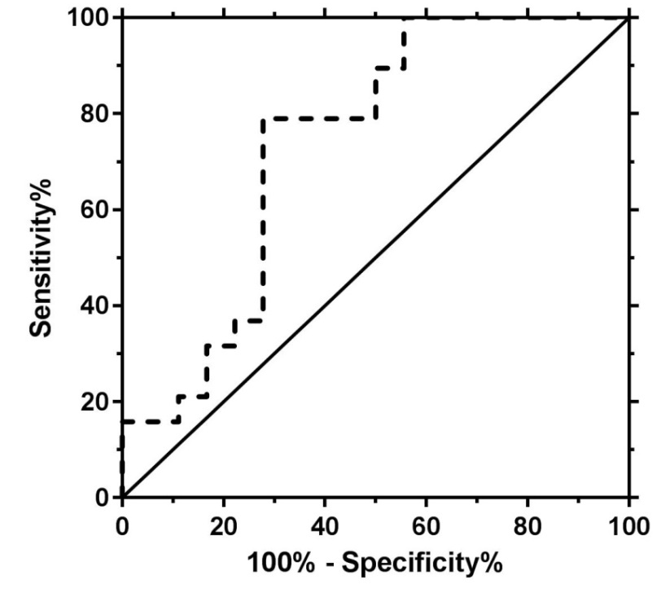

Fig. S2A illustrates the Receiver operating characteristic (ROC) curve analysis to evaluate the efficiency of LEP DNA methylation levels in differentiating full recovery AN patients from patients full syndrome AN with an area under the curve (AUC) of 0.737 (s.e.: 0.086, P=0.014).

Fig. S2b.
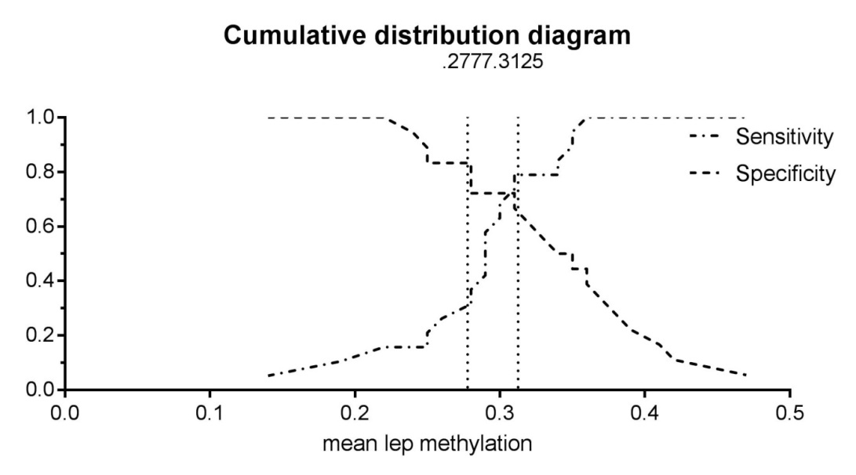

Fig. S2b shows the cumulative distribution diagram of two cut-off values with a maximized AUC (Youden’s Index). Cut-off A showed the best combined sensitivity and specificity at 0.3125(31.25%) mean LEP DNA methylation and cut-off B (0.2777(27.77%) mean LEP DNA methylation) had the highest sensitivity at specifity of 0.8.
Supplemental Figure 3.

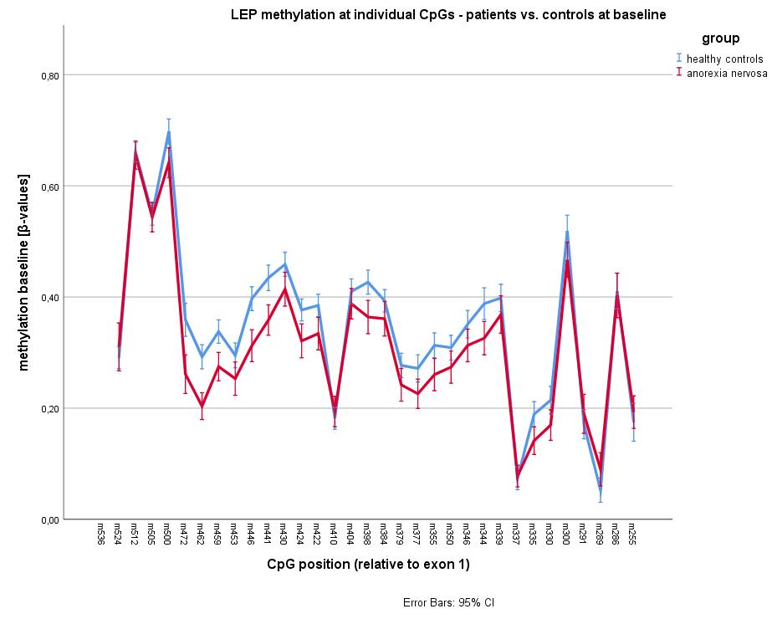

Supplemental Figure 4A.
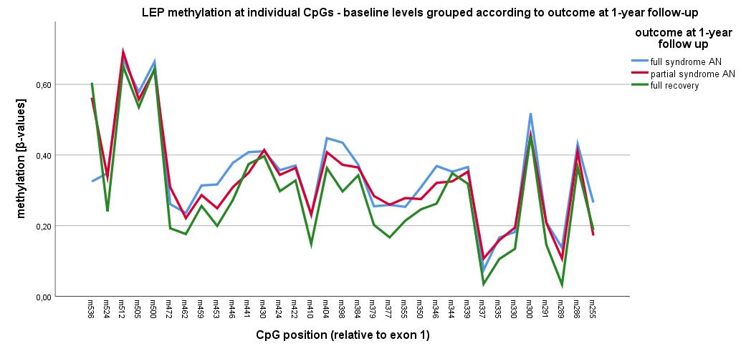

Supplemental Figure 4B.
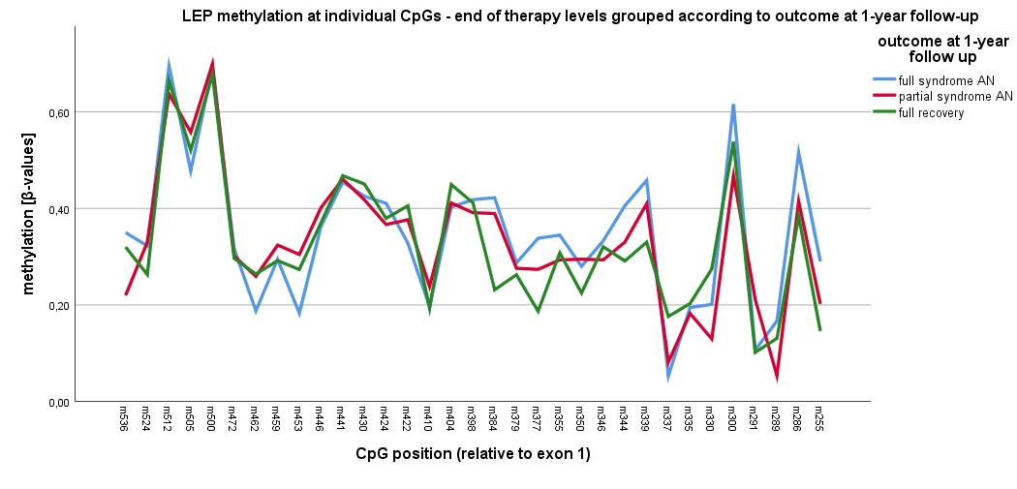

Supplemental Figure 4C.

