Supplementary Material

Article Title
Yingyu Qin *, Yuna Lee, Jae Ho Seo, Taehyun Kim, Jung Hoon Shin
* Correspondence: Se-Ho Park, sehopark@korea.ac.kr.
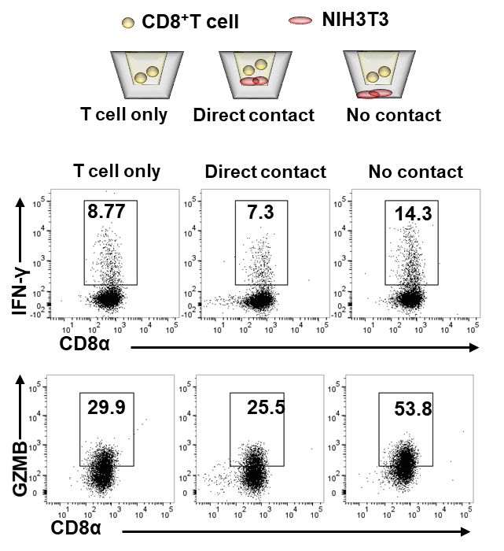
Supplemental figure 1. OT-1 CD8⁺ T cells (1×10⁵) in upper chamber only (T cell only) or were co-cultured with NIH3T3 cells (1×10⁵) also in upper chamber performing direct contaction (Direct contact) or separatively co-cultured in lower chamber (No contact). IFN-γ and gramzyme B (GZMB) expression levels in CTLs were detected for 2 days stimulation followed by intracellular staining.
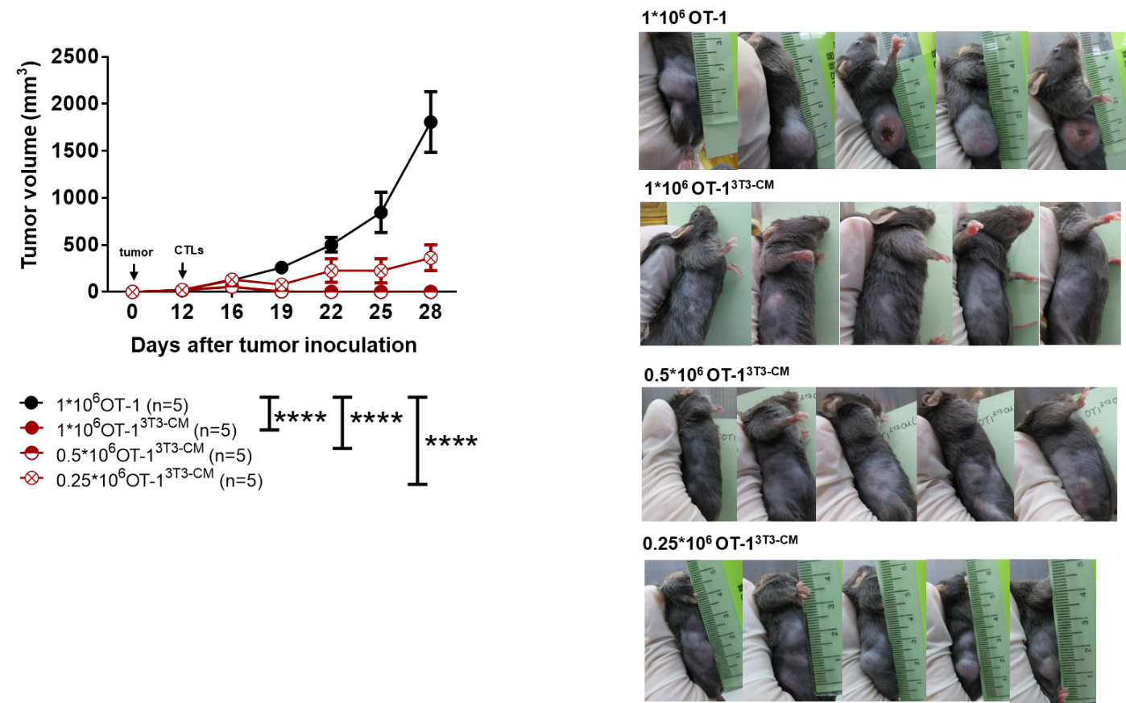

Supplemental figure 2. EG.7 tumor cells were subcutaneously transferred to WT B6 mice, after 30-50mm³ size of tumor was established, serial dilution of NIH3T3-CM cultured OT-1 CTLs (1×10⁶-0.25×10⁶) and medium alone cultured OT-1 CTLs (1×10⁶) were intravenously transferred to tumor bearing mice respectively. Then tumor growth was detected. Tumor photos were obtained after 22 days of tumor cell transfer. ****p <0 .0001.

