Supplementary Material

The Bioavailability, Biodistribution and Toxic Effects of Silica-coated Upconversion Nanoparticles in Vivo
Mingzhu Zhou^{1,#}, Xiaoqian Ge^{2,#}, Da-Ming Ke^{1,#}, Huan Tang³, Jun-Zheng Zhang¹, Matteo Calvaresi⁴, Bin Gao⁵, Lining Sun^{2,}*, Qianqian Su^{1,}*, Haifang Wang¹

¹Institute of Nanochemistry and Nanobiology, Shanghai University, Shanghai 200444, China
²Research Center of Nano Science and Technology, and School of Material Science and Engineering, Shanghai University, Shanghai 200444, China
³Beijing National Laboratory for Molecular Sciences, College of Chemistry and Molecular Engineering, Peking University, Beijing 100871, China
⁴Dipartimento di Chimica “G. Ciamician”, Alma Mater Studiorum – Università di Bologna, via F. Selmi 2, 40126 Bologna, Italy
⁵Cancer and Stem Cell Biology Program, Duke-NUS Medical School, 8 College Road, Singapore, 169857, Singapore
*Correspondence: Corresponding Authors: chmsqq@shu.edu.cn (Q. Su), lnsun@shu.edu.cn (L. Sun)
#These authors contributed equally.

Table S1. Composition of simulated body fluid (amounts based on 1000 mL of juice) (Tang et al., 2016).
Name | Reagent | Content
SBF  (pH = 7.4) | NaCl | 8.035 g
 | NaHCO₃ | 0.355 g
 | KCl | 0.225 g
 | K₂HPO₄·3H₂O | 0.231 g
 | MgCl₂·6H₂O | 0.311 g
 | 1.0 M HCl | 39 mL
 | CaCl₂ | 0.292 g
 | Na₂SO₄ | 0.072 g
 | Tris | 6.118 g
 | 1.0 M HCl | 0-5 mL

Tang, H., Yang, S. T., Yang, Y. F., Ke, D. M., Liu, J. H., Chen, X., et al. (2016). Blood clearance, distribution, transformation, excretion, and toxicity of near-infrared quantum dots Ag₂Se in mice. ACS Appl. Mater. Interfaces 8, 17859−17869. doi: 10.1021/acsami.6b05057.

Table S2. Biochemical parameters of serum in the mice after consecutive gavage administration of NaYF₄:Yb,Er@SiO₂. *Significant difference vs the corresponding control (P<0.05, n = 3).
Parameter | 7 Day |  |  | 14 Day
 | 0 mg/kg | 20 mg/kg | 100 mg/kg | 0 mg/kg | 20 mg/kg | 100 mg/kg
ALT  (IU/L) | 26.3±5.7 | 27.0±7.0 | 26. 7±4.2 | 31.3±4.2 | 33.0±7.2 | 32.0±6.2
AST  (IU/L) | 108.3±22.2 | 80.3±17.9 | 113.3±29.7 | 111.0±8.7 | 91.3±18.0 | 103.3±18.1
ALP  (IU/L) | 406.0±78.0 | 459.0±49.9 | 535.3±127.1 | 456.7±88.8 | 321.7±36.0 | 474.3±78.4
BUN  (mmol/L) | 6.9±0.5 | 8.4±0.4* | 9.3±1.5* | 8.7±1.0 | 8.3±1.3 | 8.5±1.5
Crea  (μmol/L) | 9.7±1.1 | 10.0±1.7 | 10.3±1.5 | 12.3±0.6 | 11.3±1.2 | 10.0±1.0*
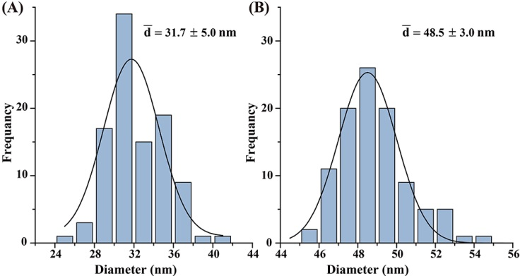
Figure S1. Size distribution of NaYF₄:Yb,Er (A) and NaYF₄:Yb,Er@SiO₂ (B) nanoparticles measured by Image J software.

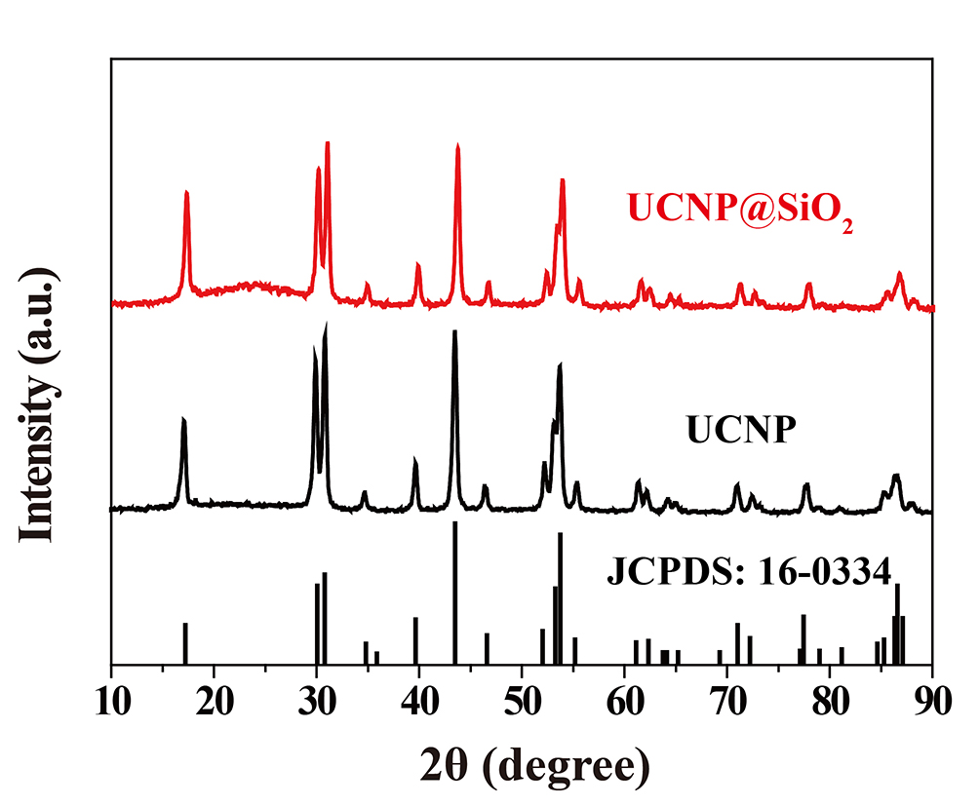
Figure S2. XRD patterns of NaYF₄:Yb,Er, NaYF₄:Yb,Er@SiO₂, and the standard card of hexagonal NaYF₄ (JCPDS: 16-0334). UCNP denotes NaYF₄:Yb,Er. UCNP@SiO₂ denotes NaYF₄:Yb,Er@SiO₂.

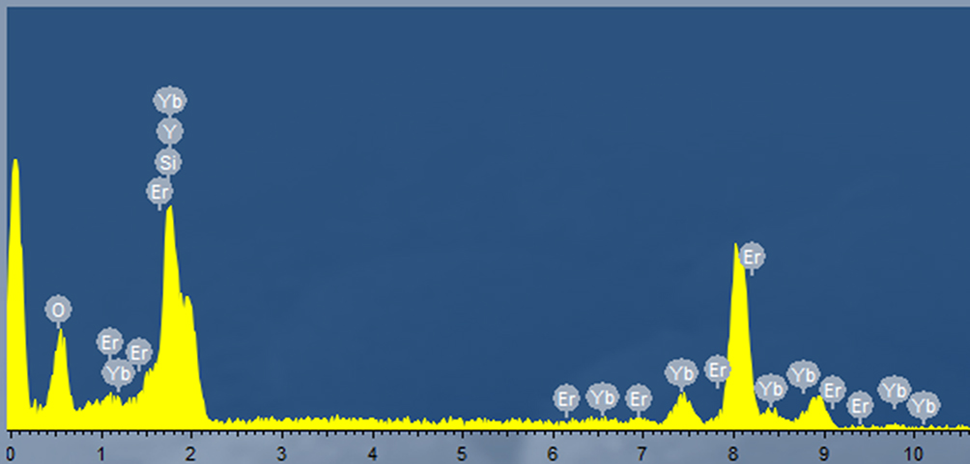
Figure S3. Energy dispersive X-ray (EDX) spectrum of NaYF₄:Yb,Er@SiO₂.

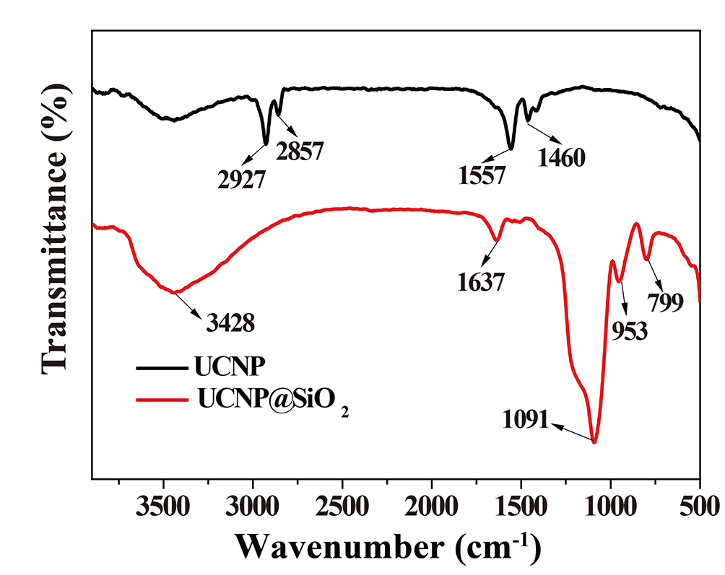
Figure S4. FT-IR spectra of the oleic acid coated NaYF₄:Yb,Er and NaYF₄:Yb,Er@SiO₂. UCNP denotes oleic acid capped NaYF₄:Yb,Er. UCNP@SiO₂ denotes NaYF₄:Yb,Er@SiO₂.
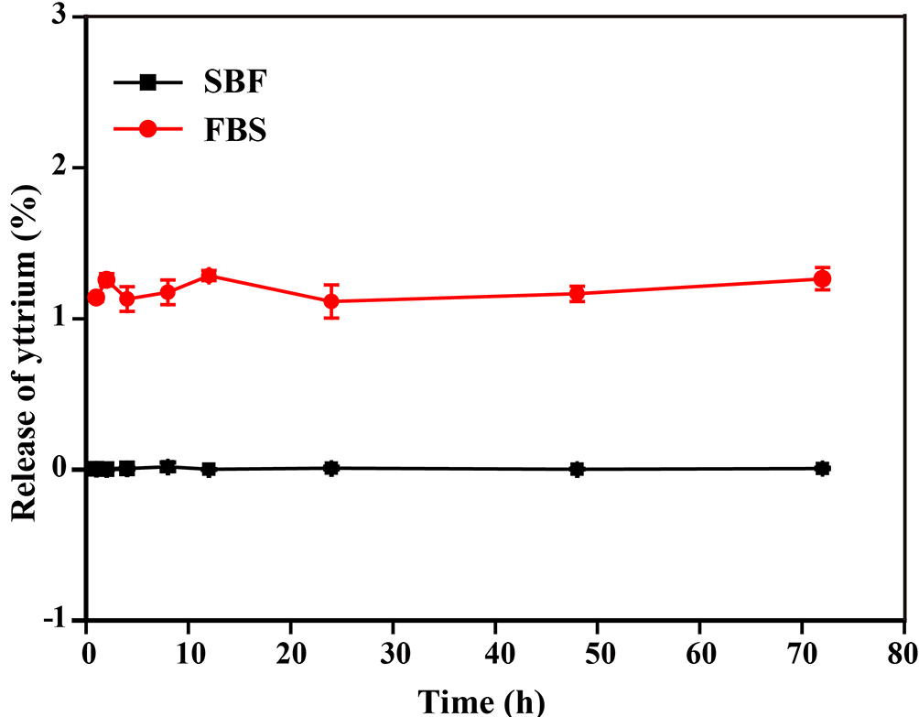
Figure S5. The release of yttrium from NaYF₄:Yb,Er@SiO₂ in SBF and FBS.

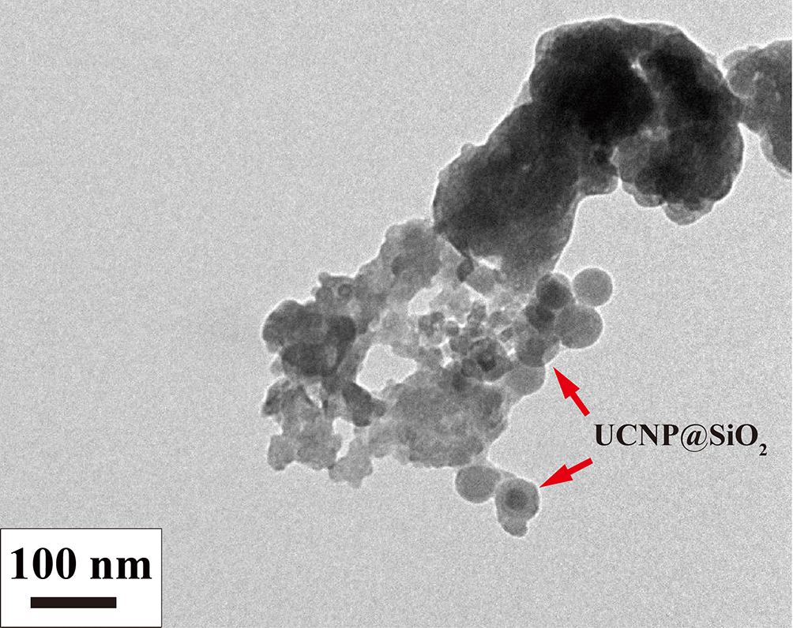
Figure S6. TEM image of NaYF₄:Yb,Er@SiO₂ in feces collected on the 14th day after mice were administrated consecutively with NaYF₄:Yb,Er@SiO₂ by gavage method. UCNP@SiO₂ denotes NaYF₄:Yb,Er@SiO₂.
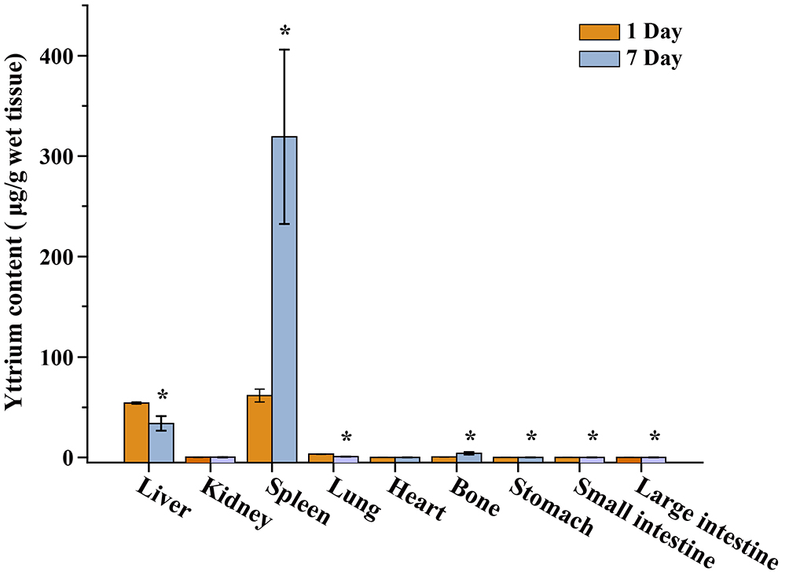
Figure S7. Yttrium content in the tissues of mice at day 1 and day 7 after a single intravenous administration of NaYF₄:Yb,Er@SiO₂, respectively. *Significant difference between the two treatment groups (P<0.05, n = 3).

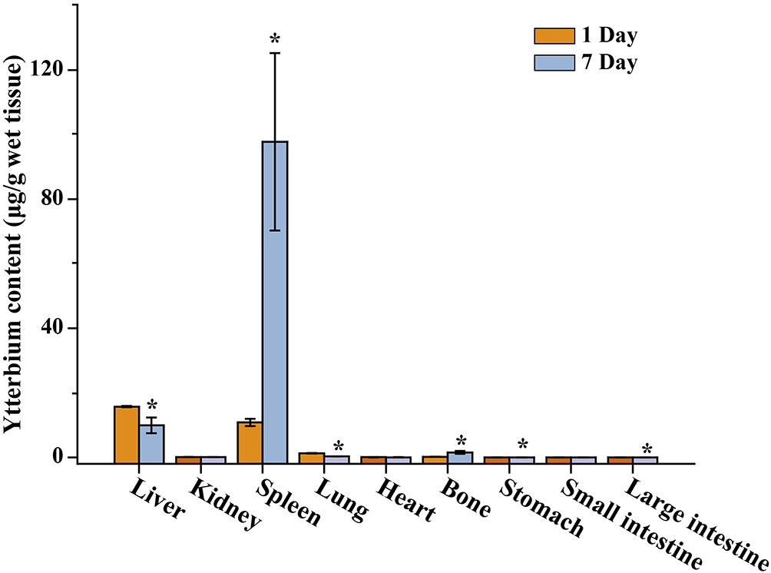
Figure S8. Ytterbium content in the tissues of mice at day 1 and day 7 after a single intravenous administration of NaYF₄:Yb,Er@SiO₂, respectively. *Significant difference between the two treatments groups (P<0.05, n = 3).
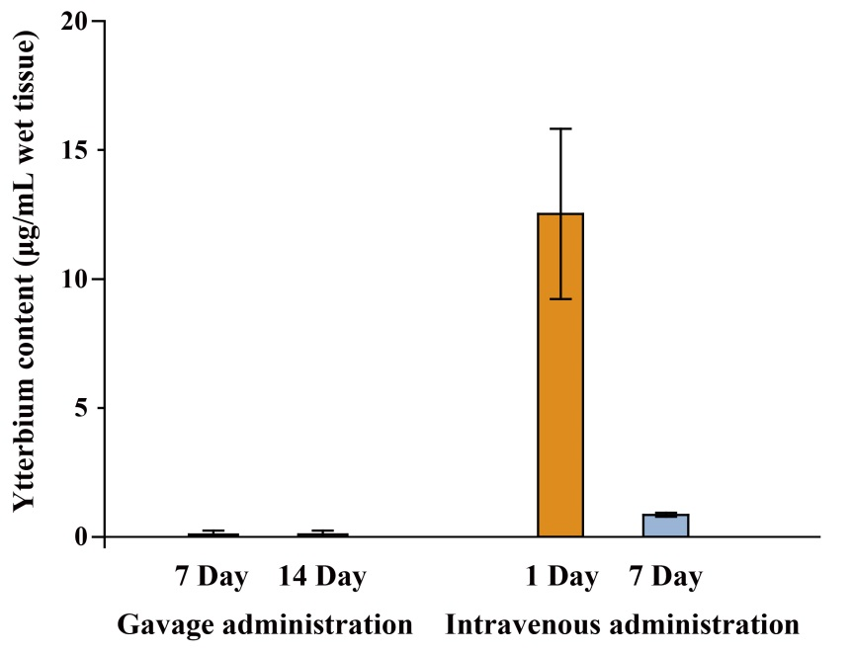
Figure S9. Ytterbium content in the blood of mice at day 7 and 14 at a dose of 20 mg/kg by gavage method and at day 1 and day 7 after a single intravenous administration of these nanoparticles with a dose of 20 mg/kg, respectively (n = 3).

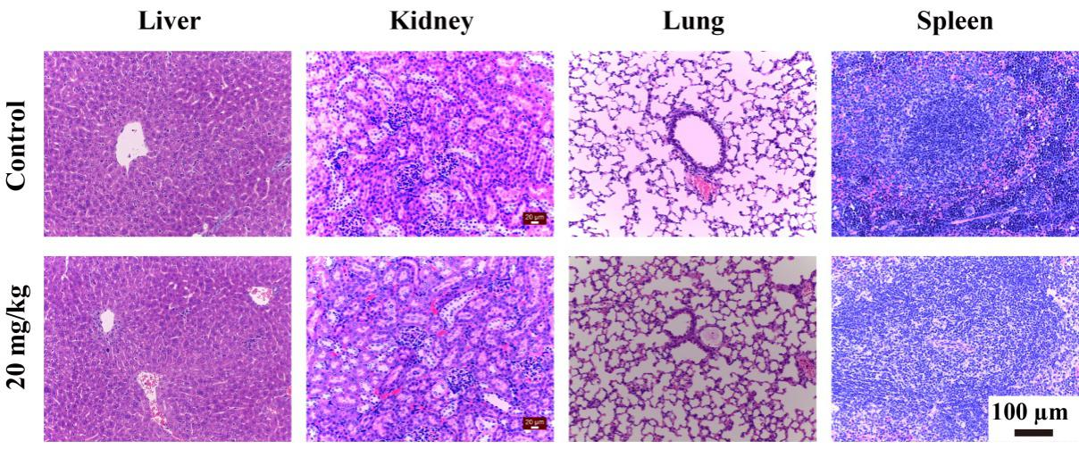

Figure S10. Histopathological observation of liver, kidney, lung and spleen of mice at day 1 after intravenous administration of NaYF₄:Yb,Er@SiO₂ into mice with a dose of 20 mg/kg.
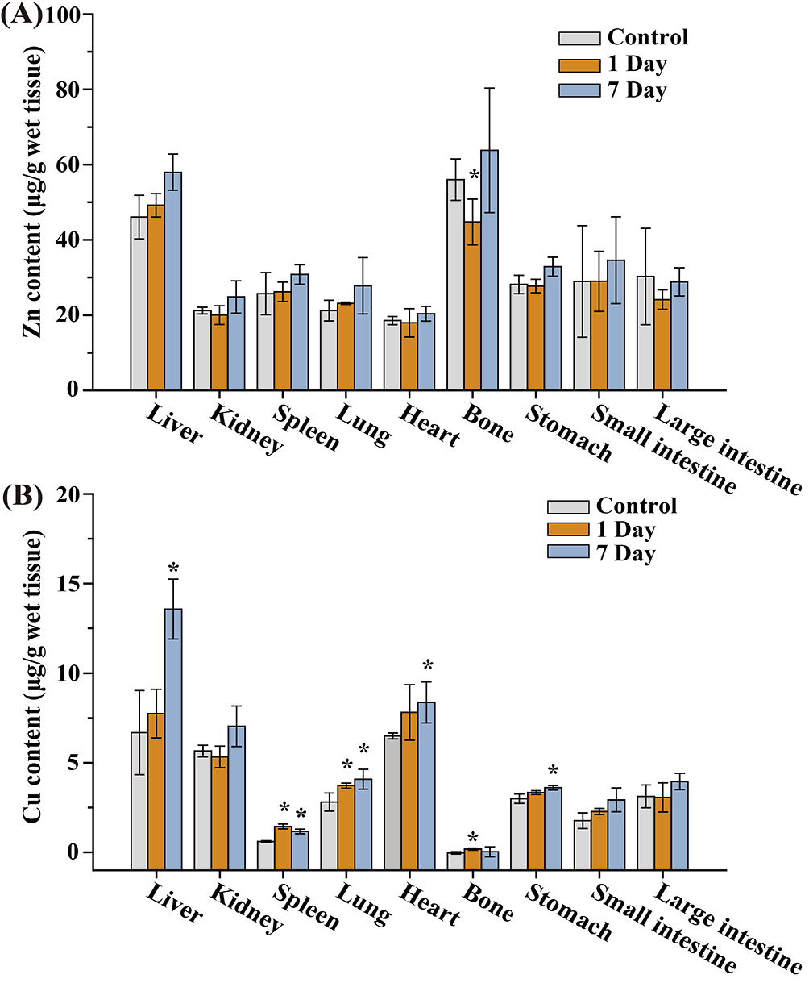
Figure S11. Zinc (A) and copper (B) content in the tissues of mice at day 1 and day 7 after a single intravenous administration of UCNP@SiO₂. *Significant difference vs the corresponding control (P<0.05, n = 3).

