Supplementary Materials
Appendix 1. Methods description of decomposition study using Typha domingensis litter
Experimental set-up
In the summer of 2016, we collected senescent Typha domingensis leaves from a freshwater marsh in Weeks Bay, Alabama. We air dried, sectioned into 17-cm lengths, and stored leaves in the laboratory until use. A subset of 324 leaf sections was measured for initial dry mass to determine mass loss over the study.
In January 2017, we anchored twelve 1.2m x 1m floating canopies, six constructed from ultraviolet-transmitting Plexiglas G-UVT (Light treatment) and six from opaque black Plexiglas (Dark treatment), in the littoral zone of Lake Thoreau, at Lake Thoreau Environmental Center affiliated with the University of Southern Mississippi. To all four sides of each canopy we attached 1 m length opaque sheeting to drape into the water and reduce back-scattering of light. We checked light transmittance of canopies in situ; light canopies permitted 88% UV and 82% photosynthetically active radiation (PAR) transmittance, whereas Dark canopies permitted <0.1% UV and PAR transmittance.
On January 13, 2017, three pre-weighed leaf sections were placed into each of 108 floating wire mesh trays and anchored and submerged under each of the twelve canopies (9 trays/canopy). Trays were sacrificially sampled from each canopy 7, 21, 42, 70, 98, 126, 154, and 221 days into the study. On each sampling date, litter sections were carefully removed from appropriate trays. Designated mass loss sections were placed into whirl-pak bags, returned to the laboratory, and frozen (-20°C). On each date, lake water samples were collected, frozen and later thawed, filtered, and measured for P-PO₄, N-NH₄, and N-NO₃ concentrations using a SEAL Autoanalyzer 3 (SEAL Analytical, Milwaukee, WI).

Sample analysis
To determine mass loss, frozen sections collected from each canopy on each date were lyophilized, desiccated, and re-weighed. A subset of 12 pre-weighed handling loss litter sections were also lyophilized and reweighed to determine mass loss during field deployment of litter. All 3 litter sections from each replicate on each date were subsequently ground, desiccated, and weighed to determine %C, %N, and %P contents. Litter %C and %N were analyzed using a Costech Elemental Analyzer (Costech Analytical Technologies, Valencia, CA), and %P contents were analyzed after combustion at 500°C, digestion in hydrochloric acid at 85°C, and dilution prior to measurement of P-PO₄ using a SEAL AutoAnalyzer 3 (Seal Analytical Inc., Mequon, WI).
We calculated exponential dry mass loss rates k (d⁻¹) based on the negative log-transformed slope of litter-periphyton dry mass remaining vs. time (Barlöcher, 2005). Mass loss rates were subsequently analyzed to determine algal priming intensity following Equation 1 within the main text. Algal effect sizes on litter C:N, C:P, k_{N}, and k_{P} were similarly calculated following equations described within the main text.

Supplemental Table S1. Mean (±SE) initial molar C:N, C:P, and N:P of leaf litter used in all datasets included in the meta-analysis. See Table 1 in the main text for further dataset description.
Citationª |  | Leaf species | Initial C:N | Initial C:P | Initial N:P
1 | Acer saccharum |  | 71.9 (2.9) | 2334 (603) | 32.1 (7.4)
2 | Liriodendron tulipifera |  | 66.4 (3.0) | 5693 (394) | 86.4 (6.3)
2 | Quercus nigra |  | 60.8 (4.8) | 6928 (909) | 120.5 (20.6)
3 | Alnus glutinosa |  | 20.5 (<0.1) | 3877 (2) | 189.0 (0.1)
4 | Zea mays |  | 10
5 | Typha domingensis |  | 88.5 (3.6) | 4031 (513) | 45.0 (4.6)
ª Citations: ¹Halvorson et al. (2016), ²Halvorson et al. (2019), ³Danger et al. (2013), ⁴Soares et al. (2017), ⁵Halvorson et al. (unpublished)

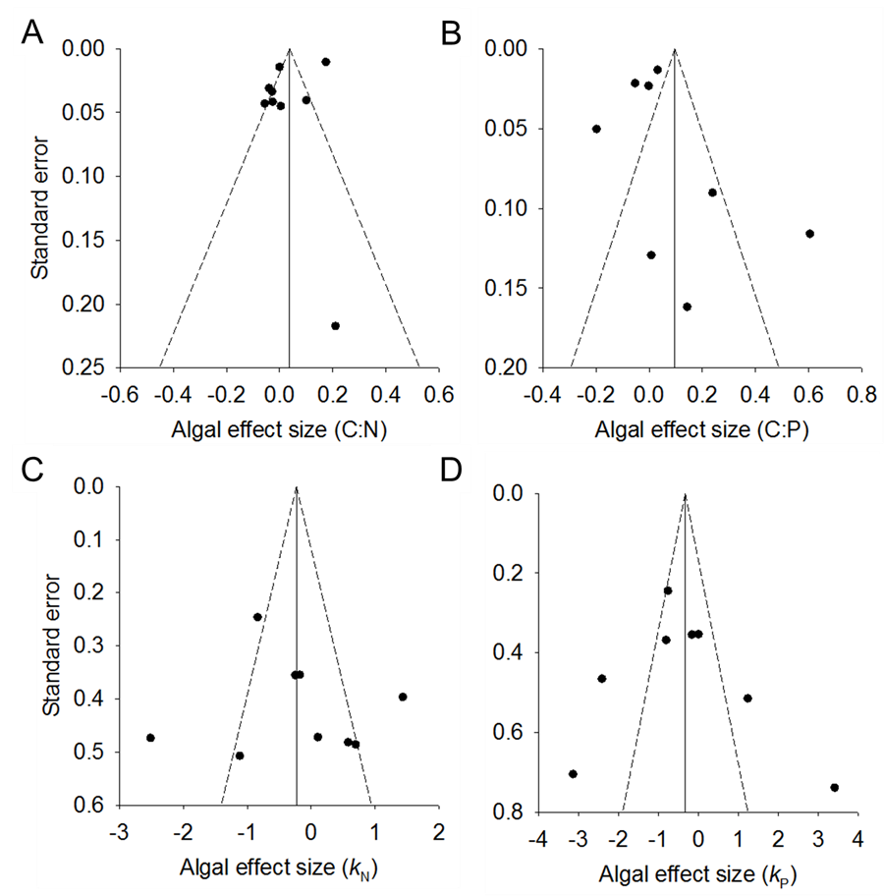
Supplemental Figure S1. Funnel plots describing algal effect sizes on litter-periphyton molar C:N (A), molar C:P (B), N mass loss rates k_{N} (C), and P mass loss rates k_{P} (D). A total of 8 or 9 datasets are included for each funnel plot. In each panel, the vertical solid line indicates the global mean effect size and dotted diagonal lines indicate ±95% confidence intervals.
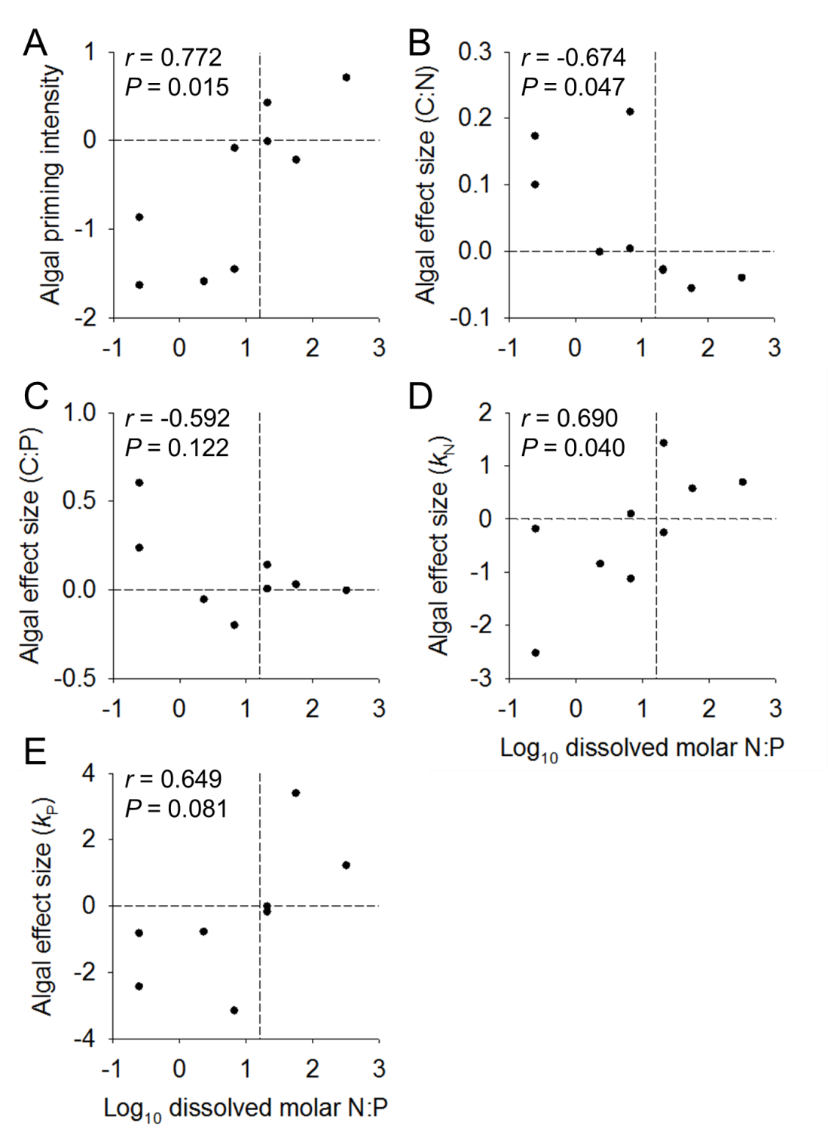
Supplementary Figure S2. Scatterplots of algal priming intensity (A) and algal effect sizes on litter-periphyton molar C:N (B), molar C:P (C), and N- or P-specific mass loss coefficients k_{N} (D), and k_{P} (E) across gradients of dissolved inorganic N:P. In all panels, vertical dashed lines describe an N:P ratio of 16 and horizontal dashed lines indicate an algal effect size of zero, indicating the switch between algal increasing (positive values) or decreasing (negative) each response variable. Pearson correlation coefficients accompany each scatterplot.

