Supplementary Material
Polysaccharide Thin Solid films for Analgesic Drug Delivery and Growth of Human Skin Cells
Tina Maver^{1,2}*, Tamilselvan Mohan¹*, Lidija Gradišnik³, Matjaž Finšgar⁴, Karin Stana Kleinschek^{1,5}, Uroš Maver^{2,3}
¹Laboratory for characterization and processing of polymers, Faculty of Mechanical Engineering, University of Maribor, 2000 Maribor, Slovenia
²Department of Pharmacology, Faculty of Medicine, University of Maribor, Maribor, Slovenia
³Institute of Biomedical Sciences, Faculty of Medicine, University of Maribor, Maribor, Slovenia
⁴Faculty of Chemistry and Chemical Engineering, University of Maribor, 2000 Maribor,
Slovenia
⁵Institute for Chemistry and Technology of Materials, Graz University of Technology, Stremayrgasse 9, 8010 Graz, Austria

* Correspondence:
Corresponding Authors
tina.maver@um.si; tamilselvan.mohan@um.si

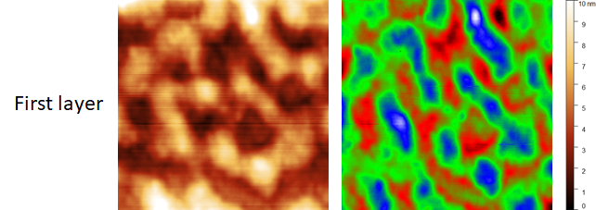
Figure S1. AFM height image (1 x 1 μm²) of the first ALG-CMC spin coated layer. Both (left and right) images are the same but are presented in different colors to confirm the existence of the phase separation.

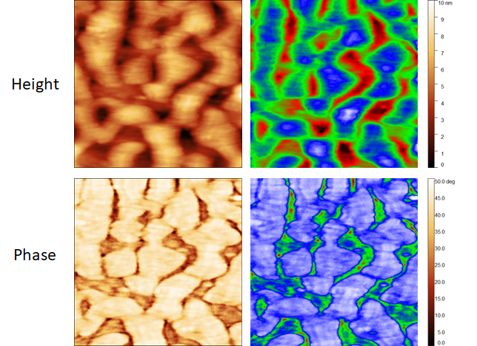
Figure S2. AFM height (top) and phase (bottom) image (1 x 1 μm²) of the third ALG-CMC spin coated layer. Both (left and right) images are the same but are presented in different colors to confirm the existence of the phase separation. In the phase image, the presence of two phases can be clearly seen.

Table S1. Static contact angle (SCA) values of alginate (ALG), carboxymethyl cellulose (CMC) and ALG-CMC spin coated multi-layers, incorporated with and without drugs.
