Supplementary Material

Improving the accuracy of flow cytometric quantification of microbial populations in sediments: importance of cell staining procedures
Longhui Deng¹*, Annika Fiskal¹, Xingguo Han¹, Nathalie Dubois^{2,3}, Stefano Bernasconi³, Mark Alexander Lever¹*

* Correspondence:
Longhui Deng
longhui.deng@usys.ethz.ch
Dr. Mark Alexander Lever
mark.lever@usys.ethz.ch

Supplementary Figure S1. Microscopic images of the positive control (sterile sediments spiked with E. coli) without (A-1) and with (A-2) HF treatment; and natural samples from Lake Baldegg without (B-1) and with (B-2) HF treatment. White bar: 25 μm.
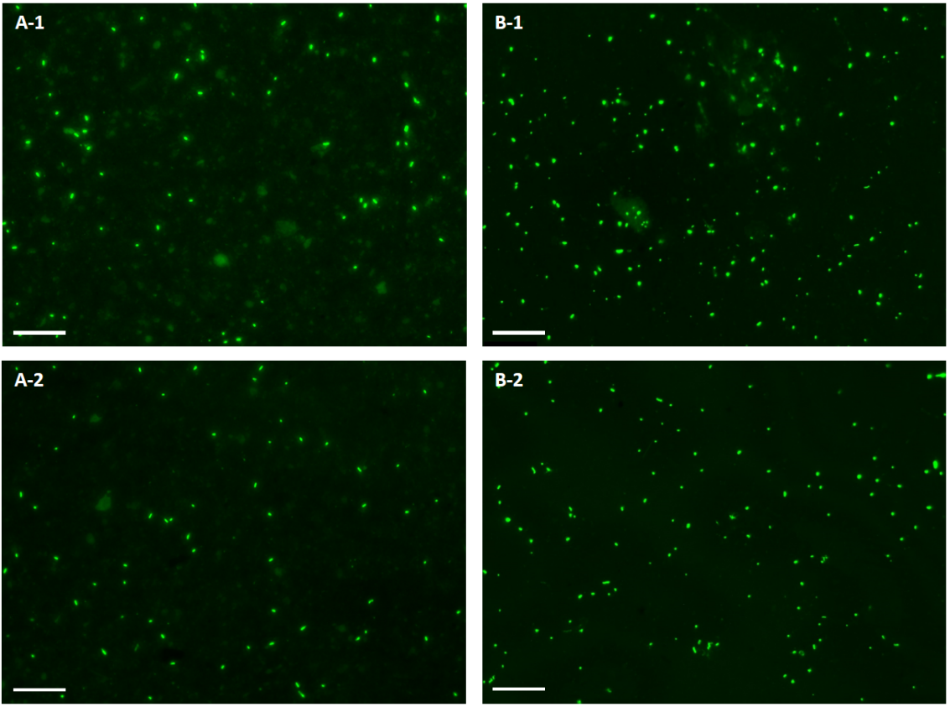

Supplementary Figure S2. Representative cytograms for testing the effect of dye concentrations on direct staining of: (A) Intertidal sediment; (B) Lake Zug sediment. 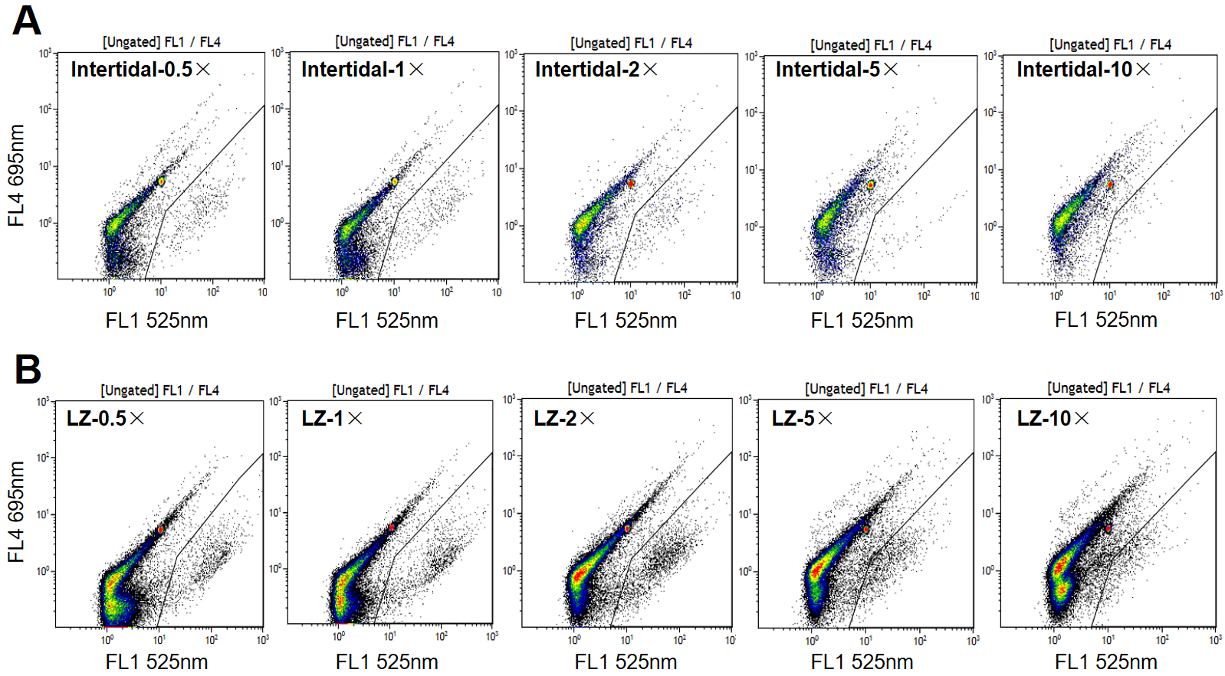

Supplementary Figure S3. Correlations between the optimal D/S ratios and (A) percentage of fine particles (clay + silt), (B) optimal D/S ratios and TOC, respectively. The optimal D/S ratios are the ratios of dye concentration to sediment volume we used, to reach the optimal cell counts. The solid lines represent the liner regression lines.
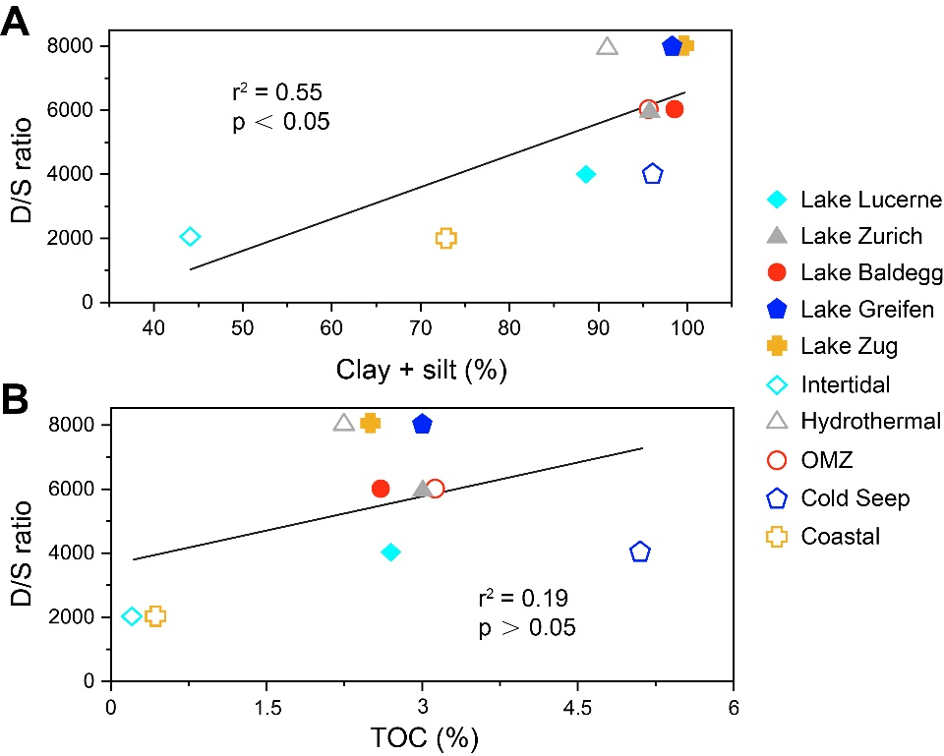

Supplementary Figure S4. Microscopic examinations of the polycarbonate membrane, before and after cells were detached from the membrane into TE buffer by 2-min ultrasonication.
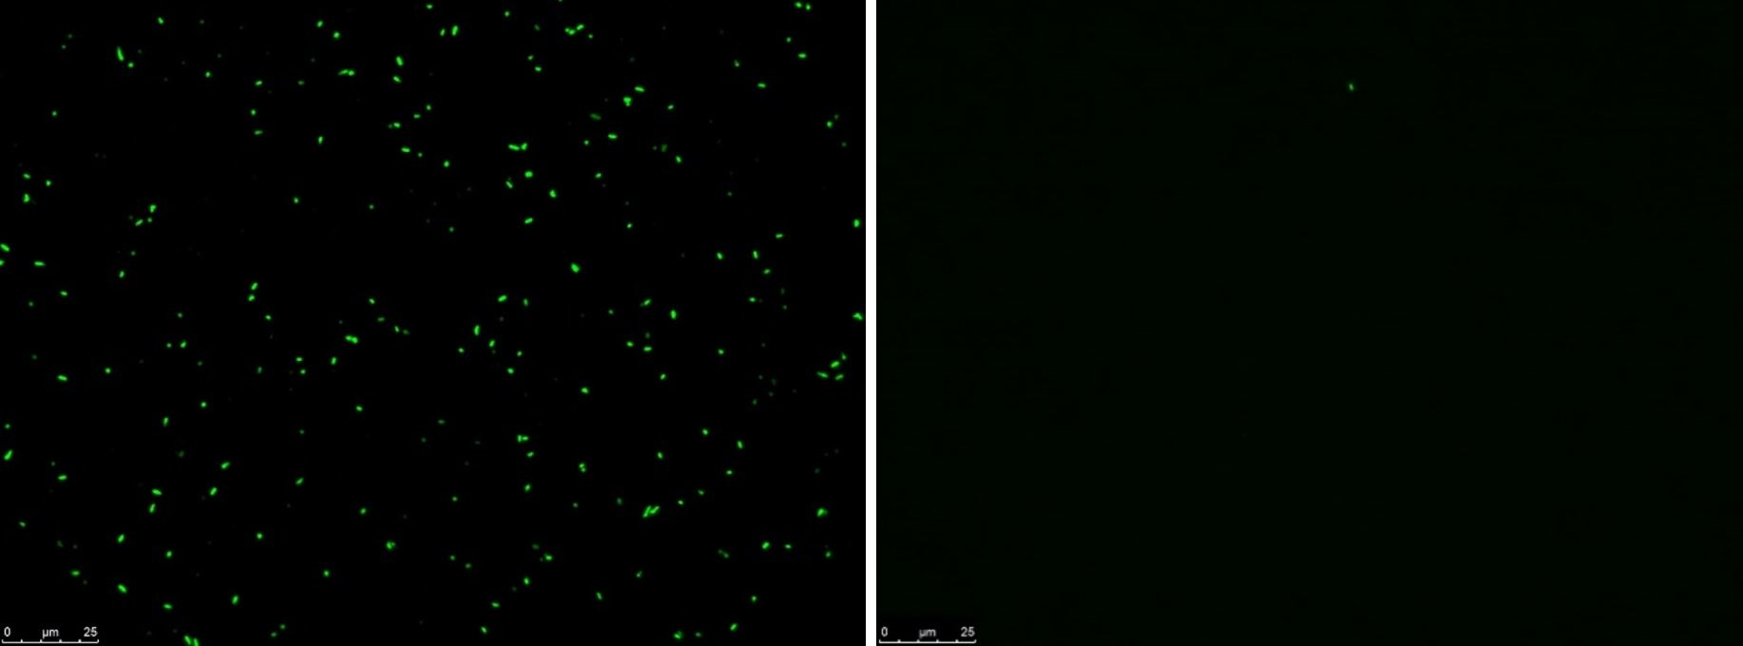

Supplementary Figure S5. Cell numbers measured in different rates of events. Sediment samples (2.5×10⁻³ cm³) from Lake Lucerne were stained on membrane with 250×SYBR-I, detached into TE buffer, and diluted serially. For event rates of 4,410 and 11,442, medium and high flow speed were used. Error bars represent the standard deviations of triplicate measurements.
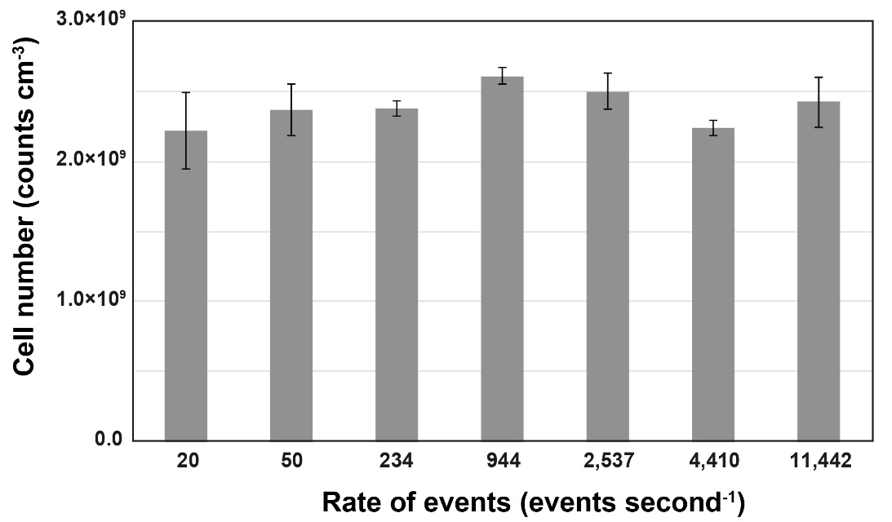

Supplementary Figure S6. Representative FCM cytograms of the positive control (sterilized sediments spiked with E. coli cells), lake and marine samples. The SYBR-stained cells were distinguished from the background fluorescence by plotting: (A) green fluorescence (525/30 nm) against red fluorescence (695/30 nm); (B) green fluorescence (525/30 nm) against forward scatter light (FS).
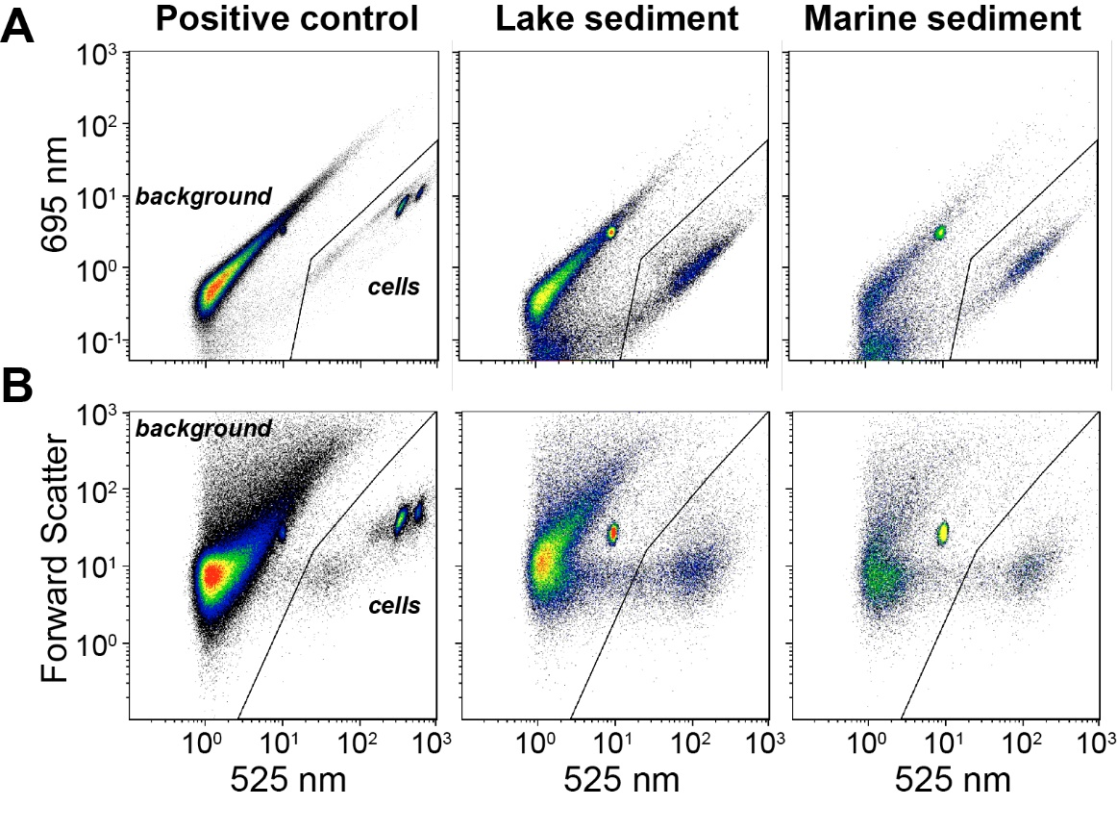

Samples | Sample depths (cm) | D/S ratio | SYBR-I | Sediment volume (cm⁻³)
Lake Sediment
Lake Lucerne (LL) | 1-1.5 | 4,000 | 1× | 0.250×10⁻³
Lake Zurich (LZ) | 1.5-2 | 6,000 | 1× | 0.167×10⁻³
Lake Greifen (LG) | 1-1.5 | 8,000 | 1× | 0.125×10⁻³
Lake Zug (LZG) | 1-1.5 | 8,000 | 1× | 0.125×10⁻³
Lake Baldegg (LB) | 1-1.5 | 6,000 | 1× | 0.167×10⁻³
Marine Sediment
False Bay (intertidal) | 0-2 | 2,000 | 0.5× | 0.25×10⁻³
Guaymas Basin (hydrothermal) | 0-1 | 8,000 | 1× | 0.125×10⁻³
Guaymas Basin (OMZ) | 0-5 | 6,000 | 1× | 0.167×10⁻³
Guaymas Basin (cold seep) | 33 | 4,000 | 1× | 0.250×10⁻³
N Gulf of California (coastal) | 0-1 | 2,000 | 0.5× | 0.25×10⁻³

Supplementary Table S1. Samples used for sample type-specific optimization during direct staining. The optimal conditions for direct staining are shown as D/S ratios, i.e. the ratio between SYBR-I concentration and sediment volume used for staining.

Supplementary Table S2. Overview of sample types (locations), sample depths, and cell numbers counted by membrane-staining based method (FCM-M), direct staining after sample type-specific optimization (FCM-D), and by epifluorescence microscopy (EFM). Samples used for testing the direct staining protocol in Fig. 3 are marked by asterisks.
Locations | Latitude (N) | Longitude | Station | Depth (cm) | FCM-M | FCM-D | EFM
Lake Baldegg (LB) | 47° 11.93' | 8° 15.61' E | 1 | 1-1.5* | 1.46E+09 | 1.13E+09 | 8.69E+08
 |  |  | 1 | 1.5-2 | 1.14E+09 | - | 1.77E+09
 |  |  | 2 | 1.5-2 | 2.88E+09 | - | 1.65E+09
 |  |  | 1 | 4-6* | 1.86E+09 | 1.34E+09 | 1.05E+09
 |  |  | 1 | 28-32* | 4.86E+08 | 2.44E+08 | 3.18E+08
Lake Greifen (LG) | 47° 21.13' | 8° 40.51' E | 1 | 0-0.5 | 2.51E+09 | - | 1.54E+09
 |  |  | 1 | 1-1.5* | 4.52E+09 | - | 3.66E+09
 |  |  | 1 | 1.5-2 | 6.70E+08 | - | 1.13E+09
 |  |  | 1 | 6-8* | 3.42E+08 | 4.00E+08 | 2.39E+08
 |  |  | 1 | 28-32* | - | 1.91E+08 | 1.55E+08
Lake Lucerne (LL) | 47° 00.05' | 8° 20.22' E | 1 | 1-1.5* | 1.43E+09 | 1.05E+09 | 1.31E+09
 |  |  | 2 | 1-1.5* | 4.10E+09 | 4.14E+09 | 2.77E+09
 |  |  | 1 | 1.5-2 | 2.40E+09 | - | 2.35E+09
 |  |  | 1 | 4-6 | 1.01E+09 | - | 4.63E+08
 |  |  | 1 | 6-8* | 5.90E+08 | 5.56E+08 | 4.55E+08
 |  |  | 1 | 10-12 | 3.17E+08 | - | 2.95E+08
 |  |  | 1 | 28-32* | 1.61E+08 | 1.23E+08 | 1.39E+08
 |  |  | 2 | 28-32 | 1.41E+08 | - | 6.02E+07
 |  |  | 3 | 28-32 | 2.24E+08 | - | 2.65E+08
Lake Zug (LZG) | 47° 10.27' | 8° 30.04' E | 1 | 0-0.5 | 1.57E+09 | - | 1.68E+09
 |  |  | 2 | 1-1.5* | 1.18E+09 | 7.64E+08 | 7.02E+08
 |  |  | 3 | 0-0.5 | 2.14E+09 | - | 2.28E+09
 |  |  | 1 | 4-6 | 2.45E+08 | - | 2.07E+08
 |  |  | 2 | 6-8* | 7.09E+08 | 4.44E+08 | 5.46E+08
 |  |  | 2 | 20-24* | 3.21E+08 | 2.10E+08 | 2.34E+08
Lake Zurich (LZ) | 47° 17.00' | 8° 35.62' E | 1 | 0-0.5 | 6.19E+09 | - | 4.21E+09
 |  |  | 1 | 1-1.5 | 8.52E+09 | - | 5.80E+09
 |  |  | 1 | 1.5-2* | 6.94E+09 | 5.38E+09 | 4.51E+09
 |  |  | 1 | 4-6* | 5.18E+09 | 4.76E+09 | 5.15E+09
 |  |  | 2 | 28-32* | 1.08E+09 | 1.06E+09 | 9.37E+08
Guaymas Basin (hydrothermal) | 27° 24.58' | 111° 23.27' W | 1 | 0-1* | 2.78E+09 | 1.10E+09 | 2.10E+09
 |  |  | 1 | 14-16* | 2.83E+08 | 2.44E+08 | 2.63E+08
 |  |  | 1 | 6-8* | 2.84E+09 | 2.99E+09 | 3.57E+09
Guaymas Basin (OMZ¹) | 27° 42.41' | 111° 13.66' W | 1 | 350* | 1.42E+09 | 1.01E+09 | 8.36E+08
 |  |  | 1 | 0-5* | 3.82E+08 | 2.85E+08 | 2.42E+08
 |  |  | 1 | 900* | 3.39E+08 | 1.96E+08 | 2.87E+08
Guaymas Basin (cold seep) | 27° 28.19' | 111° 28.36' W | 1 | 483* | 1.03E+08 | 8.95E+07 | 1.06E+08
 |  |  | 1 | 33* | 4.28E+08 | 3.97E+08 | 3.42E+08
 |  |  | 1 | 233* | 3.80E+08 | 2.49E+08 | 2.33E+08
N Gulf of California (coastal) | 27° 55.01' | 111° 01.13' W | 1 | 0-1* | 1.48E+09 | 1.50E+09 | 9.07E+08
 |  |  | 1 | 4-6* | 2.99E+08 | 3.11E+08 | 2.36E+08
 |  |  | 1 | 16-18* | 8.18E+08 | 6.96E+08 | 5.68E+08
False Bay (intertidal) | 48° 29.20' | 123° 04.48' W | 1 | 6-8* | 2.85E+08 | 2.43E+08 | 2.31E+08
 |  |  | 1 | 0-2* | 8.86E+08 | 8.37E+08 | 8.65E+08
 |  |  | 1 | 26-30* | 3.92E+07 | 3.74E+07 | 3.55E+07
Guaymas Basin (cold seep) | 27° 33.30' | 111° 32.88' W | 1 | 2-3 | 1.67E+09 | 9.87E+08 | 5.26E+08
 |  |  | 1 | 1-2 | 2.05E+09 | - | 2.31E+09
Guaymas Basin (reference) | 27° 26.52' | 111° 29.93' W | 1 | 1-2 | 5.31E+08 | - | 1.05E+09
 |  |  | 1 | 4-6 | 2.04E+09 | - | 1.40E+09
Guaymas Basin (graben) | 27° 23.83' | 111° 25.92' W | 1 | 1-2 | 1.41E+09 | - | 1.44E+09
Guaymas Basin (cold seep) | 27° 28.16' | 111° 28.35' W | 1 | 1-2 | 2.22E+09 | - | 2.08E+09
Guaymas Basin (below OMZ) | 27° 34.80' | 111° 21.54' W | 1 | 1-2 | 1.13E+09 | - | 3.98E+08
Guaymas Basin (OMZ) | 27° 42.41' | 111° 13.66' W | 1 | 1-2 | 8.70E+08 | - | 3.24E+08
Guaymas Basin (hydrothermal) | 27° 24.47' | 111° 23.38' W | 1 | 37 | 5.57E+07 | - | 2.87E+07
 |  |  | 1 | 237 | 2.22E+07 | - | 1.76E+07
 |  |  | 1 | 337 | 4.55E+06 | - | 8.73E+06
Guaymas Basin (hydrothermal) | 27° 24.49' | 111° 23.38' W | 1 | 48 | 1.42E+07 | - | 1.89E+07
 |  |  | 1 | 348 | 5.87E+06 | - | 4.03E+06
Guaymas Basin (cold seep) | 27° 28.18' | 111° 28.40' W | 1 | 50 | 5.05E+08 | - | 4.47E+08
Guaymas Basin (cold seep) | 27° 33.30' | 111° 32.88' W | 1 | 50 | 6.93E+08 | - | 3.40E+08
 |  |  | 1 | 300 | 2.08E+08 | - | 1.01E+08

