Supplementary Material

DHAV-1 inhibits type I interferon signalling to assist viral adaption by increasing the expression of SOCS3

Jinyan Xie^{1,2¶}, Mingshu Wang^{1,2,3¶}, Anchun Cheng^{1,2,3*}, Xin-Xin Zhao^{1,2,3}, Mafeng Liu^{1,2,3}, Dekang Zhu^{2,3}, Shun Chen^{1,2,3}, Renyong Jia^{1,2,3}, Qiao Yang^{1,2,3}, Ying Wu^{1,2,3}, Shaqiu Zhang^{1,2,3}, Yunya Liu^{1,2,3}, Yanling Yu^{1,2,3}, Ling Zhang^{1,2,3}, Xiaoyue Chen^{1,2,3}

Corresponding authors: Anchun Cheng, chenganchun@vip.163.com

Supplementary Figures
Supplementary Figure 1. Raw data of western blot. Interaction between IFNs and SOCS3. pCAGGS-SOCS3-His and pCAGGS-IFNα/γ-FLAG were co-transfected into CEFs, which were harvested 36 h and 48 h after transfection. Last three lines were the confirmation the expression of SOCS3 protein. Graph above is Western blot analysis of SOCS3 expression. Graph below is Western blot analysis of β-actin expression.

A
IFNα
IFNγ

B

β-actin
C

Supplementary Figure 2. Raw data of western blot. Interaction between IFNs and SOCS3. pCAGGS-SOCS3-His and pCAGGS-IFNα/γ-FLAG were co-transfected into CEFs, which were harvested 36 h and 48 h after transfection. (A) Western blot analysis of IFNα/γ-FLAG expression. (B) Western blot analysis of β-actin expression. (C) the confirmation the expression of IFNα/β/γ protein.

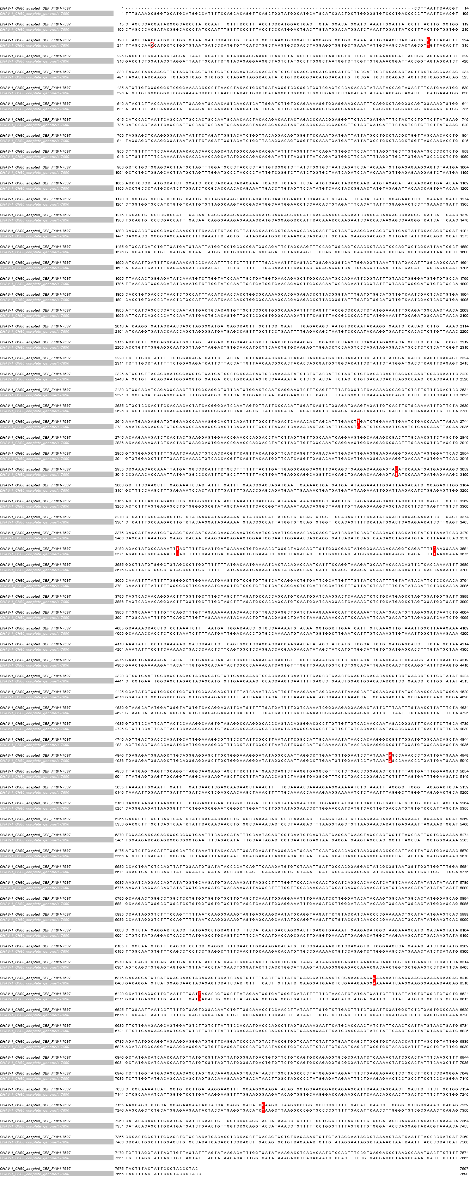
Supplementary Figure 3. The amino-acid sequence analysis of DHAV-1 CH60 strain and DHAV-1 CH60 adapted strain. red region indicates differential sequence.

A B
Supplementary Figure 4. Raw data of western blot. (A) Interaction of IFNα and SOCS3. CEFs were transfected with pCAGGS-IFNα-Flag and pCAGGS-SOCS3-His for 48 h before the coimmunoprecipitation and immunoblot analysis with the indicated antibodies. (B) Western blot analysis of STAT1 expression. DHAV-1 infected CEFs at 48 hpi and after the addition of 100 pg IFNα to stimulate CEFs at 37℃ for 15 min. Cells were harvested after stimulation.

