Supplemental Materials

Figure S1. Prevention of oxaliplatin-induced neurotoxicity by duloxetine in vitro------------------------------------------------------------------------------------------------2
Figure S2. Prevention of paclitaxel-induced neurotoxicity by duloxetine in vitro------------------------------------------------------------------------------------------------2
Figure S3. Impact of duloxetine on body weight of ICR mice treated with or without OXA or PTX--------------------------------------------------------------------------------------3
Figure S4. Effect of duloxetine on phosphorylation of p38 MAPK and ERK1/2 expression in the neuropathic mouse DRG following oxaliplatin treatment-------------3
Figure S5. Effect of duloxetine on NF-κB, phosphorylation of p38 MAPK and ERK1/2 expression in the neuropathic mouse DRG following PTX treatment---------4
Figure S6. Effect of duloxetine on IENF retraction induced by OXA or PTX. --------4
Figure S7. Effect of duloxetine on serotonin or NE level in DRG cell culture. --------5
Figure S8. Effect of duloxetine on DRG-----------------------------------------------------5
Table S1. Cytokine changes in mice following chemotherapy and duloxetine treatments -----------------------------------------------------------------------------------------5

Figure S1. Prevention of oxaliplatin-induced neurotoxicity by duloxetine in vitro. Relatived to Figure 1.
(A) Primary rat DRG neuron cells were exposed to various concentrations of oxaliplatin for 48 hours and ATP levels was measured (*p < 0.05 vs control). (B) Primary rat DRG neuron cells were exposed to oxaliplatin with various concentrations of duloxetine for 48 hours and ATP levels were measured (* p < 0.05 vs control; # p < 0.05 vs oxaliplatin alone). All the data are presented as mean ± SEM for each experiment (n = 4).
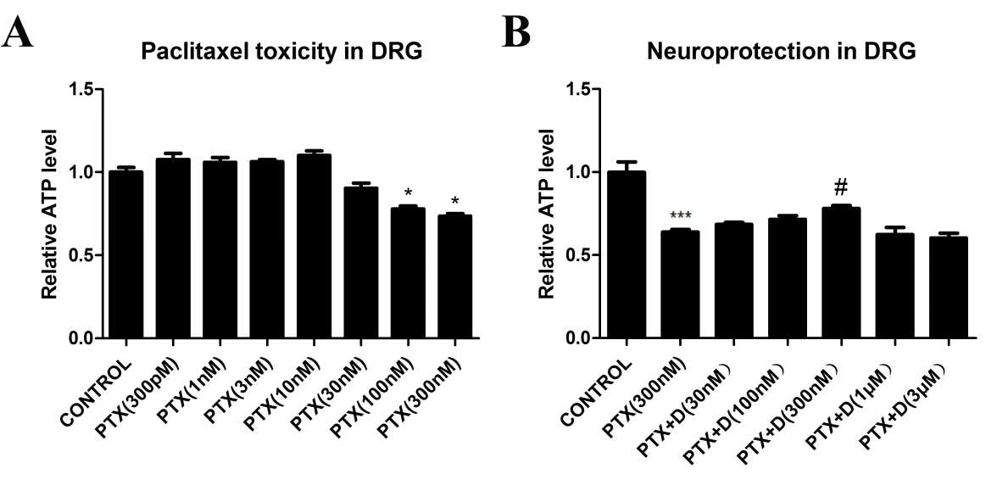
Figure S2. Prevention of paclitaxel-induced neurotoxicity by duloxetine in vitro. Relatived to Figure 1.
(A) Primary rat DRG neuron cells were exposed to various concentrations of paclitaxel for 24 hours and cell viability was measured (* p < 0.05 compared to control). (B) Primary rat DRG neuron cells were exposed to paclitaxel with various concentrations of duloxetine for 24 hours and ATP levels were measured (*** p < 0.0001 vs control; # p < 0.05 vs paclitaxel alone). All the data are presented as mean ± SEM for each experiment (n= 4).

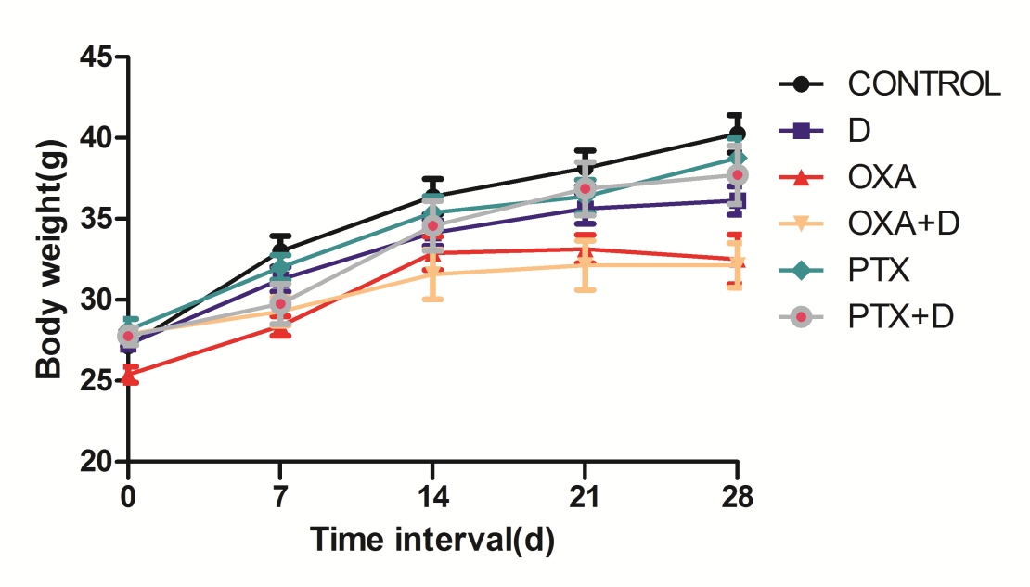
Figure S3. Impact of duloxetine on body weight of ICR mice treated with or without OXA or PTX.
There was no significant difference in the body weight after daily administration of duloxetine (30 mg/kg) in animals treated with vehicle or chemotherapeutic drugs (OXA and PTX).

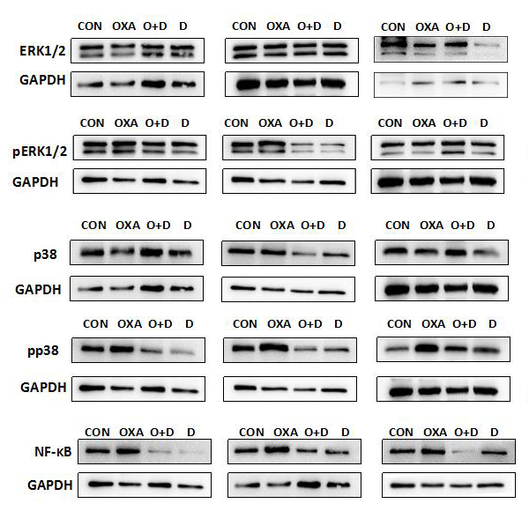
Figure S4. Effect of duloxetine on phosphorylation of p38 MAPK and ERK1/2 expression in the neuropathic mouse DRG following oxaliplatin treatment. Relatived to Figure 6.

Figure S5. Effect of duloxetine on NF-κB, phosphorylation of p38 MAPK and ERK1/2 expression in the neuropathic mouse DRG following PTX treatment. Relatived to Figure 7.

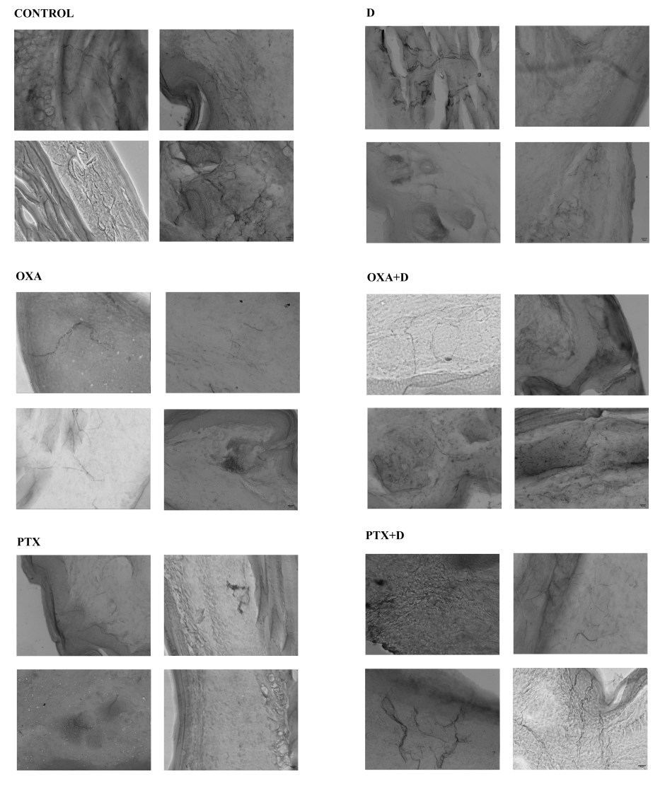
Figure S6.Effect of duloxetine on IENF retraction induced by OXA or PTX. Relatived to Figure 5.
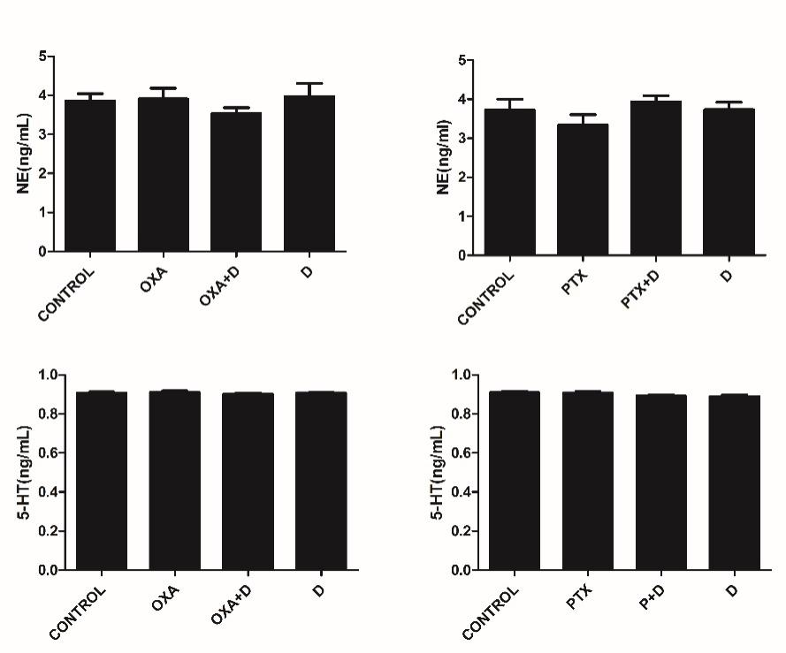
Figure S7. Effect of duloxetine on serotonin or NE level in the DRG cell culture. (ELISA) DRG neuronal cells were treated with (or without) PTX (300 nM) and duloxetine (300 nM) for 24 h, then serotonin and NE level were measured using Elisa kit.

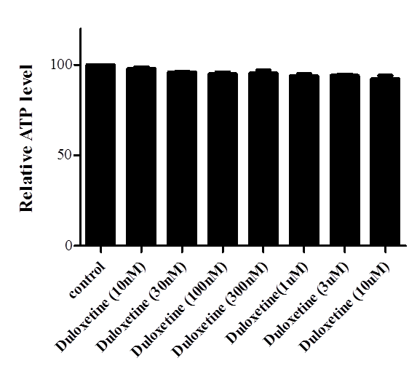
Figure S8. Effect of duloxetine on DRG Primary rat DRG neuron cells were exposed to various concentrations of duloxetine for 24 hours and ATP level was measured.

Table S1. Cytokine changes in mice following chemotherapy and duloxetine treatments (pg/mL).
The table shows the mean and SEM (standard error of the mean) for IL-1β, IL-6, TNF-α and NGF concentrations (pg/mL) in mouse blood samples. (n = 5, * p <0.05 vs control, # p <0.05 vs OXA alone, ^ p <0.05 vs PTX alone)
