**Supplementary data (Figure S1- Figure S5)**

**A**



**B**



**C**



**D**





**Figure S1∣**Three main compounds of QP.

(**A**) the LC/MS spectrum of QP; (**B**-**D**) the mass spectrums of compound (1-3). gallic acid (**B**), *m/s*:170 and t*R* 14.88; corilagin (**C**), *m/s*:634 and t*R* 66.87; and ellagic acid (**D**), *m/s*: 302 and t*R* 86.11

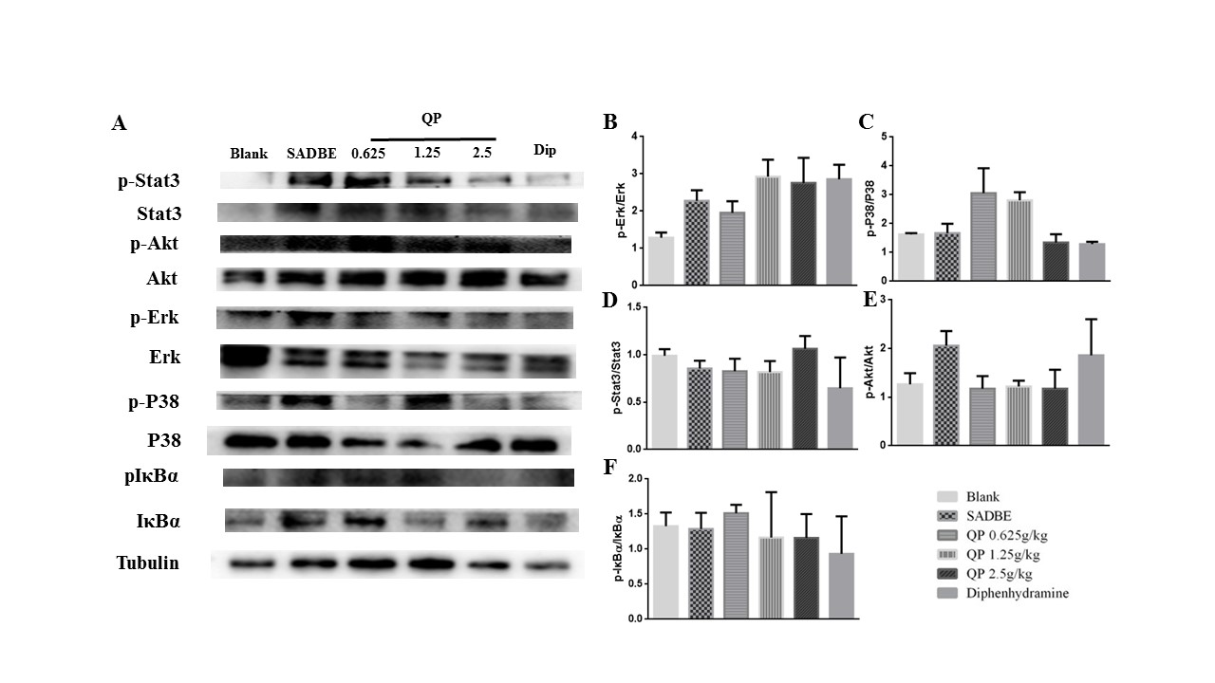

**Figure S2∣**QP suppressed the phosphorylation of MAPKs in the DRG of SADBE mice. Expression of p-Erk, p-P38, p-Stat3, p-Akt, and p-IκBα in the DRG of SADBE mice was not significantly reduced QP compared to that in the model group (*p* > 0.05). Data was expressed as mean ± SEM. ANOVA (n=3 each group).

p-Stat3

**Blank**

**SADBE**

**0.625**

**1.25**

**2.5**

**Dip**

**QP**

**Blank**

**SADBE**

**0.625**

**1.25**

**2.5**

**Dip**

**QP**

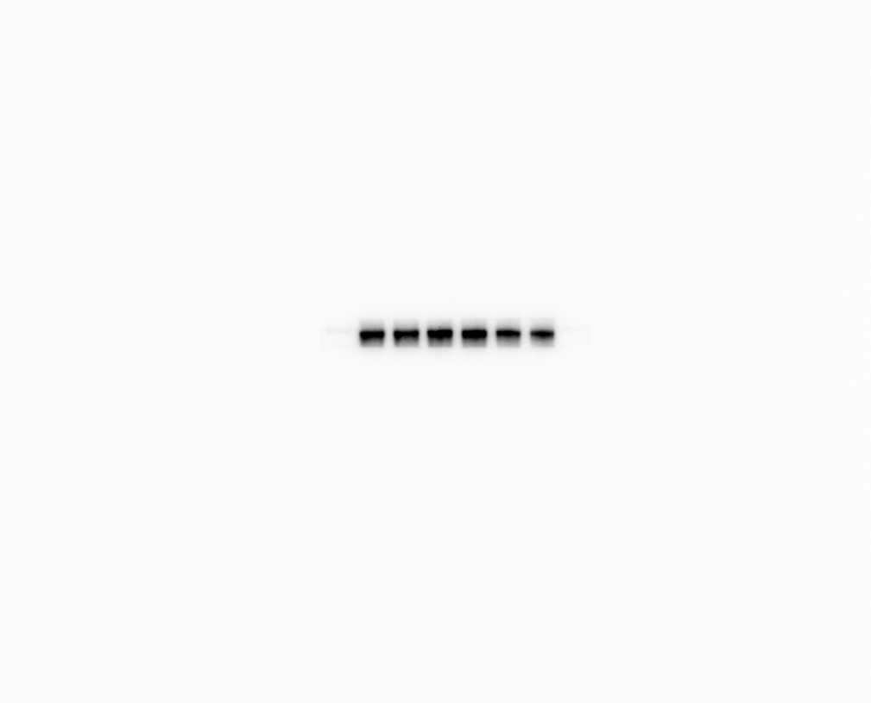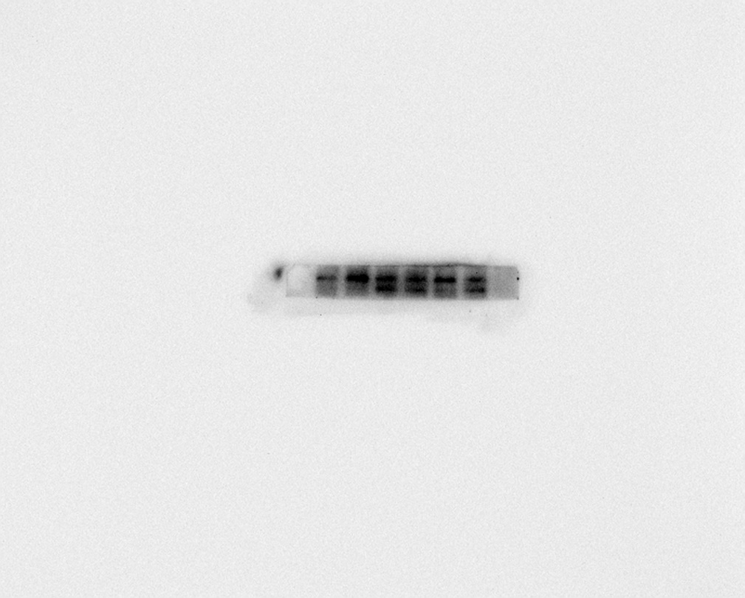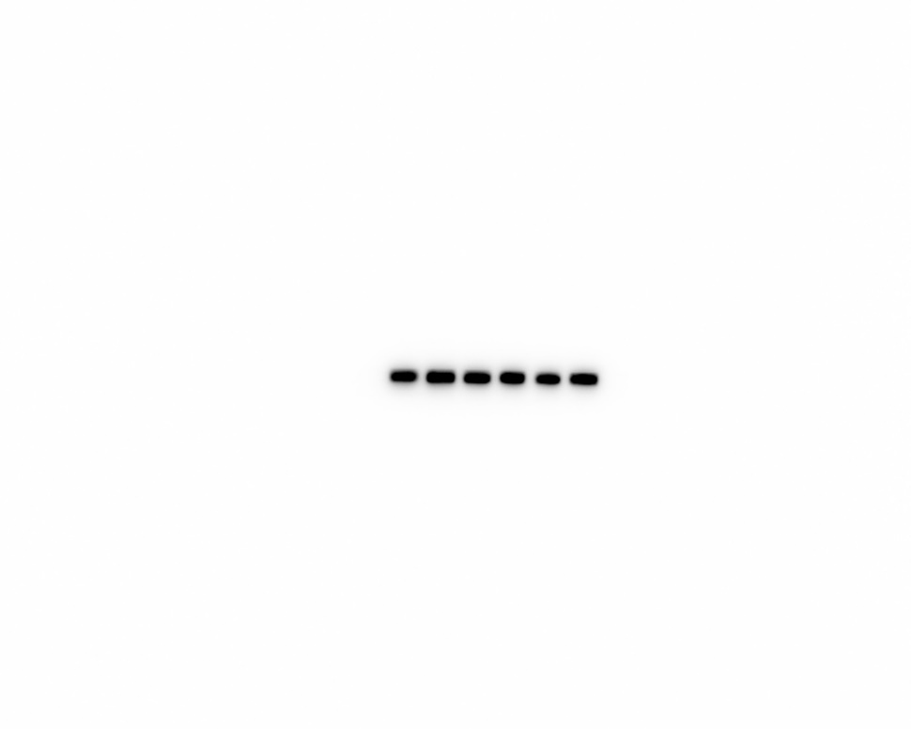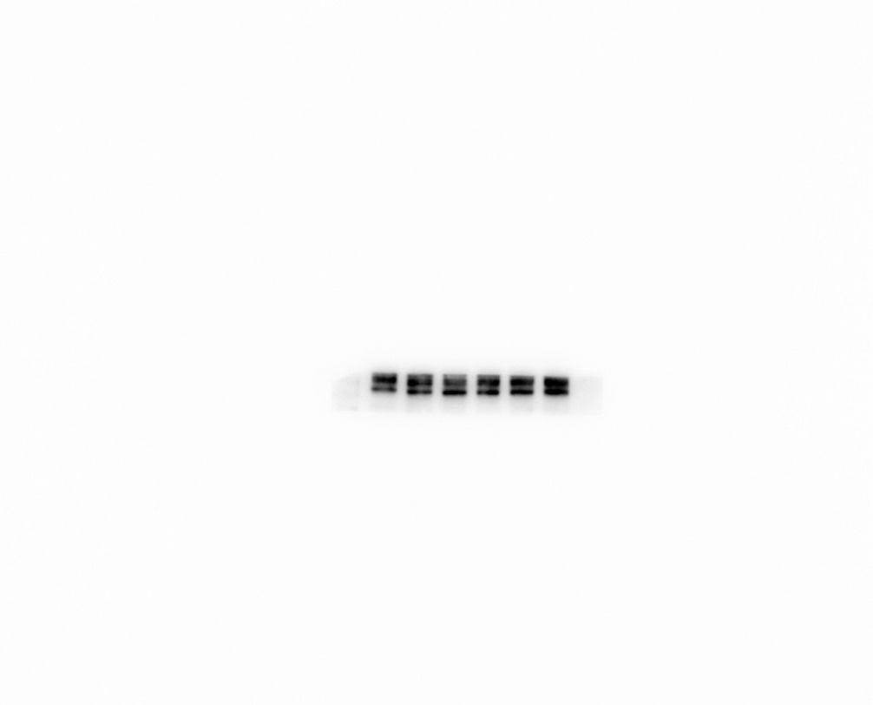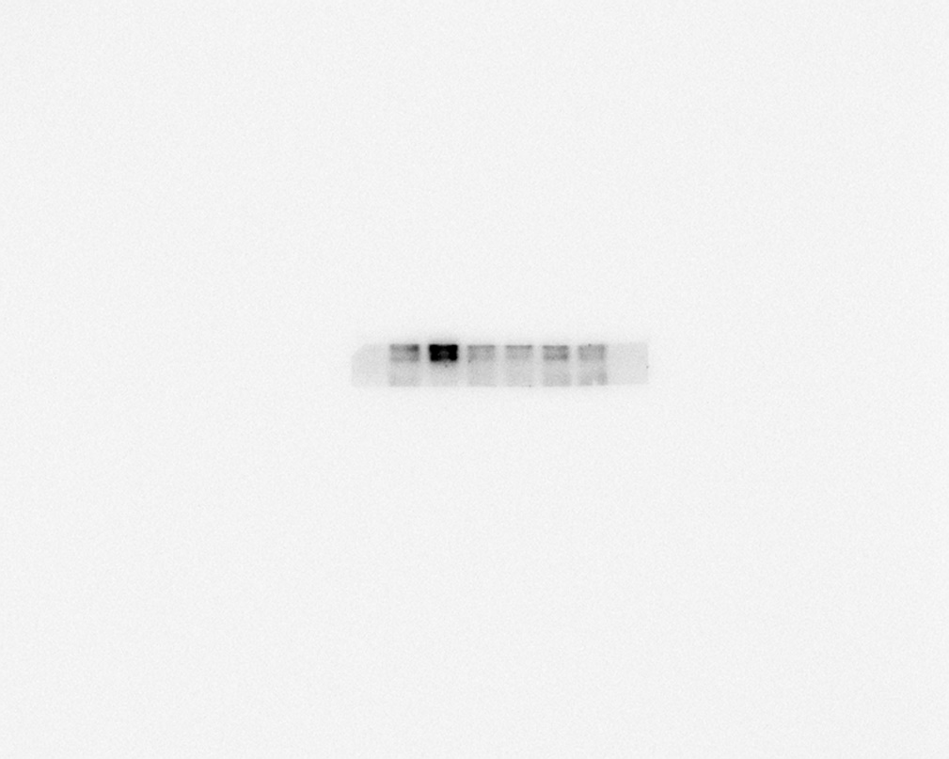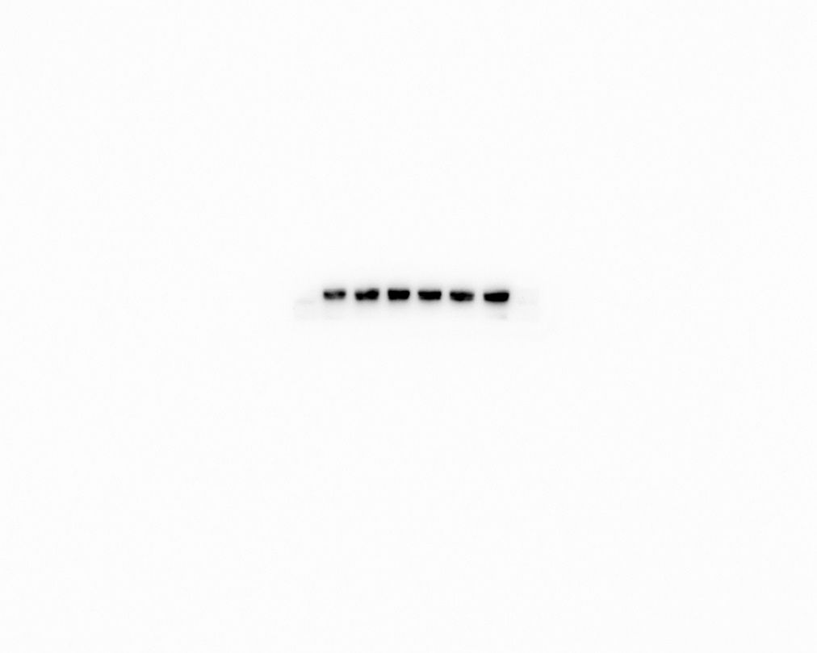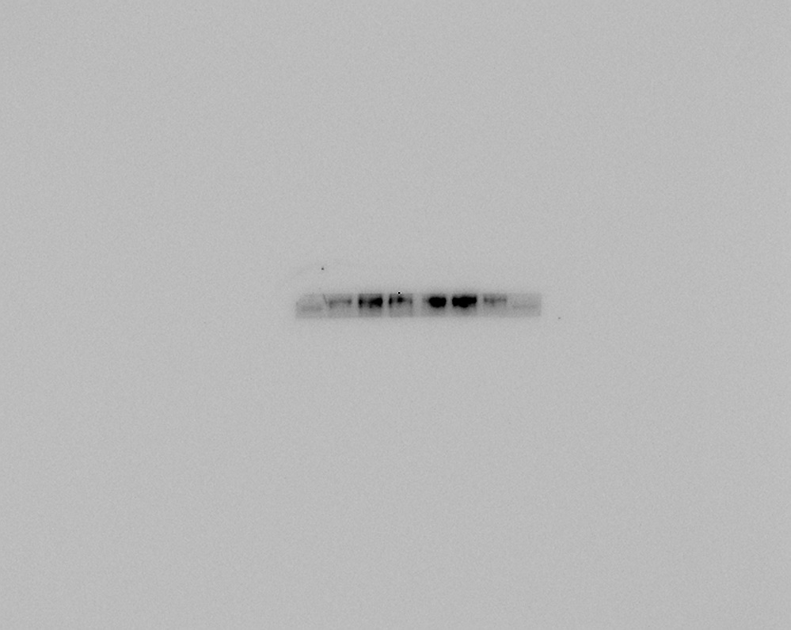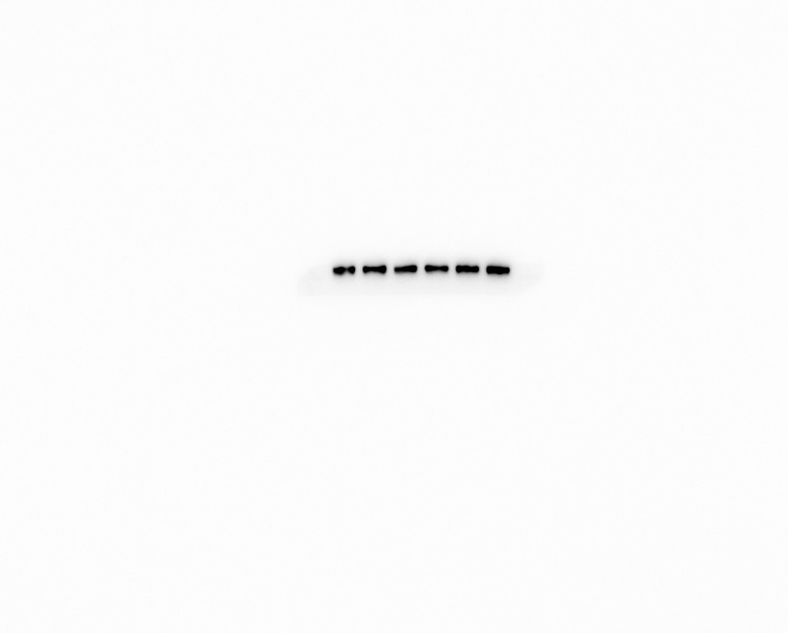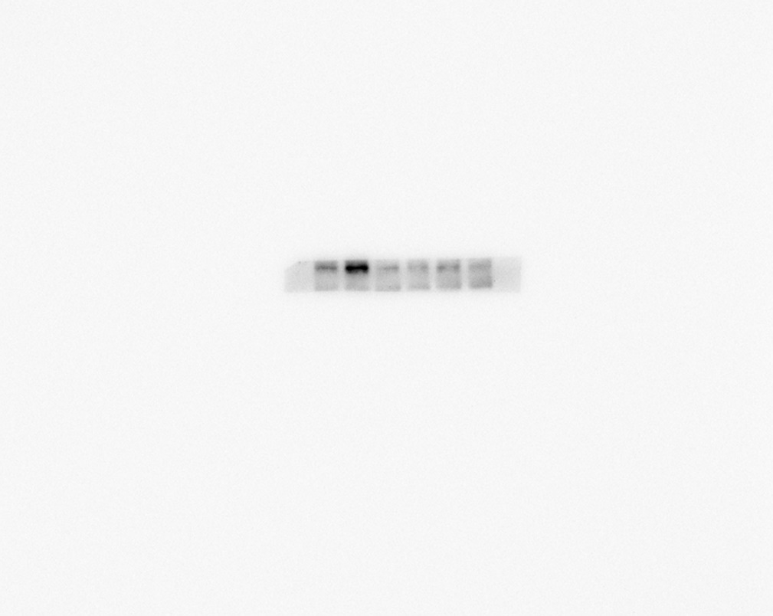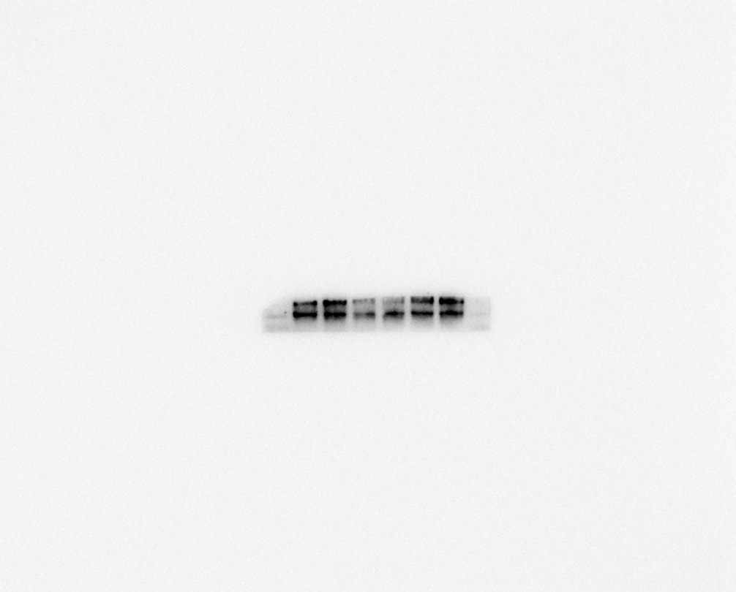

**Blank**

**SADBE**

**0.625**

**1.25**

**2.5**

**Dip**

**QP**

Tubulin

**Blank**

**SADBE**

**0.625**

**1.25**

**2.5**

**Dip**

**QP**

**Blank**

**SADBE**

**0.625**

**1.25**

**2.5**

**Dip**

**QP**

**Blank**

**SADBE**

**0.625**

**1.25**

**2.5**

**Dip**

**QP**

IκBα

P38

p-IκBα

**Blank**

**SADBE**

**0.625**

**1.25**

**2.5**

**Dip**

**QP**

**Blank**

**SADBE**

**0.625**

**1.25**

**2.5**

**Dip**

**QP**

p-Erk

**Blank**

**SADBE**

**0.625**

**1.25**

**2.5**

**Dip**

**QP**

Akt

**Blank**

**SADBE**

**0.625**

**1.25**

**2.5**

**Dip**

**QP**

p-Akt

**Blank**

**SADBE**

**0.625**

**1.25**

**2.5**

**Dip**

**QP**

Stat3

p-P38

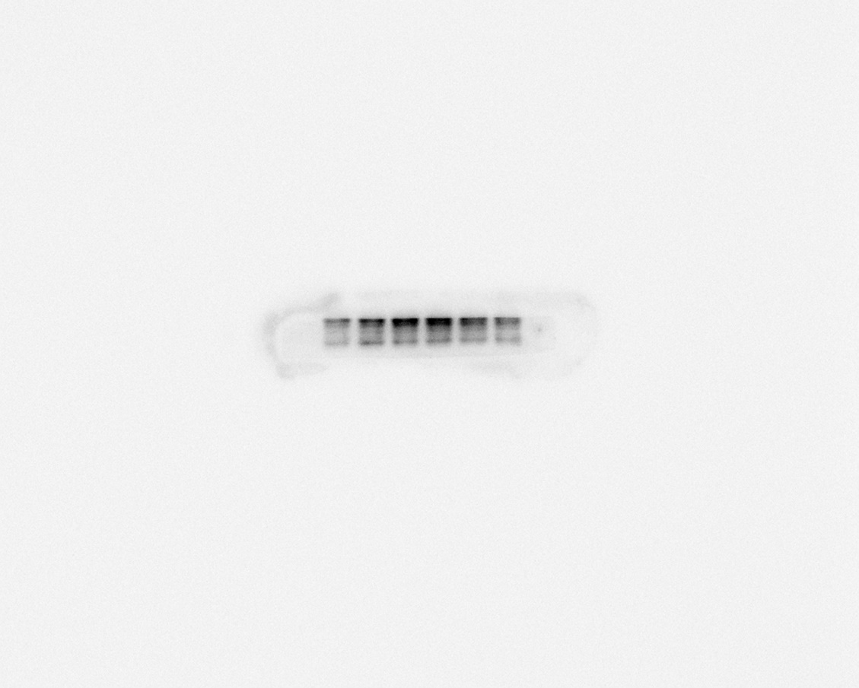

Erk

**Figure S3∣**The original western blot images of **Figure 6A** in the manuscript.

**Blank**

**SADBE**

**0.625**

**1.25**

**2.5**

**Dip**

**QP**

**Blank**

**SADBE**

**0.625**

**1.25**

**2.5**

**Dip**

**QP**

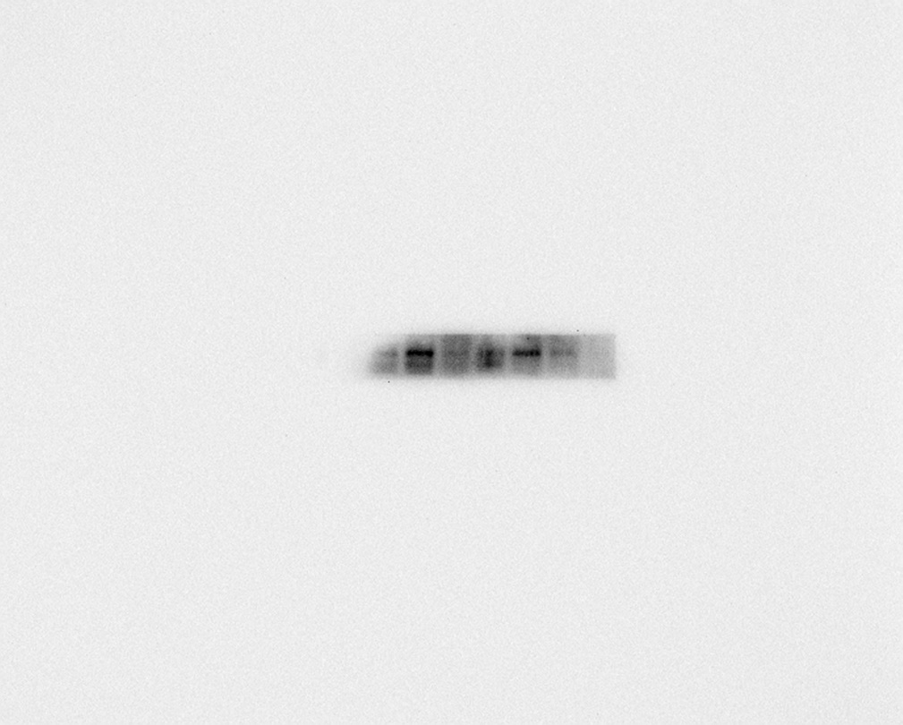

p-IκBα

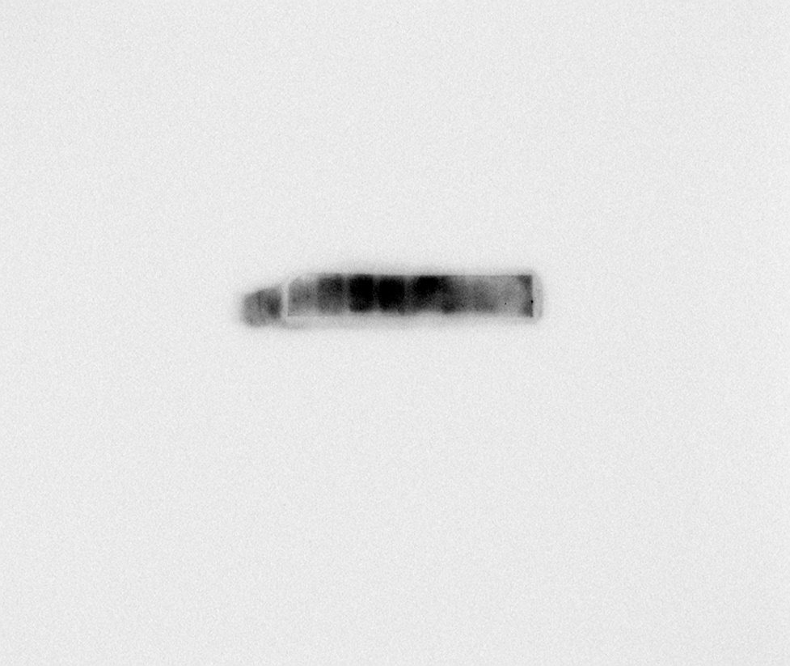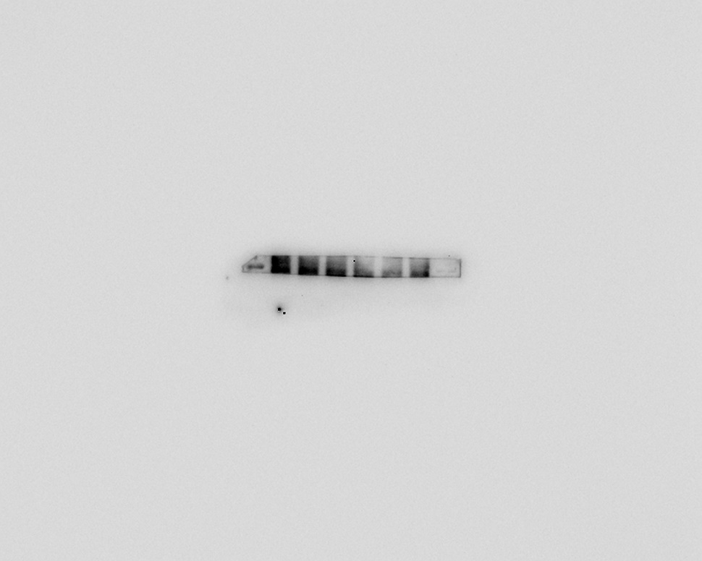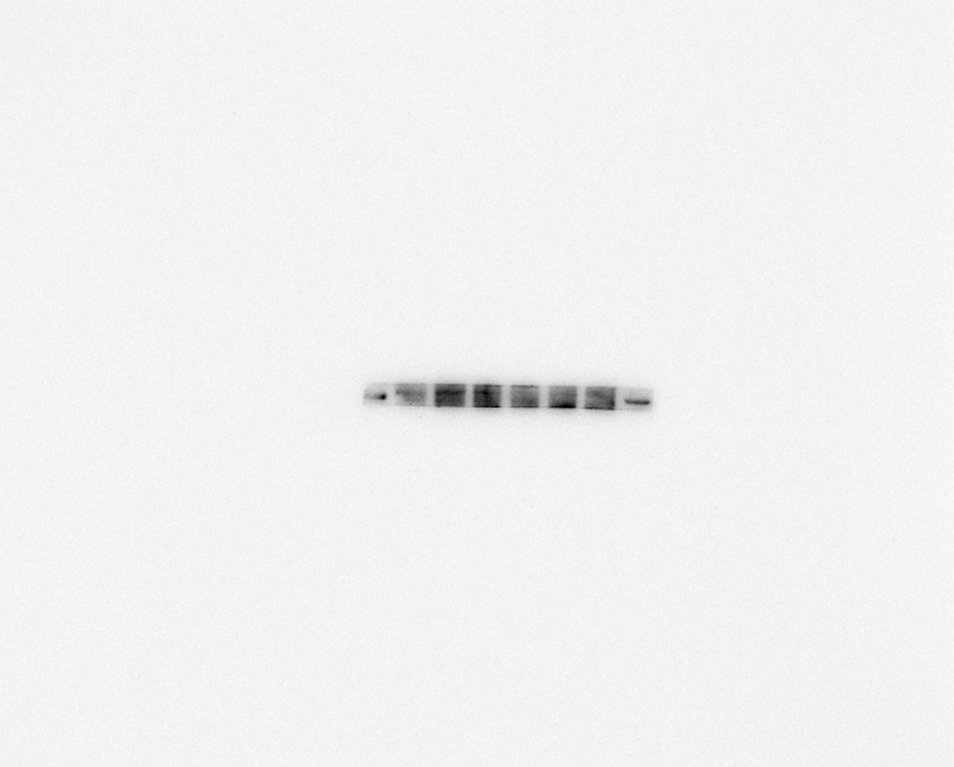

p-Akt

**Blank**

**SADBE**

**0.625**

**1.25**

**2.5**

**Dip**

**QP**

p-Erk



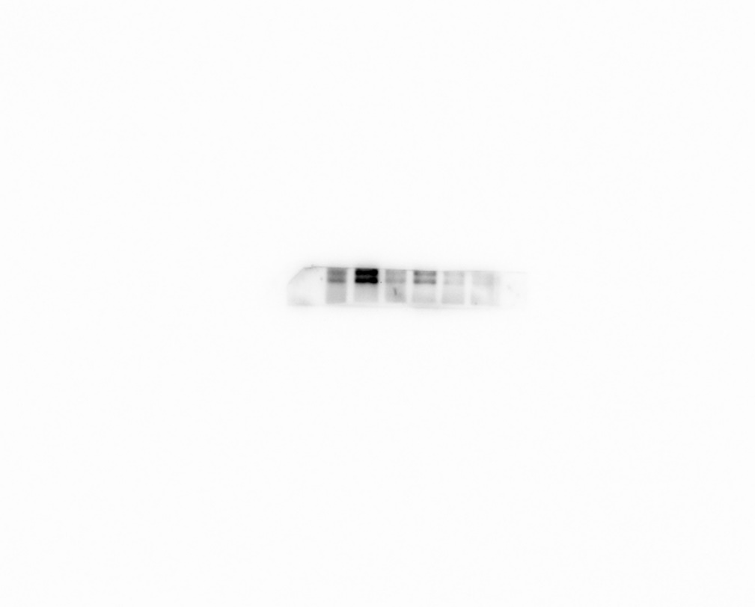

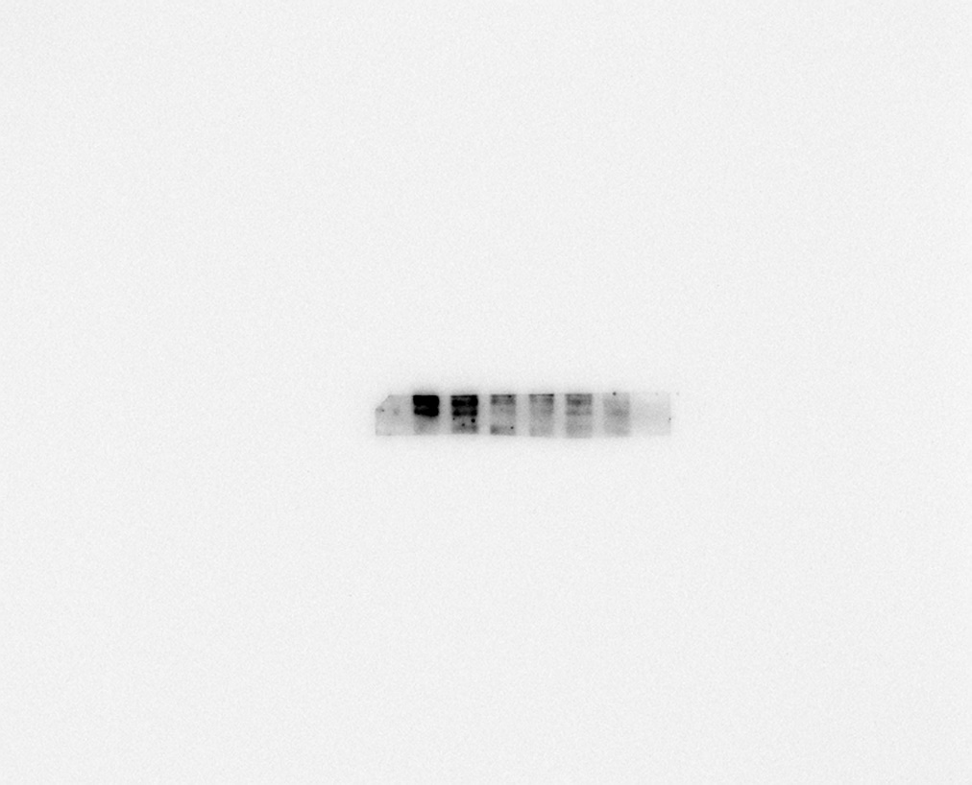

**Figure S4∣**The original western blot images of p-Akt, p-IκBα and p-Erk.

**Blank**

**SADBE**

**0.625**

**1.25**

**2.5**

**Dip**

**QP**

**Blank**

**SADBE**

**0.625**

**1.25**

**2.5**

**Dip**

**QP**

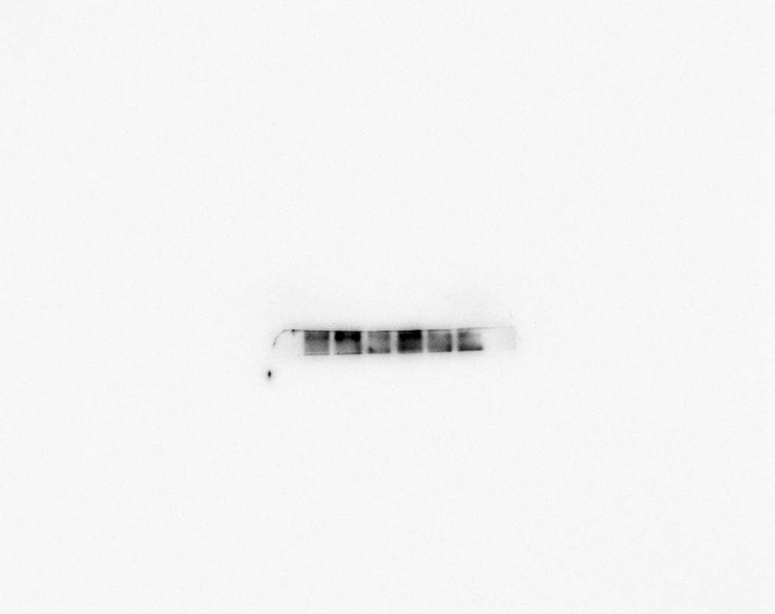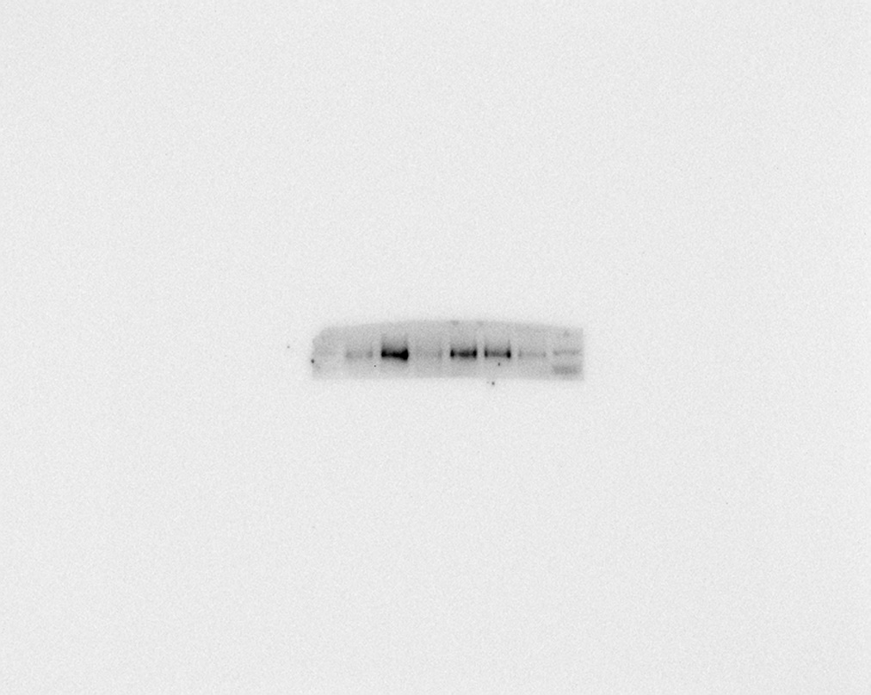

p-Stat3

p-P38

**Blank**

**SADBE**

**0.625**

**1.25**

**2.5**

**Dip**

**QP**

**Blank**

**SADBE**

**0.625**

**1.25**

**2.5**

**Dip**

**QP**

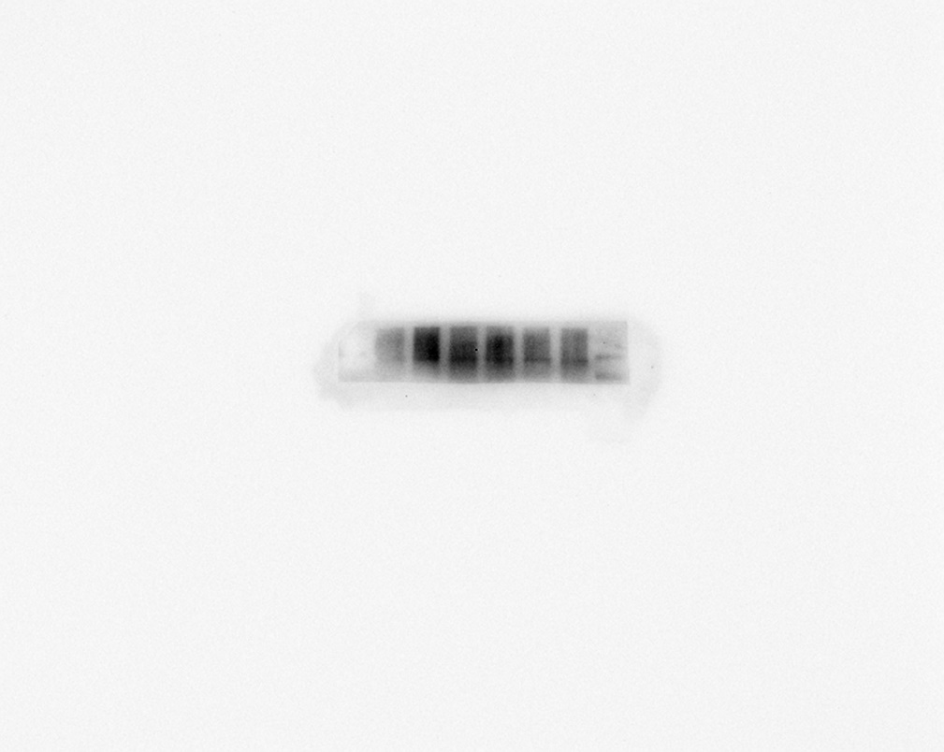

Stat3



**Blank**

**SADBE**

**0.625**

**1.25**

**2.5**

**Dip**

**QP**

P38

p-Akt

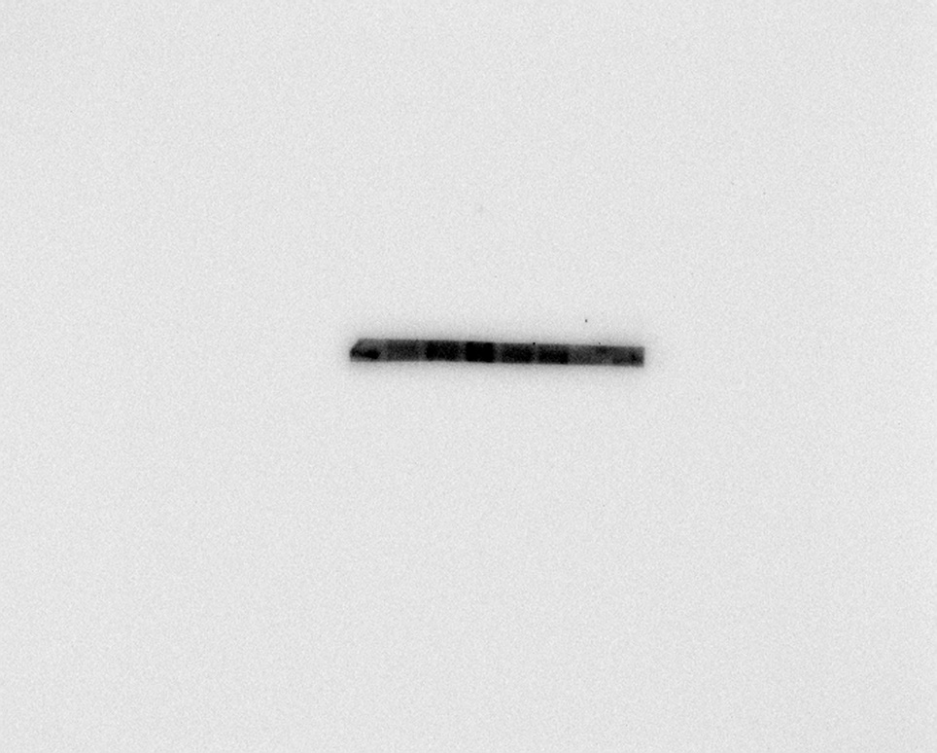

**Blank**

**SADBE**

**0.625**

**1.25**

**2.5**

**Dip**

**QP**

**Blank**

**SADBE**

**0.625**

**1.25**

**2.5**

**Dip**

**QP**

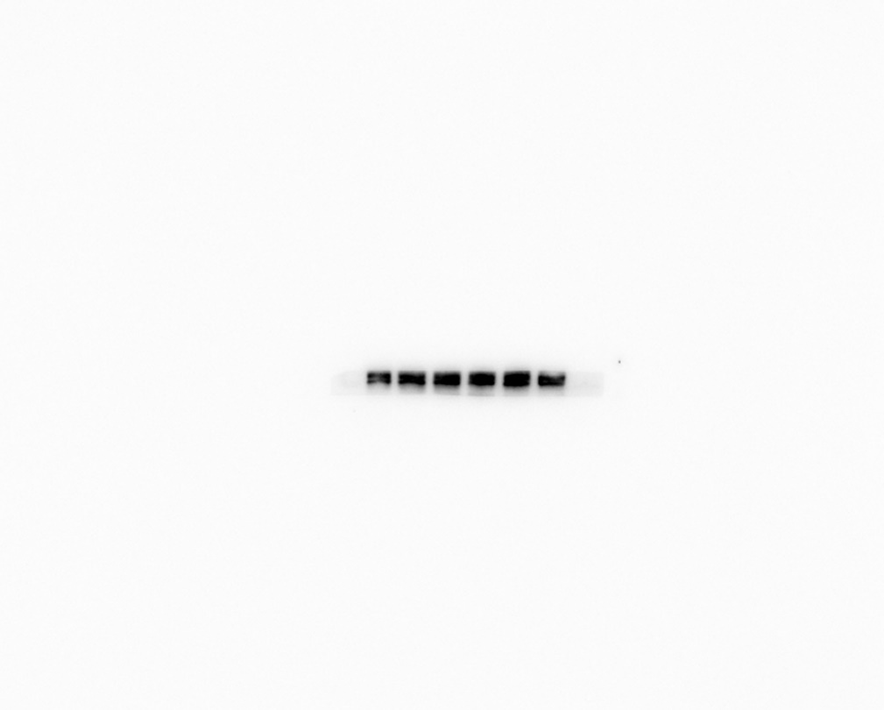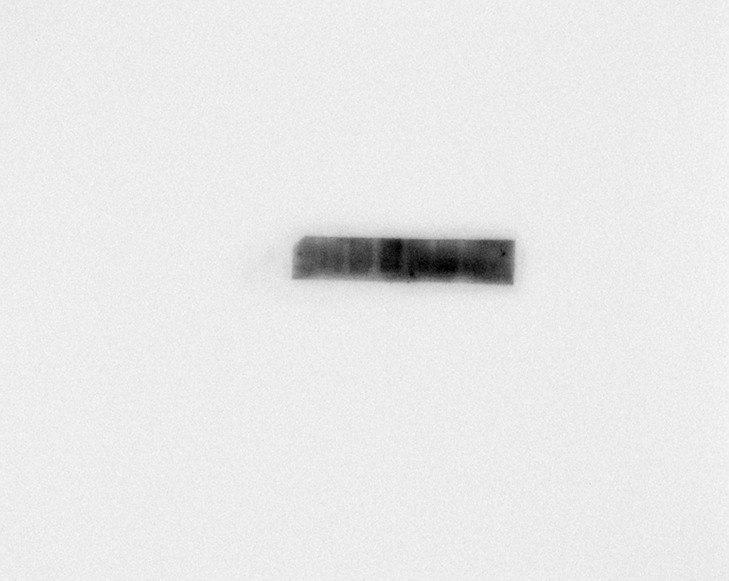

Akt

p-IκBα

**Blank**

**SADBE**

**0.625**

**1.25**

**2.5**

**Dip**

**QP**

**Blank**

**SADBE**

**0.625**

**1.25**

**2.5**

**Dip**

**QP**

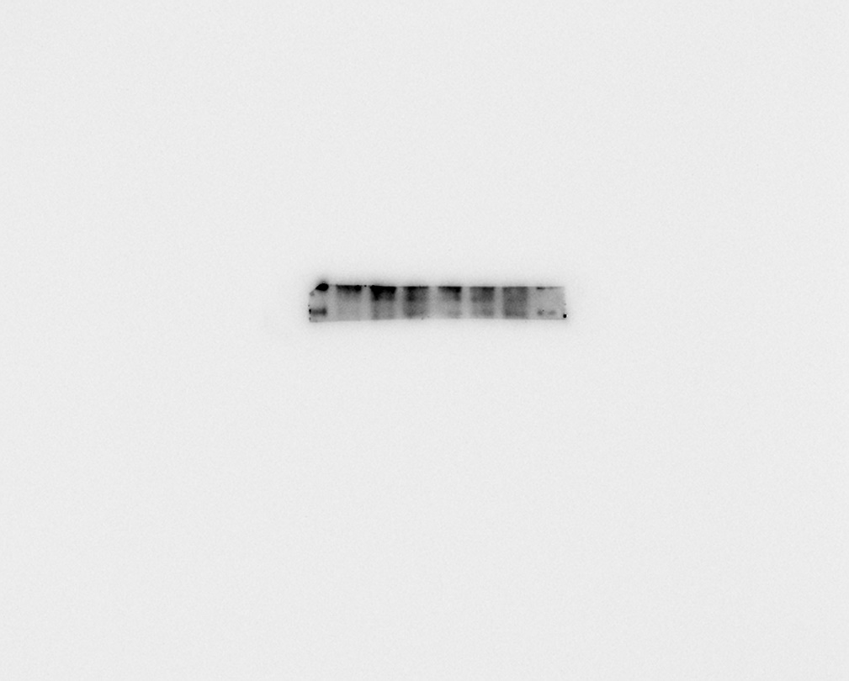

p-Erk

IκBα

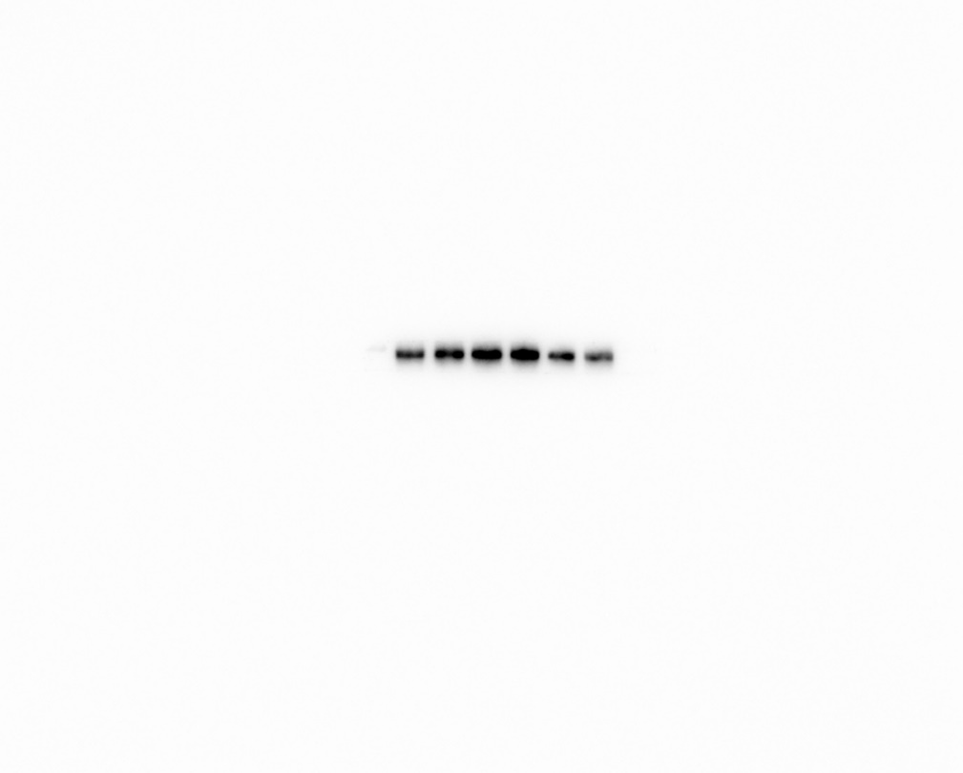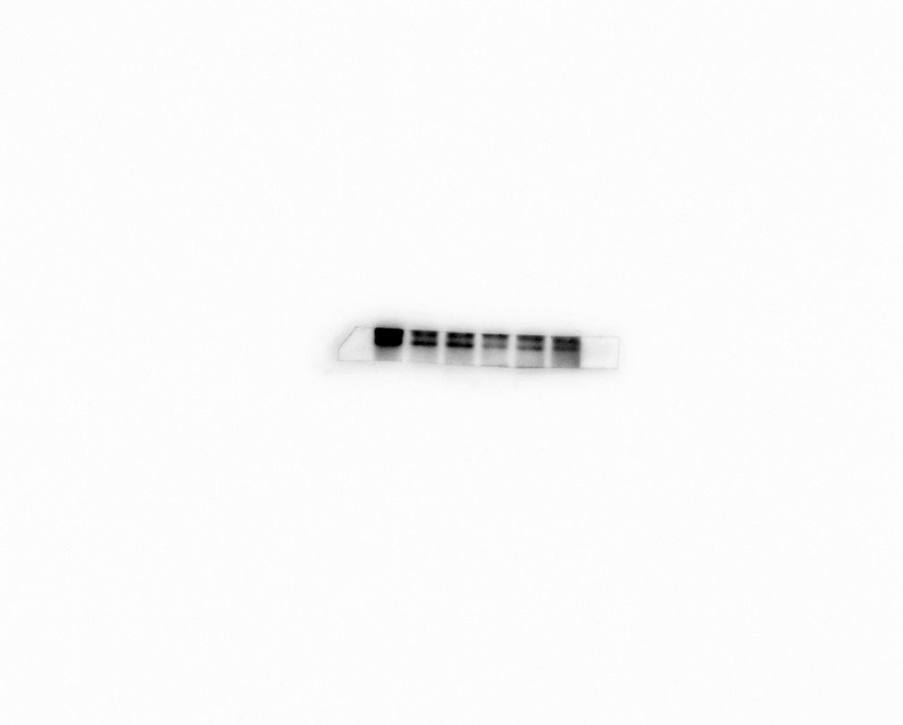

**Figure S5∣**The original western blot images of **Figure S2** in the manuscript.

**Blank**

**SADBE**

**0.625**

**1.25**

**2.5**

**Dip**

**QP**

**Blank**

**SADBE**

**0.625**

**1.25**

**2.5**

**Dip**

**QP**

Tubulin

Erk