Supplement to: Fatty acid and hopanoid adaption to cold in the psychrotolerant methanotroph Methylovulum psychrotolerans

Nicole J. Bale^{1*}, W. Irene C. Rijpstra¹, Diana X. Sahonero-Canavesi¹, Igor Y. Oshkin², Svetlana E. Belova², Svetlana N. Dedysh², Jaap S. Sinninghe Damsté^{1,3}

¹Department of Marine Microbiology and Biogeochemistry, NIOZ Royal Institute for Sea Research, and Utrecht University, Den Burg, Texel, The Netherlands
²Research Center of Biotechnology of the Russian Academy of Sciences, Winogradsky Institute of Microbiology, Moscow, Russia.
³Department of Earth Sciences, Faculty of Geosciences, Utrecht University, Utrecht, the Netherlands.

Table S1. Growth rates (h⁻¹) of Methylovulum psychrotolerans strains Sph1^{T}, OZ2, and Sph56 at 4, 10 and 20ºC.
Strain | Temperature (°C)
 | 20 | 10 | 4
Sph1^{T} | 0.061 | 0.038 | 0.013
OZ2 | 0.064 | 0.031 | 0.016
Sph56 | 0.057 | 0.041 | 0.012

Table S2. Doubling time of Methylovulum psychrotolerans strains Sph1^{T}, OZ2, and Sph56 cultivated at 4, 10 and 20ºC.
Strain | Time (h)
 | 20 | 10 | 4
Sph1^{T} | 11.4 | 18.3 | 53.7
OZ2 | 10.8 | 22.6 | 44.2
Sph56 | 12.1 | 16.9 | 56.1

Table S3. Potential and characterized members of the FAH superfamily involved in different enzymatic activities: sterol desaturase, sterol deethylase, ornithine lipid hydroxylase, C-4 sterol methyl oxidase, ceramide very long chain fatty acid and very-long-chain aldehyde decarbonylase. Amino acid sequences were analyzed in the PFAM database (El-Gebali et al.), and presence of transmembrane Helix (TMH) was analyzed with OCTOPUS (Viklund and Elofsson, 2008).

Accession | Protein name (Uniprot) | Gene | PFAM | TMH | Reference | Enzymatic activity | Organism
POZ53527.1 | Sterol desaturase | AADEFJLK_00554 | PF04116 | 5 | This work | Hopanoid desaturase | Methylovulum psychrotolerans Sph1^{T}
P32353 | Delta(7)-sterol 5(6)-desaturase | ERG3 | PF04116 | 4 | (Arthington et al., 1991) | Ergosterol desaturase | Saccharomyces cerevisiae ATCC 204508
XP_001017777 | Sterol desaturase | TTHERM_00438800 | PF04116 | 4 | (Tomazic et al., 2011) | Sterol deethylase | Tetrahymena thermophila SB210
WP_015340785 | Ornithine lipid hydroxylase | olsE | PF04116 | 5 | (Vences-Guzmán et al., 2011) | Hydroxylation of ornithine head group | Rhizobium tropici CIAT 899
P53045 | Methylsterol monooxygenase | ERG25 | PF04116 | 4 | (Bard et al., 1996) | C4 methyl oxidase | Saccharomyces cerevisiae ATCC 204508
Q03529 | Ceramide very long chain fatty acid hydroxylase SCS7 | SCS7 | PF04116 / PF00173 | 4 | (Mitchell and Martin, 1997) | Hydroxylation of very long chain fatty acid of dihydroceramides at C-2 | Saccharomyces cerevisiae ATCC 204508
F4HVY0 | Very-long-chain aldehyde decarbonylase CER1 | CER1 | PF04116 / PF12076 | 6 | (Aarts et al., 1995) | Decarbonylase | Arabidopsis thaliana

Figure S1. Geographic locations of the three sampling sites, where strains Sph1^{T} (1), OZ2 (2) and Sph56 (3) were isolated.
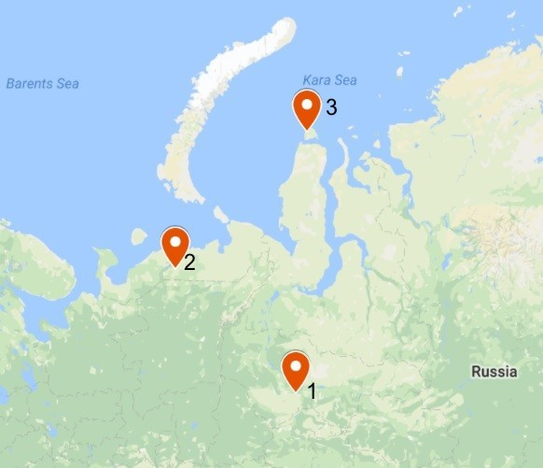

Figure S2. Growth dynamics of strains Sph1^{T} (A), OZ2 (B), and Sph56 (C) at different incubation temperatures. Circles, triangles and squares indicate incubations at 20, 10 and 4ºC, respectively. Data are means of triplicate.

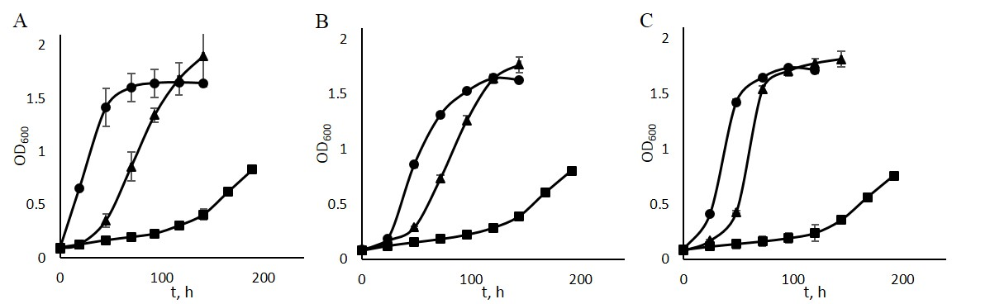
Fig. S3 Multiple Alignment of histidine rich regions of M. psychrotolerans potential hopanoid desaturase POZ53527.1 compared with other characterized members of the fatty acid hydroxylase (FAH) superfamily. Proteins that belong to the FAH superfamily contain two copies of a HXHH motif. Sequences used for the alignment were the potential hopanoid desaturase; POZ53527.1 (M. psychrotolerans sph1), sterol desaturase; P32353 (Saccharomyces cerevisiae ATCC 20450), sterol deethylase; XP_001017777 (Tetrahymena thermophila SB210), ornithine lipid hydroxylase; WP_015340785 (R. tropici CIAT 899), C-4 sterol methyl oxidase; P53045 (S. cerevisiae strain ATCC 204508), ceramide very long chain fatty acid hydroxylase; Q03529 (S. cerevisiae ATCC 20450) and very-long-chain aldehyde decarbonylase; F4HVY0 (A. thaliana).

POZ53527.1_M.psychrotolerans 92 YWQHV-ASH 99 104 LWR-LHQVHHS 113 188 LHRIHHS 194
P32353_S.cerevisiae 197 YLAHR-WLH 204 208 VYRALHKPHHK 218 287 CHTVHHL 293
XP_001017777_T.thermophila 141 YWKHR-LLH 148 152 FWY-FHRNHHS 161 240 HHNLHHS 246 WP_015340785_R.tropici 138 YMAHR-LAH 145 150 LWR-FHALHHS 159 231 LHRWHHS 237
P53045_S.cerevisiae 157 YWAHR-LFH 164 168 FYKYIHKQHHR 178 263 HHDLHHH 269
Q03529_S.cerevisiae 241 YGLHRFLFH 249 264 HFL-LHGCHHY 273 344 YHLEHHY 350
F4HVY0_A.thaliana 143 YWLHK-ALH 150 154 LYSRYHSHHHS 164 247 YHSLHHT 253
Consensus * * * ** * **

References

Aarts, M. G., Keijzer, C. J., Stiekema, W. J., and Pereira, A. (1995). Molecular characterization of the CER1 gene of arabidopsis involved in epicuticular wax biosynthesis and pollen fertility. The Plant Cell 7, 2115–2127. doi:10.1105/tpc.7.12.2115.
Arthington, B. A., Bennett, L. G., Skatrud, P. L., Guynn, C. J., Barbuch, R. J., Ulbright, C. E., et al. (1991). Cloning, disruption and sequence of the gene encoding yeast C-5 sterol desaturase. Gene 102, 39–44.
Bard, M., Bruner, D. A., Pierson, C. A., Lees, N. D., Biermann, B., Frye, L., et al. (1996). Cloning and characterization of ERG25, the Saccharomyces cerevisiae gene encoding C-4 sterol methyl oxidase. Proc. Natl. Acad. Sci. U.S.A. 93, 186–190.
El-Gebali, S., Mistry, J., Bateman, A., Eddy, S. R., Luciani, A., Potter, S. C., et al. The Pfam protein families database in 2019. Nucleic Acids Res. doi:10.1093/nar/gky995.
Mitchell, A. G., and Martin, C. E. (1997). Fah1p, a Saccharomyces cerevisiae Cytochromeb 5 Fusion Protein, and ItsArabidopsis thaliana Homolog That Lacks the Cytochromeb 5 Domain Both Function in the α-Hydroxylation of Sphingolipid-associated Very Long Chain Fatty Acids. J. Biol. Chem. 272, 28281–28288. doi:10.1074/jbc.272.45.28281.
Tomazic, M. L., Najle, S. R., Nusblat, A. D., Uttaro, A. D., and Nudel, C. B. (2011). A Novel Sterol Desaturase-Like Protein Promoting Dealkylation of Phytosterols in Tetrahymena thermophila▿. Eukaryot Cell 10, 423–434. doi:10.1128/EC.00259-10.
Vences-Guzmán, M. Á., Guan, Z., Ormeño-Orrillo, E., González-Silva, N., López-Lara, I. M., Martínez-Romero, E., et al. (2011). Hydroxylated ornithine lipids increase stress tolerance in Rhizobium tropici CIAT899. Mol. Microbiol. 79, 1496–1514. doi:10.1111/j.1365-2958.2011.07535.x.
Viklund, H., and Elofsson, A. (2008). OCTOPUS: improving topology prediction by two-track ANN-based preference scores and an extended topological grammar. Bioinformatics 24, 1662–1668. doi:10.1093/bioinformatics/btn221.

