Supplementary Material
Prevalence and risk factors analysis of Francisella tularensis in soil samples; findings of a cross-sectional study in Punjab province of Pakistan
Javed Muhammad¹⁴, Masood Rabbani^{1*}, Muhammad Zubair Shabbir¹, Khushi Muhammad¹, Muhammad Taslim Ghori², Haroon Rashid Chaudhry², Zia Ul Hassnain¹, Tariq Abbas², Muhammad Hamid Chaudhry³, Muhammad Haisem-ur-Rasool¹, Muhammad Asad Ali¹, Tariq Jamil¹, Muhammad Nisar¹, Girish S Kirimanjeswara⁵, Bhushan M Jayarao⁵
Affiliations: ¹University of Veterinary and Animal Sciences, Lahore, Pakistan; ²University College of Veterinary and Animal Sciences, The Islamia University, Bahawalpur, Pakistan; ³University of the Punjab, Lahore, Pakistan; ⁵The Pennsylvania State University, University Park, PA, USA
Corresponding author*: Dr. Masood Rabbani mrabbani@uvas.edu.pk
⁴University of Swabi, Anbar, Pakistan,

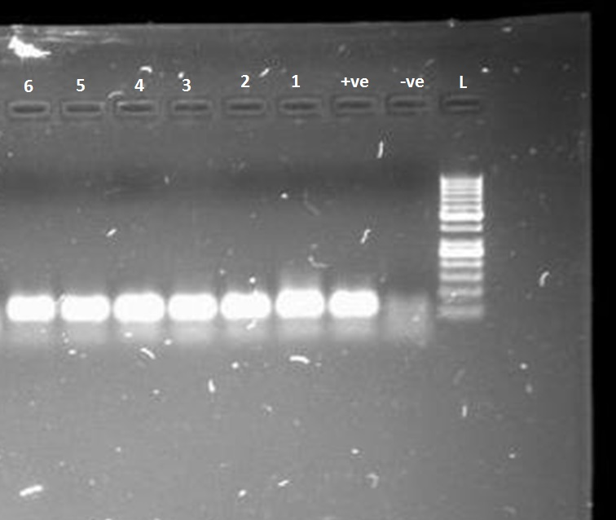

Figure 1: Gel electrophoresis of Real Time PCR products of Francisella tularensis tul4 gene (103 bp)
L: ladder (100 bp), -ve: Negative control, +ve: Positive control 1-6: Samples

