Supplementary Material

Nitrosomonas europaea MazF specifically recognises the UGG motif and promotes selective RNA degradation
Tatsuki Miyamoto†, Akiko Yokota†, Yuri Ota, Masako Tsuruga, Rie Aoi, Satoshi Tsuneda*, and Naohiro Noda*

†These authors have contributed equally to this work.
* Correspondence:
Dr. Satoshi Tsuneda
stsuneda@waseda.jp
Dr. Naohiro Noda
noda-naohiro@aist.go.jp

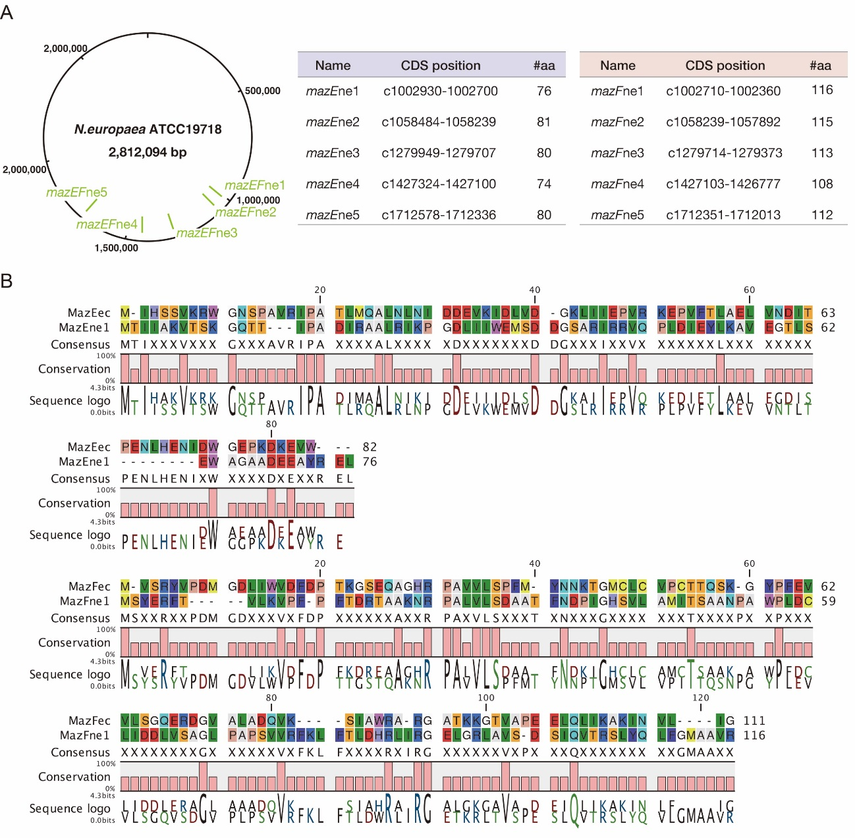
Supplementary Figure S1 N. euroaea MazEF pairs (A) Five MazEF loci predicted in N. europaea. (B) Pairwise alignment of E. coli MazEF (MazEec and MazFec) and N.europaea MazEF (MazEne1 and MazFne1); upper panel, MazE comparison; lower panel, MazF comparison.

Supplementary Figure S2 The mazEFne1 pair in N. europaea (A) Schematic representation of mazEFne1 genes and the primer sets used in this study (top) and the electrophoresed bands (bottom): lanes 1 and 14, DNA ladders; lanes 2, 6, and 10, genomic DNA of N. europaea was used as a template; lanes 3, 7, and 11, cDNA was used as a template; lanes 4, 8, 12, extracted RNA without reverse transcriptase added to exclude the possibility of genomic DNA contamination; lanes 5, 9, 13, no template addition. (B) Growth profile of E. coli cells with (orange) or without (blue) MazFne1 induction.
Supplementary Table S1 PCR primers used in this study
Name | Sequence (5' to 3')
mazEne1 forward (Primer1) | CCTCAAAGGGACAGACCACG
mazEne1 reverse (Primer2) | GCGTTCCCTCCACTGCTTTC
mazFne1 forward (Primer3) | CGTACGGCTGCCAAAAACCG
mazFne1 reverse (Primer4) | AAGCTGATACAGAGATCGTGTG

Supplementary Table S2 Top 50 sequences showing large RCI
Rank | RNA type | Position | Coverage | RCI | Sequence (5′ to 3′) ª | Rank | RNA type | Position | Coverage | RCI | Sequence (5′ to 3′) ª
1 | 1000-4 | 782 | 332 | 332 | ACUUUGGUUGC | 26 | 1000-5 | 828 | 853 | 8.12 | AUGGUGGUACA
2 | 2000-1 | 1861 | 329 | 329 | AUAAUGGUAGG | 27 | 1000-2 | 51 | 192 | 7.38 | CGCAUGGUUCU
3 | 2000-1 | 916 | 1239 | 309.8 | CUCAUGGCAAU | 28 | 1500-1 | 1279 | 194 | 6.93 | UAUGUGGUGCA
4 | 1500-1 | 952 | 504 | 252 | AUAUUGGCAGA | 29 | 1000-1 | 190 | 2075 | 6.74 | UAAAUGGACAA
5 | 1000-4 | 104 | 239 | 239 | UAGUUGGUUCA | 30 | 2000-1 | 131 | 1573 | 4.93 | AAUAUGGCUGA
6 | 1000-3 | 616 | 610 | 203.3 | AACAUGGUAGA | 31 | 1000-2 | 516 | 769 | 4.5 | UAUAUGGGAGA
7 | 1500-1 | 1080 | 1106 | 158 | GACGUGGAAGG | 32 | 1000-1 | 116 | 352 | 4.4 | GAACUGGGUUA
8 | 2000-1 | 272 | 5278 | 135.3 | UCAUUGGCCCA | 33 | 1000-5 | 825 | 105 | 4.38 | GCUAUGGUGGU
9 | 1000-3 | 24 | 122 | 122 | CGAGUGGACGC | 34 | 2000-1 | 1147 | 328 | 4.32 | CAACUGGGACC
10 | 2000-1 | 1636 | 3451 | 98.6 | CCCGUGGACCA | 35 | 2000-1 | 485 | 465 | 4.31 | ACCCUGGCGCU
11 | 1000-2 | 717 | 1250 | 96.15 | UAACUGGCCUG | 36 | 1000-2 | 429 | 568 | 4.09 | CGUCUGGCUUA
12 | 1500-1 | 375 | 850 | 94.44 | AGGUUGGAAUC | 37 | 1000-5 | 623 | 2057 | 4 | CAUCUGGACGU
13 | 500-2 | 148 | 1698 | 94.33 | AUACUGGAGAA | 38 | 1000-5 | 726 | 1152 | 3.63 | CGCUUGGAUAA
14 | 1000-2 | 345 | 449 | 89.8 | CUCGUGGAAGC | 39 | 1500-1 | 82 | 403 | 3.57 | GCCAUGGUUCC
15 | 1500-1 | 174 | 1683 | 46.75 | CUGAUGGGAUU | 40 | 2000-1 | 1373 | 359 | 2.87 | AAUGUGGGUAG
16 | 2000-1 | 56 | 283 | 40.43 | UAGGUGGUAAG | 41 | 1000-4 | 586 | 287 | 2.39 | UUAGUGGGCGG
17 | 1000-1 | 403 | 312 | 39 | UUGAUGGUGGC | 42 | 1000-3 | 184 | 597 | 2.35 | AAUUUGGAGGU
18 | 1000-5 | 332 | 351 | 35.1 | UAUCUGGAAUA | 43 | 1000-2 | 922 | 279 | 2.1 | CAAAUGGCGCA
19 | 1000-3 | 104 | 362 | 30.17 | CCAAUGGAUGU | 44 | 1000-5 | 153 | 229 | 2.1 | CGGUUGGUCAC
20 | 1500-1 | 60 | 116 | 29 | GUUAUGGACCA | 45 | 1000-1 | 406 | 619 | 1.98 | AUGGUGGCAGA
21 | 1000-1 | 757 | 870 | 28.06 | GCUUUGGUAGA | 46 | 1000-5 | 111 | 104 | 1.79 | ACAGUGGUUCG
22 | 1500-1 | 563 | 1068 | 14.83 | GAGGUGGAGCG | 47 | 2000-1 | 535 | 741 | 1.66 | ACGUUGGGUCG
23 | 1000-5 | 585 | 525 | 14.19 | UUAGUGGCCCA | 48 | 1000-1 | 578 | 210 | 1.56 | UACCUGGUGUC
24 | 1500-1 | 1293 | 2186 | 11.33 | UUUCUGGCCAA | 49 | 2000-1 | 430 | 288 | 1.55 | UACAUGGUAAC
25 | 1000-4 | 232 | 185 | 9.74 | GCUUUGGUUGU | 50 | 1000-5 | 364 | 533 | 1.47 | CGAAUGGGCCG
a Underlined letters represent the base with significant coverage increase

