Supplementary Material

The Differential Effect of Excess Aldosterone on Skeletal Muscle Mass by Sex
Mi Kyung Kwak¹, Seung-Eun Lee², Yoon Young Cho³, Sunghwan Suh⁴, Beom-Jun Kim¹, Kee-Ho Song⁵, Jung-Min Koh¹, Jae Hyeon Kim^{2,*}, and Seung Hun Lee^{1,*}
* Correspondence:
Jae Hyeon Kim
jaehyeonkim26@gmail.com.
Seung Hun Lee
hun0108@amc.seoul.kr.

Supplementary Figure 1. Flow diagram showing the selection of the study population
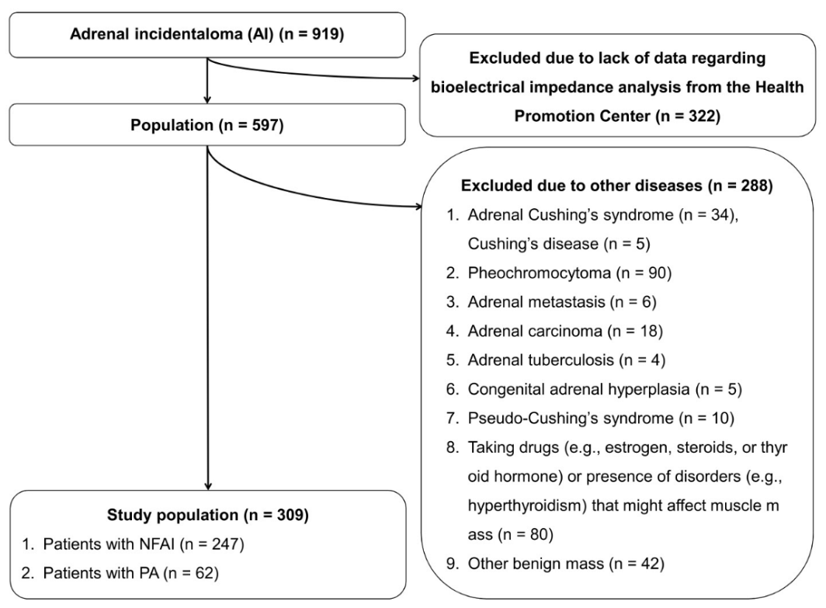
NFAI, non-functioning adrenal incidentaloma; PA, primary aldosteronism

Supplementary Figure 2. Differences in height-adjusted appendicular skeletal muscle mass (HA-ASM) and lean mass (LM) between patients with primary aldosteronism (PA) and 1:1 age- and sex- matched controls with non-functioning adrenal incidentaloma (NFAI) or 1:3 age-, sex-, and menopause status- matched controls without adrenal incidentaloma (AI)
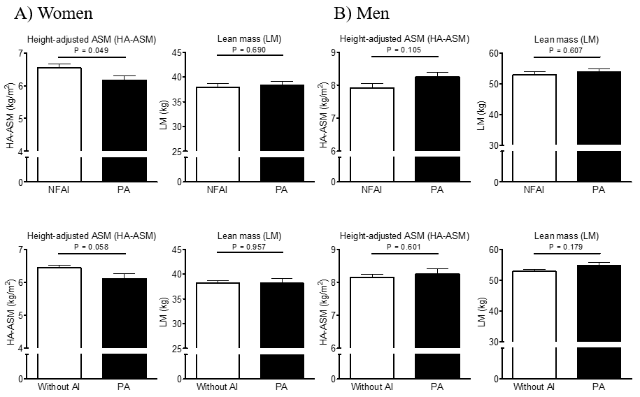
Values represent estimated means, with 95% confidence intervals calculated from analysis of covariance (ANCOVA) after adjusting for age, menopausal status in women, body mass index, regular outdoor exercise, alcohol intake, current smoking, mean arterial pressure, glomerular filtration rate (GFR), and K⁺ levels.
Supplementary Figure 3. A receiver operating characteristics (ROC) curve analysis to determine the plasma aldosterone concentration (PAC) threshold for predicting low skeletal muscle mass in women
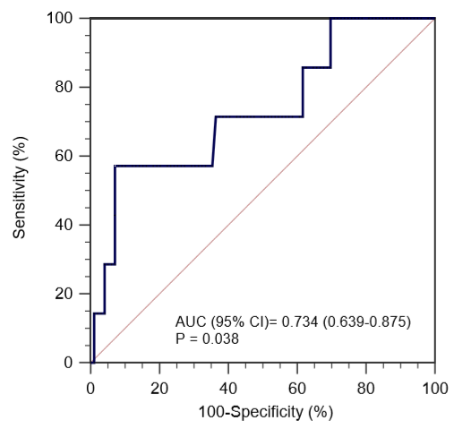

Supplementary Table 1. Baseline characteristics of 57 patients with primary aldosteronism (PA) and 1:1 age- and sex- matched 57 controls with non-functioning adrenal incidentaloma (NFAI) (n = 114)
Variables | Women (n = 48) |  |  | Men (n = 66)
 | NFAI (n = 24) | PA (n = 24) | P |  | NFAI (n = 33) | PA (n = 33) | P
Age (y) | 56.7 ± 8.0 | 56.3 ± 7.9 | 0.886 |  | 57.6 ± 6.1 | 57.5 ± 6.0 | 0.951
Postmenopausal, n (%) | 20 (83.3%) | 19 (79.2%) | 0.999 |  | – | – | –
Height (cm) | 157.5 ± 5.0 | 158.2 ± 4.9 | 0.646 |  | 168.6 ± 6.4 | 170.4 ± 5.1 | 0.200
Weight (kg) | 59.5 ± 9.2 | 61.6 ± 10.6 | 0.466 |  | 71.9 ± 9.6 | 77.8 ± 10.8 | 0.022
BMI (kg/m²) | 24.0 ± 3.8 | 24.6 ± 3.5 | 0.575 |  | 25.3 ± 2.8 | 26.7 ± 2.6 | 0.035
Systolic BP (mmHg) | 128.5 ± 16.2 | 132.8 ± 14.4 | 0.328 |  | 125.3 ± 9.9 | 142.3 ± 15.5 | <0.001
Diastolic BP (mmHg) | 78.8 ± 11.2 | 79.7 ± 10.0 | 0.766 |  | 78.0 ± 9.5 | 87.1 ± 10.3 | <0.001
MAP (mmHg) | 95.1 ± 12.4 | 97.4 ± 9.9 | 0.493 |  | 93.7 ± 8.6 | 105.5 ± 10.6 | <0.001
Current smoker, n (%) | 1 (4.2%) | 0 (0.0%) | 0.999 |  | 15 (45.5%) | 7 (21.2%) | 0.068
Alcohol intake ≥3 U/day, n (%) | 0 (0.0%) | 0 (0.0%) | 0.999 |  | 5 (15.2%) | 9 (27.3%) | 0.366
Regular exercise ≥30 min/day, n (%) | 5 (20.8%) | 1 (4.2%) | 0.019 |  | 17 (51.5%) | 5 (15.2%) | 0.004
GFR (mL/min) | 90.7 ± 19.3 | 98.0 ± 17.8 | 0.114 |  | 91.1 ± 24.5 | 96.8 ± 42.0 | 0.567
K⁺ (mEq/L) | 4.2 ± 0.3 | 4.1 ± 0.4 | 0.242 |  | 4.2 ± 0.4 | 3.9 ± 0.5 | 0.046
PAC (ng/dL) | 14.5 ± 7.3 | 26.1 ± 9.5 | <0.001 |  | 14.6 ± 6.6 | 23.7 ± 8.9 | <0.001
PRA (ng/mL/h) | 0.8 ± 0.8 | 0.5 ± 1.0 | 0.393 |  | 2.4 ± 4.8 | 0.3 ± 0.2 | 0.018
ARR ([ng/dL]/[ng/mL/h]) | 37.4 ± 33.1 | 98.5 ± 61.7 | <0.001 |  | 29.9 ± 54.6 | 100.3 ± 68.7 | <0.001
Data are expressed as the mean ± standard deviation or as the median (interquartile range), unless indicated otherwise. Bold numbers indicate statistically significant values.

NFAI, non-functioning adrenal incidentaloma; PA, primary aldosteronism; BMI, body mass index; BP, blood pressure; MAP, mean arterial pressure; GFR, glomerular filtration rate; PAC, plasma aldosterone concentration; PRA, plasma renin activity; ARR, aldosterone to renin ratio.

Supplementary Table 2. Baseline characteristics of the 62 patients with primary aldosteronism (PA) and 1:3 age-, sex-, and menopause status- matched 186 controls without adrenal incidentaloma (AI) (n = 248)
Variables | Women (n = 116) |  |  | Men (n = 132)
 | Without AI (n = 87) | PA (n = 29) | P |  | Without AI (n = 99) | PA (n = 33) | P
Age (y) | 57.9 ± 8.2 | 57.9 ± 8.3 | 0.999 |  | 57.5 ± 6.0 | 57.5 ± 6.0 | 0.999
Postmenopausal, n (%) | 71 (81.6%) | 24 (82.8%) | 0.999 |  | – | – | –
Height (cm) | 155.0 ± 5.7 | 157.6 ± 5.0 | 0.029 |  | 167.9 ± 6.4 | 170.4 ± 5.1 | 0.040
Weight (kg) | 59.0 ± 8.8 | 60.5 ± 10.0 | 0.444 |  | 68.4 ± 10.0 | 77.8 ± 10.8 | <0.001
BMI (kg/m²) | 24.5 ± 2.9 | 24.3 ± 3.3 | 0.756 |  | 24.2 ± 3.0 | 26.7 ± 2.6 | <0.001
Systolic BP (mmHg) | 123.4 ± 17.4 | 134.0 ± 16.0 | 0.004 |  | 121.2 ± 16.1 | 142.3 ± 15.5 | <0.001
Diastolic BP (mmHg) | 77.1 ± 9.6 | 79.2 ± 10.2 | 0.332 |  | 78.8 ± 10.9 | 87.1 ± 10.3 | <0.001
MAP (mmHg) | 92.6 ± 11.4 | 97.4 ± 10.4 | 0.044 |  | 92.9 ± 11.8 | 105.5 ± 10.6 | <0.001
Current smoker, n (%) | 6 (7.0%) | 0 (0.0%) | 0.328 |  | 62 (62.6%) | 7 (21.2%) | <0.001
Alcohol intake ≥3 U/day, n (%) | 3 (3.5%) | 0 (0.0%) | 0.730 |  | 44 (44.4%) | 9 (27.3%) | 0.124
Regular exercise ≥30 min/day, n (%) | 15 (17.4%) | 2 (6.9%) | 0.280 |  | 7 (7.1%) | 5 (15.2%) | 0.294
GFR (mL/min) | 80.9 ± 17.5 | 92.9 ± 39.2 | 0.121 |  | 83.3 ± 19.2 | 98.0 ± 17.8 | <0.001
Data are expressed as the mean ± standard deviation or as the median (interquartile range), unless indicated otherwise. Bold numbers indicate statistically significant values.

Without AI, without adrenal incidentaloma; PA, primary aldosteronism; BMI, body mass index; BP, blood pressure; MAP, mean arterial pressure; GFR, glomerular filtration rate.

