Supplementary Material

The Transcription Factor T-bet is Required for Optimal Type I Follicular Helper T Cell Maintenance during Acute Viral Infection
Pengcheng Wang^{1,2,#},Youping Wang^{1,#}, Luoyingzi Xie^{1,#}, Minglu Xiao¹, Jialin Wu¹, LifanXu¹, QiangBai¹, YaxingHao¹, Qizhao Huang⁴, Xiangyu Chen¹, Ran He¹, Baohua Li¹, Sen Yang³, Yaokai Chen^{3,}*,Yuzhang Wu^{1,}*and Lilin Ye^{1,}*
¹Institute of Immunology, PLA,Third Military Medical University, Chongqing, China
²National Clinical Research Center of Kidney Diseases, Jinling Hospital, Nanjing, China
³Chongqing Public Health Medical Center, Chongqing, China
⁴Cancer Center, The General Hospital of Western Theater Command, Chengdu, China

#These authors contributed equally to this work
*Correspondence:
Yaokai Chen
yaokaichen@hotmail.com
Yuzhang Wu
wuyuzhang@tmmu.edu.cn
Lilin Ye
yelilinlcmv@tmmu.edu.cn
Supplementary Table
Supplementary Table 1 | Antibodies and Reagents
Antibody/Reagent | Clone/Cat.No. | Company
CD4 | RM4-5 | Biolegend
CD8 | 53-6.7 | BD Biosciences
B220 | RA3-6B2 | eBioscience
CD19 | 6D5 | Biolegend
CD44 | IM7 | eBioscience
CD69 | H1.2F3 | Biolegend
CD25 | PC61.5 | Biolegend
T-bet | 4B10 | Biolegend
Foxp3 | FJK-16s | eBioscience
CXCR5 | 2G8 | BD Bioscience
TNFa | MP6-XT22 | Biolegend
IL2 | JES6-5H4 | Biolegend
IFNγ | XMG1.2 | BD Bioscience
SLAM | TC15-12F12.2 | Biolegend
Bcl6 | K112-91 | BD Bioscience
TCF1 | C46C7 | CST
PNA | FL-1071 | Vector Labs
FAS | JO2 | BD Bioscience
CD138 | 281-2 | BD Bioscience
Ki67 | B56 | BD Bioscience
Bcl2 | 51-15025X | BD Bioscience
Caspase3 | 51-68654X | BD Bioscience
CD45.1 | A20 | Biolegend
CD45.2 | 104 | Biolegend
Va2 | B20.1 | Biolegend
CD127 | A7R34 | Biolegend
CD62L | MEL-14 | eBioscience
PD-1 | RMP1-30 | eBioscience
GITR | DTA-1 | eBioscience
CD71 | R17217 | eBioscience
CD98 | RL388 | eBioscience
IgG2c | 130-097-950 | MiltenyiBiotec
IgD | 11-26c.2a | BD Bioscience
Tim3 | RMT3-23 | Biolegend
Annexin V | 51-65875X | BD Bioscience
Brdu | 51-23619U | BD Bioscience
FC-blocker | NB309 | Innovex Biosciences
KLRG1 | 2F1 | BD Bioscience
GL-7 | GL7 | BD Bioscience

Supplementary Figures
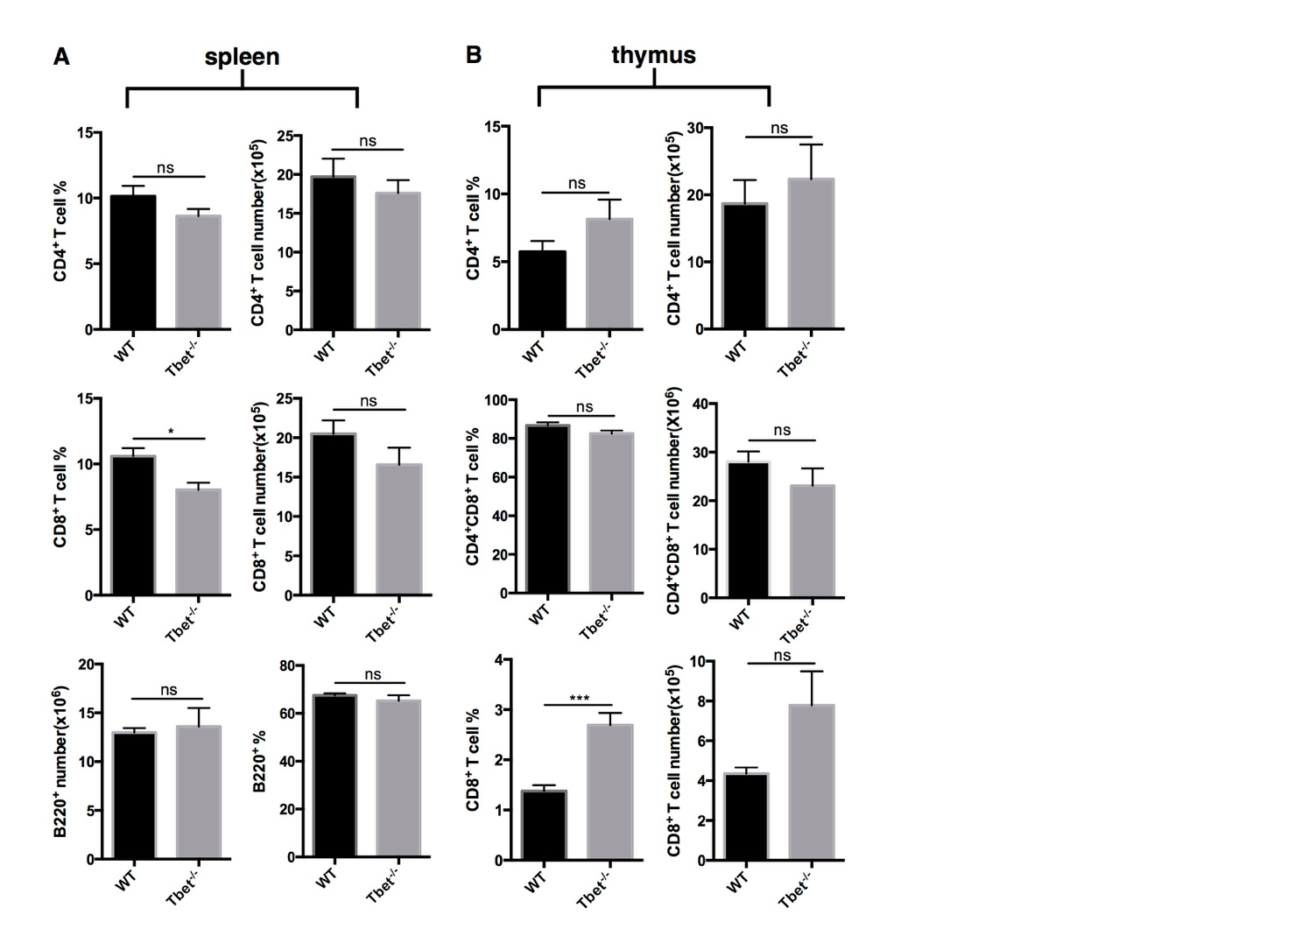
S FIGURE 1 | Naive state of CD4/CD8+T cells in Tbx21^{-/-} mice (associated with Figure 2). Spleen as well as thymus were harvested from Naïve WT and Tbx21^{-/-} mice and analyzed for naïve state of lymphocytes. (A) Summary the percentages and numbers of CD4⁺ T cells, CD8⁺ T cells and B220⁺ B cells in spleen. (B) Summary the percentages and numbers of CD4⁺ T cells, CD8⁺ T cells and CD4⁺CD8⁺ T cells in thymus. ns, not significant; *P < 0.05, ***P < 0.001 (unpaired two-tailed t-test). Data are representative of two independent experiments with 3-5 mice per group (error bars, SEM).
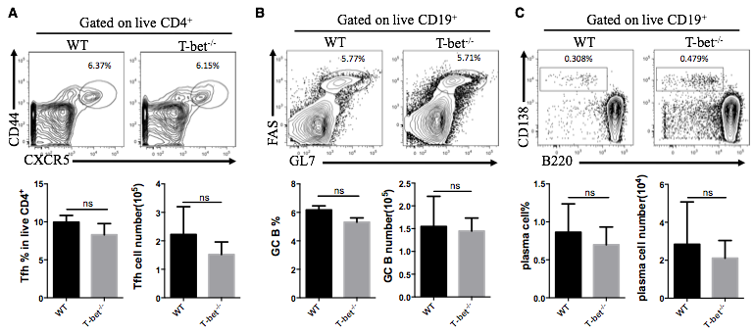
S FIGURE 2 | T-bet is not required for Type II TFH cell response. (A-C) WT and Tbx21^{-/-} mice were immunized with NP-KLH. Draining lymph nodes were harvested at day8 post infection. Representative flow cytometry of TFH cells (CD44⁺CXCR5⁺) (A), GC B cells (FAS⁺PNA⁺) (B) and plasma cells (CD138+B220^{low}) (C) (up) with its percentages and numbers (below) in WT and Tbx21^{-/-} mice. Numbers adjacent to outlined areas indicate percent of each cell subset in parent subset. ns, not significant; *P < 0.05, **P < 0.01, ***P < 0.001 (unpaired two-tailed t-test). Data are representative of two independent experiments with 3-5 mice per group (error bars, SEM).

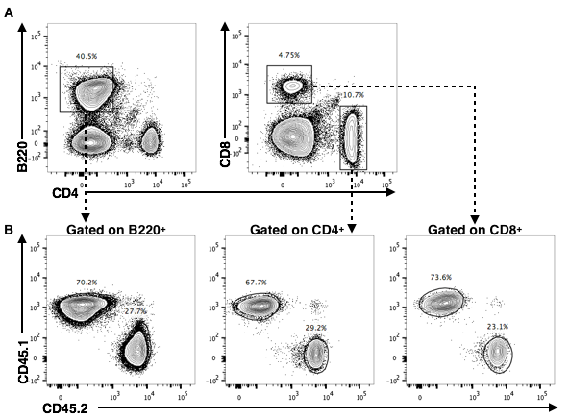
S FIGURE 3 | successful reconstitution of bone marrow chimera mice (associated with Figure 4). Bone marrow cells collected from CD45.2⁺ Tbx21^{-/-} mice and CD45.1⁺ WT mice were mixed at a ratio of 3:7 and transferred intravenously into lethally irradiated (5.5 Gy, twice) naïve WT CD45.1⁺ mice (5 x 10⁶ cells/mouse). 8 weeks later, peripheral blood of recipients was tested. (A) Flow cytometry of B220⁺ B cells, CD4⁺ T cells and CD8⁺ T cells in chimera mice at day60 post cell transfer. (B) Flow cytometry of WT (CD45.1⁺) and Tbx21^{-/-} cells (CD45.2⁺) in B220⁺ B cells, CD4⁺ T cells and CD8⁺ T cells of chimera mice. Numbers adjacent to outlined areas in (A,B) indicate percent of each cell subset in parent subset.
S FIGURE 4 | T-bet does not inhibit Tfh activation at early phase (associated with Figure 6). (A) Flow cytometry of CD25 expression, with the summary of CD25 expression (showed as MFI) in SMARTA TFH cells at day2 post infection. (B) Flow cytometry of CD69 expression, with the summary of CD69 expression (showed as MFI) in SMARTA TFH cells at day2 post infection. ns, not significant; *P < 0.05 (unpaired two-tailed t-test). Data are representative of two independent experiments with 3-5 mice per group (error bars, SEM).
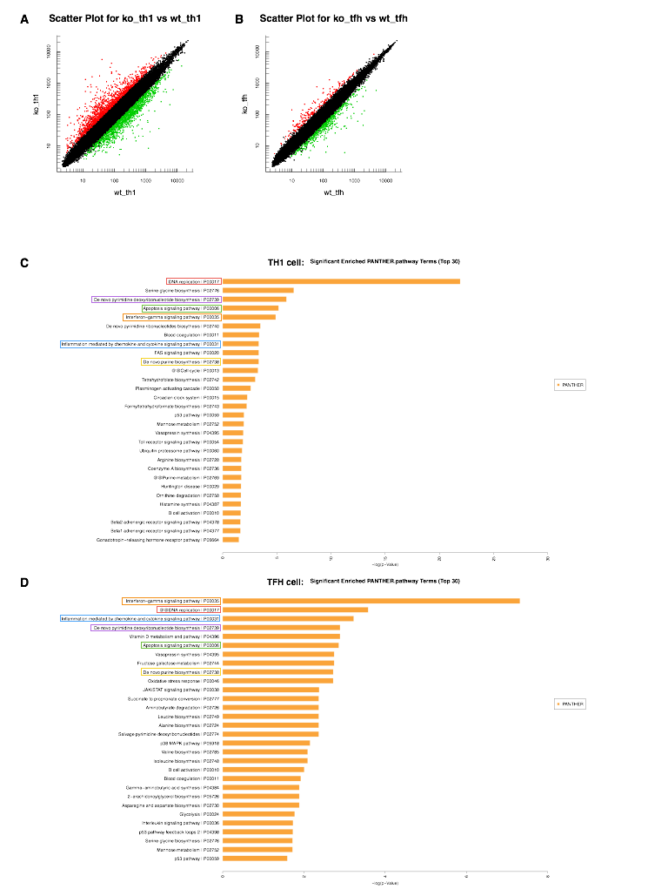
S FIGURE 5 | Scatter plot of differentially expressed genes and Pathway enrichment of the TFH and TH1 cell transcriptomes (associated with Figure 7). (A,B) Scatter plot showing the differentially expressed genes in TH1 (A) and TFH (B) cells of Tbx21^{-/-} mice relative to WT mice. The red plots represent upregulated genes, the green plots represent downregulated genes, and the black plots represent genes without clear differences in expression between Tbx21^{-/-} and WT cells (fold change≥ 2). (C) PANTHER pathway enrichment analysis of TH1 cells (WT TH1vsTbx21^{-/-} TH1 cells). (D) PANTHER pathway enrichment analysis of TFH cells (WT TFHvsTbx21^{-/-} TFH cells).

